Drought Feeding and Management of Sheep

A Guide for Farmers and Land Managers 2025
Contents
Acknowledgements 4
Abbreviations 4
Introduction 6
Chapter 1: Preparing for drought 8
Planning for drought 8
Tips from past droughts 13
Management options 13
Other management decisions 17
Preparing a Drought Action Plan 19
Further information 21
Chapter 2: Setting targets for sheep 22
Condition score targets 22
Setting targets for sheep production 23
Assessing condition and fat reserves of sheep 25
Targets for sheep 28
Further information 41
Chapter 3: What to feed sheep 43
Nutrition of sheep 43
Choosing a supplement 49
Further information 62
Chapter 4: Feeding sheep – how much and how often 63
Making the most out of pastures 64
When to start feeding 65
Introducing sheep to hand feeding 66
Feeding frequency 69
Managing and monitoring 70
How much to feed 72
Further tips for feeding 78
Further information 81
Chapter 5: Water during a drought 82
Will you have enough water? 82
Animal requirements 83
How to calculate how much dam water you have 84
Water quality 86
Options to reduce water requirements 90
Actions to address a water shortage 91
Farmer tips from past droughts 92
Further information 92
Chapter 6: Stock containment 93
Why use stock containment areas 93
Site selection 96
Design 97
Construction 100
Water 100
Feed 102
Management 103
Animal health 104
Releasing sheep 104
Farmer tips from past droughts 104
Further information 105
CASE STUDY 106
CASE STUDY 110
CASE STUDY 113
Chapter 7: Sheep diseases associated with drought 117
Diseases associated with feeding cereal grains 118
Diseases of intensively fed sheep 122
Other diseases 126
Abortion 126
After the drought 135
Humane killing 138
Further information 139
Chapter 8: The feed value of unusual feedstuffs 141
High moisture content feeds 143
Blending and levels of feeding 143
Types of feeds 143
Further information 164
Appendix I – Humane killing 165
Appendix 2: Drought Action Plan template 167

We acknowledge and respect Victorian Traditional Owners as the original custodians of Victoria’s land and waters, their unique ability to care for Country and deep spiritual connection to it.
We honour Elders past and present whose knowledge and wisdom has ensured the continuation of culture and traditional practices.
DEECA is committed to genuinely partnering with Victorian Traditional Owners and Victoria’s Aboriginal community to progress their aspirations.
© The State of Victoria Department of Energy, Environment and Climate Action January 2025.
This publication is copyright. No part may be reproduced by any process except in accordance with the provisions of the Copyright Act 1968.
Authorised by the Victorian Government 1 Spring Street, Melbourne Victoria 3000 Australia
First edition 1997
Revised and reprinted 2002 Reprinted November 2006
Revised and reprinted December 2007
Revised and reprinted September 2015
Revised and reprinted April 2018
Revised and reprinted January 2025.
ISBN 978-1-74146-385-9 (print)
ISBN 978-1-74199-772-9 (internet)
Disclaimer
This publication may be of assistance to you but the State of Victoria and its employees do not guarantee that the publication is without flaw of any kind or is wholly appropriate for your particular purposes and therefore disclaims all liability for any error, loss or other consequence which may arise from you relying on any information in this publication.
Accessibility
To receive this document in an alternative format, phone the Customer Contact Centre on 136 186, email Customer Service, or contact National Relay Service (Access Hub) on 133 677. Available at DEECA website (DEECA).

Acknowledgements
The Department of Economic Development, Jobs, Transport and Resources thanks the following people and organisations for their contribution to this publication:
Jane Court, Ralph Behrendt, Robert Suter, Rachael Holmes, John Bowman, Nick Linden, Graeme Anderson, Gervaise Gaunt, Heather Field, Clem Sturmfels, Belinda Pritchard, Dale Grey, Dale Boyd, Bill Malcolm, Frank Mickan, the Ipsen family, Jim Younghusband and Ben and Jodie Greene.

Original and previous editions
Peter Hanrahan, Jane Court, Peter Williams, Stuart Warner, George Miller, Maria Wilson, Gary Hallam, Trevor Pollard, Tony Britt, Kate Blaszak, Bruce Radford, Allan Semmler, Sally Murray, Peter Berg, Greg Bell, Martin Dunstan, Elizabeth Parker, Kieran Ransom, Kate McCue, Gary McLarty, Peter Thomas, Karin Morgan.

Other organisations
Rebecca Doyle – Animal Welfare Science Centre, University of Melbourne
Todd Andrews – NSW DPI
Australian Wool Innovation Limited
Meat & Livestock Australia

Abbreviations
BoM | Bureau of Meteorology
cm | centimetre
CP | crude protein
CS | condition score
CVD | Commodity Vendor Declaration
DM | dry matter
DSE | dry sheep equivalent
EC | electrical conductivity
FOO | food on offer (in kg DM/ha)
g | gram
HSCW | Hot Standard Carcase Weight
IOD | Indian Ocean Dipole
kg | kilogram
L | litre
LTEM | lifetime ewe management
m2 | square metre
ME | metabolisable energy (energy units)
MJ | megajoule
MLA | Meat & Livestock Australia
mm | millimetre
N/kTex | Newtons per kilotex (a measure of staple strength)
NDF | neutral detergent fibre
NLIS | National Livestock Identification Scheme
NVD | National Vendor Declaration
PIC | Property Identification Code
ppm | parts per million
SOI | Southern Oscillation Index
t | tonne
WEC | worm egg count

Introduction
Droughts and dry seasons are a regular part of farming in Australia. They bring hardships to farming enterprises, farmers and their families, and rural communities.
This book is a practical guide to sheep feeding and management during a drought to help producers plan their response in manageable steps. How well you survive a drought will depend on the information sourced, the initial plan of action and the modifications to the strategy as the drought progresses.
Feeding guidelines in this book have been developed from both research and farmer experience. Strategies for managing droughts, including supplementary feeding rates, will depend on the cash flow situation as well as the financial recovery timeline and this will differ for each farming business.
This resource should be used in conjunction with practical training in pasture assessment and condition scoring of sheep.
The feed requirements outlined in these pages are guides only and monitoring stock condition is critical for getting it right. Feeding for production and doing feed budgets on pastures are outlined well in other resources such as the Lifetimewool website, which is referred to frequently in this resource. There are a range of resources and guides to finishing lambs on the Meat & Livestock Australia and Agriculture Victoria websites. The advice on animal health during drought is provided as a guide only. Where health and welfare issues arise, producers are obligated to provide appropriate care and seek veterinary advice. Producers should also be aware of their obligations under the Code of Accepted Farming Practice for the Welfare of Sheep.
This edition has been updated to reflect the shift in focus in the Victorian sheep industry from a Merino wool base to sheepmeat and dual purpose enterprises. While the guidelines for feeding are targeted at maintenance, advice on ewe condition for future reproduction and the implications for different production levels are included. The authors have also been mindful of the increasing community interest in how animals are treated and consideration of animal welfare beyond basic nutrition.
As no two droughts are the same, this resource cannot cover all situations. It aims to provide general recommendations that can be modified to fit the individual requirements. Plans should include conservation issues, animal feed requirements, feeding in confined areas and assessing water reserves and water quality.
Droughts can be demoralising, but planning and management based on sound information can help you through the experience. We hope this resource will contribute to you and your family successfully managing through drought.
If you require more information on the many dimensions of drought, contact Agriculture Victoria on 136 186.
This chapter is about planning and preparing for drought. Developing an action plan that will cover when and what decisions need to be made will reduce the stress and make management easier. Early indicators of drought, including climate indicators, are discussed as guides to making the early decisions that farmers agree are a key to the successful management of, and recovery from, droughts.

Chapter 1: Preparing for drought
Key messages
- Droughts and dry seasons are a normal part of farming in Victoria and plans on how to manage them should be part of managing the business.
- Farmers who have managed past droughts successfully agree that a key component was making and acting on decisions early.
- Climate drivers can provide some indicators of the season ahead, particularly in late winter when El Nino or drier Indian Ocean Dipole is a more reliable indicator for southern Australia. Other indicators may include low soil moisture and early seeding of annual pasture species.
- Developing an action plan, or drought strategy, that can be triggered by these seasonal indicators will make managing droughts easier and less stressful. The plan should be reviewed regularly as circumstances change.
- Feeding all or some sheep through droughts may be your strategy, but is not the only option.
Early decision making ensures good welfare outcomes for livestock, as well as for the people involved in the farm business.
A drought is an extended period of dry weather (6 to 8 months) where pasture, and sometimes water, become limiting for livestock production and supplementary feeding is needed to maintain production.
Droughts in Victoria typically arise on the back of short dry springs and late autumn breaks where the period of reduced pasture growth is longer than normal. Many consider droughts are a one in 10-year occurrence but they can be more frequent and can occur in successive years. They are the extreme end of dry seasonal conditions that occur annually in most Victorian environments.

Planning for drought
A strategy or action plan for dealing with drought should be prepared as part of farm business planning and be reviewed annually. This planning should occur well before a drought occurs or is forecast. The plan needs to consider what feed is normally stored on farm and held in reserve, the infrastructure, facilities and labour required for dealing with drought, and the contingency plans for dealing with shortfalls in feed and water for your livestock.
Your Drought Action Plan should be activated as soon as you recognise the possibility that the poor season may become a drought. If you leave the decisions until the drought worsens, many of the management options available early may have passed by. Hay and grain prices usually rise significantly, stock prices may drop dramatically, there are fewer agistment options and off-farm employment becomes difficult to find.
Stock and feed prices can respond dramatically to poor seasons as farmers purchase feed and offload stock. Figure 1.1 shows wheat and hay prices (Source Dairy Australia, compiled by Mackinnon Project) from January 2000 to September 2024. Both rose substantially in the 2002–2003 drought and again in 2006–2008 and 2018-19. In 2024, hay prices started to climb but wheat did not.
Similarly stock prices can drop quickly if droughts are widespread and farmers quit stock. This occurred in the 2002 and 2006 droughts but held in 2016 due to low supply and good seasons in other parts of Australia.
Prices will therefore not always be affected significantly by droughts depending on how widespread the drought is and other factors such as export demand and grain harvests in other states. But wherever the external factors sit at the time, prices will still be less in a drought than they would have been if it didn’t happen (and grain and fodder prices higher than they would have been). Farmers face this effect whenever drought happens so making an early decision to purchase supplementary feed and/or sell surplus stock, can result in significant savings.
Figure 1.1: Hay and wheat prices (Source Dairy Australia) and modelled pasture availability for grazed pasture in Central Victoria (GrassGro)
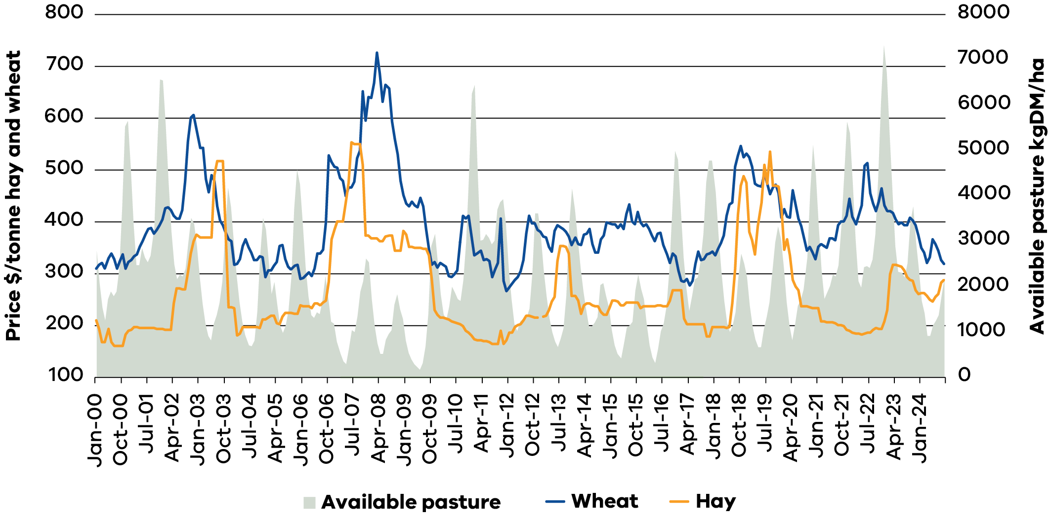

Climate indicators for predicting the season
Seasonal forecasts can offer insights into the spring ahead. There may only be strong or clear climate signals every two or three years, but it’s still worth tuning in as they can be useful indicators in some droughts or poor springs. The Bureau of Meteorology (BoM) has seven-day rainfall forecasts plus one to three month seasonal outlooks that can help you get a feel for what’s in store. Stored soil moisture (‘rain in the bank’) is measured by some croppers and some modelled data is available on websites such MLA Pasture Growth Outlook Tool.
Every farming system has key periods when major decisions about seasonal conditions are needed. Profitable farms employ a range of tactics and strategies to manage variability, with clear trigger points for decisions at key points of the production year. As always, focus on what’s under your control. Seasonal forecasts are a useful indicator of what may occur, but long-term forecasts are a guide only. They are getting better, with bigger computers, more live data from oceans and atmosphere, and a better understanding of which climate drivers affect each region and when.
The four key climate drivers listed below have major effects on our wetter and drier seasons. While they are linked and usually affect one another, here is a short summary of what each driver does.
ENSO (El-Nino/Southern Oscillation) – refers to sources of rain-bearing moisture that comes from the tropical Pacific Ocean. Historically, El Nino years like 2015, produce less moisture, increasing the chance of drier springs. La Nina years (like 2010) send us more moisture and eastern Australia tends to have an increased chance of average or wetter springs. Changes to ocean temperatures along the Equator affect ocean temperatures to the north and north-east of Australia, one of our major moisture sources. Farmers can track what the ENSO is up to, and so can see what the outlook is for each spring. June to August is a good time to look at how things are set up for spring rainfall. The SOI (Southern Oscillation Index) is a measure of the pressure difference between Darwin and Tahiti. In El Nino years, the pressure is higher over Darwin and lower at Tahiti (SOI negative), which is not helpful for the flow of tropical moisture towards Australia.
IOD (Indian Ocean Dipole) – refers to changes in ocean temperatures off Africa and Indonesia that affect moisture sources to our north-west and alters the position of fronts and lows across south-east Australia. The IOD is a major influencer of north-west cloud bands. Victoria’s spring rainfall has a strong correlation with the IOD: positive IOD tend to be drier years when cooler water off Indonesia limits north-west cloud bands and the moisture flow into them. Wetter springs are more likely during negative IOD phases (like 2016), when extra moisture flows and rainfall triggers get sent down to us via north-west cloud bands that drop out their moisture when they hit our cold air down south.
SAM (Southern Annular Mode) – refers to belts of westerly winds that circulate around the southern ocean and can influence the strength of frontal activity and rain triggers that get to Victoria. More regular or stronger fronts lead to wetter winters. When the SAM is in a positive phase, fronts sit a lot further towards the south pole, which can lead to drier winters. However, in summer the same SAM positive phase can boost rainfall along the south-east coast and eastern Victoria, and southern NSW. These days, the SAM spends more time further south than it once used to.
STR (Subtropical Ridge) – is a natural high pressure belt that sits across southern parts of Australia and can influence the location and strength of high pressure systems. The STR can be affected by ENSO, IOD and SAM. Farmers know that seasons with stronger or more frequent blocking high pressure systems over south-east Australia don’t tend to produce the regular rainfall that we would like. In recent decades, the pressure pattern has become a bit stronger, which meteorologists blame for the less reliable autumn rains in south-east Australia.

When are these seasonal indicators most useful and reliable?
For south-eastern Australia, seasonal predictors are most reliable in late winter and spring. An El Nino becomes a more reliable indicator of lower rainfall in July and August and the likelihood of below-average spring pasture growth, but is a poor indicator of the autumn break. Similarly, the positive IOD is most active in winter and spring and usually departs in November.
Examples of climate drivers affecting the season:
- The wet spring and early summer of 2010 was due to both a strong La Nina and a weak negative IOD sending more moisture our way.
- The 2006 drought was the result of a combination of an El Nino and positive IOD. The bigger droughts often occur when both phenomena are in their dry phase.
The wetter 2016 winter-spring was thanks to a negative IOD, which helps herd extra moisture to Victoria via north-west cloud bands.

Beware modern day ‘curveballs’
While these climate drivers have always driven our seasonal variability, there are some recent trends and learnings from climate science that will affect variability in future:
Hot under the collar – each decade since the 1950s has been warmer, a trend that is expected to continue. Spring has been our fastest warming season, which affects pasture and crop yields and the length of the growing season. Seven of our last 10 springs (2007-2017) have been 1–3°C warmer than average, effectively extending the summer.
Under pressure – the pressure pattern during the growing season over south-east Australia has been trending stronger as global temperatures have increased. Scientists expect this to continue. This pressure tends to squeeze out a few rain events each year, and in some seasons this is not useful. It also tends to be making autumns less reliable. Some of our biggest weather events occur when ‘blocking’ high pressures sit in the same spot for too long, resulting in a stuck weather pattern (e.g. giving us an extended heatwave or a big rain event).
Warmer oceans – overall, a warmer world will be wetter, driven by warmer tropical oceans. But it won’t be wetter everywhere, especially in Victoria, which sits under the subtropical ridge that has a rising pressure, pushing weather patterns polewards (south). This means that we might expect increasing hot and dry periods, but when conditions are right we could receive bigger or more extreme individual rainfall events.
Managing for seasonal variability will become increasingly important in modern farming enterprises.

Making early decisions
Agile producers tend to have set key decision trigger points for action and as each season unfolds they exert the discipline to act as needed. Many farmers say that not taking, or delaying, decisions can prove costly to the business, livestock, soils and their state of mind.
In making decisions early, a number of indicators are more likely to give greater accuracy in predicting a drought year or a very poor spring. For example, in July you might start to look at:
- A predicted El Nino (if SOI is strongly negative and the Coral Sea is cooler), which increases the likelihood that spring rain will be below average.
- Stored soil water. If soil moisture is low in late winter then the chances of getting good pasture growth from rain when it comes will be reduced. Studies that have looked at modelled soil water have indicated that this can be a quite reliable indicator of spring pasture growth in some Victorian locations. One study of modelled soil water on farm sites in central and north-east Victoria reported that if soil moisture was in the lowest decile on 1 September and the SOI was at or below -8, there was an 88 per cent probability that spring pasture growth would be very poor (in the lowest two decile) with only a 4 per cent chance of above-average growth.
Other indicators may also be observed from your own experience, such as annual grasses seeding early.
It is worthwhile setting your own seasonal and farm indicators that can be used to trigger your Drought Action Plan. While our climate and weather patterns will change in coming decades, the key will be how well farm businesses set themselves up to make the most of the good seasons and have strategies to limit the impact of tough or ‘curveball’ years.

Tips from past droughts
Farmers who successfully managed past droughts were asked what they did to ensure they got through. In summary, they:
- made plans and acted early
- did simple budgets for various feeding and selling options
- knew their hay supplies and were prepared to ration roughage
- prepared cash flow budgets for 2–3 years
- used current market prices for fodder, grain and livestock to make informed decisions
- reviewed decisions regularly
- acted quickly and decisively
- looked for opportunities
- remained positive
- planned a holiday
- looked out for family and friends
were prepared to put sheep into stock containment areas to preserve pastures and soil.

Management options
If you were not on your farm during a previous drought, talk to neighbours and other locals about what happened in your district. They may be able to suggest strategies that reduce the impact of the drought without significantly increasing your financial burden.

Toughing it out
It is your legal responsibility to ensure that sheep do not become distressed or starve during a drought. You may be tempted to do nothing in the hope that a poor season will not turn into a drought. In the meantime, paddock feed diminishes, the condition and value of stock slip, and feed prices soar. These changes close off many of the options available to you earlier in a drought. In contrast, if the season improves or is not as dry as predicted, you can put the plan to one side and continue with a normal season program.

Feeding livestock
Feeding is an expensive and time-consuming option. Consider feeding targets carefully and complete cost/benefit budgets on the implications for cashflow and when feeding needs to begin.
Previous experience is that the quality of dry pastures, stubbles and failed crops is often much better than first anticipated. This reduces the feeding levels – and cost – needed to maintain live weight, but be mindful of not over-grazing paddocks, leading to loss of soil, nutrients and seed.
Weighing, assessing and recording the condition of stock ensures that feed demands are being met and that stock are not overfed or underfed. The cost of sheep scales can often be recouped through avoiding over-feeding or preventing under-feeding during a drought.
The following chapters provide information on the nutritional requirements of various classes of sheep, feeding rates and stock management. Courses such as Prograze and Lifetime Ewe Management provide the skills to accurately assess stock condition as well as detailed feed assessment and budgeting skills. Consider doing a course if they are available in your area.
Remember: Allowing stock to starve is not an option and is an offence under Victorian law.

Agistment
Sending sheep away on agistment is sometimes more economical than feeding, and the time saved might be more usefully employed. It also releases more feed for the stock remaining on the property. How close to home agistment can be found and the quality of its infrastructure and pastures will affect the practicality and labour requirements. You may be able to find local ungrazed paddocks for lease, but if the drought becomes more widespread, agistment becomes harder to find and the cost rises rapidly. It may then be cheaper to feed stock at home. It may also be costly and impractical to supervise sheep (especially lambing ewes) at a distance.
The cost of transport and the possibility of disease and losses must be taken into account. The possibility of selling the stock after the drought in the area of agistment may also be considered, eliminating the return transport costs.

Droving
Another source of off-farm feed may be droving stock along roadsides. This is allowable only in some council areas. Legal restrictions and local environmental considerations that apply to this practice vary between councils and may change. The risk of disease spread also needs to be considered. Check with all councils involved before taking stock on the road.

Selling
Early planning and action improves the options for selling sheep. Decisions need to be made before stock have lost too much condition to be saleable and market prices have started to drop.
When deciding what stock to sell and when, consider:
- Present value of stock (including the wool value).
- The quality of stock and the genetics that need to be retained for future productivity. Alternatively, it may be an opportunity to improve your genetics by selling and then buying in better quality sheep that may come up for sale during the drought.
- Which animals are your essential breeders. Pregnancy scanning ewes post-joining to identify dry, single and twin bearing ewes will provide better options for saving and targeting feed and targeted selling.
- Taxation effects (there are options to set aside funds to restock after the drought – speak to your accountant).
- Likely demand for the stock at the end of the drought.
- Likely length of the drought.
In general, a sound policy is to sell some stock and feed the rest. Cast-for-age and cull sheep will normally be the first to go. Ask yourself: “What stock are not required in the long term?”.
Further sales should be planned, keeping two general aims in mind. One is to maintain as many breeders as possible to assist in building stock numbers quickly after the drought breaks. The second is to keep the most productive sheep.
Wethers would generally be sold before ewes and older sheep before the 2–4 year-old groups (1–3 years for wethers).
Dry ewes identified at pregnancy scanning can be sold to reduce feed requirements. If the drought is not widespread, selling some ewes that are carrying multiples (e.g. triplets) may also be an option, and attract a premium, in some circumstances. However, you will need to consider whether these are some of your most productive ewes.
Better-grown ewe weaners destined to be replacement ewes in the flock should be given preference for available feed over other ewes or wether weaners. Given a suitable ration, weaners may be carried through a drought, but they are more susceptible to nutritional stress and disease than mature sheep.
Taxation can have an important bearing on your selling policy during a drought. Its effects, especially if a large part of the flock is to be sold, need to be worked out before the stock are sold, particularly where low ‘cost price’ valuations are used for taxation purposes. Speak to your accountant about the possibility of spreading the income over a five-year period if the sheep sale was forced due to drought conditions or holding funds for restocking after the drought breaks.

Requirements for stock leaving the farm
All sheep and goats in Victoria must be tagged with an NLIS Sheep tag before leaving their property of birth. All lambs and kids born in Victoria after 1 January 2017 must have an electronic identification (EID) NLIS ear tag before leaving the property of birth.
All movements to a new owner, saleyards, processor or another Property Identification Code (PIC) must be accompanied by a properly completed National Vendor Declaration (NVD). The only tagging exemption is for dairy goats, but an NVD must accompany sheep and goats when moved to another property having a different PIC.
If sheep or goats on agistment have lost their NLIS tag before their return they must be re-tagged with an NLIS sheep or goat Post-Breeder tag printed with the PIC of the agistment properties.
In some cases, agistment properties can be linked to the PIC of the home property, which would eliminate the need to use an NVD or attach an NLIS Post-Breeder tag. For more information, contact the NLIS Helpline on 1800 678 779.

Fit to travel
Stock must be in a fit condition if they are to be transported, whether for slaughter or to another farm. An animal is not fit if it:
- is not strong enough to undertake the journey
- cannot walk normally, bearing weight on all legs
- is severely emaciated or visibly dehydrated
- is suffering from severe visible distress or injury
- is blind in both eyes
is in late pregnancy.

Buying sheep after the drought
To minimise the risk of introducing disease, sheep must be accompanied with a completed National Sheep Health Declaration. The form is available on the farm biosecurity website.

Humane killing
If some classes of stock are unsaleable, and no other option is feasible, these animals should be humanely destroyed. In past droughts, councils have made facilities available to dispose of carcasses.
Information on appropriate methods of destruction and disposal can be obtained from animal health staff from your local Agriculture Victoria office. See Appendix 1: Humane killing of sheep.

Other management decisions
Shearing, pregnancy and lactation all increase the flock’s nutritional requirements. Changes to mating, weaning and shearing times can sometimes be used to reduce feed demands during a drought.
The cost of drought-feeding a breeding ewe for 6 months (including late pregnancy and lactation) is about 50 per cent more than for a dry ewe, so savings can be made by delaying joining or by not joining. However, the long-term effect of this action needs to be carefully considered.
Delaying the time of joining for an early autumn lambing flock has the potential to greatly reduce supplementary feeding costs. Joining may be put back a few weeks or changed to a late winter or spring lambing.

Transition to green feed after the drought breaks
Planning is needed for when the drought finally breaks to ensure the sheep are slowly transitioned from a drought ration to the emerging green feed diet. Many sheep in past droughts have been successfully fed through the dry months only to perish chasing the green pick once the drought has broken. For the benefit of both the sheep and the emerging pastures maintain the drought ration for a few weeks and gradually transition the sheep to the green feed.

Environmental impacts of drought
Droughts can be hard on pastures and soil. Over-grazing can lead to soil being blown away and pasture being lost but most farmers manage this well and the dust storms of 1982 are rare. However, a drought plan needs to consider the impacts on pasture and soil, as well as the stock.
If your pastures are mostly annual species or the soil type is unstable, you may need to lower stocking rates to minimise the long-term effects on the environment. You should seriously consider confining at least some of your flock to a small part of the farm. This may be on sacrifice paddocks (paddocks with stable soils but pastures that need resowing) or contained in specifically built yards (stock containment areas). This option has been successfully undertaken by farmers in previous droughts with the stock, pastures and soils emerging from the drought with minimal impact (see Chapter 6 – Stock containment for more on stock containment areas).

Animal welfare
- Good welfare means that all nutritional, behavioural and health requirements of the sheep are being met.
- Early decision making ensures good welfare outcomes for livestock.
Low stress and calm handling of livestock lead to good welfare outcomes.
Consideration of animal welfare beyond food and water is innate for most farmers and the responsibility of all animal owners and managers. Good animal welfare means that animals receive appropriate veterinary treatment, shelter, humane handling and humane slaughter. The World Organisation for Animal Health defines animal welfare as how an animal is coping with the conditions in which it lives. It says an animal is in a good state of welfare if it is healthy, comfortable, well nourished, safe, able to express innate behaviour, and is not suffering unpleasant states such as pain, fear and distress.
It’s important that animal welfare is assessed objectively. There is a step-wise approach to improving animal welfare. This involves making improvements that are practically realistic and continue to move towards best practice that promotes positive welfare as well as minimising negatives (Mellor & Beausoleil, 2015).
When drought feeding, farmers tend to have much more contact with sheep than they normally would. Ensuring that the movement and handling of stock is done in a calm manner can help reduce the stress load that additional handling may create. Positive interactions at this time – such as calm handling and the provision of feed – can lead the animals to have positive responses to handling that can persist after normal management has resumed.
Stock owners and managers have an obligation to, at all times, provide proper and sufficient food, water and shelter for livestock under their care. Failure to do so is a breach of legislation. Sheep must not be allowed to starve to death. Where food and water requirements cannot be met sheep should be agisted, sent for slaughter or humanely destroyed on the property.
Animal welfare is a core component of a responsible livestock sector and must be maintained in any drought or dry season.

Effect on you and your family
It is essential to discuss your drought strategy with your family and with others who may be affected; the personal stress of drought can be overwhelming if not addressed and shared. Many farmers have found outside help invaluable, so do not hesitate to seek it out. Farming field days can be good opportunities to share ideas and unburden with people in similar circumstances. Keep up social contacts, such as church and sporting groups, to give you and your family a break from farming activities.
A Drought Action Plan should address these issues to help you develop the most appropriate strategy for your business.

Preparing a Drought Action Plan
To develop your plan, consider:
- What are the triggers that will put your plan into action?
What is the seasonal weather forecast and how will it affect your locality?
What is your current financial situation?
- Cost out various feeding or selling scenarios.
- Prepare a 12-month as well as a 2–3 year cash flow budget.
- Use partial budgeting or a computer spreadsheet to explore various options.
- Who do you need to talk to, e.g. bank manager, accountant, financial adviser (and when)?
- Consider your options (for example):
- sell some stock early – identify priority mobs for selling early (e.g. cull sheep, wethers)
- sell all stock – consider buy back price and financial recovery
- agistment – is it available and practical?
- feeding – how (paddock or in stock containment area) and how much for how long
- Should you reduce sheep numbers?
- What prices are sheep now? What prices might they be after the drought?
- Prioritise mobs that can be sold as conditions change.
- Consider the impacts of shearing and joining times.
What effect will reduced stock numbers have on overall feeding costs and longer-term recovery?
Do you have the capability to feed sheep for long periods?
- Do you have the equipment to feed sheep (silos, feed wagons, grain feeding equipment)?
- Do you have the labour and time to feed sheep for long periods?
- Can you improvise, borrow, or purchase equipment to feed the sheep?
- What will you feed and do you have a reliable source?
- How much will it cost?
Is stock containment an option and, if so, when will it be utilised and for which stock?
Will you feed for maintenance or production targets?
- What are your condition score targets for joining, lambing and weaning?
- What are the impacts of feeding for different production targets on short-term costs and longer-term recovery?
- What are the feeding needs of the various classes of sheep?
Which are the priority mobs for the best feed?
Water supplies
- Do you have adequate water supplies to last through the drought?
- Measure the water storage on the farm.
- Calculate your farm’s stock water requirements over the summer months.
Can you access water from other sources early before supplies dry up, e.g. creeks, bores or outlying dams, neighbours’ dams or creeks?
Sustainability and protection of pastures and soil
- What effect will your strategy have on your pastures and soils?
- Identify priority pastures to protect (e.g. newly sown).
- What effect will your plan have on long-term farm viability?
Will the native vegetation on the farm be protected during the drought?
Appendix 2 contains a template for undertaking a stocktake of the farm livestock, water and feed resources that can be used to develop your Drought Action Plan.
The plan does not need to be implemented all at once, and should be flexible and staged to allow for changes in circumstances. For example, you may only sell a certain class of stock or buy some fodder if conditions do not improve by a certain date.
A written action plan is helpful and needs to include dates and targets such as ewe condition score targets, pasture residual levels, expected autumn break dates and next steps if the break is late. It is important to seek as much information as possible so that well-informed decisions can be incorporated into your plan.
Having a plan of action will greatly reduce the stress on you, your family members and employees. Though the plan may need continual modification as the drought progresses, each family or staff member will be working towards specific shared aims, especially if you have discussed the plan with them beforehand.

Further information
Climate and seasonal forecasts
- For a heads-up in seasonal rainfall outlooks and what climate drivers are up to, Agriculture Victoria produces a free monthly email update called ‘The Break’. To subscribe, send an email to The Break. It includes a monthly YouTube video summary that provides a three-minute update on the latest information.
- The BoM has new seasonal outlooks, which now have a monthly video snapshot as well as 1–3-month outlooks for rainfall and temperatures. Bureau of Meteorology
- The Australian Water Outlook produced by BoM shows current and projected soil moisture. Australian Water Outlook
CliMate app – useful tool to look up your nearest long-term rainfall station data and then ask questions like “How often we do we get autumn breaks with 50mm over 2 weeks in March-May?” CliMate app
Pasture growth indicators
The Australian Feedbase Monitor shows pasture mass and trends in pasture growth. myMLA
Selling and purchasing stock – NLIS
- LPA National Vendor Declaration: National Vendor Declaration (NVD)
National Sheep Health Declaration. Farm Biosecurity Sheep webpage
Animal welfare
- Code of Accepted Farming Practice for the Welfare of Sheep: Animal Welfare Victoria
- ‘Is it fit to load’:
- Australian Animal Welfare Standards and Guidelines Land Transport of Livestock.
- O.I.E. (World Organisation for Animal Health). (2004). Terrestrial Animal Health Code. Paris.
- Mellor, D.J. and Beausoleil, N.J. (2015). Extending the ‘Five Domains’ model for animal welfare assessment to incorporate positive welfare states. Animal Welfare, 24(3), 241–253.
The Australian Animal Welfare Standards and Guidelines for Sheep.
People welfare
- Dry seasons and drought support.
- Beyond Blue. Phone: 1300 22 4636
Lifeline. Phone: 13 11 14

Chapter 2: Setting targets for sheep
This chapter outlines the methods used to assess stock, targets for production, implications of lower than ideal targets and monitoring to ensure your targets are being met.
Key messages
- Assessing body reserves of sheep as Condition Scores (CS) can be used to set and monitor production targets, especially for pregnant ewes.
- Monitoring live weight is more sensitive for monitoring weight change, especially for young and dry sheep.
- Monitor regularly to ensure targets are being met.
- Set targets for the average AND minimum production of any mob, remembering that the lowest condition sheep will be more than half a CS lower than the average.
Individual sheep with a CS of less than 2 are at higher risk of disease, health and welfare issues, and require regular monitoring and careful management. There are also consequences for production and mortality rates, particularly in reproducing animals.

Condition score targets
Targets for sheep during droughts or long periods where pasture is limited:
- Dry sheep – CS of 2 or above.
- Ewes
- Joining – ideal target is CS 3, sheep at lower CS will have lower conception rates.
- Late pregnancy and lactation – ideal targets are CS 2.7 – 3.3 at lambing (2.7 for singles and 3.3 for twins) to support good birth weight, growth rate and survival of lambs.
- Maintaining ewes at CS 3 rather than CS 2, from joining to lambing, will require higher rates of feeding and for feeding to start earlier. Ewes maintained at CS 2 will have lower lambing rates, lower wool production and higher mortality rates and production and survival of both single and twin lambs will be lower.
- Rams – CS 2 after joining but need to be above CS 3 for three months before and at joining.
- Young sheep/weaners:
- Growth rate of 0.5–2 kg/month after weaning. Early weaned and light weaners (less than 20 kg at weaning) need to grow at the higher growth rates.
- 45 per cent of their mature weight when feed dries off.

Setting targets for sheep production
Setting production targets for maintaining sheep through drought will define how they perform during and after drought, as well as how much and what quality feed will be required, and when you will need to start supplementing.
Depending on the class of sheep and your enterprise objectives, these targets may be growth rate, live weight and/or body condition score. The targets for the feeding program may be, for example, to maintain ewes in a suitable condition for joining or to hold replacement weaners at their present weight and body condition for the next three months. These will have significant impact on the costs of feeding, cash flow and income from animal production and therefore need to be considered when formulating and budgeting in a Drought Action Plan (Chapter 1 – Preparing for drought).
The level of production that sheep are managed to through a drought will affect their performance the following season. For example, the condition that ewes are maintained at will affect their lambing results and the performance of their lambs. Different targets will impose a different feeding regime and cost. In addition, the targets set may affect the most economical choice of feed.
When setting production targets for a class of sheep, consider both the mob average and the minimum acceptable target for individual sheep in that mob. Maintaining sheep at minimum weight or condition targets and not accounting for the tail of the mob will increase the risk of disease and mortality. Typically, about 95 per cent of sheep in a mob will be within 0.5 condition score (CS) of the average. For a mob with an average CS of 2.5 this means some sheep will be lower than CS 2 and some will be higher than CS 3. Adult sheep below CS 2 will be at a much higher risk of disease and reduced reproduction rate. Similarly, merino weaners that are fed as a mob to maintain at an average of 22 kg live weight will have a significant proportion of the mob well below 22 kg. Lighter weaners have a higher risk of mortality unless they are drafted off and fed separately to grow at reasonable rates. Similarly, drafting and splitting large mobs of ewes into similar groups (e.g. fat, average, thin) based on CS will enable better targeting of feed to meet requirements to individual mobs. Figures 2.1 and 2.2 illustrate a typical range and spread of condition or live weight in a mob of ewes and weaners at average CS 2.5 and 22 kg live weight, respectively.
Figures 2.1: Spread and range of condition scores in a mob of ewes with an average condition of 2.5.
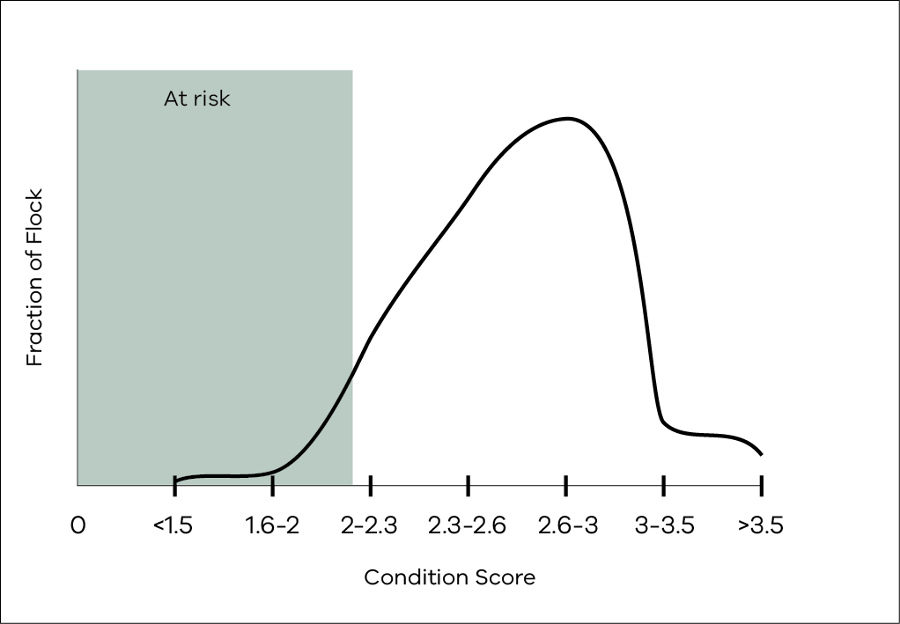
Figure 2.2: Spread and range of body weights in a mob of Merino weaners with an average weight of 22 kg.
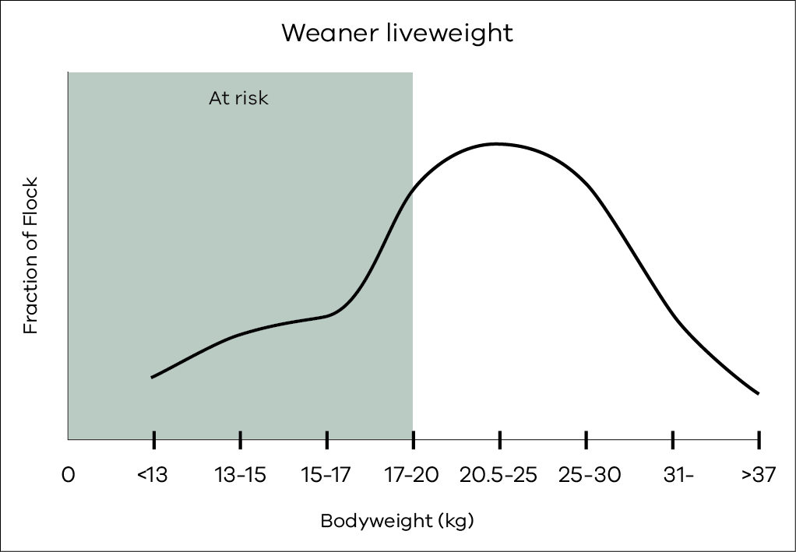
The production targets you set will also determine when to start supplementary feeding. It is far more efficient to maintain stock at a weight or condition score than to feed the high-quality diets needed to put weight back on if stock have dropped below target weight.

Condition, fat or weight
Assessing the amount of fat and muscle that an animal has in reserve is useful for monitoring stock and assessing their need to gain or even lose weight. Body condition is most important for assessing reproductive targets for pregnant sheep, as ewe live weight will be affected by the developing lamb/s and reproductive targets for mature ewes are well correlated to body condition.
Given the wide range of sheep breeds and mature sizes, assessing body condition may be a more accurate indication of production if the mature live weight is unknown.
Fat and muscle cover in sheep is measured either at the short ribs (condition score) or the long ribs (fat score).
Fat scoring assesses the soft tissue (fat and muscle) cover over the GR site which is 110 mm down from the backbone on the second last long rib (Site A on Figure 2.3). This is the site used for measuring fat depth of the carcase as an indicator of total fat so is more useful for ensuring that stock meet fat specifications at sale. It can also be a useful measure for monitoring the status of the animal but is less sensitive than condition scoring at the lower range.
Condition scoring assesses the soft tissue over the short ribs and backbone (Site B on Figure 2.3). What to feel and where for each condition score is outlined in Table 2.2. Condition scoring is more sensitive for monitoring condition of sheep for management such as for reproduction targets.
Both systems have a scoring system ranging from 1 to 5 and these are outlined in the following section.
There is a strong correlation between condition score and fat score but the relationship is not linear. Fat score 2 covers a wide range in condition score from 2 to 3.5 (store to greater than forward store). When managing ewe flocks there is greater precision in using condition scores than fat scores.
Weighing is the most accurate way to measure even quite small changes or monitor changes in animals that are not pregnant. Live weight can be misleading for assessing ewes in late pregnancy as they will be putting on considerable weight associated with the developing lamb/s and may be losing some of their own fat and muscle reserves while doing this.
The standard reference weight (SRW) is the expected weight of a mature animal with a condition score in the middle of the range (CS3).
For example, an adult medium-frame Merino ewe may have a SRW of 50 kg at CS3 but a large framed ewe may be 60 kg at CS3. If a medium-frame ewe loses condition to CS2 she may weigh about 40 kg; if she gains condition to CS4 she may weigh about 60 kg, but her SRW is still 50 kg.
Young animals such as weaners can lose weight quickly, resulting in health and welfare risks. They have little fat reserves and generally need to gain some weight.

Assessing condition and fat reserves of sheep
Fat and condition scoring require some training and practice to be confident and consistent in making the assessment. With practice, it is possible to pick quite small differences in tissue cover and to do this quite quickly for a sample in a mob, which will provide a guide to the average condition and the range within the mob. If you don’t have the confidence to pick differences of at least half a score, consider monitoring a sample of live weights as well. For example, if a condition score is equivalent to 9 kg live weight, a loss of half a condition score (4.5 kg), is a significant amount of weight to lose. Assessing condition by eye is not recommended and can be misleading as both wool length and pregnancy status can cause sheep to look in better condition than they are.

Fat score
Fat scores are an assessment of tissue depth (muscle and fat, but predominately fat) over the GR site which is 110 mm from the centre of the backbone on the second last long rib (Site A on Figure 2.3). Fat scores range from 1 to 5 and each score is equivalent to 5 mm of tissue. A sheep with a Fat Score 5 will have more than 21 mm of tissue at this site compared to an animal of Fat Score 1, which will have 0–5 mm tissue. Table 2.1 outlines the tissue depth and what it feels like for each fat score.
Figure 2.3: Picture of the sites on the sheep for assessing fat reserves.
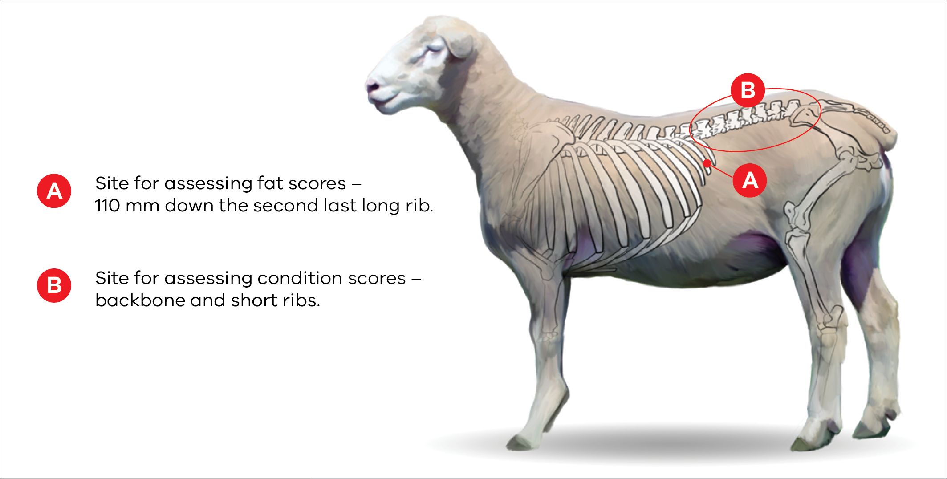
Table 2.1: Fat scores and what to feel.
Fat Score | 1 | 2 | 3 | 4 | 5
GR tissue depth (mm) | 0–5 | 6–10 | 11–15 | 16–20 | 20 and above
Feels like | Individual ribs felt easily and cannot feel any tissue over the ribs. | Individual ribs easily felt but can feel some tissue cover. | Individual ribs can be felt with more pressure as more tissue cover  (i.e. >10 mm). | Can only feel ribs with pressure. There is fluid movement of tissue. | No ribs can be felt.

Condition score
Condition scores, ranging from 1 to 5, assess the soft tissue over the short ribs and backbone (Site B on Figure 2.3). What to feel and where for each condition score is outlined in Table 2.2.
Table 2.2: Condition scores and what to feel. Source – lifetimewool
1  | Backbone  The bones form a sharp narrow ridge. Each vertebra can be easily felt as a bone under the skin. There is only a very small eye muscle. The sheep is quite thin (virtually unsaleable). | Short Ribs  The ends of the short ribs are very obvious. It is easy to feel the squarish shape of the ends. Using fingers spread 1 cm apart, it feels like the fingernail under the skin with practically no covering.
2 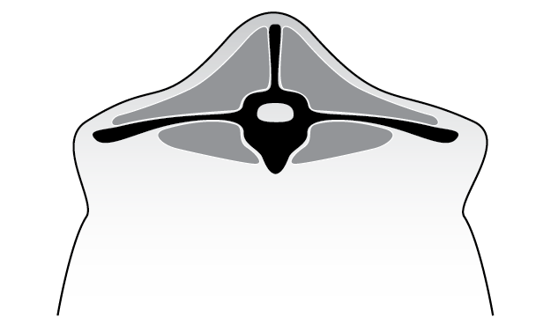 | Backbone  The bones form a narrow ridge but the points are rounded with muscle. It is easy to press between each bone. There is a reasonable eye muscle. Store condition – ideal for wethers and lean meat. | Short Ribs  The ends of the short ribs are rounded. Using fingers spread 0.5 cm apart, the ends feel rounded like finger-ends. They are covered with flesh but it is easy to press under and between them.
3  | Backbone  The vertebrae are only slightly elevated above a full eye muscle. It is possible to feel each rounded bone but not to press between them. (Forward store condition ideal for most lamb markets now. No excess fat). | Short Ribs  The ends of the short ribs are rounded and filled in with muscle. Using 4 fingers pressed tightly together, it is possible to feel the rounded ends but not between them. They are well covered and filled in with muscle.
4  | Backbone  It is possible to feel most vertebrae with pressure. The back bone is a smooth slightly raised ridge above full eye muscles and the skin floats over it. | Short Ribs  It is only possible to feel or sense one or two short ribs and only possible to press under them with difficulty. It feels like the side of the palm, where maybe one end can just be sensed.
5 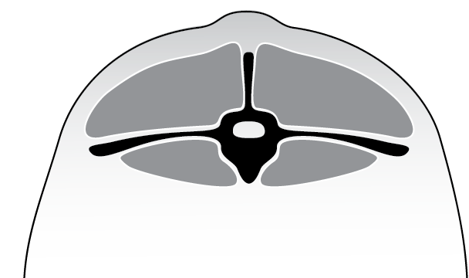 | Backbone  The spine may only be felt (if at all) by pressing down firmly between the fat covered eye muscles. A bustle of fat may appear over the tail (wasteful and uneconomic). | Short Ribs  It is virtually impossible to feel under the ends as the triangle formed by the long ribs and hip bone is filled with meat and fat. The short rib ends cannot be felt.

Other useful tools and resources for condition scoring are available from lifetimewool.
This site includes templates and a video for condition scoring. There is also the free lifetime ewe management app that is available for download (LTEM).

Targets for sheep

Dry adult sheep (>2 years old)
Dry/unjoined ewes, rams (post-joining) and wethers can be maintained at CS 2 during drought feeding situations. If the average condition of a mob is CS 2, it is likely that 50 per cent of the mob are less than score 2 and the lightest animals will be less than CS 1.5. These animals will have a higher risk of health and welfare issues. Mobs maintained at CS 2.0 will also be at higher risk when nutritional demands increase or when circumstances put more stress on the animal, such as high worm burdens or extreme weather events (e.g. after animals are shorn or the autumn break results in cold, wet and windy conditions). To maintain the entire mob at CS 2 and not below will require drifting or drafting off tail end sheep to feed separately.

Reproducing ewes
Feeding levels and targets for pregnant ewes during drought need to be considered carefully as both ewe and lamb production are affected by ewe nutrition during pregnancy.
Conception rates are very responsive to ewe condition at joining. Both time of lambing, breed and genotype will affect the responses to both nutrition and absolute condition score at joining. Responses are typically an increase in the number of lambs conceived of 1.5–2.5 per cent for every extra kilogram of weight that ewes were joined at. Where response rates were assessed across a number of farms in the lifetimewool project, Merino ewes joined at one condition score heavier, scanned on average 20 extra lambs per 100 ewes joined, but there was wide variation across the farms involved (0 to 40 extra lambs per 100 ewes joined). The response varies with breed and within breeds (autumn lambing crossbred ewes and small Merinos are likely to have a lower conception rate than spring lambing crossbred ewes).
Figure 2.4 illustrates the impact of condition score on the pregnancy status of ewes at scanning. As ewes increase in condition above CS 2, the number of dry ewes reduces and the number of ewes with twins increases. There is little change in the number of ewes with singles, until condition score increases above CS 3 when the number of ewes with singles reduces in favour of twins.
Figure 2.4: The influence of condition score at joining on the pregnancy status of ewes. Source – lifetimewool
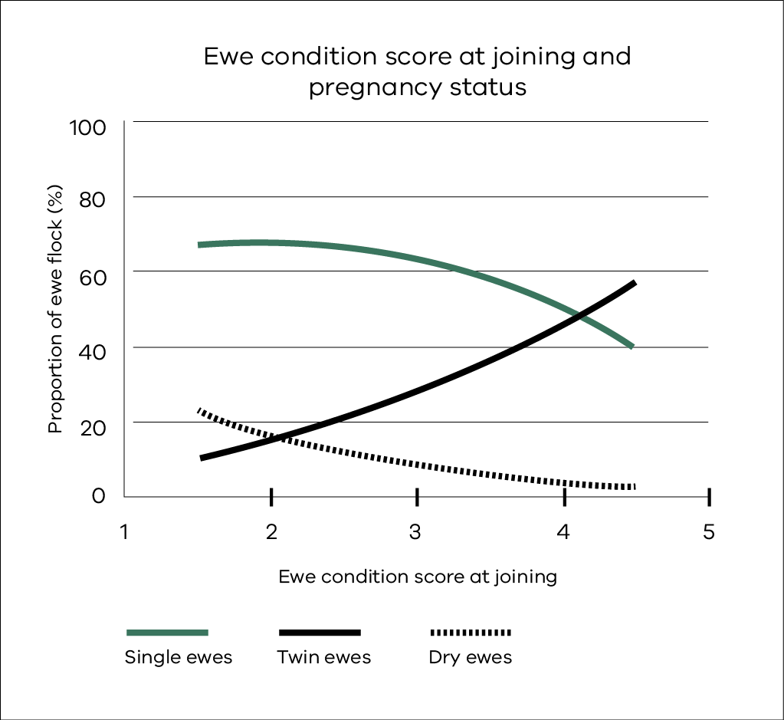
Setting a target for joining will set the scene for the number of lambs conceived, but also for their future lambing success. In drought, there will be limited options for increasing condition to improve lambing success through higher birth weights, survival rates and lamb growth rates. For wool-focused enterprises, cost savings may be made by not joining or by delaying joining, but this needs to be considered against the longer-term effect on income and the proportion of income dependent on surplus livestock sales. If you decide not to join ewes in spring or summer because of drought, joining may still be possible in early autumn if there is an early break.
While nutrition and condition of ewes have the most impact on conception and lambing percentages, there may be other contributing factors, such as ram condition and health, genetics and disease.
For pregnant and lactating ewes, the mob’s average condition score needs to be at least 2.5 to reduce the number of ewes at or below CS 2.0, which have higher risk of mortality. Optimal condition targets for pregnant ewes range from CS 2.7 (ewes with singles) to 3.3 (ewes with twins) to achieve best results for lambing and subsequent lamb performance. Scanning ewes to identify dry, single and multiple lambs is an extremely valuable tool to identify and manage ewes to their nutritional needs and production targets.
Figures 2.5 and 2.6 have been adapted from the lifetimewool program to illustrate the optimal condition scores for spring lambing Merino ewes in a high rainfall zone (Figure 2.5) and May lambing in the low rainfall zone (Figure 2.6). These condition scores are for a flock that includes both singles and twins. Where scanning has been undertaken and twins are separately managed from singles a higher target at lambing (+0.3 CS) should be reached for twins. Singles should lamb at their joining condition score.
At the autumn break, when spring lambing ewes are in early to mid-pregnancy, the ideal average CS is 2.7. This means they can lose 0.3 CS during early pregnancy provided this condition/liveweight is regained by lambing. Individual ewes below CS 2 are at a higher risk of death particularly in late pregnancy.
Figure 2.5: The optimum condition score target over a year for Merino ewes lambing in spring in the high rainfall zone. The middle line represents the ideal average. The top and bottom dotted lines represent higher or lower targets that can be followed but the higher target costs more to feed and the lower target has increased risk of higher mortalities in both ewes and lambs. Source – lifetimewool Ewe Management Handbook
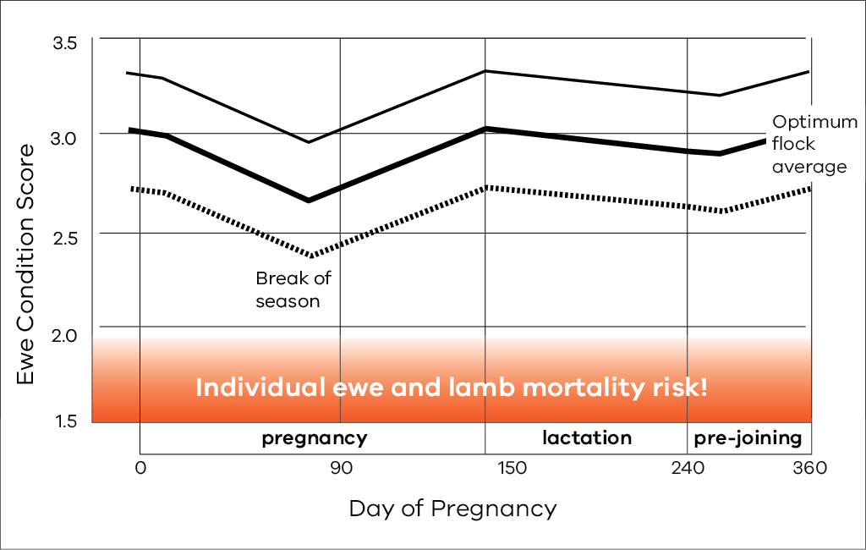
Figure 2.6: Ideal condition scores over a year for Merino ewes lambing in May in the low rainfall (cereal sheep) zone. Adapted from: lifetimewool Ewe Management Handbook
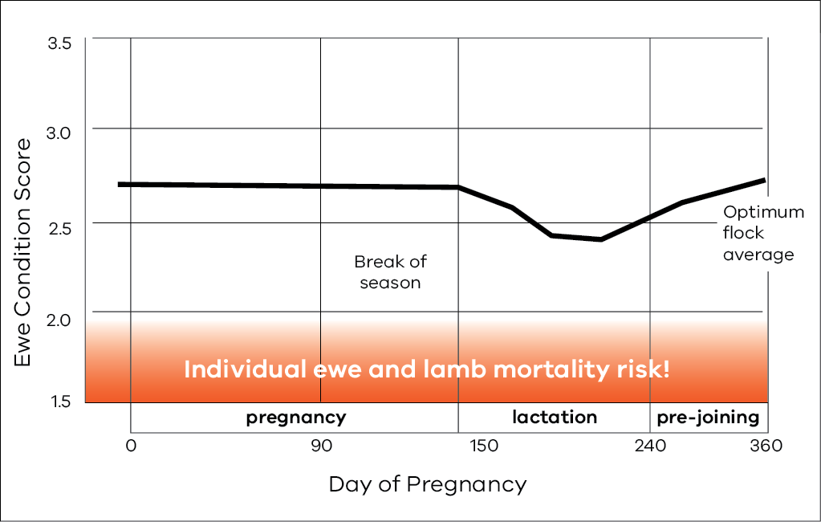
Setting an appropriate and cost-effective condition score to maintain ewes when dry or in early pregnancy must take into account the consequences for later in pregnancy and at lambing. Under-nutrition before joining reduces the number of lambs conceived. Under-nutrition during pregnancy reduces birth weight and lamb survival. Severe under-nutrition of a pregnant or lactating ewe, can permanently decrease the lifetime wool production of her lamb (see Implications of different targets in this chapter). Maintaining ewes below the ideal condition score of 2.7 will affect subsequent lambing performance. This needs to be balanced against the extra cost and cash flow requirements to maintain sheep at heavier weights. For example, for every extra kilogram that a ewe is maintained at, about 70 grams extra of barley or wheat is needed per week to maintain that weight and feeding will need to start earlier, before they drop below the target weight.

Maiden ewes and joining ewe lambs
Two-year-old maiden ewes need to be about 75 per cent of their mature weight at joining (Table 2.3). If maiden ewes are well below this target, consider not joining.
The reproductive performance of ewe lambs (joined at 7–9 months of age) is generally poor if they are mated at less than 35 kg live weight. Their reproductive rate improves as live weight increases above 40 kg. A ewe lamb that is heavier at breeding is more likely to wean a heavier lamb herself and she will be heavier at weaning and so in a good position for the next joining. In poor seasons, joining ewe lambs is unlikely to be a cost-effective option. However, if a drought year is followed by a good season, joining ewe lambs that are up to target weights and condition may provide opportunities for rebuilding stock numbers.
If the risk is high that drought conditions will extend well into pregnancy, consider not joining maiden ewe hoggets and ewe lambs. The cost of feeding can be high and the consequences for under-nutrition are greater for these two groups and their lambs.

Lambs (<3 months)
Early weaning can reduce feed costs and simplify management of both ewes and lambs. One of the main advantages is to wean lambs before ewes lose too much condition, enabling ewes to be maintained at a weight and condition that meets the target for getting back in lamb at joining.
For breeders who traditionally wean lambs at 12–14 weeks, there may not be any advantage in weaning earlier. However, when feed for ewes and lambs is scarce, lambs can be weaned at an absolute minimum age of 6 weeks and a minimum live weight of 9 kg (small Merinos). Crossbred lambs have been successfully weaned at 5 weeks onto high-quality diets, but generally weaning at 8-9 weeks can lead to good growth rate, final weight, carcase weight and fat composition, if good nutrition is provided. Early-weaned lambs require high-quality rations, particularly meeting their higher protein requirements and good overall management, including internal parasites.

Weaners (3–12 months)
Weaning weight and consequent growth rate are the most critical targets that can reduce the risk of mortality in weaners. Weaners under 20 kg at weaning and those that lose weight post-weaning are at high risk of mortality during dry seasonal conditions. In a drought, weaners will be one of the first classes of animals to be affected, primarily because of the reduced availability of pasture of sufficient nutritive value to maintain growth.
For Merino weaners, there are two key management targets to ensure good weaner survival:
- weaning weight of at least 20 kg and 45 per cent of adult weight by pasture senescence (haying off)
growth rate of 0.5–2 kg/month after weaning.
Research has shown that even if weaners achieve a good weaning weight, low growth rate after weaning significantly increases the risk of mortality. A growth rate of at least 0.5 kg per month is critical but a higher rate will bring added benefits. The recommended minimum targets for weaners are:
- 2 kg/month for weaners weighing <20 kg
1 kg/month for weaners weighing 20–30 kg.
The lightweight tail of the weaner flock (20 per cent) should be drafted off at weaning for preferential feeding and management.
Consider the mature live weight of your sheep when setting targets for larger Merinos, crossbred or maternal sheep breeds.
Table 2.3 shows target weights for young sheep from birth to first joining. In a ‘normal’ season, the growth target for weaners would be to exceed 50 per cent of their mature (4-year-old) weight by the autumn break. Lower growth rate targets during drought months could be considered as part of the target drought-feeding strategy, but losses in live weight of weaners should be avoided. Severe under-nutrition of ewe weaners in their first year can reduce lifetime reproduction by up to 20 per cent. Severe nutritional restrictions in the 6 months after weaning can lead to 25 per cent lower mature body weight. Weaners on a poor level of nutrition will also be more prone to parasites, diseases and other health and welfare risks.

Finishing lambs
If the season is such that lambs do not meet market specifications before feed limits production, finishing lambs with grain must be costed carefully. Consider selling all or poor-performing lambs as store lambs, as the cost to finish these lambs may outweigh any extra returns. For example, on average you might budget on 7 kg of grain to produce 1 kg of live weight (or half a kg of carcase weight) but there will be lambs that require much more than this and/or just do not grow well. Research into lamb feed efficiency by Agriculture Victoria consistently finds high-efficiency animals with feed conversion ratios (kg of feed consumed per kg of live weight gain) as good as 3:1, but there are lambs as poor as 20:1. Using an average feed conversion ratio of 7:1 for budgets and planning is a realistic average.
Table 2.3: Target weights for weaners. Source – Sheep nutrition in the Victorian environment
Mature weights | Target weights (kg) Birth | Target weights (kg) Pasture  drying off | Target weights (kg) Autumn break | Target weights (kg) Late winter | Target weights (kg) Joining
45 kg | 4 | 20 | 22.5 | 27 | 34–36
50 kg | 4.5 | 22.5 | 25 | 30 | 37–40
55 kg | 5 | 25 | 27.5 | 33 | 41–44
60 kg | 5 | 27 | 30 | 36 | 45–48
70 kg | 5.5 | 31.5 | 35.5 | 42 | 52 –56
% Mature weight | 8–9% | 45% | 50% | 60% | 75–80%

As part of the preparation in developing a budget and business case, clear targets need to be established for the finishing operation, such as what carcase weight will need to be achieved to deliver the proposed return. Combined with a knowledge of starting live weights, having a clear picture of a target slaughter weight, such as light domestic (18–20 kg HSCW), domestic trade (20–22 kg HSCW) or heavy export (>24 kg HSCW) will help determine if required growth rates are feasible, as well as how long lambs will need to be fed to reach the target weights.
For finishing lambs to make a reasonable margin, you need lambs with the frame, body size and genetics to capitalise on good nutrition. Lambs that have suffered a significant check or nutritional restriction due to drought are likely to always be lighter and may be best targeted towards a traditional domestic market specification (20 kg HSCW) rather than taking them through to higher export carcase weights (>24 kg HSCW). Beware of taking light weight older lambs through to a heavier carcase weight, as longer periods on feed is less likely to be profitable. There are a number of good sources of information and feed budgets available to work through options to finish or sell store lambs.
You can do your own calculations and test feedlot rations, costs and market specifications using a feedlot calculator that can be downloaded from the web: Feedlot calculator

Rams (>1 year old)
Rams should not be ignored; they need to be on the same level and type of rations as the ewes at least 3 months before joining. Sperm production takes about 8 weeks, so ram health and nutrition cannot be left to the last few weeks before joining. It may be feasible to maintain rams at CS 2 after joining but they will need to be at or above CS 3.5 for joining. If rams are not in ideal condition at joining, consider increasing the percentage of rams per ewe.

Implications of different targets
Calculating the cost and financial returns of managing sheep at different production targets is complex and will differ for every enterprise and farm. The most critical is the production target for ewes over the reproduction cycle.
When the sheep industry in Victoria was dominated by Merinos with a wool focus, targets in droughts were often set at the lower end of the range (CS 2–2.5) to reflect the lesser influence of livestock sale on returns and lower response of wool to nutrition. The consequences of ewes in lower condition tended to be greater after droughts broke with low lambing percentages, wool of lower staple strength and stock at higher risk of mortality and disease when conditions were cold and wet. If the focus of the sheep enterprise is dual purpose (meat and wool) or meat production, the implications on reproduction and lamb performance cannot be ignored. Research, such as the lifetimewool (LTEM) project referred to frequently in this book, highlights critical condition targets for optimal ewe and lamb performance and the consequences of not achieving these targets. The research was predominantly conducted on Merino ewes but there is supporting evidence that optimal condition score targets will be similar for crossbred or meat breeds.
The following calculations provide a guide on how to estimate the value of maintaining ewes at a higher or optimal (e.g. CS 3) condition compared to a lower or minimum condition (e.g. CS 2).

Costs
The main cost of maintaining ewes in higher condition score will be feeding higher rates of supplements, both in the daily amount and starting feeding earlier. As a guide, for every extra kilogram that a ewe is maintained, about 70 grams extra of barley or wheat is needed per week.
Example:
One condition score is equivalent to about 6–9 kg live weight. For this example, we will use 8 kg as the live weight difference between a ewe in CS 2 and a ewe in CS 3.
Ewes in CS 3 will require about 0.6 kg more barley per week than ewes maintained at CS 2.
Assuming that ewes are fully fed for 6 months, the extra maintenance requirement would be 14.4 kg grain/ewe (0.6 x 4 weeks x 6 months).
Feeding will need to start up to a month earlier to maintain them at the higher condition. The extra feed at the start will vary due to pasture availability, sheep type, etc, but a reasonable estimate would be 9 kg grain/ewe extra.
Therefore, the total additional amount of grain would be 23.4 kg/ewe (14.4 kg + 9 kg).
If grain is $300/tonne, the extra cost would be $7.00 a head or $700 per 100 ewes.
If the reproduction response is 20 per cent more lambs scanned per 100 ewes and assuming 80 per cent survival rate of scanned lambs (16 lambs per 100 ewes) then the cost per lamb could be $44 ($700 for 100 ewes/16 extra lambs)
If only 10 per cent more lambs were scanned for the extra condition score, at 80 per cent survival, this would indicate a cost of $88. Alternatively, a highly responsive flock of 50 per cent (40 extra lambs born) would reduce the cost per lamb to $17, assuming the same survival rate and other variables. This is an example only; you need to use your own estimates based on likely flock responses, feed costs, etc. You need to consider cash flow required and the extra costs if money is borrowed.
Table 2.4 provides an indication of the response in survival rates of singles and twins (for Merinos) when target condition score differs from CS 3 at some or all stages of the reproduction cycle. The first row of figures shows ewe production and progeny production when the ewe is maintained at condition score 3.0 throughout pregnancy. All other figures show the difference in production when condition score throughout pregnancy differs from 3.0. These figures relate to the genotype of a medium Merino (50 kg) ewe with 4 kg clean fleece weight and 20.5 micron wool.
As indicated in this table, survival rates of singles and twins are reduced quite severely if ewes are mated at CS 3 and then drop to CS 2 between joining and lambing compared to ewes maintained in CS 3 (19 per cent lower survival for singles and 39 per cent lower for twin born lambs). If ewes were maintained at CS 2.5 from day 90, instead of dropping to CS 2, the table indicates that survival is only reduced by 6 per cent for singles and 15 per cent for twin lambs, further illustrating the impacts on reproduction of having ewes at CS 2.
There will also be extra feeding and variable costs associated with more animals carried through as a result of the higher survival rates of ewes and lambs.

Returns
The extra returns from maintaining ewes in better condition are the extra lambs that are available for sale or as replacements beyond weaning, but also higher survival rates of the ewes. The simple calculation is the cost per lamb and the likely return for the lambs at sale. If the cost to get the extra lamb on the ground is $42, the returns from the lamb need to be more than that to recoup the feed costs plus other associated production and sale costs.
Table 2.4 also indicates that with Merinos there will be some additional benefits with wool production from the ewes and the lambs. The value of this will also be influenced by the micron premiums at the time (given that the ewes’ wool will be broader and the progeny’s wool finer for the ewes held at CS 3) and staple strength, which is often lower following the season break. The other impact not reflected here is the ongoing performance of progeny that are kept as replacement ewes. As illustrated in Figure 2.4, ewes joined at CS 3 will have more twins scanned and fewer dry ewes than ewes joined at CS 2 (so there will be more ewes lambing and more ewes with multiples). This will be balanced by ewes being in better condition at lambing to support higher birth weights, growth rates and weaning weights. Lambs that do not meet production targets pre- and post-weaning may struggle to reach joining weights at the usual time and may have lower longer-term reproduction rates.

Table 2.4: Production consequences (wool traits, reproduction and mortality) for Merino ewes and their lambs of maintaining ewes below CS 3 from joining to lambing. Source – lifetimewool
Condition score profile Joining | Condition score profile Day 90 | Condition score profile Lambing | Ewe production CFW (kg) | Ewe production FD (µm) | Ewe production Mortality | Ewe production Reprod. rate (%) | Progeny production CFW singles (kg) | Progeny production CFW twins (kg) | Progeny production FD singles (µm) | Progeny production FD twins (µm) | Progeny production Survival singles (%) | Progeny production Survival twins (%)
3.0 | 3.0 | 3.0 | 4.1 | 20.5 | 3.2 | 120 | 3.4 | 3.1 | 17.6 | 18.1 | 91 | 71

Condition score profile Joining | Condition score profile Day 90 | Condition score profile Lambing | Difference in ewe production compared to ewes maintained at CS 3.0 CFW (kg) | Difference in ewe production compared to ewes maintained at CS 3.0 FD (µm) | Difference in ewe production compared to ewes maintained at CS 3.0 Mortality | Difference in ewe production compared to ewes maintained at CS 3.0  Reprod. rate (%) | Difference in progeny production compared to ewes maintained at CS 3.0 CFW  singles (kg) | Difference in progeny production compared to ewes maintained at CS 3.0 CFW twins (kg) | Difference in progeny production compared to ewes maintained at CS 3.0 FD singles (µm) | Difference in progeny production compared to ewes maintained at CS 3.0 FD twins (µm) | Difference in progeny production compared to ewes maintained at CS 3.0 Survival singles (%) | Difference in progeny production compared to ewes maintained at CS 3.0 Survival twins (%)
2.5 | 2.0 | 2.0 | -0.6 | -0.6 | 3.2 | -11 | -0.1 | -0.1 | 0.2 | 0.2 | -13 | -28
2.5 | 2.0 | 2.5 | -0.3 | -0.2 | 0.8 | -11 | -0.1 | -0.1 | 0.0 | 0.0 | -3 | -6
2.5 | 2.5 | 2.0 | -0.6 | -0.6 | 3.2 | -11 | -0.1 | -0.1 | 0.2 | 0.2 | -17 | -35
2.5 | 2.5 | 2.5 | -0.3 | -0.2 | 0.8 | -11 | -0.1 | -0.1 | 0.0 | 0.0 | -5 | -12
2.5 | 2.5 | 3.0 | 0.1 | 0.3 | 0.0 | -11 | 0.0 | 0.0 | -0.2 | -0.2 | 3 | 7
3.0 | 2.5 | 2.0 | -0.7 | -0.6 | 3.2 | 0 | -0.2 | -0.2 | 0.3 | 0.3 | -19 | -39
3.0 | 2.5 | 2.5 | -0.4 | -0.2 | 0.8 | 0 | -0.1 | -0.1 | 0.2 | 0.2 | -6 | -15
3.0 | 2.5 | 3.0 | -0.0 | 0.2 | 0.0 | 0 | 0.0 | 0.0 | 0.0 | 0.0 | 2 | 5
3.0 | 3.0 | 2.5 | -0.3 | -0.2 | 0.8 | 0 | -0.1 | -0.1 | 0.2 | 0.2 | -9 | -21
3.0 | 3.0 | 3.0 | 0 | 0 | 0 | 0 | 0 | 0 | 0 | 0 | 0 | 0
3.0 | 3.0 | 3.5 | 0.3 | 0.7 | -0.1 | 0 | 0.1 | 0.1 | 0.0 | 0.0 | 5 | 16
3.5 | 3.0 | 2.5 | -0.4 | -0.2 | 0.8 | 11 | -0.1 | -0.1 | 0.3 | 0.3 | -11 | -24
3.5 | 3.0 | 3.0 | -0.1 | 0.2 | 0.0 | 11 | 0.0 | 0.0 | 0.2 | 0.2 | -1 | -2
3.5 | 3.0 | 3.5 | 0.2 | 0.6 | -0.1 | 11 | 0.0 | 0.0 | 0.0 | 0.0 | 5 | 14
3.5 | 3.5 | 3.0 | -0.1 | 0.3 | 0.0 | 11 | 0.1 | 0.1 | 0.2 | 0.2 | -3 | -8
3.5 | 3.5 | 3.5 | 0.3 | 0.7 | -0.1 | 11 | 0.0 | 0.0 | 0.0 | 0.0 | 4 | 10
3.5 | 3.5 | 4.0 | 0.6 | 0.8 | 0.1 | 11 | 0.1 | 0.1 | -0.2 | -0.2 | 7 | 23
Source: Values based on lifetimewool experimental data. CFW = clean fleece weight, FD = fibre diameter.

Using this table, if a ewe is joined at CS 2.5 and drops to CS 2 in late pregnancy and lambing, then compared to a ewe that is maintained at CS 3, clean fleece weight is reduced by 0.6 kg; fibre diameter by 0.6 micron; ewe mortality increases to 3.2 per cent; and reproduction rate will be 11 per cent lower. Fleece weight of the lambs (progeny) will also be slightly lower, fibre diameter will be higher, and survival rate of single lambs will be 13 per cent lower and 28 per cent lower for twin-born lambs. The information in the table can be used as a guide to estimate the possible impacts of different feeding targets have on reproducing Merino ewes.
Table 2.5 provides an example of developing your own partial budget for estimating the potential benefits to your enterprise of feeding stock to higher production targets.
Table 2.5: Example of a partial budget for estimating the cost benefits of feeding to meet different targets.
Extra benefits for better fed ewes | Extra costs of feeding sheep and/or benefits foregone by feeding sheep for higher targets (i.e. an extra cost as a result of better feeding)
Extra lambs sold: $ | Extra feed: $
Extra wool sold (including from those saved from dying): $ | Feed and variable costs of ewes that would have been saved if ewes/stock had died: $
Deaths prevented: $ | Feed and variable costs of lambs that would have been saved if not born/survived: $
Total extra benefits: A (sum above) | Total extra costs: B (sum above)
Net benefit: A-B = C | $
Percentage Return on Extra Capital: (C/B) x 100 | $

Weaner targets
Target weights for weaner sheep are outlined in Table 2.3. Not achieving these targets will reduce their chances of survival and their ability and readiness to reproduce at their first joining. In farm trials, it was found that for Merino weaners the target of 45 per cent of mature weight at pasture senescence (feed drying off) was a more reliable target than a set weight of 23 kg and achieved weaner survival rates of 95 per cent. Weaners fed to reach 40 kg by the time green feed was available had greater survival to hogget shearing and the mortality rate for not achieving this was much higher for ewe weaners compared to wethers.
Research in lambs has indicated that early restriction in nutrition (at and/or before weaning) will lead to fatter carcases than animals that have been well fed, at the same carcase weight. This also occurred in crossbred weaners that had restricted feed at and/or before weaning and were later well fed to catch up and assessed at the same carcase weight as lambs fed well all through (Hopkins et al, 2007; Butler-Hogg and Johnsson, 1986).
Research with cattle has shown in addition to potential impacts on weight gain, the impact of an animal’s growth path prior to entry to a finishing system will affect carcase composition and retail yield at slaughter. When compared at the same age, pre-natal and pre-weaning growth and nutrition have been shown to have a significant impact on carcase composition at slaughter. Calves that were subjected to a nutritional restriction have a reduced carcase yield (compared to calves that have been well grown early in life) driven by a reduction in weight of retail beef (from lighter carcase weight) and an increase in fat trim (Greenwood and Café 2007).
As a general rule, the earlier a restriction to animal growth occurs, the less likely it is to be fully recovered. The impacts of an in utero restriction that results in lighter birth weights may be evident all the way through to slaughter weights, while a restriction to post-weaning growth may be recovered (depending on severity and duration of restriction) once animals are returned to suitable nutrition. This highlights the need to ensure weaners achieve the best possible weight gains prior to weaning as a way of setting them up for future finishing or production.

Cash flow
While simple sums can give an indication of the likely value of the production targets you might aim for, a more robust cash flow and budget will be required to ensure you have both the funds and cash flow to meet potential financial requirements in the longer term. Some of these decisions will have impacts on the cash flow and recovery of the farm finances beyond the year of the drought. For example, if replacement ewe numbers are severely reduced, then sales from surplus stock will be reduced until ewe numbers and weaning rates are back to normal.

Monitoring
Whatever targets you set, monitoring a sample of each mob is critical for assessing whether the supplement is enough or too much, and to check that weight and/or CS targets are being met. If stock are fed on pasture and not in containment, it is difficult to estimate what proportion of a ration they are getting from the pasture. Pasture will change over time depending on the season and regular assessments are required. Also, nutritional requirements can vary slightly between breeds and flocks so estimating a ration should always be viewed as a guide that needs to be checked. If stock drop below your target, it can be difficult and expensive to put weight back on as weight gain requires not only more energy but also a higher proportion of protein in the diet than maintenance feeding. Alternatively, if stock are doing better than required, it may be possible to decrease the ration and save some money.
To monitor a mob for weight or condition change, tag or identify 50 sheep and monitor them regularly. This will give a good indication of whether the mob as a whole is putting on or losing weight. If it is easier to randomly draft some sheep to monitor, 10 per cent of the mob or a maximum of 80 sheep/mob should give confidence of identifying weight changes of 2 kg or more. If using CS to manage weaners, it is important to measure a minimum of 100 randomly selected animals or 50 tagged weaners to assess the change in CS. Monitoring a proportion of the mob will provide guidance on the ration required but will not identify the sheep in the mob that are below minimum targets and need feeding separately. Drafting off animals below your targets and managing them separately to meet their needs will improve production results and make setting targets for individual mobs easier.

Further information

Further reading and resources
- Sheep Nutrition in the Victorian Environment (1987). Technical Report series No. 136. Edited by Foot, J.Z., Egan, J.K. and Love, K.J. ISBN 0 7306 0308 3
- Lifetime wool – condition scoring
- Condition Scoring of sheep
- Making More From Sheep Module 3 Market Focused Lamb and Sheepmeat Production
- Lot feeding lamb calculator
Managing Merino weaners: Sheep CRC Practical Wisdom

Scientific references
Behrendt, R, van Burgel, AJ, Bailey, A, Barber, P, Curnow, M, Gordon, DJ, Edwards, JEH, Oldham, CM, Thompson, AN (2011) On-farm paddock-scale comparisons across southern Australia confirm that increasing the nutrition of Merino ewes improves their production and the lifetime performance of their progeny. Animal Production Science 51, 805–812.
Butler-Hogg, BW, Johnsson, ID (1986) Fat partitioning and tissue distribution in crossbred ewes following different growth paths. Animal Science 42, 65–72.
Campbell, AJD, Vizard, AL, Larsen, JWA (2009) Risk factors for post-weaning mortality of Merino sheep in south-eastern Australia. Australian Veterinary Journal 87, 305–312.
Edwards, JEH, Gould, RM, Copping, KJ (2008) Putting Merino weaner management recommendations to the test. Australian Journal of Experimental Agriculture 48, 974–978.
Greenwood PL, Hunt AS, Hermanson JW and Bell AW (1998) Effects of birth weight and postnatal nutrition on neonatal sheep: 1. Body growth and composition, and some aspects of energetic efficiency. Journal of Animal Science 76, 2354–2367.
Greenwood, P, Bell, A (2003) Prenatal nutritional influences on growth and development of ruminants. Recent Advances in Animal Nutrition in Australia 14. pp.57–73.
Hegarty RS, Shands C, Marchant R, Hopkins DL, Ball AJ and Harden S (2006) Effects of available nutrition and sire breeding values for growth and muscling on the development of crossbred lambs. 1: Growth and carcase characteristics. Australian Journal of Agricultural Research 57, 593–603.
Hopkins, DL, Stanley, DF, Martin, LC, Ponnampalam, EN, van de Ven, R (2007) Sire and growth path effects on sheep meat production 1. Growth and carcase characteristics. Australian Journal of Experimental Agriculture 47, 1208–1218.
King, J, Fisher, J, Murphy, P (1990) Threshold condition scores of Merino ewes for improved autumn lambing performance in Western Australia. Proceedings of the Australian Society of Animal Production 18, 272–275.
Morgan-Davies, C, Waterhouse, A, Pollock, M, Milner, J (2008) Body condition score as an indicator of ewe survival under extensive conditions. Animal Welfare 17, 71–77.
Paganoni, B.L, Ferguson, M.B, Kearney, G.A, Thompson, A.N (2014) Increasing weight gain during pregnancy results in similar increases in lamb birthweights and weaning weights in Merino and non-Merino ewes regardless of sire type. Animal Production Science 54, 727–735.
Thompson, A.N, Ferguson, M.B, Gordon, D.J, Kearney, G.A, Oldham, C.M, Paganoni, B.L. (2011) Improving the nutrition of Merino ewes during pregnancy increases the fleece weight and reduces the fibre diameter of their progeny’s wool during their lifetime and these effects can be predicted from the ewe’s live weight profile. Animal Production Science 51, 794–804.
Thompson, A.N, Young, J.M (2002) Potential economic benefits from improving ewe nutrition to optimise lifetime wool production and quality in south-west Victoria. Wool Technology and Sheep Breeding 50, 503–509.
Young, JM, Thompson, A.N, Curnow, M, Oldham, C.M (2011) Whole-farm profit and the optimum maternal live weight profile of Merino ewe flocks lambing in winter and spring are influenced by the effects of ewe nutrition on the progeny’s survival and lifetime wool production. Animal Production Science 51, 821–833.

Chapter 3: What to feed sheep
This chapter covers some background information on the nutritional requirements of sheep. It includes an explanation of feed analysis tests used to help choose a supplement that will fill the needs of all classes of sheep through drought or in any supplementary feeding situation.
Key messages
- Ruminants have a unique digestive system that enables them to utilise energy from pastures, but consideration of this system is required when supplementing with other sources.
- Energy is generally the most important and limiting requirement for sheep.
- Protein becomes more important with the need to grow and reproduce, but protein levels higher than needed can be wasteful.
- Roughage, or fibre, is required for healthy rumen function but too much will limit intake.
- Calcium is the most limiting mineral on high-grain diets.
- Vitamins A and E may be required for young stock fed for long periods with no green pick.
- Supplements vary considerably in their nutritive value. A feed analysis is the only accurate way to determine their suitability for your stock, how much is required and value for money.
- Feed test analyses will supply estimates of dry matter, energy and digestibility, protein and fibre. Estimates of water-soluble carbohydrates and fat are also available for some feeds.
If purchasing feeds, compare the feed costs based on what you are buying the feed for – energy, protein or fibre.

Nutrition of sheep
Sheep, like cattle and goats, are ruminants that have a digestive system that enables them to digest fibrous pasture diets. To do this they have four stomachs, the largest being the rumen. The rumen acts as a large fermentation vat, filled with microbes that ferment feed into products (energy, protein and vitamins) that the animal needs to maintain, grow and reproduce. The rumen is maintained at constant temperature and generally at a constant acidity level or pH. This system gives the animal the unique ability to utilise dry and fibrous feed in which cellulose is the main structural carbohydrate and the most abundant energy source in plants. Rumination or ‘chewing the cud’ is when a bolus of food (cud) is regurgitated for further physical breakdown and production of saliva, which acts as a buffer to maintain the pH.
The microbes digest carbohydrates in the diet to produce volatile fatty acids, which are the main source of energy for the sheep. Easily digestible carbohydrates, like soluble sugars and starch, are broken down quickly compared to the more complex cellulose. The products of fermentation are available to both the animal and to the microbes. The microbes are able to use nitrogen to make new protein and also to make many vitamins required by the animal. Partially digested feed and microbes continue through the other stomachs and intestine for further breakdown and absorption. Undigested material is eventually excreted as faeces. Fermentation in the rumen also produces carbon dioxide and methane, which are both greenhouse gases. One of the other downsides of the system is that the rumen and its microbes need time to adjust to changes in feed types. When considering the nutritional needs of sheep, both the animal and the microbial population need to be catered for.
Nutritional requirements can be broadly classified as:
- energy
- protein
- minerals
vitamins.
Non-nutritional requirements include fibre and water.

Energy
Energy is the most important requirement for all livestock and is the most common limitation during a drought or any feed-limited situation. An animal’s requirement for energy is measured in megajoules (MJ) and expressed as metabolisable energy (ME). One megajoule is equivalent to 1,000 kilojoules. Metabolisable energy is the amount of total energy that can be utilised by the animal. When referring to pasture energy values, the term digestibility is used. Digestibility refers to how much of the feed is retained and used by the animal. If the digestibility of a feed is 75 per cent, then for every kilogram of dry matter eaten, 750 g is retained by the animal and 250 g is excreted.
Energy requirements can be estimated in Dry Sheep Equivalents or DSE ratings. This measure gives all classes and sizes of animals an energy rating that can be used for estimating stocking rates. A DSE is the energy required to maintain the body weight of a 2-year-old non-lactating sheep in condition score 3. The body weight of the standard dry sheep is not always consistent but is generally 45–50 kg, requiring between 7.6 and 9.7 MJ ME/day. More commonly, as sheep have got bigger, a 50 kg wether is considered to be 1 DSE. A 50 kg wether can still vary in its requirements for energy, depending on its genetics, how much activity it is doing, if it is cold or bare shorn, and even how much extra energy it might need to digest poor-quality feed. Estimates of energy requirements are just that – estimates – and they need to be adjusted and monitored for your animals and the conditions. But the DSE system is useful as a simple estimation of the different energy requirements across classes of sheep. For example, if a dry 50 kg wether is considered to be 1 DSE, requiring 8.3 MJ ME to maintain weight at Condition Score 3, a 50 kg ewe with one lamb at foot would be classed at 2 DSE, requiring 16.6 MJ ME.
The daily energy requirements and DSE rating for different classes of sheep are given in Table 3.1, along with minimum crude protein as a percentage of the dry matter of the diet fed.
Table 3.1: Energy and protein requirements of a range of classes of sheep.
Class of stock | Live weight (kg) and  Condition Score (CS) | DSE rating | Energy requirement  MJ ME/day | Approximate protein requirement  CP (%)
Adult dry sheep (wether or ewe dry or early stages of pregnancy) | 40 kg CS 2 | 0.7 | 6
Adult dry sheep (wether or ewe dry or early stages of pregnancy) | 45 kg CS 2 | 0.8 | 6.5
Adult dry sheep (wether or ewe dry or early stages of pregnancy) | 50 kg CS 2 | 0.9 | 7
Adult dry sheep (wether or ewe dry or early stages of pregnancy) | 50 kg CS 3 | 1 | 8 | 6-8
Adult dry sheep (wether or ewe dry or early stages of pregnancy) | 60 kg CS 3 | 1.1 | 9
Ewes  Pregnant last 4 weeks before lambing (single) | 45 kg CS 2 | 1.2 | 10
Ewes  Pregnant last 4 weeks before lambing (single) | 50 kg CS 2 | 1.5 | 12 | 8-10
Ewes  Pregnant last 4 weeks before lambing (single) | 60 kg CS 3 | 1.8 | 14.5
Ewes  With lamb at foot (single) | 45 kg CS 2 | 1.8 | 15
Ewes  With lamb at foot (single) | 50 kg CS 3 | 2.2 | 18.5 | 12–14
Ewes  With lamb at foot (single) | 60 kg CS 3 | 2.6 | 21.5
Weaners | 15 kg (growing at 100 g/day)  15 kg (growing at 200 g/day) | 0.8  1.2 | 6.5  10 | 16  18–20
Weaners | 25 kg (growing at 0 g/day)  25 kg (growing at 100 g/day) | 0.7  1.0 | 6  8 | 9–12  12–14
Weaners | 35 kg (growing at 0 g/day)  35 kg (growing at more than 200 g/day) | 0.8  2.5 | 6.5  21 | 9–11  15–18
Note that weather and other conditions can change energy requirements (see Chapter 4 – Feeding sheep – how much and how often).

Sources of energy
Understanding the different sources of energy is useful because they vary in the rate of digestion and some energy sources require more care in how they are fed. Rumen microbes need time to adapt to different sources.
Carbohydrates are the main component of the dry matter of plants and consist of water-soluble carbohydrates and sugars, starch, cellulose and lignin. The water-soluble sugars are the most digestible and the lignin component is largely indigestible. Water-soluble carbohydrates include glucose, fructose, sucrose and complex sugars. Plants contain only small amounts of these sugars. As plants mature, the proportions of cellulose, lignin and water-soluble carbohydrates change and this affects their nutritive value.
Starch is the main source of energy in cereal grains. The microbes that process starch are different to those that process cellulose. Starch is rapidly converted to D-lactic acid in the rumen, producing a drop in rumen pH. The acid crosses the rumen wall and can overwhelm the sheep’s buffering systems. This can lead to acidosis, the most common disease experienced with feeding high levels of cereal grains to ruminants (Chapter 7 – Sheep diseases associated with drought). The microbe population will change and adapt to a high-starch diet but this takes time and so cereals need to be introduced slowly to enable the rumen to adapt.
Fats or oils are not common sources of energy for ruminants. Although fat represents a concentrated form of energy, levels greater than about 5 per cent fat in a sheep diet will affect microbial fermentation and decrease intake. Some of the oilseeds and their by-products can have high oil levels, which is important when considering some alternative feed sources and how much can be incorporated into a ration.

Protein
In Victoria, protein is generally not the limiting factor in drought rations that supply adequate energy to meet the maintenance needs of stock. The requirement for protein increases with the level of production, such as increasing body weight or milk production, and selecting a supplement needs to ensure these extra requirements are met.
Green pasture is high in protein (leafy pasture is 25-30 per cent protein) so some short green pasture can go a long way in lifting the level of protein in the diet. When no green pasture is available, protein intake may be below requirements for some classes of stock. When the crude protein in the diet falls below 7 per cent, the microbes in the rumen are not able to reproduce themselves and utilise the carbohydrates, so feed intake and growth rate of the sheep starts to fall.
Dietary protein is measured as ‘crude’ protein’ (CP), which is the percentage of protein (by weight) in the feed.
Ruminants can utilise both the protein in a diet as well as non-protein nitrogen to meet their protein needs. For example, urea can be used as a cheap protein source.
Growing sheep need 12–15 per cent crude protein in their diet while sheep fed for maintenance only need about 7–8 per cent. Estimates of protein requirements for different classes of sheep are provided in Table 3.1. Feeding extra protein can be wasteful. Rumen microbes digest protein faster than cellulose and fully degrade much of the protein entering the rumen into ammonia. This ammonia can be made into microbial protein for use by the sheep, but any excess ammonia is absorbed into the bloodstream and is excreted as urea in the urine. There are some forms of ‘protected’ protein, either natural or treated feeds, that prevent the protein being broken down in the rumen. This can sometimes have efficiency or live weight benefits on low-quality feed, but providing fully protected proteins would not feed the microbes, leading to an even less-efficient system.

Minerals
Sheep require certain minerals in their diet. These are classified as either macro-minerals or trace elements. In most cases, the minerals they require are obtained from pasture and soil, except in areas that have known trace element deficiencies.

Macro-minerals
Calcium is needed for bone growth, muscle contraction, growth of the unborn lamb and milk production. Pastures usually supply adequate calcium. Legumes are high in calcium but cereal grains are deficient. Late pregnant and lactating ewes are particularly prone to calcium deficiency if deprived of feed and young sheep can have poor growth and bone deformities if calcium is inadequate.
Magnesium is needed for muscle function and milk production and is also usually sufficient in pastures. Deficiency may cause grass tetany, which is more a problem with cattle than sheep.
Phosphorus is needed in balance with calcium. Phosphorus deficiencies are rarely seen in south-eastern Australia. A phosphorus-calcium imbalance, where there is too much phosphorus for the calcium, can lead to milk fever and other diseases.
Sodium is seldom limiting except in grain diets.
Sulphur is required for wool production, but responses to supplements are seldom seen.

Trace elements
The trace elements – iron, zinc, manganese, copper, cobalt, iodine, molybdenum and selenium – are required in very small quantities. Iron and zinc are unlikely to be deficient in sheep diets. In some areas copper, cobalt, selenium and iodine can be deficient and require supplementation, particularly to young sheep or to late pregnant ewes in the case of iodine.
Mineral nutrition will vary depending on soil types and can also vary throughout the year, depending on mineral uptake and seasonal growth patterns, how much soil the sheep ingest and the mineral content of the water supply.

Vitamins
Most vitamins required by sheep are made by rumen microbes. Vitamin A and E are sourced from green plants, so deficiencies in young sheep have been reported during prolonged droughts. Supplementation is generally recommended for lambs in feedlots. Particular risks exist when sheep have gone from long dry periods to an intensive finishing system with no access to green feed. In these conditions injectable supplementation may be a necessity. Vitamin D is produced by the action of sunlight on the skin so Vitamin D is needed when sheep are shedded for long periods.

Fibre
Fibre, or roughage, is not a nutrient as such but has physiological benefits and is required for a stable digestive system. Fibre promotes saliva production, which helps to maintain the rumen pH, activity and stable digestion. Fibre in plants includes cellulose, hemicellulose and lignin. Generally, as plants mature, fibre increases but energy and protein levels decrease. The best measure of fibre for ruminants is neutral detergent fibre (NDF), which includes all the components of fibre, however fibre must also be sufficient length and size to be effective. Finely milled feed products can be high in NDF but may not supply sufficient effective fibre in the diet.
Sheep grazing pastures or crop stubbles are unlikely to benefit from a fibre supplement. Cereal grains are low in fibre so sheep on full grain diets may benefit from a fibre source and this is recommended particularly for young growing animals, and ewes and lambs. If the fibre in a diet is too high, e.g. some hays, sheep may not be able to eat enough to meet their nutritional requirements. Where sheep are confined or shedded (e.g. Sharlea sheep) and so are unable to graze, additional roughage as hay has reduced the incidence of wool biting and may also contribute to other behavioural and welfare requirements.

Water
Water requirements of sheep are covered in Chapter 5 – Water during a drought.

Choosing a supplement
The aim of feeding sheep in a drought is generally to maintain weight in dry sheep and to meet the requirements of late pregnancy and lactating ewes. Lambs and weaners need to grow sufficiently to avoid permanent checks (Chapter 2 – Setting targets for sheep). Other classes of stock may require a finishing ration if it is a profitable option. Targets for sheep will be based on required production, welfare and cash flow considerations; these will set which sheep will be fed and how much.
Selecting what supplements to feed involves:
- estimating the energy and protein requirements of each class of sheep
- assessing what and how much can be met from pasture and/or crop residues (and for how long)
- calculating which available fodders are suitable, lowest cost and practical to feed
• assessing other needs (e.g. calcium and fibre).

Feed testing
Feed resources held on the farm are often the most obvious choice for a drought ration, but may not necessarily match your sheep’s needs. If the farm feed resources are in demand commercially, it may even pay to sell them and buy in something else at a lower price, provided that the feeding targets can still be met with the purchased supplement. Feed prices usually rise as drought progresses, so do not be too anxious to sell off surplus feed only to discover that it is needed later on.
Storage and feed-out facilities will also influence the choice of practical feed sources. Some pellet suppliers require attachments to silos to allow feed to be ‘blown’ in. Silage may require specific equipment and sometimes cheap alternative products have come onto the market (e.g. copra meal) that do not store or flow well in silos. Generally, grain and hay or straw will supply most drought rations.
To supply your needs for the best value for money, you need to know the nutritive value of the feedstuffs. It is difficult to judge the quality of a feed visually, so it is important to have feeds analysed to get an objective measure of the quality so that you can estimate its value to you and how much will need to be fed.
The main feed components that can be tested are energy, protein, fibre and dry matter.

Energy
As energy is the main requirement of livestock, knowing the metabolisable energy (ME) values of different feeds is important for two reasons:
- Calculation of the amount of feed required to meet production targets is only possible when the energy value of the various feeds that make up a ration is known.
Deciding to buy feed should be based on the cost per unit of energy rather than the cost per tonne.
A feed analysis report will report on metabolisable energy (ME), expressed as megajoules per kilogram dry matter (MJ/kgDM), sometimes also written as MJ ME/kgDM.
ME is the amount of energy in the feed that is available to sheep for use. It involves measurement of energy excreted in faeces, urine and exhaled as methane. This requires specialised equipment and, in Australia, is not available as a direct measure. Instead, it is calculated based on the digestibility of a feed.
An example of the range in feed values as tested at one of the Victorian feed-testing laboratories is given in Table 3.2. Hay and silage values range considerably and some grains vary less than others. For example, if you purchased a load of oats, assuming a feed value of 10 MJ ME/kg DM, and the actual value was 8 MJ ME/kg DM, you could be underfeeding your stock by 20 per cent or, conversely, have paid 20 per cent more than if you had bought grain with the higher value.

Protein
Protein is measured as crude protein as a percentage of dry matter. Protein contains nitrogen, and this is used to estimate the protein content of feeds. A portion of the nitrogen in feed is non-protein nitrogen (nitrates, ammonia and urea); crude protein is a measure of both this and the true protein (amino acids).
Crude protein values give a good indication of whether or not a particular feed will satisfy the protein needs of an animal.
Some supplements, such as grain legumes, are high in protein and will be useful if they are cost effective and practical. Supplements that are likely to be low in protein include cereal hays, straws, low-quality pasture hays and some cereal grains. Protein can range from 6 to 19 per cent in hay. Silage can show similar variation, and in the case of cereal grains, protein can vary from 5 to 16 per cent. Lupins are very high in protein and are often added to a cereal grain to increase the protein level of the diet.
Table 3.2: Nutritive values and ranges of common feeds. Source: FeedTest Laboratory
Feed type | Energy (megajoules/kg DM) Average | Energy (megajoules/kg DM) Common range | Protein (% Crude Protein) Average | Protein (% Crude Protein) Common range
Wheat, Triticale | 13 | 12–15 | 12 | 8–23
Barley | 13 | 11–13 | 11 | 6–17
Maize | 13 | 12–14 | 9 | 8–13
Lupins | 13 | 12–14 | 30 | 26–40
Peas | 13 | 10–13 | 23 | 18–29
Faba Beans | 12 | 10–13 | 25 | 18–28
Oats | 11 | 9–13 | 9 | 6–12
Sheep pellets (brands vary) | 10 | 6–13 | 12 | 4–21
Lucerne hay | 8.5 | 7–9 | 20 | 16–25
Clover hay (early) | 8.5 | 7–9.5 | 18 | 15–20
Pasture hay (mid-season) | 7 | 6–7 | 11 | 8–16
Oaten hay | 7 | 6–8 | 8 | 5–10
Grass hay | 6 | 5–7 | 8 | 5–10
Cereal straw | 5 | 4–8 | 4 | 2–5
WARNING: As seen from the large ranges for each feed type, feeds vary considerably in their nutritional value depending on growing conditions, stage of harvesting and storage conditions. The only way to be sure of the nutritional value of a particular batch of feed is to have it tested for energy, protein and dry matter.
Forms of non-protein nitrogen such as urea can be used to increase the rate of digestion of high-fibre feeds such as hay and straw, but caution is needed as products such as urea can be toxic if consumed in large quantities. In general terms, at least two-thirds of an animal’s crude protein intake should be provided as true (natural) protein. That is, not more than one-third of the crude protein should be represented by non-protein nitrogen (NPN). These additives should not be included in levels above 2 per cent of the diet.

Fibre
Neutral detergent fibre (NDF), as reported via a feed analysis, is a measure of all the fibre (the digestible and indigestible parts) and indicates how bulky the feed is. It is reported as a percentage of dry matter.
A high NDF will mean lower intake. Conversely, lower NDF values lead to higher intakes and tend to have higher energy values.
Too little fibre can result in acidosis, as the feed is digested too quickly and the rumen isn’t able to function properly. Low-fibre, high-starch diets (grains) cause the rumen to become acidic. The fibre levels of most high-starch grains are generally low. Oats and lupins are both generally higher in fibre and lower in starch. This is why these grains are generally much safer to feed than the cereal grains. Oats are the safest and highest-fibre cereal grain with 29 per cent NDF, compared with barley at 14 per cent NDF and wheat at around 11 per cent NDF.
Cereal grains can be feed in large amounts for long periods very safely, but slow introduction is the key. See Table 4.2 for a guide on introducing sheep to grain.

Dry matter
All measurements of energy and protein are made on a dry matter basis so feeds of different moisture contents can be compared. Dry matter is the amount of feed left after all the water in the sample has been removed by oven drying. It is expressed as a percentage of the original sample.
Silage has a high moisture content and is around 45 per cent dry matter. This means that 1 tonne of silage has only 450 kg of dry matter and 550 kg of water. Grain has a much lower moisture content, and is about 90 per cent dry matter. This means that 1 tonne of grain has 900 kg of dry matter and only 100 kg of water.
Knowing the dry matter percentage enables you to work out how much feed to provide to meet the energy requirements of the stock.
Example: If silage has an energy level of 11 MJ ME/kg DM, how much silage do you need to feed 10 MJ ME of energy?
Silage required:
10 MJ ME ÷ 11 MJ ME/kgDM = 0.9 kgDM
0.9 kgDM ÷ 0.45 (silage 45% dry matter)
= 2 kg as fed

Other components of a feed analysis
Moisture – measured as a percentage of the original sample, it is the amount of water in the feed. It is what is taken out to give the dry matter reading.
Digestibility – is provided on a feed analysis report as DDM (Digestible Dry Matter) or DMD (Dry Matter Digestibility), depending on the company doing the analysis, and is reported as a percentage of dry matter. It is the percentage of the dry matter actually digested by the animal. High-quality feeds will have a figure over 65 per cent. Feeds below 55 per cent are of poor quality and even if sheep are given free access, they will be unlikely to be able to maintain their live weight if it is supplying all of the diet.
Digestibility of organic matter – DOMD is a calculated figure and is expressed as a percentage of dry matter. It is a measure of the digestibility of the organic component of the feed and takes into account the inorganic component (referred to as ash) such as sand, dirt and clay that may be present in the sample.
Acid Detergent Fibre – ADF is reported as a percentage of dry matter. It estimates the proportion of feed that is indigestible to stock (mainly cellulose and lignin). Feeds with a low ADF are high in energy, and those with a high ADF are low in energy.
Ash – is reported as a percentage of dry matter and is the inorganic portion that is not utilised by the stock. It is any sand, dirt and clay present in the sample.
Fat – expressed as a percentage of dry matter, is a measure of the lipid content of the feed. If the diet of sheep is too high in fat (i.e. greater than 5 per cent), intake will be reduced.
Water soluble carbohydrate – WSC is reported as a percentage of dry matter and is a measure of the total naturally occurring sugars in the feed. The sugars are a highly digestible source of energy for the rumen bacteria and therefore the sheep.
Note: Not all companies test and report on the same components. Metabolisable energy, protein, neutral detergent fibre and dry matter are key components to have tested.
When sourcing feeds, ask for the feed analysis before you buy. If a test is not available, it may be possible to get a sample and send the test off yourself before deciding whether to buy. If you buy feed without a test, it is still worth taking a sample and getting a test done so that you can fine tune your rations and assess whether all requirements are being met.

How to sample for a feed analysis
There are a number of companies in Victoria that do feed tests and can provide follow-up advice if needed. Three are listed below and their websites will provide details about how to sample, costs involved, how to access sampling kits and payment methods.
- FEEDTEST®, PO Box 728, Werribee Vic 3030 Ph: 1300 655 474
Email: FEEDTEST
- Forage Lab Australia, 12 Gildea Lane, Bendigo East, Victoria 3550 Ph: 03 5443 9665
Email: Forage Lab Australia
Feed Central, 10775 Warrego Highway, Toowoomba Queensland 4350
Ph: 1300 669 429
Email: Feed Central

Sampling and sample submission
The analysis is only as good as the sample taken, which must adequately represent the feed being tested. Hay and silage in particular are quite variable, so great care is needed when sampling them.
Sampling hay and bale silage
Use a coring device, made from 32 mm steel tubing about 450 mm long, and attached to an electric drill or hand brace. The cutting edge should be slightly scalloped and must be kept sharp. Each sample should consist of cores taken at random from 15–20 bales, with each core taken from the ‘butt’ end of a bale.
Take separate samples to represent different paddocks, cutting times, clover content, weather damage, etc.
Hay and silage can be sampled by hand as described in the silage section. This method, however, is much less accurate.
Sampling pit silage
Sample by hand from 10–20 spots across a freshly cut face of the stack, mix thoroughly and sub-sample, to yield a total amount not exceeding 500 g. Alternatively, use a hay corer if feasible.
Seal the sample in a strong airtight plastic bag. Send the sample immediately. If a delay is unavoidable, refrigerate the sample until it is sent, especially in hot weather.
Sampling grains and pellets
Select several sub-samples from different locations or bags within the complete lot. Thoroughly mix the sub-samples and send 300-400 g of this mix for testing.
One bag should be used for each sample. The sample analysis company’s sample information sheet must also be filled out, giving details of the feed and its intended use.
Samples should be posted as soon as possible after collection.

Costing fodders on energy value
Fodders such as grain and hay are always bought and sold on a price per tonne (or some other unit of weight or size) of feed. Feeds contain moisture and need to be converted to a dry matter basis before they can be compared. This section aims to help you calculate which feed is the best value for money. To make comparisons you must first look at the energy and dry matter content of the feed.
Example: Two feeds are available for purchase. Which feed is better value?
Feed | Cost/tonne | Dry Matter  (%) | Energy  (MJ ME/kgDM)
Feed A | $195 | 85% | 10
Feed B | $230 | 90% | 13

Calculate the cost per unit of energy, i.e. cost/MJ of ME.
Feed A
Step 1 – Calculate the price of the feed on a dry matter basis at 85% dry matter
In a tonne of this feed, there is 850 kg dry matter and the rest is water. To calculate the cost of a kilogram of dry matter, divide the cost/tonne of feed by the number of kilograms of dry matter.
$/tonne as fed | x 10 | ÷ | % DM | = | Cents/kgDM
195 | x 10 | ÷ | 85 | = | 23

Step 2 – Calculate the cost per MJ of energy
In each kilogram of dry matter there are 10 MJ of energy.
Cents/kgDM | ÷ | MJ ME/kgDM | = | Cents/MJ ME
23 | ÷ | 10 | = | 2.3

Feed B
Step 1 – Calculate the price of the feed on a dry matter basis at 90% dry matter
In a tonne of this feed there is 900 kg dry matter and the rest is water. To calculate the cost of a kilogram of dry matter, divide the cost/tonne of feed by the number of kilograms of dry matter.
$/tonne as fed | x 10 | ÷ | % DM | = | Cents/kgDM
230 | x 10 | ÷ | 90 | = | 25.6

Step 2 – Calculate the cost per MJ of energy
In each kilogram of dry matter there are 13 MJ of energy.
Cents/kgDM | ÷ | MJ ME/kgDM | = | Cents/MJ ME
25.6 | ÷ | 13 | = | 1.97

Therefore, Feed B (2¢/MJ) is better value per unit of energy than Feed A (2.3¢/MJ).
Table 3.3 calculates some of the relative prices of feed energy, over a range of prices. It can be used to compare the purchase of feeds with different energy levels.
Example: If you can buy wheat, with 12 MJ/kg DM, for $225 per tonne, you are paying a unit energy cost of 2.1¢/MJ. This would be the same value as another grain with an energy value of 10 MJ ME/ kg DM at $190/t or good hay (10 MJ ME/kg DM) at $175/t. If these alternatives were cheaper, they would be better value than the wheat option.

Table 3.3: Cents per megajoule of energy calculated from $/tonne and MJ/kg DM.
Fodder | MJ/kg DM | 125 | 150 | 175 | 200 | 225 | 250 | 275 | 300 | 325 | 350 | 375 | 400 | 425 | 450 | 475 | 500
Grain/pellets (assuming 90% DM) | 14.0 | 1.0 | 1.2 | 1.4 | 1.6 | 1.8 | 2.0 | 2.2 | 2.4 | 2.6 | 2.8 | 3.0 | 3.2 | 3.4 | 3.6 | 3.8 | 4.0
Grain/pellets (assuming 90% DM) | 12.0 | 1.2 | 1.4 | 1.6 | 1.9 | 2.1 | 2.3 | 2.5 | 2.8 | 3.0 | 3.2 | 3.5 | 3.7 | 3.9 | 4.2 | 4.4 | 4.6
Grain/pellets (assuming 90% DM) | 10.0 | 1.4 | 1.7 | 1.9 | 2.2 | 2.5 | 2.8 | 3.1 | 3.3 | 3.6 | 3.9 | 4.2 | 4.4 | 4.7 | 5.0 | 5.3 | 5.6
Grain/pellets (assuming 90% DM) | 8.0 | 1.7 | 2.1 | 2.4 | 2.8 | 3.1 | 3.5 | 3.8 | 4.2 | 4.5 | 4.9 | 5.2 | 5.6 | 5.9 | 6.3 | 6.6 | 6.9
Hay (assuming 85% DM) | 10.0 | 1.5 | 1.8 | 2.1 | 2.4 | 2.6 | 2.9 | 3.2 | 3.5 | 3.8 | 4.1 | 4.4 | 4.7 | 5.0 | 5.3 | 5.6 | 5.9
Hay (assuming 85% DM) | 8.0 | 1.8 | 2.2 | 2.6 | 2.9 | 3.3 | 3.7 | 4.0 | 4.4 | 4.8 | 5.1 | 5.5 | 5.9 | 6.3 | 6.6 | 7.0 | 7.4
Hay (assuming 85% DM) | 6.0 | 2.5 | 2.9 | 3.4 | 3.9 | 4.4 | 4.9 | 5.4 | 5.9 | 6.4 | 6.9 | 7.4 | 7.8 | 8.3 | 8.8 | 9.3 | 9.8
Silage (assuming 40% DM) | 14.0 | 2.2 | 2.7 | 3.1 | 3.6 | 4.0 | 4.5 | 4.9 | 5.4 | 5.8 | 6.3 | 6.7 | 7.1 | 7.6 | 8.0 | 8.5 | 8.9
Silage (assuming 40% DM) | 12.0 | 2.6 | 3.1 | 3.7 | 4.2 | 4.7 | 5.2 | 5.7 | 6.3 | 6.8 | 7.3 | 7.8 | 8.3 | 8.9 | 9.4 | 9.9 | 10.4
Silage (assuming 40% DM) | 10.0 | 3.1 | 3.8 | 4.4 | 5.0 | 5.6 | 6.3 | 6.9 | 7.5 | 8.1 | 8.8 | 9.4 | 10.0 | 10.6 | 11.3 | 11.9 | 12.5
Silage (assuming 40% DM) | 8.0 | 3.9 | 4.7 | 5.5 | 6.3 | 7.0 | 7.8 | 8.6 | 9.4 | 10.2 | 10.9 | 11.7 | 12.5 | 13.3 | 14.1 | 14.8 | 15.6
Straw (assuming 90% DM) | 6.0 | 2.3 | 2.8 | 3.2 | 3.7 | 4.2 | 4.6 | 5.1 | 5.6 | 6.0 | 6.5 | 6.9 | 7.4 | 7.9 | 8.3 | 8.8 | 9.3
Straw (assuming 90% DM) | 4.0 | 3.5 | 4.2 | 4.9 | 5.6 | 6.3 | 6.9 | 7.6 | 8.3 | 9.0 | 9.7 | 10.4 | 11.1 | 11.8 | 12.5 | 13.2 | 13.9
Straw (assuming 90% DM) | 2.0 | 6.9 | 8.3 | 9.7 | 11.1 | 12.5 | 13.9 | 15.3 | 16.7 | 18.1 | 19.4 | 20.8 | 22.2 | 23.6 | 25.0 | 26.4 | 27.8

Feed intake – how much can they eat
In choosing the best value feed that will meet the needs of the various classes of stock, you may also need to consider whether the animals can eat enough of the supplement to meet their energy needs. This is particularly relevant when considering cheap but low energy feeds, including those with high fibre content. How much an animal can and will eat will depend on its body weight, requirements to grow, reproduce and lactate and also the quality of the feed. Other factors that may reduce how much they can eat include high water content, some mineral deficiencies, extreme temperatures (very hot or very cold and wet), palatability, trough space, access to feed, feeding time and disease. Generally dry adult sheep will eat 2-3% of their body weight. This proportion increases for growing lambs (approximately 4%) and for lactating ewes (4 to 5.5%) on good quality feed.
Intakes will vary depending on the type of feed as low quality, fibrous feeds will decrease intake. This means that high-fibre diets that have low energy values (like some hays and straws) will not supply enough energy for the animal because they cannot digest enough feed in a day to meet their needs. A measure of fibre that is available with a Feed Test of hay and straw is Neutral Detergent Fibre (NDF). If this measure is known, a simple sum can provide an estimate of how much the animal can eat. The maximum percentage of a sheep’s live weight that can be eaten is 120/NDF%.

Example
A lucerne hay sample has a FeedTest of:
10 MJME/kg DM
15% Crude Protein
50% NDF
NDF of 50% will mean that an estimate of maximum daily intake is 120/50 = 2.4% of bodyweight.
Therefore, the maximum a sheep can eat of this feed per day is 2.4 per cent of its weight.
- A 25 kg lamb could eat about 0.6 kg of this feed per day supplying 6 MJME/kg DM. These animals need to grow and require about 8 MJ ME/day and so could not eat enough to do this, even though the protein level is adequate (Table 3.1).
A 60 kg ewe could eat 1.44 kg/day (at 2.4% of 60 kg bodyweight) which would supply 14.4 MJ ME/kg DM. Using the requirements from Table 3.1, this would be enough if she was dry or pregnant (requiring 9 or 14.4 MJME/day respectively) but not once she is lambing (requiring at least 21.5 MJ ME/day). Similarly with the lambs, protein is adequate for all stages.

Other nutritional considerations
Cost feeds on energy first, but take into account the protein requirements of the sheep you intend to feed and that other mineral requirements are supplied.

Protein
Either consider only costing feeds that meet the protein requirements of the sheep you will feed (e.g. if oats is the cheapest on energy but too low in protein, don’t purchase) or consider adding a small proportion of a high-protein supplement (e.g. lupins) if this is practical and cost effective. It is important to know the protein content of some feeds before they are used as a diet. This is particularly the case for grass hays and oats. The only way to obtain this information is to have samples tested in a laboratory.

Minerals and vitamins
Only two major minerals, calcium and sodium, are likely to be needed as additional supplements during a drought.
Calcium is deficient when diets consist mainly of cereal grain. To prevent calcium deficiency, add 2 per cent of finely ground agricultural limestone (calcium carbonate) to cereal grain (i.e. for every tonne of grain add 20 kg of limestone). Do not use builders lime, burnt lime or slaked lime. Spread lime onto grain when filling the feed out bin. Lime is largely not lost when feeding out as the fine particles stick to the grain. Do not add lime to stored grain when filling the silo as lime may corrode the silo lining.
Sodium is deficient in most grains. Common salt can be provided at 0.5 per cent if needed, but water supplies often have sufficient salt to alleviate the need to supplement.
The addition of salt can have other benefits than nutritional. Salt is palatable and so can be used to encourage sheep to eat the limestone. It will also increase water intake which can be useful to prevent bladder stones in wethers and rams (see Chapter 7 – Sheep diseases associated with drought). Increasing water consumption may not be useful for other sheep, so if sodium is not limiting, the amount of salt supplied can be reduced once all animals are consuming the limestone.
Alternatively, both salt and calcium can be provided in a salt lick. The percentage of each mineral can vary, but calcium levels above 30 per cent start to limit uptake. You can mix your own licks cheaply or buy commercial blocks. One difficulty with licks is that the intake can be highly variable. Some sheep in the mob do not touch them whilst others consume more than is needed.

Mixing supplements to meet energy and protein needs
If you have the infrastructure to store and mix more than one grain or other supplement, an option may be to buy two sources and make up a ration that meets stock needs for energy and protein. Typically, this can occur when a cheap energy source does not supply enough protein for young animals that need to grow or for ewes with lambs at foot. There are some useful tools to make your own estimates for this, but a common method is Pearson’s Square. A tool or spreadsheet for this can be found online but an example is given below which can be used to make your own estimates.

Pearson’s Square – Example for balancing the diet for energy and protein.
Example is for 25 kg lambs that need to grow (see Table 3.1). They require 8 MJME/day in energy and 14% crude protein. An option may be to mix a high protein grain (as lupins) with a cheaper energy source grain that is not high enough in protein (in this example – oats).
Feed 1 | Oats | 10 MJ ME/kgDM | 10% Crude Protein | 90% dry matter
Feed 2 | Lupins | 13 MJ ME/kgDM | 32% Crude Protein | 90% dry matter

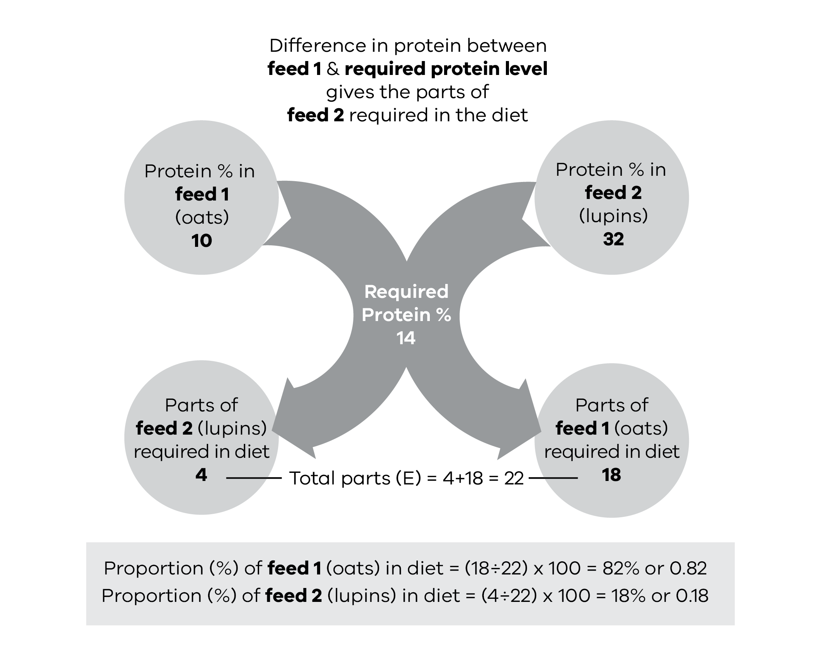
The lambs will require 82% of the ration in oats with 18% lupins to supply their protein needs. The amount to feed will need to supply their energy needs.
Amount of energy needed from feed 1 (oats)
Proportion of oats in diet  0.82 | x | Animal requirements  MJ ME/day  8 | = | Amount of energy needed from oats  MJ ME/day  6.6 MJ ME/day

kgDM required of feed 1 (oats)
Amount of energy needed from oats  MJ ME/day  6.6 | ÷ | Energy value of feed 1 (oats)  MJ ME/kgDM  10 | = | Amount required of feed 1 (oats)  kgDM  0.7

Amount of feed required on an as fed basis (oats)
Amount required of feed 1 (oats)  kgDM  0.7 | ÷ | Dry matter of  feed 1 (oats)  (expressed as a decimal,  i.e. 90% = 0.9)  0.9 | = | Kg as fed per head per day of feed 1 (oats)  0.8

Amount of energy needed from feed 2 (lupins)
Proportion of lupins in diet  0.18 | x | Animal requirements  MJ ME/day  8 | = | Amount of energy needed from lupins  MJ ME/day  1.4 MJ ME/day

kgDM required of feed 2 (lupins)
Amount of energy needed from lupins  MJ ME/day  1.4 | ÷ | Energy value of feed 2 (lupins)  MJ ME/kgDM  13 | = | Amount required of feed 2 (lupins)  kgDM  0.1

Amount of feed required on an as fed basis (lupins)
Amount required of feed 2 (lupins) kgDM  0.1 | ÷ | Dry matter of  feed 2 (lupins) (expressed as a decimal,  i.e. 90% = 0.9)  0.9 | = | Kg as fed per head per day of feed 2 (lupins)  0.1

Each lamb will therefore require 0.9 kg of the ration per day as 0.8 kg of oats and 0.1 kg of lupins. This will meet their energy requirements of 8 MJ ME/head/day with the required protein of 14%. You may also need to check that the animals will be able to eat the daily quantity required, as outlined in the section on feed intake. As these lambs can eat about 3-4% of their bodyweight, they will be able to eat 0.8 to 1 kg of good quality feed and so will be able to eat the ration as required.

Further information
- Making More From Sheep: Module 8 Turn Pasture into Product
Sheep Farming for Meat and Wool. Edited by J. Court, J. Webb Ware and S. Hides. Published by CSIRO.
Scientific references
Nutrient Requirements of Domesticated Ruminants. Edited by M. Freer, H. Dove and J.V. Nolan. CSIRO.
Trace Elements in Pastures and Animals in Victoria. Prepared by W.J. Hosking., I.W. Caple., C.G. Halpin., A.J. Brown., D.I. Paynter., D.N. Conley., P.L. North Coombes.
Franklin, M.C. (1942). ‘Studies on mineral metabolism in sheep. 1. On the necessity to supplement cereal grains with calcium in sheep rations.’ Journal of the Council for Scientific and Industrial Research, Australia 15: 85–93.
Clements, B.W., Gleeson, A.R. and Nicholls, P.J. (1979). ‘Survival Feeding of pregnant and lactating ewes with combinations of wheat and lucerne hay.’ Australian Journal of Experimental Agriculture and Animal Husbandry 19(19): 419–425.
Van Burgel, A.J., Oldham, C.M., Behrendt, R., Curnow, M., Gordon, D.J. and Thompson, A.N., 2011. The merit of condition score and fat score as alternatives to liveweight for managing the nutrition of ewes. Animal Production Science, 51(9): 834-841.

Chapter 4: Feeding sheep – how much and how often
This chapter pulls together the information on nutritional requirements for different classes of sheep to assist in working out rations, how to get started and how often to feed.
Key messages
- Prioritise paddocks for grazing by different livestock classes to utilise the best feed early.
- Manage ground cover, protect valuable pastures and utilise paddocks that will run out of water first.
- Where pasture feed will become limited, set feed and ground cover targets for destocking and containment feeding.
- Train lambs to eat supplements when on their mothers, even in non-drought years.
- Start feeding before sheep reach the targets set for maintenance feeding.
- Introduce grain feeding gradually over 3–4 weeks.
- Monitor live weight and/or condition score to review rations and whether targets are being met.
- Check mobs regularly for health issues and remove shy feeders early for separate management.
- Calcium must be provided to pregnant ewes and young growing stock when they are on high grain diets.
- Ration good-quality hay supplies and/or safe grains (e.g. lupins) for events that require quick increases of rations (e.g. cold weather/shearing).
- Shandy or carefully introduce sheep to new batches or grain sources.
Gradually introduce sheep back to pasture after the drought breaks.
The start and finish of feeding, level of supplementation and feed introduction strategy are all important components of drought management. As sheep need to adapt to high-grain diets, feeding needs to start several weeks before full rations are required. If stock have not been trained to eat grain at some stage (e.g. as lambs on their mothers) the training will take longer. Unlike fire or flood, when sheep may have to suddenly rely on hand feeding alone, the onset of a drought is usually gradual. This means that dry standing pasture is a valuable resource to use in conjunction with supplementary feeding. Assessing how much to feed and when to start can be tricky without good feed assessment skills, so monitoring stock for live weight and/or body condition is critical to ensure targets for production are being met.
At the end of drought, the weather can turn wet and cold quickly. Continuing to feed until pasture availability meets sheep needs will prevent undoing all the good work in managing sheep over the drought. Often the largest stock losses occur after the drought has broken.

Making the most out of pastures
During droughts, the nutritive value of standing dry feed can be quite reasonable and be retained for longer due to the dry conditions and decreased rates of decay. As a rule of thumb for mixed perennial pastures with a perennial component the digestibility of the pasture will be around 60 per cent when the pasture dries off and will decline by about 5 per cent per month until it reaches minimum of 35 per cent. For annual pastures, digestibility is about 70 per cent when the pasture dries off but then rapidly decreases in digestibility during the first two months to around 50 per cent. Dry sheep can usually maintain weight on pastures that are at or above 50 per cent digestibility.
A Drought Action Plan (Chapter 1 – Preparing for droughts) should include an audit of the feed available, the state of your pastures at the beginning of the drought and target levels for removing stock (or reducing stocking rates) to protect pasture and soil cover. Feed budgeting can be used to estimate when those pastures are likely to reach threshold levels of feed on offer (FOO, kg DM/ha) and percentage of ground cover for de-stocking and containment feeding.
If containment feeding is likely to be used and you have sufficient fibre reserves (e.g. hay) in storage it is worth using as much pasture as possible while the feed quality is reasonable, as long as productive pastures are not over-grazed and ground cover thresholds are met. If fibre resources are limited and sheep will be supplemented on pastures, the pasture will be an important component of fibre supplied in the diet and will need to be rationed more carefully. Also consider that some classes of stock may not be managed as easily in containment (e.g. weaners/shy feeders/lambing ewes) so reserve suitable paddocks for these animals. Water supplies may also reduce access to some paddocks so use these while they still have good water.
Utilisation of pastures early in a drought will be very similar to normal grazing management. Other aspects to consider are:
- Use of rotational grazing and periods of spelling to optimise productivity of perennials and improve persistence.
- Using those pastures with high nutritive value earlier rather than later to capture benefits before digestibility decreases.
- Identify any paddocks that can withstand heavy grazing for use as sacrifice paddocks and potential paddocks for resowing after drought.
- Consider the potential for weed introduction in paddocks where introduced hay and/or grain are fed.
- Management of pastures later in drought will need to consider:
- When to destock or reduce grazing due to critical ground cover.
- Restricting grazing to increase persistence of perennials.
Animal health issues, such as nitrate poisoning or phalaris toxicity, that can occur when hungry sheep chase the green pick after summer or the first autumn rains.
Courses on assessing how much feed and their value or quality in the paddock are available and are invaluable in making feed budgeting estimations based on these assessments with the needs of the stock. The feed budgeting of sheep while on pasture can be achieved using the tools and tables available at Feed Budget Tables and Feed Budgeting for Ewe Flocks in the Dry Season

When to start feeding
Feeding should start well before sheep become lower than the targets for Condition Score (CS) and live weight you want to maintain them at (Chapter 2 – Setting targets for sheep). If they have not been fed grain before, it will take some time before they become accustomed to hand feeding and begin eating their ration. Even if they have been supplemented before, it will take a while to adapt to the supplement and full rations cannot be reached quickly. If sheep have lost too much condition before feeding has begun, or before they readily accept grain, it may be hard – and expensive – to lift them back to the desired level. This is particularly applicable to lambs or weaners that were not fed supplements when grazing with their mothers. Weaners in this situation can take up to 3 weeks to become accustomed to the feeding of supplements.
Feeding should start before sheep meet target weights or condition to allow for some weight loss as sheep adapt to the supplement and you get the ration right. If you start feeding at that stage, the sheep can lose weight during the introductory period without drastically altering their chances of survival or the cost to bring them back up to the desired weight.
Table 4.1 provides some guidance on weights to start feeding sheep to maintain them at CS 2 and CS 3.
Adult sheep above these starting weights can be allowed to lose some weight and condition at the start of a drought. This weight loss needs to be controlled. A drop in weight of 5 kg over a number of weeks and a drop back to store condition will save a lot of feed but also has implications for future production and the risk of mortality and poor animal welfare (Chapter 2 – Setting targets for sheep).
The period of controlled weight loss can coincide with the feeding of introductory rations. The flock can safely lose from 1 to 1.5 kg on average a week for this period. Losses of 2–2.5 kg (or more than 3–4 per cent of bodyweight) or more per week should be avoided.
Table 4.1: Suitable weights for starting to feed sheep to maintain at CS 2 or CS 3.
Type | CS 2  Average live weight (kg) | CS 2  Bottom ¼ of mob (kg) | CS 3  Average live weight (kg) | CS 3  Bottom ¼ of the mob (kg)
Small frame Merino | 35 | 32 | 45 | 42
Medium frame Merino | 40 | 37 | 50 | 47
Medium frame cross-bred | 50 | 47 | 60–65 | 57
Large frame cross-bred | 60 | 57 | 70–75 | 72

Introducing sheep to hand feeding
Sheep have to be brought onto grain gradually to allow the rumen to adapt to the change in source of energy (Chapter 3 – What to feed sheep). This is critical for cereal grains or supplements that have high starch and low fibre content. A sudden change in diet can cause acidosis. Chronic acidosis can lead to poor intake, weight loss and ill thrift. Acute acidosis leads to deaths (Chapter 7 – Sheep diseases associated with drought).
If sheep are not accustomed to grain feeding, it can also take a while to get them to recognise and eat grain. Sheep need to learn to graze, browse or eat supplements. They usually learn this as lambs and are strongly influenced by the grazing behaviour of the mother and other sheep in the flock. Sheep can be fearful of new or novel feeds, new ways of feeding and/or feeding in new situations where they need to interact closely with many other sheep (e.g. trail feeding, containment feeding and feedlots).

Training sheep to feed
Training sheep to feed on supplements is best done every year when they are still lambs following their mothers. It is a valuable management practice to do before weaning, even if supplementary feeding is not expected to be needed, as they will remember for some years into the future when feeding may be required. As little as 3–4 feeds of 100 g/ewe will allow the ewe to teach the lamb to seek and eat the supplement. Lambs may need to be mustered onto the trail a few times to ensure they are all recognising the feed. If practical, it is worth feeding a variety of supplements that are normally used in your feeding programs as sheep remember different types of supplementary feeds later in life. If this is not practical, training them to a supplement is still very valuable and if a different grain type or ration is used later, they will adapt to this more quickly than if they had not been trained.
When starting the hand-feeding program introduce the feed to the sheep while there is still reasonable paddock feed. If sheep have not been trained to grain before, include a few adult sheep that have been fed before in the mob to encourage the inexperienced sheep to feed. Untrained sheep are best educated in small paddocks. Placing a grain trail over a trail of good-quality hay can sometimes help show inexperienced sheep (particularly weaners) the location of the feed trail and introduce sheep to the feed. Once the sheep start recognising both the feeding process and the feed and all of them come to the trail by themselves and eat, the hay can be removed. Sheep will soon learn to recognise the vehicle that is used to feed them.
When introducing a new or unfamiliar feeds (e.g. changing over types of grain) offering a shandy of the old and new feeds can help sheep accept the new feed.
It is important that untrained sheep are started on a feeding program earlier so that they have extra time to learn and adapt. Good training of sheep can take time and observation. Some sheep may need to be encouraged onto the feeding trail and the paddock should be checked to ensure all sheep are brought on to the feeding trail. A sheep or groups of sheep with their heads down grazing may not notice the feed cart at the other end of the paddock. Using a sound (e.g honking the horn) when starting feeding can help attract animals that are further away and ensure all animals are given equal chance to feed on the supplement. It will also save time later when feeding sheep in larger paddocks with a range in topography.
Putting effort upfront to train sheep will make it easier to ensure all animals are feeding well and that sheep gain equal access to the feeding trail. This will mean individual animals are less likely to gorge on the grain.

Adapting sheep to grain
Start the ration at a rate of up to 50 g/head/day for adult sheep (25 g for weaners) and increase slowly to the full ration over about 3–4 weeks (Table 4.2). Once the desired feeding rate is reached, the introduction program can stop. If you have decided to feed 2 kg of feed per week you can stop the program after day 17 when the stock have been established on the less-regular feeding regime. If you have decided to feed only 1 kg/week, you could start feeding 300 g every second day from day 7.
The table is only a guide to educating animals to take grain. Some farmers have commented that they can get sheep onto rations quicker, possibly due to the type of grain. Others have had to progress to the higher rates more slowly. If the ration is increased too quickly, you may notice sheep with signs of acidosis that are standing away from the feed with a belly ache and will generally have scours. As acidosis becomes more severe, they may appear lame or walk with a disjointed gait. These need to be differentiated from shy feeders. There will always be a proportion of shy feeders that do not take to supplementing easily. They will tend to eat only when most of the mob have finished and left the trail. They will be harder to get onto grain because of this. Getting onto a level that allows feeding every second or third day will help (as there will be grain left after the main mob has eaten). Alternatively, draft these sheep off and feed separately. In the early stages it is unwise to progress to higher levels of feeding until nearly all of the sheep have taken to the ration and are feeding from the trail.
If a day is missed early in the feeding program, stay at the same level feeding for that day rather than stepping up to the next level. If there are multiple days missed at different stages of the program start again at the level sheep were last fed for at least 2 days. For example, if sheep were being fed 300 g/day and were due to increase to 600 g/day and the sheep were then not fed for 3 days do not re-introduce the feed at 600 g/day. Instead, step back to 300 g/daily for 2 days and then proceed to the higher feeding rate.
If many cases of grain sickness or founder (lameness) occur, particularly at the 2–3 week stage, the program needs to be modified by not increasing the ration for a few days or reverting to daily feeding. See Chapter 7 – Sheep diseases associated with drought for diagnosis and treatment.
The educational ration may be fed out in thin trails so that it can be eaten along with paddock feed on the ground. If no paddock feed is available, the ration will need to be boosted with hay (or similar) until the full ration is reached and then hay can be included at as little as 10 per cent of the ration.
Table 4.2: A program for bringing sheep on to grain.
Feeding days | Amount of grain per feed | grams/head | kg/100 sheep
1, 2 | feed daily | 50 | 5
3, 4 | feed daily | 100 | 10
5, 6 | feed daily | 150 | 15
7, 8 | feed daily | 200 | 20
9, 10 | feed daily | 250 | 25
11, 12, 13, 14 | feed daily | 300 | 30
15, 17 | feed on alternate days | 600 | 60
19, 21 | feed on alternate days | 850 | 85
23, 26, etc | feed every third day | 1,300* | 130*
* Gradually adjust to suit final ration.
This feed introduction program applies to wheat, barley, maize, sorghum and pellets, or rations with a high starch and low fibre content. Oats have higher fibre content than the other grains and the rate of feeding can be increased a little more quickly. Lupins also have a higher fibre and much lower starch content and can be introduced more quickly. This can be particularly useful when introducing grain feeding to lambs and weaners or when there is an immediate demand for extra energy such as post-shearing in cold weather. While there is little risk of causing digestive upsets with lupins, it is still good practice to build the rate of feeding up over 14–21 days.
A guide to the amount of feed you will use in the first few weeks for a flock of 1,000 sheep is provided in Table 4.3.
Table 4.3: Feed consumption in the first month of a drought.*
Week | Tonnes per 1,000 sheep
1 | 0.8
2 | 1.9
3 | 2.9
4 | 3.0
Full feeding** | 3 to 5
* Based on Table 4.2
** Will depend on type of sheep and feed

Feeding frequency
Frequency of feeding will be determined by class of sheep, type of feed, practicality and whether a full ration (as in containment) is being fed or part ration on pasture. Some circumstances such as cold weather or a change of feed type may require reverting from feeding 2 or 3 times per week to daily feeding.
Dry sheep and ewes up to the last 6 weeks of pregnancy can be fed 3 days apart or twice weekly. A number of trials have illustrated no benefits of feeding dry sheep more frequently and in some cases performance was lower for sheep fed daily. Much of the explanation for this was that daily fed sheep ate the ration quickly (in one trial they took 15–30 minutes on high-grain diets), so there was insufficient time for slow and shy feeders to get enough. With more fibre in the diet, they took longer (45–30 minutes). When sheep were fed weekly, they took 4 days to finish the ration, so that there was plenty of time for the shy feeders to get a feed. There was also a wide variation in intake with daily feeding and a tail developed. As slow feeders died, the difference between daily and weekly feeding was less. The majority of sheep that died had lost 40 per cent or more weight over the feeding period. Table 4.4 shows results of one of these early drought feeding trials that looked at frequency of feeding (weekly or daily) on grain and fibre mixed rations. The daily fed sheep had more sheep gaining weight (the greedy ones that consumed most of the ration quickly) but the death rate was high, due to shy and slow feeders being unable to get enough feed. With weekly feeding, there were fewer sheep gaining weight (and the gutses may have had some mild acidosis), but death rates were reduced and wool production was higher.
Table 4.4: Impacts of feeding drought rations daily or weekly on sheep performance (proportion gaining weight and wool production) and mortality rate. Source – Franklin, 1952
Impact | Daily | Weekly
% sheep gaining weight | 41.9% | 14.2%
Death rate | 30.2% | 11.8%
Mean wool production | 3.05–3.15 kg/sheep | 3.26–3.43 kg/sheep
% sheep heavier at the end than beginning | 41.9% | 14.2%

Ewes in late pregnancy or during lactation and young weaners require daily feeding. This can be achieved with a self-feeder or by feeding hay and grain on alternate days.

Managing and monitoring
Monitoring sheep is critical to ensure that the ration is sufficient; that tail end sheep or poor doers are identified, removed and fed separately; and that disease is identified early. While sheep that are not doing well may be identified by eye, the only way to ensure that sheep are maintaining condition is to weigh or condition score them regularly. By the time weight loss is observed, the loss could be too high, requiring more intervention and costly feed to prevent deaths. Wool length and pregnancy can hide condition to even experienced eyes. By having sheep identified individually with Electronic Identification or visual tags, may allow those sheep that are continually poor adapters to be identified and culled later if appropriate. Chapter 2 – Setting targets for sheep, outlines the numbers of sheep to monitor.

Identify and manage shy feeders separately
A variable proportion of sheep and lambs will not adapt to drought feeding. Shy feeders are generally later to join the feeding trail and will leave the trail earlier to graze. They show less interest in the food. During an introduction and adaptation period, the shy feeder is often the one you are moving around to coax up to the trail. Some may adapt but if they are repeatedly the same sheep they could be a problem in the longer term. Shy feeders may also spend more time with their head up rather than eating, even if they are on the trail next to other sheep that have their heads down.
Shy feeders can be identified by watching the behaviour of the flock and individuals and doing a flank check if sheep aren’t in full wool. After a number of days with low intake, shy feeders will look hollow in the flank (compared to other sheep) even though they may still seem quite healthy. Over time these sheep will become more lethargic and show signs of ill thrift.
Shy feeders can also be identified by monitoring individual live weight gain or loss and condition score over 2–3 weeks. Sheep that continue to lose weight and condition score below target levels should be separated from the main flock groups and fed and managed separately. It may be difficult to differentiate the shy feeders from those with acidosis, so when feeding these sheep separately assume they have not adapted to grain. Good-quality hay or silage and safe feeds such as lupins and oats should be provided to these animals.
The proportion of shy feeders depends on age, previous feeding history, ration, mob size (the proportion rises steeply once the mob size is above 400), but up to 10 per cent is not uncommon.
To minimise the incidence of shy feeders, ensure that all sheep have easy access to the supplement. If trail feeding, make sure the trail is long enough for all sheep to feed. If containment feeding or feeding in troughs, you may need to allow more trough space for shy feeders.
Use a separate hospital paddock or pen for animals that are unhealthy or are not responding well to feeding. Check animals for underlying animal health problems such as foot abscesses, infections, pneumonia, poor teeth or any other external symptoms that can cause reduced intake and weight loss. When specific health issues (Chapter 7 – Sheep diseases associated with drought) are identified, seek veterinary advice and/or euthanase animals that do not respond to management or treatments.

Breaking routine or changing feed
If a break in the normal 2–3 day feeding routine occurs, do not resume feeding the full ration when supplies become available. Begin feeding again daily, on about half-rations, and build up to the full ration over a few days before returning to every third day.
Avoid sudden changes in the ration. Sheep that have become accustomed to one type of grain cannot immediately adjust to another. Even a change in source or batch load of the same grain has caused acidosis issues. New batches of pellets have also caused digestive upsets, as sometimes the main ingredients or energy source will change, depending on availability and cost.
Deaths and a high incidence of tender wool can result from a sudden switch of feed.
It is necessary to estimate early in the program how long supplies will last by feed budgeting. This will allow time for planning of a gradual changeover from one feed to another.
When getting a new source or batch, the ideal is to shandy this with the old batch, gradually increasing the concentration over at least four feeds before a total change over. If this is not possible, and it is necessary to use a different grain, it may be necessary to go back to an introductory phase again and include more hay until the full ration is again achieved. Additions to the ration of 1 per cent sodium bentonite or 1 per cent salt may reduce the risk of grain poisoning during the change.

How much to feed
The total weekly energy requirements for different classes of sheep, maintained at CS 2, are given in Table 4.5 along with minimum crude protein as a percentage of the dry matter of the diet fed. Full rations are provided for small-framed sheep of 40 kg and large-framed sheep at 60 kg. All sheep are assumed to be rearing single lambs. Tables 4.6 and 4.7 give the weekly energy requirements for a range of sheep sizes and stage of pregnancy at CS 2 (Table 4.6) and CS 3 (Table 4.7).
Rations for sheep of different weights need to be adjusted accordingly. Increase the ration if necessary by 10 per cent (which is equal to 0.4 kg of wheat or 0.6 kg of medium quality hay/head/week) for each 5 kg of extra live weight.
For example, a wheat ration of 3.5 kg/head/week should keep a medium-framed sheep in store condition at about 40 kg live weight. A further increase of 0.4 kg would be needed to keep a sheep at about 45 kg.
Similarly, rams are larger framed than ewes or wethers of the same breed. They will need 10 per cent more ration to maintain their condition in the non-breeding season.
Depending on their condition, they may need an extra 10 per cent to 20 per cent added to their ration for 4–6 weeks to ensure that they reach a strong ‘forward store’ condition at joining.
Table 4.5: Total drought rations for sheep maintained at CS 2.
Weekly energy requirements for maintenance and minimum dietary protein concentrations for different classes of sheep, assuming no paddock feed is available. Check adjustments to rations for allowances needed for larger breeds, and setting your own rations for more detail.
1. Adult dry sheep, ewes in early stages of pregnancy in store condition
Class of stock | Energy requirement (MJ/week) | Minimum crude protein  (% DM) | Feed | Ration kg per head per week
45 kg liveweight small framed | 46 | 6 | Wheat | 3.8
45 kg liveweight small framed | 46 | 6 | Or Oats | 4.6
45 kg liveweight small framed | 46 | 6 | Or Hay (good) | 5.4
Large framed, or crossbred ewe at 60 kg liveweight | 57 | 6 | Wheat | 4.75
Large framed, or crossbred ewe at 60 kg liveweight | 57 | 6 | Or Oats | 5.7
Large framed, or crossbred ewe at 60 kg liveweight | 57 | 6 | Or Hay (good) | 7

2. Pregnant ewes, last 4-6 weeks before lambing
Class of stock | Energy requirement (MJ/week) | Minimum crude protein  (% DM) | Feed | Ration kg per head per week
Small framed | 70 | 8 | Wheat | 5.2
Small framed | 70 | 8 | Or Oats | 7
Small framed | 70 | 8 | Plus Hay (good to av.) | 1
Small framed | 70 | 8 | Or Hay (good) alone | 8
Large framed, or crossbred ewe at 60 kg liveweight | 87 | 8 | Wheat | 6.2
Large framed, or crossbred ewe at 60 kg liveweight | 87 | 8 | Or Oats | 7
Large framed, or crossbred ewe at 60 kg liveweight | 87 | 8 | Plus Hay (good to av.) | 1.5
Large framed, or crossbred ewe at 60 kg liveweight | 87 | 8 | Or Hay (good) alone | 10

Some hay (or dry paddock feed) is desirable but, if in short supply save until after lambing and increase grain ration by 0.5 kg as a substitute.
3. Ewes with lamb at foot*
Class of stock | Energy requirement (MJ/week) | Minimum crude protein  (% DM) | Feed | Ration kg per head per week
Small framed | 103 | 10 | Wheat | 7.5
Small framed | 103 | 10 | Or Oats | 9
Small framed | 103 | 10 | Plus Hay (good) | 1.5
Small framed | 103 | 10 | Or Hay (average) | 2
Small framed | 103 | 10 | Or Hay (good) alone | 10
Large framed | 123 | 10 | Wheat | 9
Large framed | 123 | 10 | Or Oats | 11
Large framed | 123 | 10 | Plus Hay (good) | 2
Large framed | 123 | 10 | Or Hay (average) | 2.8
Large framed | 123 | 10 | Or Hay (good) alone | 14

Rates apply to mobs with normal lambing patterns from start of lambing. If lambing is concentrated, increase rations by 1 kg grain plus 1 kg hay for first 3–4 weeks following the lambing peak, for full milk production.
Wheat alone is satisfactory feed for lactating ewes, if roughage as paddock feed or straw is available.
4. Lambs
Class of stock | Energy requirement (MJ/week) | Minimum crude protein  (% DM) | Feed | Ration kg per head per week
Early-weaned lambs up to 15 kg live weight gaining 1 to 2 kg per hd/wk | 35 | 12 | Mixed cereal grain (3 parts) and lupins (1 part). Hay (good) at 10% | Feed to appetite  (3.5)
Combine the mixed grain feed with hay and feed the combined ration.
Class of stock | Energy requirement (MJ/week) | Minimum crude protein  (% DM) | Feed | Ration kg per head per week
Weaned lambs greater than 15 kg liveweight | 35 | 10 | Wheat | 2
Weaned lambs greater than 15 kg liveweight | 35 | 10 | Or Oats | 2.3
Weaned lambs greater than 15 kg liveweight | 35 | 10 | Plus Hay (good) plus grazing (about 1/3 ration) | 3
Weaned lambs greater than 15 kg liveweight | 35 | 10 | Or Hay (good) alone | 4.5

Give access to the best grazing at all times. If no useful grazing is available, give extra 1.5 kg good hay (or 2 kg average hay).
If hay is very scarce, reduce to 0.3 kg and increase grain by 0.8 kg (per week).
* Energy requirements for lactating ewes assume that ewes maintain body condition. If lambs are kept on the ewes longer than 6–8 weeks, requirements will increase as the lamb requirements increase.
If you know the energy value of the feed you have, you can calculate your own ration requirements using Tables 4.6 and 4.7. These tables give estimates for the weekly energy requirements of a range of sheep sizes maintained at CS 2 (Table 4.6) or CS 3 (Table 4.7).
Table 4.6: Total weekly energy requirements for sheep maintained at CS 2 with single lambs.
Total weekly energy requirements in megajoules (MJ)
Sheep weight (kg) (without foetus) | Class of sheep:  Dry mature | Class of sheep:  Pregnant  (last 4 weeks) | Class of sheep:  Ewe and lamb* | Class of sheep:  Weaned lambs**
15 | – | – | – | 35
20 | – | – | – | 37
25 | 30 | – | – | 40
30 | 34 | 49 | 90 | 45
35 | 38 | 55 | 93 | 42
40 | 42 | 62 | 97 | –
45 | 46 | 70 | 103 | –
50 | 50 | 76 | 108 | –
60 | 57 | 87 | 125 | –
* Requirements are for the ewe to maintain body condition. If the lambs are not weaned early, these requirements for the ewe and lamb will increase as the lambs get bigger.
** Assumes reasonable growth rates.
Table 4.7: Total weekly energy requirements for sheep maintained at CS 3 with single lambs (or twin lambs).
Total weekly energy requirements in megajoules (MJ ME)
Sheep weight  (without foetus) kg | Class of sheep  Dry mature | Class of sheep  Pregnant – single  (twins) | Class of sheep  Ewe and lamb – single (twins)
Small frame 45 kg | 52 | 79 (100) | 120 (152)
Medium frame 50 kg | 56 | 86 (108) | 130 (164)
Large frame 60 kg | 65 | 101 (124) | 150 (188)
Large frame 70 kg | 70 | 114 (140) | 168 (210)

If sheep are fed in containment, they will generally require 10–16 per cent less energy in walking around paddocks looking for feed.
To calculate the total feed needed, simply divide the number of energy units (ME) in your chosen feed into the energy units required for each class of stock.
Example 1: 45 kg wether, maintained at CS 2 requires 46 MJ ME/week
Feeding wheat of 12 MJ ME/kg
Full ration = 3.8 kg wheat per week
Example 2: 50 kg ewe with twin lambs at foot, at CS 3, requires 164 MJ ME/week
(1 week old)
Feeding maize at 13 MJ ME/kg
Full ration = 12.6 kg maize/week (protein may be limiting)

Adjustments to rations
In cold conditions, the sheep’s energy requirements increase and the rations will need to be increased by 20 per cent or even more under severe conditions. If cold conditions occur when sheep have just been shorn, provide whatever shelter is available and at least double the rations.
Hay and lupins are the safest for such a sudden increase in the ration, but it can be gradually replaced by grain if the increase has to be sustained. If grain alone is to be fed, the frequency of feeding rather than the amount offered at each feed should be increased.
On muddy ground, increase rations by about 0.5 kg/head if grain is trailed to make up for wastage caused by trampling.

Feed budgets
A simple feed budget will help to estimate likely grain requirements, predicted total cost as well as monthly cash flow requirements. This will also help you decide whether to keep and feed stock or sell and buy back. Two examples are given below. The cost of grain, your prediction of when the drought will break and the amount of a ration fed will change as a drought progresses. Budgets must be regularly updated.
Example 1 (see Table 4.8, assumes the drought will break in mid-April).
1,000 weaned lambs (25 kg) fed in the paddock at a half ration. Supplementation starts in December but does not reach the required ration until January.
A full ration of pellets at 12 MJ ME/kg is 3.3 kg/head/week. Pellet price = $350/tonne.
Table 4.8: Example of a feed budget assuming the drought will break mid-April.
Feed budget | Nov | Dec | Jan | Feb | Mar | Apr | May
kg/head/week | 0 | 1 | 1.6 | 1.6 | 1.6 | 1.6 | 1.3
Monthly kg required for the mob | 0 | 4,000 | 6,400 | 6,400 | 6,400 | 6,400 | 5,200
Cumulative grain requirement | 0 | 4,000 | 10,400 | 16,800 | 23,200 | 29,600 | 34,800
Cost per head/month | 0 | $1.40 | $2.24 | $2.24 | $2.24 | $2.24 | $1.82
Cumulative cost per head | 0 | $1.40 | $3.64 | $5.88 | $8.12 | $10.36 | $12.18
Cumulative cost per mob | 0 | $1,400 | $3,640 | $5,880 | $8,120 | $10,360 | $12,180

In the Table 4.8 example, you would require 34.8 tonnes of pellets for this mob at a total cost of $12,180 or $12.18 a head.
A simple budget like this will provide you with timings for when you need to order or organise delivery of more grain, depending on your storage capacity.
Example 2 (see Table 4.9, assumes the drought will break in June)
1,000 wethers (40 kg) fed wheat in the paddock at a half ration and then put in a stock containment area in January. A full ration of wheat at 12 MJ ME/kg is 3.5 kg/head/week. Wheat price = $310/tonne.
Table 4.9: Example of a feed budget assuming the drought will break in June.
 | Nov | Dec | Jan | Feb | Mar | Apr | May | Jun | Jul
kg/head/week | 1.5 | 1.5 | 3.5 | 3.5 | 3.5 | 3.5 | 3.5 | 3.5 | 2
Monthly kg required for the mob | 6,000 | 6,000 | 14,000 | 14,000 | 14,000 | 14,000 | 14,000 | 14,000 | 8,000
Cumulative grain (kg) requirement | 6,000 | 12,000 | 26,000 | 40,000 | 54,000 | 68,000 | 82,000 | 96,000 | 104,000
Cost per head | $1.86 | $1.86 | $4.34 | $4.34 | $4.34 | $4.34 | $4.34 | $4.34 | $2.48
Cumulative cost per head | $1.86 | $3.72 | $8.06 | $12.40 | $16.74 | $21.08 | $25.42 | $29.76 | $32.24
Cumulative cost per mob | $1,860 | $3,720 | $8,060 | $12,400 | $16,740 | $21,080 | $25,420 | $29,760 | $32,240

In the Table 4.9 example, you will require 104 tonnes of wheat at a total cost of $32,240 or $32.24/head. Some hay or roughage would need to be supplied when in containment and this cost would need to be added in.

Further tips for feeding

Ground feeding versus troughs
Laying a trail on the ground is the simplest and most practical method of feeding grain in the paddock, despite there being some wastage. A long thin trail has the advantage of allowing all animals in the mob easy access to the feed. Feed space for all animals can often be limited when using troughs, making it harder for shy feeders. The apparent wastage may not be as great as it appears and the scatter of grain may only represent a small proportion of the total feed. Wet and boggy conditions can be a problem (particularly for pellets) for ground feeding and rations will need to be increased if feeding in these conditions.
To reduce the risk of weed contamination from purchased grains, feed out on the same area so that any weeds that do germinate can be easily controlled.
Feeding in troughs is recommended for feeding in containment areas to reduce wastage and animal health issues. Bacterial diseases that spread through faecal contaminations, such as Salmonella, Coccidiosis, Listeria etc, can become a higher risk when animals are fed continually on the same space. The risk will only be reduced by trough feeding if the troughs are regularly cleaned out. Troughs can be made from simple materials that may be on hand or bought cheaply (e.g. corrugated iron, rubber belting, shadecloth or purloins).

Feed out trailers
There are a variety of feed trailers available. Some have built-in weighing systems, electrical actuator opening feed-out chutes and augers for filling self-feeders. If buying a trailer, consider the amount and type of use. For example, an unsprung trailer may not be suitable on rough or stony country. Consider the number of animals being fed and the capacity to feed a number of mobs in a load, to avoid frequent trips back to the silo.
Some spinner super spreaders can be converted to a feed trailer by removing the spinner. Don’t leave the spinner on when feeding grain.
Considerable time can be spent waiting to fill the feeder, so also consider the auger size; a larger auger may save significant time over the number of loads and months you may be filling up and feeding out.

Calibrating a feed trailer
It is important to know how much is being fed out. This requires calibrating the trailer for each batch or load. The bulk densities of grains vary, so that for the same volume of grain, some will weigh considerably more than others. Even different loads of wheat or barley say, can vary enough to make checking worthwhile. The simplest way to calibrate is to weigh and time some feed coming out of the trailer. Place a container (e.g. a wool pack or tarp) under the feed out chute and open the chute for 60 seconds. Weigh the grain that has run out, divide this by 60 to give the flow per second. Sixty kilograms in 60 seconds would give a flow rate of 1 kg/second. Use this to provide the time for feeding out in each mob, so if one mob requires 200 kg of grain, run the trailer for 200 seconds (3 minutes and 20 seconds). A cheap digital timer in the ute is a simple addition to get the rates reasonably accurate.

Adding limestone
If supplying calcium separately as limestone, do not add it to the silo as it is very corrosive. Add it to the feed trailer as it is being filled. For example, if the trailer holds 1 tonne of grain, then 20 kg of limestone in a bucket (a rate of 2 per cent) can be slowly added with the grain. Further mixing will occur with travelling. Alternatively, calcium (and salt) can be provided separately as a lick, as a pile on the ground or in troughs.

Self or lick feeders
There are many models of self-feeders. A ‘lick’ feeder means that each animal has to lick the grain in order to get it, which restricts the intake. Feeders can be wound down to reduce intake, and lick feeders may require regular cleaning as the saliva on the grain dust can clog up the gap. Full flow feeders mean that animals are on full ad lib feeding and they are used for production feeding.
Lick feeders may give more control over the feed consumed. When using lick or self-feeders ensure that sheep are well adjusted to a high-grain ration (at least 75 per cent of full ration); provide sufficient feeders to allow all animals reasonable access; and check for cleaning when filling.

Deciding when to stop feeding
Stop feeding when sheep are able to maintain their target level of production based on the pasture available. Do not do this suddenly.
In previous droughts, many properties have experienced their heaviest losses during the period immediately following drought-breaking rain.
Prolonged wet conditions turn sheep off their feed and there are problems under these conditions if grain is fed on the ground.
As soon as the first green pick emerges, sheep will chase it and expend more energy. In most circumstances, keep sheep confined to restricted feeding areas until adequate pasture is available. At that point, allow increasing grazing time at about an hour per day until full grazing is provided after 6–7 days. Allowing immediate full grazing will lead to digestive upsets and could cause animal health issues such as pulpy kidney. Feed sheep so that they have a full stomach before releasing them. See diseases in the section ‘After the Drought’ in Chapter 7 – Sheep diseases associated with drought, for more information.
Be aware that it may be difficult to get sheep back into containment once they have been let onto pastures.

Further information
Tools and resources
- Feed Budgets on dry feed: Feed Budgeting for Ewe Flocks in the Dry Season
- Sheep Farming for Meat and Wool. Edited by J. Court., J. Webb Ware and S. Hides. CSIRO.
Feedlotting lambs at: To feed or not to feed – that is the question
Scientific references
Franklin, M. and P. Sutton (1952). ‘Maintenance rations for Merino sheep. 1. A comparative study of daily and weekly feeding on rations containing high proportions of wheat and several proportions of roughage to concentrate.’ Australian Journal of Agricultural Research 3(2): 168–186.
Briggs, P., M. Franklin, et al. (1957). ‘Maintenance rations for Merino sheep. IV. The performance of adult Merino ewes fed daily and weekly at three levels of energy intake.’ Australian Journal of Agricultural Research 8(1): 75–82.
Foot, J.Z. (1987). Sheep Nutrition in the Victorian Environment. J. Z. Foot, Egan, J.K. and Love,K.L., Department of Agriculture and Rural Affairs: 86.
Franklin, M., G. McClymont, et al. (1955). ‘Maintenance of rations for Merino sheep. II. The performance of weaners fed daily and weekly on rations of wheat and wheaten chaff at maintenance levels and the effect thereon of vitamin A supplements.’ Australian Journal of Agricultural Research 6(2): 324–342.
Hodge, R.W., B. Bogdanovic, et al. (1981). ‘Wool production of merino sheep fed daily or twice weekly on oats or lupins.’ Australian Journal of Experimental Agriculture 21(110): 277–279.
Langlands, J., J. George, et al. (1967). ‘Observations on the calcium intake and serum calcium status of grazing ewes during drought.’ Australian Journal of Experimental Agriculture 7(27): 325–328.
Rice, M., E.C. Jongman, et al. (2016). ‘Characterisation of Shy-feeding and Feeding lambs in the first week ina feedlot.’ Applied Animal Behaviour Science 179: 39–45.
Watson, M.J., R.A. Leng, et al. (1975). ‘Metabolic studies on daily and weekly feeding of ruminants given all-wheat diets. I. Digestibility and nitrogen balance in sheep.’ Australian Journal of Agricultural Research 26(2): 329–336.

Chapter 5: Water during a drought
This chapter outlines stock water requirements, problems that may occur and options for managing water resources on farm.
Key messages
- Do water budgets early, based on your experience with water supplies, how much water you have available and how much your stock will need.
- Have a water plan that includes the worst case scenarios.
- Evaporation rates can be very high over dry summers and small dams are inefficient water storages.
- Consider water reticulation systems and transfer requirements between storages, particularly for containment areas.
- The major threat to water quality during drought is high levels of salt, although algae and animal manure can foul water following heavy summer rains or strong winds.
Water can be tested for salinity and other minerals to check suitability for various classes of stock and for toxicity of algal blooms.
One of the main limitations of feeding animals through a drought is the availability of good-quality drinking water. Whether stock are in containment areas or in the paddock, water is essential for animal survival and performance. Poor water quality is a common cause of under-performing animals.
If your main water storage and supply is from dams, stock can get stuck in the mud trying to access the depleted pool of water left. This may require limiting access to some dams before they run out of water.

Will you have enough water?
Knowing your property and how water supplies perform in times of drought is essential information for the planning phase. Calculating the total water available and the total required by stock will tell you how many stock and of what class you can carry through a dry period.
If all stock water is supplied by dams, list all the dams by paddock and calculate the water available in each one.

Animal requirements
The amount of water an animal requires will depend on a number of factors including:
- the class of animal (a lactating ewe will require significantly more water than a weaner)
- the temperature and season (sheep consume more water in summer and during warmer weather)
- the feed on offer (stock will drink more on dry feed such as grains, hay and dead pasture than on feeds with higher water content)
the quality of the water (water with higher salt levels will increase consumption).
Table 5.1 provides a guide to the average and summer daily requirements of most classes of sheep as well as beef cattle and horses. Complete the template on page 54 to calculate weekly stock water requirements.
Table 5.1: Stock water requirements litres/animal/day.
Stock type | Consumption (litres/animal/day) Summer | Consumption (litres/animal/day) Average daily
Sheep
Weaners | 6 | 4
Adult dry sheep | 10 | 6
Ewes with lambs | 14 | 10
Beef Cattle
Weaner (250–300 kg) | 70 | Up to 55
Adult Dry stock | 112 | Up to 80
Horses (grazing) | 49 | 35
For more information on water requirements for sheep and other livestock types refer to ‘Managing farm water supplies’ https://agriculture.vic.gov.au/farm-management/water/farm-water-solutions/managing-farm-water-supplies

How to calculate how much dam water you have
Step 1
To calculate how much water you have stored in your farm dams at any given time requires you to know the volume of water. To do this you need to know:
- The length of the dam at water level.
- The width of dam at water level.
The depth of the dam.
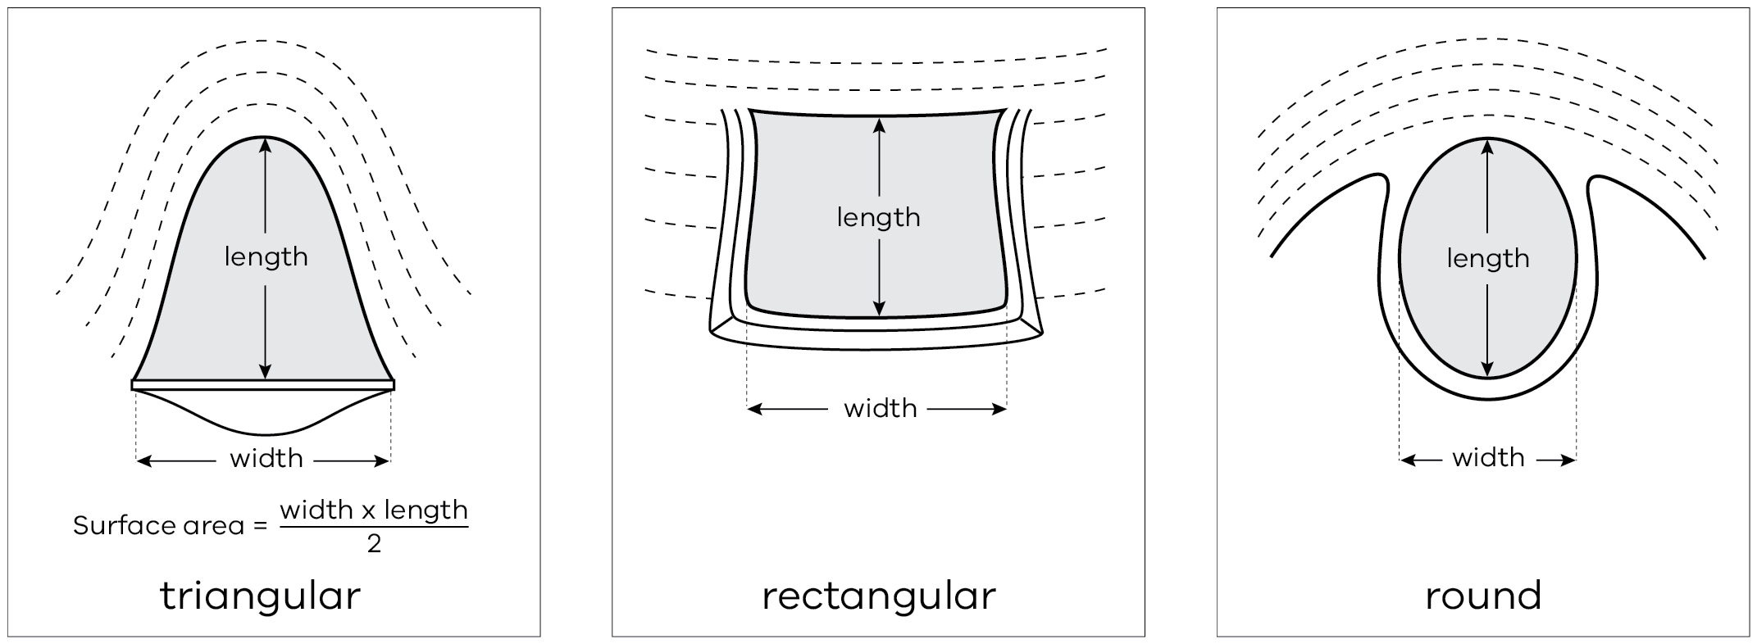
Source: Office of Water Factsheet (2010) Dams in NSW – What size are your existing dams?
From this website: Assessment of quantity of dam water, livestock demand and loss factors
Step 2
Once you have these measurements you can use tables 5.2 and 5.3 to estimate how much water you have in each dam. The information can be used to estimate stocks on hand in the template on page 103.
Table 5.2. Volume of water in a small rectangular dam (megalitres). Batter slope 3:1
Water dimensions (metres) Length | Water dimensions (metres) Width | Depth of water (metres) 0.5 | Depth of water (metres) 1.0 | Depth of water (metres) 1.5 | Depth of water (metres) 2.0 | Depth of water (metres) 2.5 | Depth of water (metres) 3.0
5.0 | 5.0 | 0.01
5.0 | 10.0 | 0.02
10.0 | 10.0 | 0.04 | 0.05 | 0.06
10.0 | 15.0 | 0.06 | 0.09 | 0.10
10.0 | 20.0 | 0.08 | 0.12 | 0.14
15.0 | 15.0 | 0.09 | 0.15 | 0.18 | 0.19 | 0.19
15.0 | 20.0 | 0.13 | 0.21 | 0.25 | 0.28 | 0.28
15.0 | 25.0 | 0.16 | 0.27 | 0.33 | 0.37 | 0.38
15.0 | 30.0 | 0.19 | 0.33 | 0.41 | 0.46 | 0.47
20.0 | 20.0 | 0.17 | 0.29 | 0.37 | 0.42 | 0.44 | 0.44
20.0 | 25.0 | 0.22 | 0.38 | 0.49 | 0.56 | 0.59 | 0.61
20.0 | 35.0 | 0.31 | 0.55 | 0.72 | 0.84 | 0.91 | 0.94
20.0 | 40.0 | 0.36 | 0.63 | 0.84 | 0.98 | 1.06 | 1.10

Table 5.3. Volume of water in a small gully dam (megalitres). Batter slope 3.1
Water dimensions (metres) Length | Water dimensions (metres) Width | Depth of water (metres) 0.5 | Depth of water (metres) 1.0 | Depth of water (metres) 1.5 | Depth of water (metres) 2.0 | Depth of water (metres) 2.5 | Depth of water (metres) 3.0
5.0 | 5.0 | 0.01
5.0 | 10.0 | 0.01
10.0 | 10.0 | 0.01 | 0.02 | 0.03
10.0 | 15.0 | 0.02 | 0.03 | 0.05
10.0 | 20.0 | 0.02 | 0.04 | 0.06
15.0 | 15.0 | 0.02 | 0.05 | 0.07 | 0.09 | 0.11
15.0 | 20.0 | 0.03 | 0.06 | 0.09 | 0.12 | 0.15
15.0 | 25.0 | 0.04 | 0.08 | 0.11 | 0.15 | 0.19
15.0 | 30.0 | 0.05 | 0.09 | 0.14 | 0.18 | 0.23
20.0 | 20.0 | 0.04 | 0.08 | 0.12 | 0.16 | 0.20 | 0.24
20.0 | 25.0 | 0.05 | 0.10 | 0.15 | 0.20 | 0.25 | 0.30
20.0 | 30.0 | 0.06 | 0.12 | 0.18 | 0.24 | 0.30 | 0.36
20.0 | 35.0 | 0.07 | 0.14 | 0.21 | 0.28 | 0.35 | 0.42
20.0 | 40.0 | 0.08 | 0.16 | 0.24 | 0.32 | 0.40 | 0.48
25.0 | 40.0 | 0.10 | 0.20 | 0.30 | 0.40 | 0.50 | 0.60

Step 3
Allow for evaporation and seepage.
Evaporation can be one of the biggest losses from farm dams, especially small or shallow dams. The smaller dams less than 3 meters deep can lose up to 60% of their water over summer. This can be up to 1 meter of water depth or more.
Allowance for loss from seepage may also need to be taken into account. Variation between dams can be significant, and daily seepage losses between 1 mm and 8 mm depth per day have been measured. Experience will guide you as to which dams cannot be relied on to hold water for long and it may be worthwhile to graze paddocks with unreliable water storage early. Regular monitoring or prior knowledge of a dam’s capacity to hold water is necessary to accurately estimate how long your dam water will last. More depth may need to be taken off to account for this seepage.
Use Table 5.1 to calculate the daily requirements of all animals that rely on dam/s for their drinking water.
Example: A paddock with a 15 m X 20 m X 2 m deep dam with 500 dry sheep consuming 10 litres a day will consume 5,000 litres/day (Table 5.1 using the summer average daily rate). Divide your paddock dam water volume by the daily water usage: 280,000 litres/5,000 litres = 56 days of water available, noting that water quality may be very poor once the dam levels are low.
Download the Summer Water Calculator from Farm water calculator to determine how much water you have; how long it will last and how to make and use DAMDEEP measuring the depth of your dam.

Water quality
Stock do best on water that is fresh, cool and clean. Water should be low in salt, low in organic matter (<20 mg/litre Dissolved Organic Carbon (DOC)), low in suspended clay (<200 Nephelometric Turbidity Unit (NTU)) and free of other toxic substances, such as blue green algae. Avoid using water that looks or smells bad. Water should be tested if there is any question of its suitability for stock. The major threat to water quality during drought is high levels of salt, although algae and animal manure can foul water following heavy summer rains or strong winds.
Water quality can affect plant growth, livestock health, soil quality, farm equipment and infrastructure. The quality of water will vary, depending on the season and weather conditions and storage source, particularly from dams. Evaporation increases the concentration of salts while a flush of water dilutes salts but may increase sediment, fertilisers and manure or nutrient runoff. Monitor sources regularly and more frequently in summer or in periods of prolonged moisture stress.

Salt content
Salinity is a major water quality issue in areas where accumulated salts are mobilised in the landscape and make their way into waterways and dams. Salinity refers to all the mineral salts present in the water including sodium, calcium, magnesium, chloride, sulphate and carbonate. Evaporation of water sources increases the concentrations of the salts and the problems associated with them. During a drought year, low water levels can double salt concentrations over the summer.
Young sheep have difficulty thriving on water supplies with higher than 5,000 ppm salt while adult stock can handle up to 14,000 ppm, especially once they get used to it. However, levels of above 10,000 ppm need to be treated with caution. Table 5.4 lists salt levels in drinking water that can be tolerated by sheep and cattle. In general, the salt content of water should not exceed 10,000 ppm.
Table 5.4: Salinity tolerance levels for stock water.
Type of Livestock | Salt Concentration | EC (µS/cm) | Mg/L (ppm)
Beef cattle | Production decline begins* | 6,250 | 4,000
Beef cattle | Maximum level** | 15,600 | 10,000
Lactating ewes and weaners | Production decline begins* | 6,000 | 3,800
Lactating ewes and weaners | Maximum level** | 10,000 | 6,400
Dry mature sheep | Production decline begins* | 9,300 | 6,000
Dry mature sheep | Maximum level** | 21,800 | 14,000
* Production decline begins = upper limit salt concentration for healthy growth.
** Maximum = maximum salt concentration that may be safe for limited periods.
Table 5.5 outlines the upper limit tolerances for a range of elements across all stock types and classes. Some tolerance levels will be lower for sheep, particularly young sheep, such as magnesium, which should not exceed 400 ppm (mg/L) for young sheep or 600 ppm (mg/L) for adult sheep.
Table 5.5: Water quality stock tolerance levels.
Element | Rainwater | Upper limit | Effect
Calcium | 40 mg/L | >1,000 mg/L | Phosphorous deficiency
Magnesium | 0-19 mg/L | >1,000 mg/L | Scouring and diarrhoea
Nitrate | 10 mg/L  1 mg/L | >1,500 mg/L nitrate,  >30 mg/L nitrite | Vomiting, convulsions, death
Sulfate | 250 mg/L | >1,000-2,000 mg/L | Diarrhoea
Aluminium | 0.05-0.2 mg/L | 5 mg/L | Phosphorous deficiency
Arsenic |  | 0.5 mg/L | Diarrhoea, anaemia, poor coordination
Copper | 1 mg/L | 0.5 mg/L | Liver damage and jaundice,  Copper accumulation in the liver
Fluoride | 1 mg/L | >2 mg/L | Tooth damage and bone lesions
Iron | 0.3 mg/L | Low toxicity
Lead (notifiable disease)* | 0.015 mg/L | 0.1 mg/L | Reduced coordination, blindness, going off feed
Molybdenum  (related to copper) |  | 0.15 mg/L | Scouring and loss of condition. Infertility, skeletal disorders, testicular damage.
pH | 6.5-8.5 | >9  <5 | Other minerals become available, such as copper and aluminium
Total Dissolved Solids | 500 mg/L | Variable generally  >5,000 mg/L | Poor production, diarrhoea, higher mortality rates
The upper limits of mineral and metal levels described will vary due to specific geology weathering and acid conditions, in conjunction with high salinity levels or specific management. If feed contains the particular minerals then the limits are lower (Guidelines from the ANZECC 2000).
* Notifiable disease – seek advice from DEDJTR Animal Health

Pollution
During the 1982–1983 and 2015–16 droughts, many dams in northern Victoria were severely polluted by manure and dried vegetation blowing from bare paddocks. The water turned black and gave off a putrid smell and stock stopped drinking.
Keeping ground cover on paddocks adjacent to dams will help to avoid soil and contaminants entering dams. Fencing off major water storages and reticulating water will improve water quality and stock performance. If paddocks that have significant dam storages do become very bare, sediment traps around the inflow area can reduce sediments entering dams when rain falls, or on the windward side to prevent sediment blowing in. Sediment traps can be made from shade cloth or straw bales to capture vegetation and manure before it runs into dams. A video and information note about building a sediment fence is at Building a sediment fence to protect your dam.
Figure 5.1: Sediment fence built to protect dam from debris and pollution after fire.
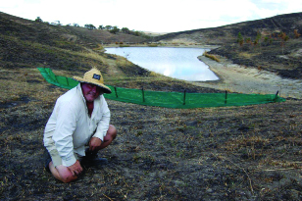
Figure 5.2: Diagram illustrating how sediment fences work to reduce sediment entering dams.
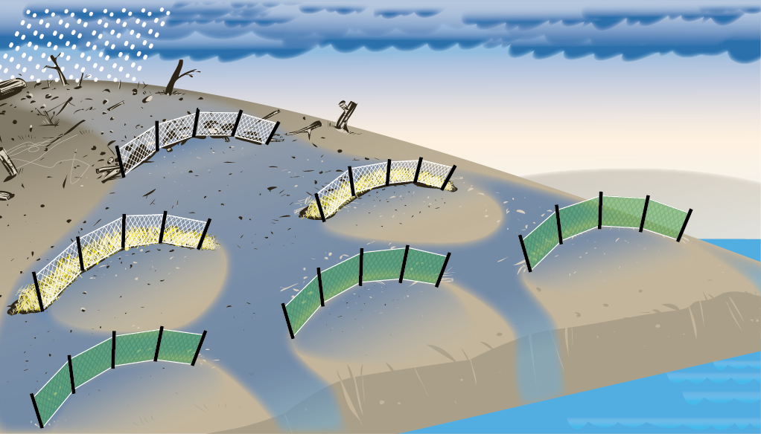
Once material is in the dam, aeration of the water is necessary to improve its condition and make it more acceptable to stock. This is best done by pumping to a tank and reticulating to a trough. If aerated water is returned to the dam, the organisms growing on the organic material will quickly use all the oxygen again.

Algal blooms
Algal blooms are common over summer months when water temperatures rise as dams become shallow and the levels of phosphorus and nitrogen in the water build up.
Most algal blooms are not toxic. Some blue-green algae, however, produce toxins that can have serious health implications for humans, animals and birds drinking or coming in contact with the water. It can kill animals within a few hours of ingestion.
Blue-green algae forms a scum that looks like green acrylic paint and leaves sky blue marks on rocks or plants around the edge of the dam.
If you suspect you have a blue-green algal bloom:
- isolate all stock from the dam or water supply
- collect a sample for testing by a water laboratory (use gloves, don’t allow the water to come in contact with skin)
- contact a veterinarian if animals show symptoms of poisoning (loss of appetite, breathing difficulties, muscle twitches, weakness, scours, photosensitisation – any white areas of skin become swollen and reddish)
contact Agriculture Victoria for further advice on controlling blue-green algae; see Blue-green algae in water for further information.
The best way to be certain about the quality of your water is to have it tested. The National Association of Testing Authorities (NATA) is the authority that provides independent assurance of technical competence through a network of best practice industry experts.
Basic test includes salinity, hardness, pH and iron. Provides an indication only; more detailed testing may be required depending on initial results.

Options to reduce water requirements
If your water budget is indicating that you will not have enough water to carry all stock through, you may need to consider selling some or using agistment options if available.
Consider stock containment in purpose-built yards that eliminate the need for stock to wander large paddocks in search of feed, and may provide more efficient options for providing and monitoring water quantity and quality.

Minimise evaporation
To conserve water and maintain good water quality, one large deep dam is more efficient than numerous shallow dams. Depending on dam location, etc, it may be advantageous to pump the contents of a number of smaller dams into a single dam to minimise evaporative loss.
Reticulate from dams rather than allowing animals direct access. Reticulating water avoids pugging and bogging problems and allows a more efficient use of the water. Reticulation systems must be simple, reliable and have sufficient storage capacity and flow to meet peak demands. Schemes should include troughs and storage tanks. Reticulation systems should also consider water transfer and pumping requirements and emergency contingency plans in case of failure.
Where possible, site troughs, tanks and pipes to suit future needs. For example, in or near yards or smaller paddocks. Also consider the minimisation of energy requirements for pumping and transferring water. Gravity-fed systems to troughs can provide cheap and efficient distribution of water from a higher water storage point. They also work when the power goes out or you have a fire and power will not be restored for weeks.

Actions to address a water shortage

Cart water
Carting water is extremely labour intensive. For valuable stock, it may be a valid option but otherwise it is best regarded as a last resort.
Check the quality of the water supply available for carting. Many streams and bores are quite salty.
It is not feasible to put carted water into earthen dams due to seepage and evaporation so use tanks and reticulate to troughs.

Sink bores
Investigate likely water yields and likely water quality before drilling emergency bores. Consult your Water Authority if you are considering constructing a bore as you will need a licence. For more information and to apply for a licence visit My Water – Victorian Water Register

Dig new dams
Do not dig a new dam when soil moisture is low. Only build earth dams when soil is moist enough for maximum compaction. A permit is required to dig a new dam on a waterway. Seek advice and permission before construction from your Catchment Management Authority.
Dam design, siting and construction can be a complex and important part of dry time survival. Getting this correct is not a matter of luck but using the right people for the right job. When seasonal conditions improve build up a contingency plan for the next dry period. Aim to drought-proof your property and its enterprises. Do not get caught by the next dry period.

Farmer tips from past droughts
- Have a water plan and undertake a water audit, taking into consideration the worst case scenario. Calculate stock water requirements and water available using the online farm water calculator Farm water calculator
- Assess reliability of all your water sources. A dam that fails five or more years out of 10 is not reliable.
- Have a large, fenced catchment dam on your property and reticulate from this to troughs.
- Spend money and set up your reticulation system properly from the start but do it in stages.
- Prepare early and ensure you have all permits in place well before summer.
Plant trees strategically to reduce evaporation from dams.

Further information
- Farm Water Solutions (Package): Farm water solutions
- Dams: Summer Water Calculator
- Organic pollution in farm dams: Organic pollution in farm dams
- Farm Water Calculator: Farm water calculator
- Water quality: Water quality for farm water supplies
- Water supply for stock containment areas: Water supply in stock containment areas
Anzecc and Armcanz. ‘Australian and New Zealand guidelines for fresh and marine water quality’. Australian and New Zealand Environment and Conservation Council and Agriculture and Resource Management Council of Australia and New Zealand, Canberra (2000): Section 9.3 pp 1-32.

Chapter 6: Stock containment
This chapter outlines the principles and guidelines for setting up a containment area to manage and feed sheep intensively through droughts or other feed limited periods.
Key messages
- Stock containment areas can be used to manage sheep intensively when paddock feed is limiting, protecting soil and pastures.
- Set-up and design need to consider soil type and slope, vehicle access, shade and shelter, water and feeding as well as mob sizes and numbers.
- Mob density in containment needs to at least meet minimum standards but sheep are generally run at lower densities (5–10 m²/sheep) to improve access to feed, water and shade. Very low densities may exacerbate dust problems depending on soil type.
- Sheep in containment require access to good-quality water at all times and require full maintenance feeding, including access to roughage, such as hay or straw.
- Calcium and possibly sodium need to be provided with high-grain diets. Calcium may need to be continued to pregnant and lambing ewes after release back into paddocks.
The main issues experienced by growers in managing sheep in containment have been acidosis, shy feeders, dust and muddy yards when the season broke.

Why use stock containment areas
A stock containment area is a carefully selected, fenced section of the property that is set up to intensively hold, feed and water livestock to protect soil and pasture resources during adverse seasons. This may be following a fire, during drought or late autumn breaks, or for other farm management activities.
Lot feeding for production, such as for finishing prime lambs, is a separate issue and is not covered in this chapter. If investigating this option seek specialist advice. Feedlots must meet local government planning requirements and the Australian Animal Welfare Standards and Guidelines for Sheep.
Stock containment areas are for short term use during adverse seasons when seasonal conditions restrict or prevent the animals from grazing.
The value of feeding in stock containment areas may include:
- protection of vegetative cover on pastures or failed crops and to allow pastures to recover after the break
- reducing seed set of introduced weeds in purchased feed
- protection of areas vulnerable to erosion
- more control of stock
easier or more localised management of stock feeding, watering, monitoring and handling.
Other benefits for containment areas outside of drought can include:
- holding stock when large areas need re-fencing (following a fire, flood or other emergency)
- faster pasture recovery after long summers or fire
- quarantine area for introduced stock
holding stock prior to other management tasks.
Figure 6.1: About 50% groundcover. A paddock that has been grazed this low is prone to considerable topsoil losses through wind and water erosion.
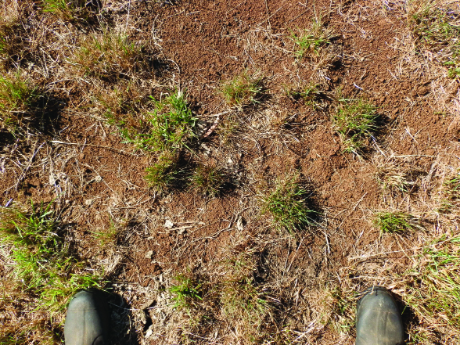
Figure 6.2: About 70% groundcover. Bare patches are quite large and start to join up, creating opportunities for soil movement.
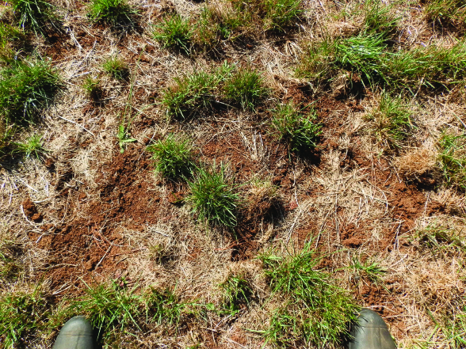
Figure 6.3: About 85% groundcover.
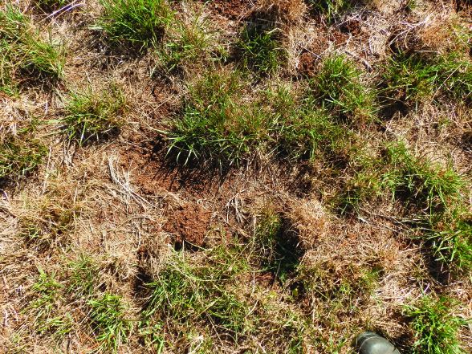
During a drought, or long dry summers, there is a high risk of losing valuable soil as pasture cover reduces. If pasture cover falls below about 70 per cent, wind will start to blow away soil particles, causing erosion and loss of valuable nutrients and topsoil. Bare areas will also be more prone to washing when the rain does come. Figures 6.1 to 6.3 provide a guide as to what a range of ground covers might look like in a perennial pasture. Even when stock have been removed, ground cover will continue to decrease as plants decay. This will accelerate with rain and wind, particularly in pastures dominated by annual species, so remove stock before critical ground cover targets have been reached.
Improved pastures that you have invested money and time in establishing can be lost if over-grazed and should be among the first paddocks to consider destocking.
Regular monitoring of stock and water is a full-time commitment. Animals need to be monitored for any signs of disease, as this can spread quickly in these conditions. Shy feeders or stock that are not coping with containment need to be identified and removed for feeding elsewhere.
Before moving stock into containment, ensure you have the key resources – cash flow, grain and roughage, water supply and commitment to fully manage stock over a realistic period before adequate pasture is available. In Victoria in 2006, farmers had sheep in containment generally for 3–5 months but for as long as 13 months.
It may be possible to release stock if you are away for an extended period of time, providing the appropriate care is taken, although farmers report that it was hard to get stock back into containment after short periods of release.

Site selection
Avoid locating the containment area adjacent to public roads (particularly high traffic) or close to property boundary fences. The yards should be set up as a permanent structure, like sheep yards, for future emergencies (drought, fire or flood) or other management opportunities.
The site should be accessible all year round.
The site should have:
- a moderate slope and a well-drained, stable soil such as a clay or clay loam
- ready access to existing handling infrastructure (yards, sheds) and water infrastructure
- no significant remnant vegetation
- shade, shelter and good drainage
- access to good-quality water
minimal problems with noise and smell that will cause concern to you or your neighbours.
Containment areas should be constructed across the slope and aligned with the natural contour of the land to avoid yard-to-yard drainage. Siting adjacent to existing shelter belts or vegetation is advantageous to utilise existing shade – otherwise shade and shelter need to be provided another way.
Dust can be an issue so shelter from prevailing winds should be considered. Soil type is an important consideration to reduce dust. A stable soil such as clay or clay loam is best and will also compact during use. Choose a soil that will carry stock in all seasons.
Stock should be checked daily so it is advantageous if the site has ready access from the house. This makes for easier monitoring and will reduce the time involved. However, consider the location to minimise issues of noise and smell to you or your neighbours. Proximity to other stock-handling facilities can be an advantage. No more than 20 per cent of the site should contain remnant vegetation.
Consider water quality in terms of runoff. The stock containment area should be set back from watercourses and water storages to protect against risk of nutrient run-off. A nutrient filter should be established on the down slope side of the site to prevent runoff into farm water storages and watercourses if applicable.

Design
Good yard design and access will improve the ease of managing a containment area.

Size
The minimum areas required for different classes of sheep under the Australian Animal Welfare Standards and Guidelines for Sheep in intensive feeding systems are:
- Lambs (up to 41 kg) – 1 m² per head
- Adult sheep – 1.3 m²
- Heavy wethers (CS 4 or greater) – 1.5 m²
Ewes and lambs – 1.8 m²
These densities are the minimum welfare guidelines and larger area per sheep is recommended. Heavier stocking may have the advantage of increasing soil compaction in the containment area to reduce dust but this is dependent on soil type. Allowing too much space may result in more dust, which can lead to issues including pinkeye and wool contamination. Stock density rates and mob sizes can also affect ease of access to feed and water by all stock. There is no one measure for ideal density rates. Densities of 5 m²/head is a general guide that balances space allowance for feeding and access to feed and shade. Farmers who used stock containment in past droughts ran sheep successfully at average rates between 7 and 10 m², but with individual ranges of 2 to 17 m² per head. The lower densities were usually associated with larger sheep (e.g. crossbred ewes) or were run as sacrifice paddocks rather than stock containment areas.
Sacrifice paddocks are small paddocks, rather than yards and stock densities are lower. The high nutrient values contributed by sheep will contribute to pasture re-sowing costs after the drought. Feed can be fed in long trails directly on the ground to allow ease of access, but dust may be more of a problem and identifying and removing poor doers may be more difficult. This may be an option for lambing ewes if removing them from pastures is necessary.
Optimum mob size in containment depends on the size of the yards and the class of stock. Larger mob sizes can be more difficult to manage and to identify and remove sick or poor performing animals. Small mob sizes will be easier to manage but will require more infrastructure and associated costs. The yard should be large enough to turn a vehicle around in.
If you are considering containing more than one group, you will need good subdivisional fencing as well as boundary fencing. Having several yards allows for sheep to be separated according to class, age or condition.
Figure 6.4: Sheep in a sacrifice paddock/containment area in south-west Victoria, June 2005, stocked at 12 m2/head. Source David Rendell, Livestock Logic
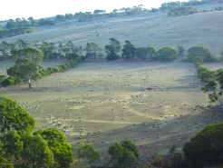

Layout
In designing the containment area, consider your management and operations, including:
- number and sizes of yards
- feeding system – separate or within the main yards, feed method and type (e.g. side fill)
- access to roughage and grain
- water access
- ease of cleaning troughs
ease of removing or treating stock that are under-performing.
Having a separate yard for grain feeding troughs can be an advantage as this will allow mixing of feeds and additives (if required) before stock can eat and provide easier access with vehicles. However, many farmers have fed successfully while sheep are in pens, either filling troughs from outside (side fill) or allowing vehicle access entry and exit. Provide adequate subdivision to enable separation of different classes of stock, including shy feeders or sick animals.
A number of different layouts and shapes have been used successfully, including yards with adjacent laneways for feeding and stock movement as shown in Figure 6.5.

Shade and shelter
There is no simple guideline for the amount of shade and shelter that should be provided to sheep in a containment area, except that it should be provided to reduce the impacts of adverse weather.
There is a wide variation in shade use by sheep as some animals in a flock can consistently use shade three or four times as much as others. Sheep with long wool are less sensitive to solar heating than newly shorn animals. Stage of production (reflecting different metabolic load) may also play a role, with ram lambs having a lower heat stress threshold than adult rams and wethers. Different breeds can also have varying tolerances to both heat and chill.
Shade structures should not impede the drying of the yard surface or ventilation beneath the structure. Shade cloth, stacked hay bales (secured and fenced), trees, galvanised sheeting or old hay sheds are all options that have been used.
Consider prevailing winds and locate shade in the western half of the pen – angle shade structures to the north-west to maximise the shade provided during the hottest part of the day.
Figure 6.5: SCA design suggestions.

Any existing trees in the containment yard/s should be fenced (using the same standard of fencing as the boundary fences) at least 1 metre around the tree. This will prevent animals ringbarking the trees and reduce the impacts of compaction. Established trees are very valuable in providing shade so you don’t want to lose them.

Access and safety
Ensure that a vehicle can access the yards (when stock are absent) to allow for cleaning and maintenance. Also consider stock access and ease of moving stock in and out of containment from paddocks or into feeding laneways.
Personal safety is of the utmost importance. Consider design and construction of facilities to minimise the risk of injury.

Construction
Containment yards should be constructed as permanent long-term facilities. The use of seven horizontal wires and a plain top and bottom wire is recommended. Fences should not contain any barbed wire. Posts should be no more than 5 metres apart and strainers should be stayed. The use of metal or concrete strainers and posts is recommended due to fire resistance and longevity. Keep in mind that stock may push up against fencing or run into it, so ensure it is constructed to withstand this treatment.

Water
A good, reliable water supply is essential in stock containment areas. Generally, stock will be fed diets very low in water content and so must be supplied with water at all times.
Water should be low in salt, low in organic matter, low in suspended clay and free of other toxic substances such as blue-green algae. Refer to Chapter 5 – Water during a drought, for more information on water quantity and quality requirements.

Water supply
The source of water may be a dam, creek, channel or bore. It is most important that the quantity and quality of the water is properly checked before siting the stock containment area. Farm dams lose a significant amount of water through evaporation over summer. When estimating the quantity of water needed in storage refer to Chapter 5 – Water during a drought, to allow for estimations of evaporation, seepage and stock needs. In the case of bores, the yield should be checked to ensure it is capable of providing the daily demand over the peak summer period. Assuming a fairly normal autumn break, the water supply should be designed to last until at least June of the following year.

Reticulation scheme layout
The ideal scheme is to pump from a dam, creek or bore into an elevated tank close to the containment area and then supply the troughs by gravity. Continuous pumping is then not required. Pumping may only be required every few days if the tank can hold enough water. An alternative system is to use a pressure unit, pumping direct to the troughs, with a gravity standby supply tank holding at least two days’ supply. This standby tank should be connected in such a manner that it is kept full by the pressure unit and automatically provides back-up supply to the troughs if the pump fails.
If a gravity tank is not incorporated and a pressure unit is used to pump direct to the troughs, a backup pump is vital to maintain water supply if the first pump fails. Another advantage of the gravity-type scheme is the possible utilisation of cheaper night rate power if electric pumping is intended.

Night rate pumping
If an electric pump is proposed, consider utilising cheaper night rate power. A storage tank holding 3-4 days’ supply should be used. Site a pressure unit at the water source, connected to night rate power. Use an automatic time switch to turn the pump on at 11 pm to fill the storage tank. A pressure switch would switch off the pump when the tank is full and the float valve on the tank shuts. The night rate pumping period generally operates from 11 pm until 7 am and the design flow rate should deliver the daily requirement within this 8-hour period. In any system like this it is advisable to have a manual over-ride so the pump can be switched to day rate and operated at any time if necessary.

Trough design and layout
Water trough allowance does not need to be more than required in a paddock as sheep will adjust and take turns to drink at the trough. Trough space is less important than flow rate.
Troughs need to be cleaned every couple of days – more often for younger stock. As a result, trough design needs to allow for easy cleaning. Troughs should be located as far away from the feed supply as possible, to prevent water contamination.

Design flow rates
A tank-to-trough water system should be able to deliver the total maximum daily requirement within 4 hours. It is critical that water can enter the trough at a minimum flow rate of 21 litres/minute for sheep and 42 litres/minute for cattle. A higher flow rate is required for lactating animals.
Example: A gravity supply tank to hold two day’s supply for 500 dry sheep would need to hold 10,000 litres, i.e. 500 sheep x 10 litres x 2 days = 10,000 litres.
A reticulation scheme to supply 500 dry sheep, with a tank holding two day’s supply would need to be capable of a flow rate of 21 litres per minute, i.e. (500 sheep x 10 litres) / (4 hours x 60 minutes) = 20.8 litres/minute.
When budgeting on a water allowance plan for average daily consumption of 4 litres/head/day, however this can change dramatically with the weather. On very hot days, intake will be greatly increased so you need to be able to supply up to 10 litres/head/day. Sheep will increase their water intake on hot days and if the water is hot. Deeper troughs will stay cooler and avoid running water to troughs through above-ground poly pipe as this can lead to extreme temperatures. The volume of water stored in the water source (e.g. supply tank) should be sufficient to meet containment area usage between pumping intervals plus reserves in case of leaks. Contingency plans for the emergency supply of water should be made in case of pump breakdowns, major leaks or storage failure.

Feed
Animals in containment need to be provided with 100 per cent of their diet, including energy, protein, mineral and roughage requirements. It is critical that these requirements are met for each class of stock. Full rations for different classes of stock are outlined in Chapter 3 – What to feed sheep. Confining stock so that they do not need to walk around in search of feed can reduce feed requirements (depending on the size and slope of paddocks) but as sheep usually manage to obtain some feed from even seemingly bare paddocks, the containment ration may be higher. Animals need to be monitored daily for condition and poor performers should be removed.
Including straw or hay roughage in the diet will reduce death rates and also the number of poor doers and can be provided on days when grain is not being fed. It does not have to be good quality hay, and the best hay should be saved for when stock need to be fed higher rates quickly. One survey reported better survival rates with straw than hay. The suggested interpretation for this is that sheep on the hay substituted some of the higher value grain with the hay, but utilised the straw as a roughage supplement.
Allow 15–20 metres of double-sided trough for 100 sheep. Use longer troughs for large or full-woolled sheep. Feed troughs can be bought or made cheaply from materials such as roof capping, folded roofing iron and suspended shade cloth. Troughs or feeders should be on the opposite side of the yard to water troughs to minimise the contamination of the water source from food carried in the animals’ mouths.
Farmers have used various designs for grain troughs that are easy to fill, clean and allow easy access for feeding, as well as feeding directly onto the ground. Lick feeders and self-feeders can be installed in the yard, but consider putting them on the boundary to enable filling from outside. If possible, avoid driving into the yard while sheep are present. If using a feeding laneway, iron, purlins, raised feeders, rubber or raised shade cloth troughs are options. Feeding directly onto the ground has been used with success and may allow more access to grain if trough space is limited, but may increase the risk of disease pick up and spread. Refer to Chapters 3 – What to feed sheep and 4 – Feeding sheep – How much and how often for information on rations, requirements and feeding management.

Management
Adult sheep are the easiest to manage in containment. Containing ewes and lambs should be avoided if possible. Adult sheep, weaners and hoggets should be yarded separately. Sheep should be vaccinated against enterotoxaemia (pulpy kidney) with a clostridial vaccine such as a 5-in–1 or 6-in-1. They should be drenched into the area and worm tested regularly.
It is preferable to start sheep on grain in the paddock for 2 weeks before introducing them to a containment situation. If you can’t do this, make sure that most of the diet in the first 2 weeks of containment is hay and then increase the grain ration gradually. Start at 50 g/head/day grain and make up the rest with hay building up to the desired ration over 2 weeks. Feed hay before grain and use the best hay first whilst the animals are adjusting to the ration. This ensures they don’t lose condition. Once adapted to the full grain ration poorer quality hay or straw may be used. Start off feeding daily for the first 2 weeks and then cut down to 2–3 times a week. You can then feed hay one day and grain the next.
Rations provided in Chapter 3 – What to feed sheep and 4 – Feeding sheep – How much and how often are guides and the amount can vary with breed and size of sheep and your production level (e.g. condition score and lambing rates) so sheep should be monitored to fine tune these rates. Overfeeding is expensive and underfeeding will lead to weight loss that is difficult to regain.
There will always be a number of sheep that do not adapt to containment and they should be identified regularly and removed to pasture or smaller yards, or sold. These sheep should receive additional feeding with good-quality hay, together with cut back grain-based rations that are then built up slowly, as they will most likely not have adapted to the containment ration and may not have fed well previously (e.g. shy feeders).
In cold, wet and windy weather, increase the feed by 20 per cent, or up to 100% more for recently shorn sheep, preferably by feeding more good-quality hay or safer grains like oats and lupins. If extra hay is not available, give one extra feed during the week. Replace any feed wasted as a result of rain damage with new feed.

Animal health
Feedback from producers who have contained sheep for a range of time periods, has generally reported low mortality rates at less than 2%. Death rates tended to increase with time spent in containment. Acidosis was the most common disease associated with stock containment, followed by shy feeders. Diseases like flystrike and pink eye need to be identified quickly. Refer to Chapter 7 – Sheep diseases associated with drought for more detailed information on diseases specific to droughts and grain-fed sheep – diagnosis, treatment and prevention.
Avoiding stress such as boggy ground, overcrowding, dust and irregular feeding will help reduce diseases such as salmonellosis and pneumonia. Regular cleaning of feed and water troughs will also help prevent diseases. Ensuring diets meet the requirements of adult sheep for healthy maintenance of condition score and for growth in weaners will also make animals more robust and resistant to these disease challenges.

Releasing sheep
When the break does come and pastures in the paddocks have recovered, the change in feed from containment feeding to pastures can be quite sudden and may cause digestive problems. Release sheep from the containment area gradually, ensure they have a full stomach and continue to feed hay and grain for a few days. One strategy is to feed hay in the morning and release the animals for a short while in the evening while they have a full stomach so that they don’t gorge on lush pastures. This can be repeated over several days until their digestive systems have had time to adjust. Alternatively, continue to make hay available in the paddock.
Ewes that are lambing may need the full ration for a few weeks.
There have been reported cases of hypocalcaemia in late pregnant ewes, despite being fed sufficient limestone over the intensive grain feeding period. Continuing to supply calcium as limestone in the paddock to heavily pregnant/early lambing ewes may reduce this risk (Chapter 7 – Sheep diseases associated with drought).

Farmer tips from past droughts
Farmers who contained stock in previous droughts believed it to be a worthwhile exercise, and it is now part of their future drought management strategies. However, managing a stock containment area involves a transition from a broadacre manager to an intensive manager. All feed and water is supplied by you. It requires constant vigilance and good management. However, it also means you can have better control over weight loss and gain and come out of a drought with valuable land assets and stock numbers intact.
Four surveys of farmers in south-eastern Australia who used stock containment in 2002 and 2006 reported observations including:
- Merinos were contained for longer than crossbreds and cattle for less time than sheep.
- Consensus was that acidosis followed by ‘shy feeders’ were the main causes of mortality and disease.
- Generally, feeding roughage reduced mortality and/or incidence of shy feeders.
- Reducing death rates from acidosis includes training animals onto grain carefully, including roughage and taking care with diet changes (including releasing onto pastures)
- Shy feeders must be removed from containment areas regularly and this needs to be more frequent as mob size increases.
- Dust was reported as a major issue and mud caused problems in 2006.
Containment was hard on stock confined for long periods and it was difficult to get sheep back in if they were released briefly.
Suggestions for what some farmers would do differently next time included:
- increase feed before release
- reduce stock density
- protect trees
- not keep them in for as long; feed problems worsened after time
- have a buffer silo to counteract problems with delays in getting loads of grain
- have small paddocks for when pens get very muddy
- make feeding area larger
- five pens and four mobs that were fed in the empty yard worked well, but wide gates were needed as they rushed to feed
- 15 cm of double-sided trough was insufficient
do a lot of planting to increase shade and reduce wind exposure, introduce tyres/logs, etc, to entertain stock, also reduce rubbing.

Further information
Resources and tools
- Managing resources in a drought
- Drought resources across states: Drought Resources
- Managing Sheep in Droughtlots – a best practice Guide: Managing Sheep in Droughtlots – a best practice Guide
Department of Primary Industries (Vic) (2007) Code of accepted farming practice for the welfare of Sheep (Victoria) (Revision number 2)
Scientific publications
Ashton B (2007) Farmer experiences – What was learnt by sheep and cattle managers in the 2006 drought.
Savage, D.B., Nolan, J.V., Godwin, I.R., Mayer, D.G., Aoetpah, A., Nguyen, T., Baillie, N.D., Rheinberger, T.E. and Lawlor, C., 2008. Water and feed intake responses of sheep to drinking water temperature in hot conditions. Australian Journal of Experimental Agriculture, 48(7), pp.1044-1047.

CASE STUDY
Jim Younghusband, Inglewood
Jim Younghusband is all for stock containment areas (SCAs). The four SCAs on his Inglewood district farm have proven to be perfect for all-purpose, all-season and all-weather use.
Located next door to the shearing shed and the stock yards, the SCAs are used regularly during shearing and crutching, before sheep are loaded for market and as an adjustment paddock for any new rams. If it wasn’t a closed flock, they would also make an ideal quarantine yard.
“The sites were convenient, with shelter and shade, water and the nearby shearing shed and yards,” he said.
Jim finds the optimum stocking rate for his SCAs is 3-5 m² per head and generally keeps containment mobs to around 300.
“Before we started using SCAs, the place was like a dust bowl in summer. Sheep walked around the paddock and it powdered off.”
Jim’s farm mix is about 85-90 per cent sheep and the rest cropping. The self-replacing 18-19 micron Merino ewes are joined either to Merinos or White Suffolk rams, with crossbreds lambing from mid-April and the straight Merinos a month later.
Over the past 10 years Jim has developed and refined a system to include SCA in his farm management.
“If the year has not been flash I start thinking in December about what I am going to do. If you are starting to think it is time for them to be in containment, you probably should have done it a month earlier.”
Shearing is in early October and lambs are weaned, cull ewes disposed of and White Suffolk rams put in with the ewes before any sheep move into containment.
With straight Merino joining in December, the rams have at times been with ewes in the containment areas.

Farm information
Producer: Jim Younghusband
Location: Powlett
Property size: 930 hectares
Annual Rainfall: 300-350 mm
Enterprise: Prime lambs and wool from Merinos and White Suffolk breeds

Entering containment
Jim said the sheep must start on a good footing so their condition can be maintained over the containment period.
“You put them into containment in good condition and keep them going. It is much easier to keep something in good condition than to have to improve condition during a dry year,” he said.
All sheep are drenched and vaccinated before going into containment and Jim estimates it takes 7-10 days for the stock to get accustomed to the new environment.
Sheep in containment.
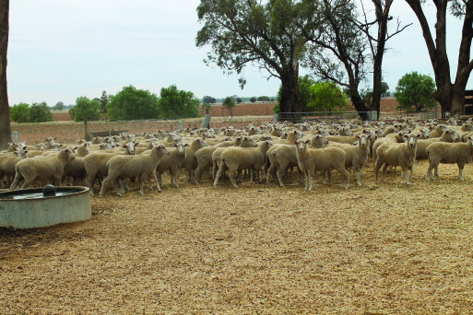

Feeding and water
Straw and grain are fed in the early weeks, with a mix of straw and hay later into the pregnancy. The grain ration is generally barley grown on the farm fed into a 7 m long piece of steel purlin sitting on the ground in a laneway adjacent to the SCA.
“I drive the grain trailer over the top (filling the purlin) and then open up the gate for one yard and let the sheep in,” Jim said. This is done every second day, with 400 kg of grain feeding 300 sheep.
Water comes in a pipeline from the Loddon River and Jim also has a bore that services about seven paddocks on the farm.
Jim keeps a close eye on the water quality. Dust and hay on the surface of the trough can discourage sheep from drinking, so he regularly skims this off rather than emptying the whole trough and potentially wasting water.
Wind direction is a key consideration when delivering a new bale of hay and straw, to avoid too much debris ending up in the water troughs.

Animal health
His decade working with containment has taught Jim the value of keen observation.
“I get a bit paranoid about having 1,200 sheep locked up and first thing every day I just come out and stand and look at them.”
This helps him identify shy feeders or other issues and any early signs of illness, which increases in risk after 6-8 weeks of containment.
His keen eye has helped reduce such risks but one year some very healthy ewes, who were heavy in lamb, suddenly took ill. He called in an Agriculture Victoria vet, who identified the problem as a Vitamin B1 deficiency – a common complication of containment. The worst-affected sheep were injected and the rest of the mob drenched with Vitamin B1.

Behaviour
Jim has also gained some insights into the body language of his flock and the vast differences between breeds.
He said crossbreds had a very healthy appetite and a small space with lots of food was sheer paradise for them. But for Merinos it is a different story.
Steel purlin in adjacent laneway used for feeding grain.
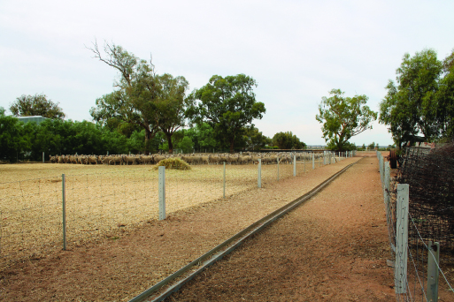
“Merinos like to fossick about the paddock. A SCA is a confined space and it doesn’t suit their nature as much.”
He will never forget what happened when the two breeds were put in the one SCA.
“The crossbreds bossed them around and the Merinos sulked. I won’t ever box them up together again.”

Learning
“You learn from your own mistakes and if you don’t there is something wrong. My biggest learning is you must drench and vaccinate before putting them in, and preferably put sheep in with the minimum amount of wool on them. If you don’t, their fleece gets full of dirt and you are wasting all the feed on wool,” he says.
“It is important to have shade and shelter but you also have to allow the air to flow through the area. And think carefully where you put the containment yards. Can it be connected to your sheep yards (and serve several purposes)?”
Trees in his containment areas have been protected by several old gates that were around the farm and one fence has been sheltered with several old bales of straw.

CASE STUDY
Ben and Jodie Greene, Elmhurst
Ben and wife Jodie live at ‘Millbanks’, near Elmhurst, in the upper catchment of the Wimmera River in the Pyrenees ranges. The diverse farm has steep hills, intermediate rises, undulating land and river flats.
The Greenes run a self-replacing Merino flock for meat and wool, grow out Friesian bulls and run Friesian steers on an adjacent property.
Ben’s father constructed purpose-built stock containment areas (SCAs) in the early 1990s that were used to feed sheep in the 1994 drought.
The SCAs also proved pivotal in feeding sheep during the drought years of 2002, 2006, 2007, 2008 and 2016.
Ben said the hardest thing was making the actual decision to lock up sheep.
“Once that is all done and dusted then it is relatively easy to manage,” he said.

Feeding
Ben said it was important to do your numbers before putting stock in containment.
“We do a quick feed budget when heading into drought and work out what we need to feed the sheep until 30 June. Feed budgeting and money budgeting are the two big ticket items in drought planning.
“You have to draw a line in the sand and say ‘this is what we are up against’. Then you can work out if you have enough feed on hand, and when you may have to buy some in and how much.”
Sheep are fed 1-2 kg/head of straw for roughage and about 4.5 kg/head of grain per week. This usually involves grain being fed on Monday, Wednesday and Friday.
“Feeding can generally be done within 2-3 hours in the morning. This is a huge time saver because we don’t have to drive over the farm delivering feed to multiple paddocks. Grain is stored within 200 m of the SCAs and the sheep yards are there as well.”

Farm information
Producer: Ben and Jodie Greene
Location: ‘Millbanks’, Elmhurst
Property size: 1,300 ha
Annual Rainfall: 600 mm
Soils: Sandy loams, heavy river flats
Enterprise: limited cropping of 100-200 ha triticale for feed; self-replacing Merino ewe flock; bought-in Friesian bulls and steers.
Grain consists of wheat and triticale grown on the farm. Lime is added to the grain for calcium but Ben has calculated that the sheep get adequate salt from the water supply.
Ben says it is important to carefully watch sheep while in containment. “A change in grain can upset them,” he says, citing an example of a mob developing acidosis when introduced to a different batch of grain.
Shy feeders are removed from containment weekly as they are identified and are typically turned back out into the paddock. They respond well to being fed without the competition.
After three months off green feed, Vitamin E deficiency can be a problem. It is identified when otherwise healthy sheep are unable to rise. Sheep in containment for more than three months are drenched with Vitamin E to prevent this condition.

Water
While feeding is a major consideration, the other huge benefit of containment is having one water point. “A big reason for containment on our farm has been to manage, develop and refine a system to avoid carting water.”
If reliable stock water is a challenge, having one watering point saves time and effort. Keeping sheep off vulnerable paddocks also preserves the pasture base and prevents soil erosion.
Millbanks’ dams, springs and wells all dried up in the 2006-07 drought. Since then, Ben and Jodie have sunk deeper bores and consolidated many smaller dams into one larger, deeper dam. They then started reticulating water around the farm. To date, 70 per cent of the property has piped water and the process of combining dams to larger, low evaporation storages, continues.
While reticulation requires more labour (cleaning and checking troughs), it has reduced the problems of stock getting stuck in muddy dams and large losses of water to evaporation.

Multi-purpose
Drought has been an important time to use the stock containment yards, but it is certainly not the only use.
With steep hills that must retain ground cover over drier times of the year, the containment areas provide an excellent place to feed sheep when the hills may be vulnerable if stocked.
“Stock containment areas help you manage your ground cover (on these hills) and preserve the asset of your pasture base. There is great winter and spring feed available on that hill country,” Ben says.
The areas are also ideal holding paddocks for times including shearing, drenching, crutching and for quarantining brought-in stock.
Containment yards and adjacent lane way.
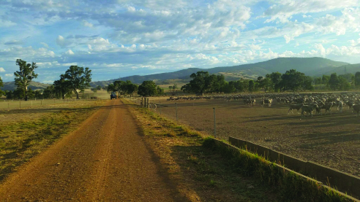

Environmental benefits
The Greenes have honed their feeding and water conservation skills, improved their understanding of sheep health in containment and seen many advantages that stretch way beyond Millbanks’ boundary.
The summers are not as dusty, the Wimmera River is not at risk of silting from soil off the hills and the land is more productive.
“I see containment areas as benefitting the whole community and not just us. The last thing I want to do is damage the river,” Ben said.
“Containment benefits the community because soils and water quality are protected.”

CASE STUDY
Matthew Ipsen, Wareek
The Ipsen family have been using the five stock containment areas (SCAs) on their Central Victorian property since 2007.
The areas, located near the stock yards, were home to the family’s 2,000 breeding ewes for six months in 2015. They are also used during shearing and at other times during the year.
“We are constantly using them. Their versatility is amazing and I don’t think enough people realise what they could have,” Matthew said.
Matthew said that, with good laneways on the property, it only takes a few minutes to move the ewes and lambs into the yards.
The five SCAs can hold 2,500 sheep and Matthew and Robert see them as a vital piece of farm infrastructure in drought, fire and even flood. “When you lose fencing, you have somewhere secure to put stock.”

Site selection
Matthew said it was important to select a suitable site on higher ground with stable soil. The Ipsens reinforced the soil in their yards with 1,000 cubic metres of blue metal to further stabilise the soil and prevent erosion. They also chose a location adjacent to some existing trees to provide shade.
Matthew and Robert were keen to ensure that nutrients did not run off into the nearby Bet Bet Creek. A minimum distance of 200 metres was set and they always try to maintain good groundcover in the paddock below the yards to filter the runoff from the SCAs.
Proximity to other infrastructure was also important. The Ipsens’ SCAs are adjacent to the existing shearing shed and sheep yards. They have often used the SCAs during other activities, including shearing.

Farm information
Producer: Robert, Barbara and Matthew Ipsen
Location: Wareek (near Maryborough)
Property size: 1060 ha
Annual Rainfall: 500 mm
Soils: Sandy-Clay
Enterprise: Cereal cropping; self-replacing Merino ewe flock
Sheep in containment.
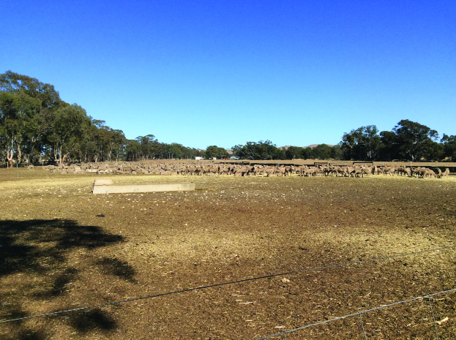

Water
The Ipsens’ farm has a reliable bore close to the SCA, with another on a nearby property connected to the same pipeline. Their airwell pump provides water directly to the troughs in the yards and they can change the direction it pulls from if they need to get water from the alternative bore.
Robert tests the water regularly for salt content. Mathew said they planned to install a tank nearby to gravity feed the troughs so they don’t have to rely on the pump in power failures. The 600 litre concrete water troughs are cleaned out regularly.

Design and feeding
Each SCA is about 50 x 50 metres in size and contains 500 sheep. Four of the containment yards have an adjacent laneway. A feed trough running the full length of the laneway was constructed using shade cloth and wire. Matthew said this had been an effective way of feeding grain – he drives alongside the ‘trough’ with the grain feeder dispensing a pre-calculated and measured amount of feed. Then he opens the gate to one SCA and the sheep come out to feed.
When they have eaten, the sheep walk themselves back into their yard, and a short while later Matthew comes back and repeats the process with another yard. This process repeats for the other two yards in the afternoon.
During containment Matthew calculates the feed ration based on the daily nutritional requirements for each class of sheep. Grain is provided on the first two days of a three-day rotation and hay and straw is provided on the third day.
The fifth SCA is adjacent to the shearing shed and yards with separate laneway access to the other four SCAs.
The feeding laneway and grain trough.
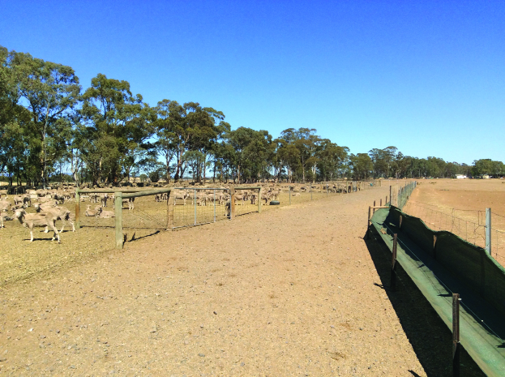
Figure 1: The Ipsens’ SCA design with the feeding laneway running full length of the four SCAs.


Disease management
“The commitment of feeding sheep every day for sometimes up to six months can be daunting and exhausting,” Matthew said.
“People should also be aware that containment yards can increase the risk of a disease spreading. With any intensive livestock system, the risk of spreading an infection or disease increases due to the close proximity of the animals.
“It is mentally challenging when you come and check on the stock and find a dead animal. This is on top of a poor season and having to feed out for months on end.
“The key to managing disease and infection is getting it diagnosed early,” Matthew said.
The Ipsens use their containment yards most years to allow their pastures to recover and build up a feed wedge prior to lambing in August. “It is such an important part of our system now but we are learning all the time,” Matthew said.

Chapter 7: Sheep diseases associated with drought
Intensively feeding sheep can produce a range of disease risks that are not usually apparent in pasture-fed sheep. This chapter describes the diseases caused by dietary imbalances, those associated with grain feeding, intensive management and some that may occur when sheep are not grazing pastures for long periods. Diseases that may occur once the drought breaks are covered, along with recommendations to limit the risk of these diseases.
Key messages
- Most diseases experienced during droughts are associated with high levels of grain feeding leading to acidosis and/or mineral imbalances.
- Ensure the ration fed is balanced for energy, protein, fibre and calcium and sodium. Include vitamins A and E if a long period of feeding is anticipated.
- Sheep to be containment-fed need to be well trained to full rations, healthy, and vaccinated against pulpy kidney.
- Monitor sheep for signs of illness or under-performance such as standing apart, lethargy, lameness, reduced feed intake, or changes in faecal colour or consistency, along with anything else unusual.
- If you see signs that concern you, act quickly as early intervention can stop a problem from escalating. Talk to an animal health officer or your local veterinarian.
- Any animals that appear unwell or sick must be immediately moved to a separate hospital pen and treated or humanely killed.
- Sheep maintained in good condition will be less at risk of diseases caused by short-term feed restrictions, such as shearing and/or cold conditions.
After the drought breaks, monitor stock for worms and maintaining calcium supplements for lambing ewes may be necessary. Avoid letting hungry sheep onto pastures that may cause problems such as nitrate poisoning, phalaris or other toxicities.
Many sheep are managed through drought and other intensive feeding scenarios with few issues. If sheep remain in good condition during a drought they will experience very little disease. Addressing their requirements beyond energy and protein becomes more important when most of their diet is from supplements. Acidosis, from high starch levels in cereals, and hypocalcaemia (low calcium) are the most common diseases on grain diets. When sheep are fed intensively, as in containment, they can be more susceptible to diseases spreading quickly (e.g. pink eye, ovine Johne’s disease). When sheep are maintained at minimal targets, they will more susceptible to stresses such as worms and cold weather when the drought breaks.

Diseases associated with feeding cereal grains

Acidosis
Cereal grains contain large amounts of readily digested starches and low levels of fibre, which can lead to acidosis. Even in the best-managed intensive feeding systems, some sheep get acidosis. It is the most widely reported disease for stock fed in containment. It is particularly common during the introduction phase, as sheep are adjusting to the starch-rich diet.
Starch is rapidly converted to D-lactic acid in the rumen, producing a drop in rumen pH that can have devastating effects on the rumen flora and rumen lining. The acid that is produced crosses the rumen wall and can overwhelm the sheep’s buffering systems, leading to catastrophic disruption of normal cellular function.
The natural buffer to the acid produced in the rumen is the bicarbonate in sheep’s saliva. Feeding fibre stimulates saliva production.
Provision of sodium bicarbonate to sheep in containment may be beneficial in reducing the incidence of acidosis.

Clinical signs/symptoms
In mild cases sheep are off their feed, appear unhappy and have a watery scour. In severe cases the sheep will be recumbent, depressed and die soon afterwards.
When you see sheep with symptoms, there are likely to be others suffering the effects of too much acid, reducing their performance without necessarily making them obviously sick.

Diagnosis
This can be achieved by clinical examination or assessing the signs with the risk factors. Squashing faecal pellets to see if they have a grey, loose consistency is a useful way to detect if any sheep in the pen have acidosis. Veterinarians can collect samples of rumen fluid for laboratory testing to confirm the diagnosis.

Treatment
Frequent drenches of bicarbonate of soda (1/4 cup dissolved in water) at 2–4 hour intervals may help save some of the least-affected animals. Those that appear a little ‘dopey’ can be moved to the hospital pen and offered good hay.

Prevention
The introductory phase is the key to prevention (Chapter 4 – Feeding sheep – how much and how often). Providing fibre in the ration of sheep fed cereal grain will help control the disease, but continuous monitoring (especially during the introductory phase) is necessary. Providing sodium bicarbonate to intensively fed sheep has reduced or removed the incidence in trials.
Figure 7.1: Autopsy of weaner sheep showing the rumen full of grain. The weaner had died from acidosis.
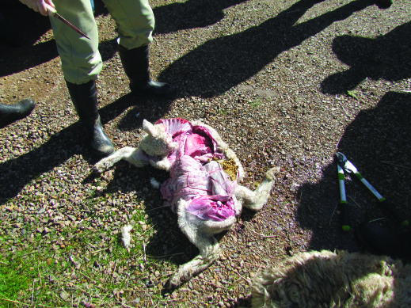

Enterotoxaemia – ‘Pulpy kidney’
Enterotoxaemia, ‘pulpy kidney’, is caused by Clostridia perfringens type D and occurs when sheep have access to starch-rich diets, such as in containment feeding or on lush spring pasture. When the consumption of carbohydrate is high, the bacteria over-grows and produces a toxin (epsilon) that leads to oedema (swelling) of the brain and the rapid onset of neurological signs. Sheep that are either in very good or very poor condition can be more susceptible to pulpy kidney on lush green feeds or high grain/concentrated diets.

Clinical signs/symptoms
Affected animals are often just found dead, but sometimes are seen thrashing about on their side with their head back. Some sheep can recover, only to develop blindness and an unusual head posture several months later – a condition called focal symmetrical encephalomalacia (FSE).

Diagnosis
Veterinarians can collect samples of the brain and gut for laboratory testing to confirm the diagnosis.

Prevention
Pulpy kidney can be easily prevented by using a clostridial vaccine (e.g. 5-in-1). Ensure all sheep entering a stock containment area have had their first two vaccinations against pulpy kidney, with the second one 2–4 weeks before entry. If it has been longer than 3 months since the last vaccination, give a booster shot.
Providing adequate fibre in the cereal grain rations will help control the disease.

Polioencephalomalacia (PEM)
Polioencephalomalacia (PEM) occurs when excess starch in the diet interrupts the normal production of vitamin B1 (thiamine) in the rumen.

Clinical signs/symptoms
This disease affects the brain, leading to sheep staggering, with tremors and their head thrown back (‘star gazing’). They will die in several hours if not treated.

Diagnosis
Veterinarians can collect samples of brain for laboratory testing to confirm the diagnosis, but the response to treatment with vitamin B1 injections is also useful to reach an on-farm diagnosis.

Treatment
Treat affected sheep with vitamin B1 by injection. Drenching the remainder of the mob with thiamine powder will stop further cases.

Prevention
Ensure sufficient fibre in sheep diets and make sure there has been a gradual transition onto the cereal grain ration.

Salmonellosis
Salmonellosis is a bacterial gut infection that causes a foul-smelling, blood-stained or dark scour and can kill sheep quickly. It is commonly seen when sheep are fed cereal grain rations, especially among the ‘shy feeders’ or those with suffering acidosis.

Clinical signs/symptoms
The signs include acute diarrhoea, fever, lethargy, dullness, sunken eyes and dehydration. Affected sheep will appear sick, tucked up and may grind their teeth.

Diagnosis
Veterinarians can collect samples of gut and faeces for laboratory testing to confirm the diagnosis.

Treatment
Antibiotic treatment of affected animals may be recommended on the advice of a veterinarian. Remove affected animals to the hospital pen and offer hay.

Prevention
Prevent feed and water troughs being contaminated with sheep faeces, as there are always some sheep carrying the disease in their gut. Clean dirty feed and water troughs. Ensure sheep are eating well, are receiving sufficient roughage (fibre) and stress is minimised.

Urinary calculi – bladder stones
Urinary calculi lead to the condition recognised as ‘water belly’, which occurs in wethers and rams due to the longer, narrower urethra (connection from bladder to the outside) in males. They are caused by the formation of ‘stones’ within the bladder, which can then block the urethra. Water belly occurs when the blockage in the urethra causes sufficient swelling of the bladder that it bursts.

Clinical signs/symptoms
In the early stages, affected sheep are uncomfortable and straining, which is often confused with constipation. A swelling may develop under the belly if the blockage has caused a rupture of the urethra in this area. The sheep becomes progressively more dull over several days, until showing some relief for a day or two after their bladder ruptures, before they finally die.

Diagnosis
Diagnosis is usually made at necropsy performed by a veterinarian. A critical part of the diagnosis is laboratory testing of the stones in the blockage to guide dietary changes to prevent the disease in more sheep. A mineral analysis of the ration should be conducted as well.

Treatment
Seek veterinary advice. Treatment is usually from surgical relief of the obstruction, however this may be expensive. You may consider salvage slaughter of the pen-mates. In some cases, the blockage can be relieved if the stone is in the urethral process at the end of the penis, but there are likely to be more formed behind it in the bladder.

Prevention
Ensure that the Ca:P ratio is correct when starting on supplementary feed. Ensure the diet has sufficient salt (1 per cent) to encourage water intake, which dilutes the urine and limits stone formation. Sheep must have access to adequate fresh, clean water.
Mineral analysis of the stones will assist in adjusting the diet to prevent further cases. The mineral balance of the ration needs to be corrected to avoid excesses of phosphorus and magnesium. An excess of protein and silica should also be avoided.

Diseases of intensively fed sheep

Hypocalcaemia
Hypocalcaemia (or ‘milk fever’) frequently occurs in ewes at or about the point-of-lambing; but also in a number of other situations when sheep are stressed, such as during transport or when holding sheep off feed for shearing.
The signs come on over a period of a few hours and affected sheep go down. The key difference between hypocalcaemia and pregnancy toxaemia (which also occurs in ewes near lambing time) is the response to treatment: sheep affected with hypocalcaemia usually recover within a few hours of treatment.

Cause
Cereal grains have a reverse ratio of calcium to phosphorous to what sheep require for health: these grains are calcium deficient. Calcium is stored in sheep’s bones, and when sheep are fed for long periods on a calcium-deficient diet the bone stores become depleted, with a range of consequences:
- hypocalcaemia
- rickets or osteoporosis
- poor growth
risk to production in future years.
Stressing sheep with low calcium levels (such as a cold weather event, mustering, holding in yards and transport) can induce an outbreak of hypocalcaemia, with many sheep affected, across all classes of sheep. Hypocalcaemia is occasionally seen when sheep are released from the containment feeding area and hit with a cold autumn weather snap.

Clinical signs/symptoms
Early in the condition sheep may show symptoms of staggering and muscles tremors. Then, as the disease progresses, sheep will become recumbent with a dull, depressed demeanour.

Diagnosis
The clinical signs, along with the risk factors and response to treatment, are often how a diagnosis is made. The on-farm diagnosis can be made when downer sheep respond within a few hours to treatment. Veterinarians can collect samples for laboratory testing to confirm the diagnosis in untreated animals, even after death.

Treatment
Warm solutions of calcium borogluconate, such as 4-in-1, to body temperature and give 60 mL by injection under the skin of affected animals. More than one dose may be necessary over the day.

Prevention
The inclusion of limestone in the grain ration at 2 per cent ensures that sheep are being fed the correct amount of calcium in the right ratio with phosphorus. Legume hays have good calcium: phosphorus ratios. If using a loose lick, limestone is unpalatable so the addition of salt will encourage sheep to consume it.
Keeping stress events to a minimum is also important. If mustering and yarding necessary, ensure time off feed is limited.
Figure 7.2: Recumbent ewe with calcium deficiency.
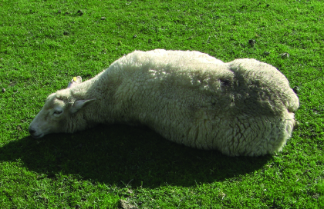

Hypovitaminosis A
Green pasture provides sufficient vitamin A for sheep, but within about two months on dry feed sheep can develop a deficiency of vitamin A, leading to ill thrift and possibly blindness.

Clinical signs/symptoms
Ill thrift, night or low light blindness.

Diagnosis
Veterinarians can collect samples of liver for laboratory testing to confirm the diagnosis.

Treatment and prevention
Vitamin A can be administered as a drench, or by injection of Vitamin ADE to affected animals, and provides protection for a further 2–3 months. Seek veterinary advice on treatment options.

Prevention
Access to green pick or green hay will correct and prevent vitamin A deficiency. Treatment with Vitamins A, D and E prior to entry may be beneficial, especially for spring drop lambs, if an extended dry period is expected.

Hypovitaminosis E
Green pasture provides sufficient vitamin E for sheep, but within 2–3 months on dry feed sheep (especially weaners) can develop a deficiency, leading to ill thrift and muscle weakness.

Clinical signs/symptoms
Staggers, muscle weakness and recumbency, often triggered by exercise such as mustering, yarding or transport.

Diagnosis
Veterinarians can collect samples of liver, muscle or blood for laboratory testing to confirm the diagnosis.

Treatment and prevention
Vitamin E can be administered as a drench or injection to affected animals and provides protection for 2–3 months. Seek veterinary advice for treatment options.
Access to green pick will correct the deficiency. Treatment with Vitamins A, D and E prior to entry may be beneficial, especially for spring drop lambs, if an extended dry period is expected.

‘Shy’ feeders
The term ‘shy’ feeder is given to sheep that are reluctant to eat the supplementary feed provided, usually grain or pellets. This may affect up to 20 per cent of sheep in feedlots. Shy feeders will visit the feed trough, although they are more likely to do so when the main mob is not there, and so may not be easily identified as staying away. Most animals will eventually start to consume feed, but prolonged non-consumption may lead to reduced productivity, increased disease susceptibility and, in some cases, result in starvation.

Clinical signs/symptoms
The identification of shy feeders requires careful observation by the producer. The key sign is an animal that stays back and doesn’t push to get to the feed on offer. They will tend to eat only when most of the mob have finished and left the trail
They may show signs of hollow flanks and weight loss to the point of emaciation.

Diagnosis
Closely watch the sheep at feeding times and monitor body condition. At necropsy, there will be little food in the gut and intestines. Your veterinarian can collect samples to confirm the diagnosis.

Treatment
Remove shy feeders from the containment area and provide other fodder to enable them to access adequate feed.

Prevention
Maternal influences on learning is the most effective way to reduce reluctance to eat both unfamiliar plants and hand-fed rations (‘neophobia’) in young sheep, so exposing lambs to unfamiliar feed before weaning is beneficial. This becomes more significant in drought conditions, where the adjustment of early weaned or light lambs onto supplementary feed is critical to increase the likelihood of survival. Other factors such as keeping the delivery method of the feed consistent and providing enough trough space to limit competition also increase the uptake of a novel food.
Further considerations are the group size, age, sex and production status.

Other diseases
These diseases are sometimes encountered in sheep fed intensively, perhaps more commonly than in sheep at pasture.

Abortion
There are a number of causes of abortion in sheep, including bacterial, viral, parasitic, toxins and congenital issues. Some causes are zoonotic (transmissible to humans) so it is important to wear gloves when handling the affected sheep or aborted foetus or membranes.

Clinical signs/symptoms
Aborted foetus or membranes will be found in the paddock or containment area. Ewes may be seen with staining around the vulva.

Diagnosis
Contact your veterinarian if you notice abortions occurring. Collect the foetus and membranes and place into a plastic bag and refrigerate. Testing these will assist in getting a diagnosis.

Treatment
Your veterinarian will advise of any treatments.

Prevention
Immediately separate ewes with signs of abortion to the hospital pen. Minimise stress, ensure any feed stuffs are free from contamination or mould and keep feed troughs clean. Consider putting the rest of the mob back onto pasture, to limit ongoing exposure.

Coccidiosis
Coccidia are a protozoan parasite that infects the intestine. Sheep are usually exposed as young animals and develop a good immunity without signs of disease. However, the right conditions, such as wet weather and stressful environments, may increase the occurrence of disease.

Clinical signs/symptoms
Clinical signs of the disease are diarrhoea with straining and fresh blood may be seen in the diarrhoea. The sheep will be tucked up, off their food, dehydrated and strain when defecating.

Diagnosis
Conduct a worm egg count (WEC). The protozoal oocytes will be seen and counted. A very high count along with disease will form the diagnosis of coccidiosis. A veterinarian can also conduct a necropsy and collect intestinal samples for confirmation.

Treatment
Treatment is in the form of a drench or injection. You must contact your veterinarian to obtain it.

Prevention
Monitor young animals in containment for signs and minimise stress by keeping the sheep well fed and protected from extremes of weather. Keep feed troughs clean and free from faecal spoilage.

Copper toxicity
Sheep are very sensitive to too much copper in their diet, and should not be fed cow or pig pellets. Over time, the excessive copper accumulates in the liver until it reaches the point where it is suddenly released, breaking red blood cells. At this point, the affected sheep die quickly.

Clinical signs/symptoms
Affected sheep are usually found dead. Observant managers may detect a yellowing of the eyes in sheep about to die.

Diagnosis
Veterinarians can collect samples of liver for laboratory testing to confirm the diagnosis. The liver and kidneys are dark in colour, as is the urine. The carcase may be jaundiced (yellow). Feed should be tested to check on the levels of copper, molybdenum and sulphur.

Treatment
Ensure the sheep with high copper levels are kept stress free. Seek veterinary advice for treatment options.

Prevention
Ensure that the ration does not contain excess copper, and limit prior access to weeds such as heliotrope or Paterson’s curse.

Internal parasites – worms
Although internal parasites (‘worms’) are associated with pasture-fed sheep, it is wise to make sure that their presence isn’t limiting the performance of intensively fed sheep. Sheep that are stressed for any reason may have reduced immunity and may show effects of a worm burden.
Drought or containment feeding systems are often employed from the end of spring, so it is an appropriate time to administer the first summer drench (conduct a worm egg count [WEC] first). Make sure you use an effective drench and do a ‘drench-check’ WEC 10 days later to confirm it has worked.
Containing sheep to intensively feed them means that the only worms remaining at the end of the feeding period are those that survived the entry drench (i.e. the worms resistant to the drench), which promotes drench resistance. Seek veterinary advice or consult paraboss on tactics to prevent this issue.
If the aim is production feeding, such as grain finishing of lambs, it is important to remove any worms. Be cautious of any withholding periods that apply to the product used – always check the label and follow directions. Record the use of the drench and advice on the NVD when selling.

Listeriosis
Listeriosis is a sporadic bacterial disease often associated with feeding of silage or possibly associated with close intense grazing.

Clinical signs/symptoms
There are two conditions caused by Listeria, the first is neurological and the second is abortions.
Sheep suffering from the neurological condition show signs of incoordination, head tilt, walking in circles and can become recumbent and die after a couple of days. The bacteria cause inflammation of the membranes surrounding the brain.

Diagnosis
Diagnosis is made at necropsy by your veterinarian. Laboratory confirmation is required to confirm the diagnosis.

Treatment
Treatment is rarely successful. Consult your veterinarian.

Prevention
Avoid feeding spoiled silage.

Liver fluke
The same advice – treat to remove – applies in the case of liver fluke as worms. If you are in ‘flukey’ country or are feeding sheep that have originated in those areas, make sure fluke are not dragging your sheep down.
Contact your veterinarian about simple tests that can confirm if a treatment is needed.

Ovine Johne’s disease
Johne’s disease is a bacterial infection of the gut and is a fatal condition. Many sheep are carriers and may not show any signs of disease but will be shedding the bacteria in their faeces.

Clinical signs/symptoms
The bacteria invades the lining of the intestines and leads to the malabsorption of nutrients and ultimately results in wasting and diarrhoea. The most common sign is a ‘tail’ to the mob, meaning a percentage of skinny sheep, some with diarrhoea stains on their hocks.

Diagnosis
Diagnosis is based on the tail or skinny animals in the mob and unexplained wasting. Your veterinarian can test samples to confirm the diagnosis.

Treatment
There is no treatment available for affected sheep.

Prevention
A vaccine called Gudair® will control the disease. Containment feed sheep that are either vaccinated or from known disease-free areas.

Pinkeye
Pink eye is a bacterial infection of the eye, caused by a range of bacteria. For disease to occur there needs to be a combination of irritation of the eye (dust) and the causative bacteria. A number of predisposing factors lead to the disease developing, such as crowding, hot, dry and dust conditions, feedstuffs that are abrasive (grass seeds, stubbles, straw) and stressful situations (such as under-nutrition, excessive handling).

Clinical signs/symptoms
One or both eyes may be affected. The eyes will be red, weepy, often closed and sore. The surface of the eye or cornea will be initially red and then will go cloudy (and change colours from red, blue and then to white).

Diagnosis
It is important to check the eye for foreign bodies such as grass seeds that can cause severe eye issues.

Treatment
Often cases of pink eye will resolve without treatment and are self-limiting. However, if treatment is necessary, consult your veterinarian. Sometimes mustering/catching animals for treatment causes more animals to be affected.

Prevention
Prevention is focused on reducing the predisposing factors such as keeping dust levels low, reducing exposure to grass seeds or stalky straw, and minimising handling, overcrowding and under-nutrition.

Pneumonia and pleurisy
Pneumonia is inflammation of the lung tissue and pleurisy is inflammation of the membrane covering the lungs and chest wall. These conditions are caused by a number of bacteria and viruses, and some non-infectious causes such as lung worm or inhalation/aspiration of drenches.

Clinical signs/symptoms
The most commonly affected are young sheep that are exposed to a number of stresses such as transport, mixing with new sheep, crowding, dust and extreme weather events.
Clinical signs include sudden death, reduced appetite, fever, depression, lethargy, increased respiratory effort and rate, coughing or nasal discharge, and deaths in the worst affected animals.

Diagnosis
Diagnosis is made by your veterinarian conducting a necropsy and collecting various samples, or during abattoir surveillance.

Treatment
Consult your veterinarian for advice on treatment. Treatment of sick animals is required and preventative measure put into place for the remaining animals. Severely affected animals should be humanly killed.

Prevention
Prevention is focused on reducing stressors. Ensure animals are well fed/watered, set appropriate stock densities, reduce dust and provide protection from extremes of weather. Avoid mustering sheep in hot conditions or in dusty yards.

Poisonings
A wide range of potential poisons are encountered in droughts when poor-quality or unusual feeds may be used or when hungry sheep eat plants they normally wouldn’t. Using contaminated feed sources is a risk whenever sheep’s natural ability to select their preferred feeds is limited, as in a containment feeding system.

Clinical signs/symptoms
Always have unknown or unexplained symptoms or deaths investigated by a veterinarian.

Diagnosis
Diagnosis can be made at necropsy by your veterinarian, often with laboratory confirmation, and after consideration of access to potential sources of the toxin involved.

Treatment
The success of any treatment depends on the toxin involved. Your veterinarian can advise.

Prevention
Avoid feeding spoiled or contaminated fodder, and access to unusual plants.

Pregnancy toxaemia (‘twin lamb disease’)
Pregnancy toxaemia occurs when heavily pregnant ewes, especially those with multiple lambs, are not getting sufficient energy to feed themselves and their lambs, and the ewe begins to break down her body fat. A common disease when there is insufficient pasture, it can occur in intensively fed sheep if the food supply is stopped for some reason or if the ewes get stressed in late pregnancy (putting them off feed).

Clinical signs/symptoms
Affected ewes become disinterested in feed, separate from the mob and stand around, become lethargic and sometimes will appear staggery or drunk. After several days they will go down and then die.

Diagnosis
Veterinarians can collect samples of blood or eye fluid for laboratory testing to confirm the diagnosis. At necropsy the liver is fat and swollen, and multiple lambs are present.

Treatment
In the early stages (before sheep are down), treatment with mineral solution containing glucose (4-in–1 or a flow pack) and drenching with propylene glycol or products such as Vytrate® may assist some ewes to recover. Euthanasia of advanced cases is advised.

Prevention
Make sure heavily pregnant ewes are receiving the correct ration with sufficient energy to meet their needs, and that there is nothing going to occur to put them off their feed. Keep handling to a minimum and limit time off feed.

Pyrrolizidine alkaloidosis
This is the name for heliotrope or Patterson’s curse poisoning, and the affected sheep will have eaten plants containing this toxin sometime before entering the containment feeding area. These plants are common in parts of Victoria and in areas where sheep are confinement fed. Sheep with affected livers are more prone to copper toxicity.

Clinical signs/symptoms
Affected sheep lose weight, will become yellow, and die.

Diagnosis
Veterinarians can collect samples of liver for laboratory testing to confirm the diagnosis. The liver is often misshapen and lumpy, and the carcase yellow.

Treatment
There is no treatment. You may consider salvage slaughter if you suspect that many animals may die before exiting the containment feeding area.

Prevention
Limit access to plants containing these toxins.

Salt poisoning
Salt poisoning is the name for the condition that occurs when sheep that have had no water or restricted access are provided with water. The sheep drink excessively and this leads to swelling of the brain (oedema) resulting in fits and convulsions.

Clinical signs/symptoms
Soon after consuming excessive water, signs such as lethargy, blindness and head pressing will be seen. Ultimately, the animal will go down, start convulsing and die.

Diagnosis
Veterinarians can collect samples of the brain for laboratory testing to confirm the diagnosis.

Treatment
There is no treatment.

Prevention
Don’t run out of water and make sure you provide adequate trough space. If water deprivation or restriction does occur, introduce the sheep back to water very, very slowly by only providing a trickle and driving them away and letting others drink.

Scabby mouth
Scabby mouth may become an issue if the virus is introduced into a containment-fed mob that isn’t immune to it (e.g. when buying lambs to finish). The virus survives for long periods in the soils and on troughs. Sheep that aren’t immune and damage their mouths can then become infected. The scabs make it difficult for the sheep to feed.

Clinical signs/symptoms
Scabs will form around the mouth and sometime around the feet. Usually these are self-limiting and sheep will develop a good immunity. However, if severely affected, these lesions may become very sore and infected and stop the sheep eating.

Diagnosis
Diagnosis is usually made by a clinical examination. Veterinarians can collect samples of the scabs for laboratory testing to confirm the diagnosis.

Treatment
There is no treatment, just provide easily eaten food until the scabs fall off, which they do in 2–3 weeks. In severely affected animals secondary infection may occur and antibiotic treatment may be necessary. Seek veterinary advice.

Prevention
Prevent contamination of the mob if you have no record of it occurring in your lambs. Consider vaccinating at marking time once you are sure the virus is on your property.

Urea poisoning
Consuming excess urea will lead to the opposite effect to acidosis. Sheep drinking the water around urea blocks after rain can be affected.

Clinical signs/symptoms
Sheep are found dead.

Diagnosis
Diagnosis is based on access to excess urea, and measurement of rumen pH.

Treatment
Drenching with vinegar may help.

Prevention
Do not include more than 1 per cent urea in the ration. Shelter urea blocks from the rain.

After the drought
The change to pasture can produce dietary upsets or expose sheep to poisons unexpectedly. After previous droughts there have been reports of:
- nitrate-nitrite poisoning
- phalaris and ryegrass staggers
- hypocalcaemia
plant poisonings.
Always gradually introduce sheep to ‘new’ feeds, even if it something that they would remember from the previous year – their digestive tract doesn’t remember that long ago!
Test the pasture with a small mob of sheep and monitor their health closely for the first 3–4 days.
Ensure that the sheep are not hungry when let out – feed them plenty of hay beforehand.
Continue to check them daily when they are left in the paddock overnight.
Make sure weaner sheep know where the water is.
Ensure heavily pregnant ewes continue to have access to a limestone and salt lick through lambing.

Internal parasitism
After a prolonged period of intensive feeding, sheep lose the immunity to worms that they built up through the previous winter and spring, through lack of exposure. All sheep can be susceptible to worms in the early winter after a drought.

Prevention
Monitor your mobs for any indications of scouring, and perform WECs 6 weeks after letting sheep out of containment, then at 2–4 week intervals. Your veterinarian can advise on an appropriate monitoring program.

Nitrate/nitrite poisoning
Nitrate/nitrite poisoning has been reported after some droughts. The lack of rain means surface nitrogen isn’t leached in the deeper subsoils, so the first plants growing can have high levels of nitrate present. This is converted to nitrite in the sheep’s rumen, and when absorbed it affects the ability of red blood cells to carry oxygen.

Clinical signs/symptoms
Affected animals shiver, pant, collapse and die. The clinical course may be as short as 2 hours or as long as 24 hours.

Diagnosis
Diagnosis is made at necropsy by your veterinarian. Laboratory confirmation is required to confirm the diagnosis.

Treatment
Nitrite poisoning can be treated with intravenous injections of the drug methylene blue but needs to be given as soon as possible. If nitrite poisoning is suspected consult your veterinarian immediately.
Treatment with the antidote may be successful.

Prevention
Slowly introduce sheep to fresh pasture, monitoring for the development of these signs.

Perennial ryegrass staggers
Perennial ryegrass staggers is caused by toxins produced by endophytes in the plant. While staggers are the most obvious visual signs, a range of toxins can also cause less obvious responses such as heat stress, increased dagginess and ill thrift. It is mainly associated with naturalised and older perennial ryegrass pastures as many of the newer varieties have been selected for endophytes that are safer on stock. However, unless paddocks have undergone significant renovation and re-sowing to remove the seed bank and plants of older varieties of perennial ryegrass, some of the volunteer plants in the perennial ryegrass pastures may still contain unsafe toxin-producing endophytes.

Clinical signs/symptoms
The severity of symptoms can vary from mild to severe. Symptoms will range from mild muscle trembling to incoordination, head shaking, to being recumbent and convulsing. Sheep can also be suffering from heat stress and have increased thirst. Most deaths occur due to misadventure.

Diagnosis
Diagnosis is based on clinical signs and history of grazing perennial ryegrass pastures.

Treatment
If affected mobs are left to graze quietly, most sheep will have few signs. However, protection from misadventure is advised, such as fencing off dams or providing troughs. Full recovery from staggers occurs within 1–4 weeks of being moved to a safe paddock. Nursing care for affected sheep is required, ensuring access to feed and water.
Consult your veterinarian.

Prevention
Closely monitor sheep grazing perennial ryegrass pastures in summer and autumn and if signs are seen quietly move sheep to a safe pasture. Avoid yarding if possible.

Phalaris toxicity (staggers and sudden death syndrome)
Two separate syndromes can be caused by phalaris toxicity: phalaris staggers and sudden death poisoning.
Phalaris staggers can occur when sheep have long exposure to phalaris-dominant pastures, in cobalt-deficient areas. The phalaris plant contains a toxic alkaloid that causes the staggers.
Sudden death syndrome is caused by compounds in the plant that interfere with normal nitrogen metabolism in the sheep.

Clinical signs/symptoms
Sheep suffering from phalaris staggers will show signs of uncoordination, muscle tremors, head nodding, bunny hopping and a stiff wide gait. If affected sheep are driven they may go down and convulse; if left alone they will recover.
The sudden death syndrome occurs shortly after sheep are exposed to fresh phalaris growth in autumn. Sudden death occurs due to heart failure.

Diagnosis
Diagnosis of phalaris staggers is made at necropsy by your veterinarian, considering the pasture available to the sheep. Laboratory confirmation is required to confirm the diagnosis.
Diagnosis of the sudden death syndrome is made by history of exposure to phalaris pastures; there are no characteristic changes seen at necropsy.

Treatment
There is no treatment or cure for sheep affected by phalaris staggers. Consult your veterinarian for further advice.

Prevention
Monitoring for the development of signs of staggers should continue for several weeks after sheep are let out to pasture. Cobalt can be used to prevent phalaris staggers. Seek veterinary advice on prevention options.
The only prevention for sudden death syndrome is to avoid putting hungry sheep onto short fresh phalaris pastures. Where phalaris pastures have a known history or a suspected of causing sudden death and they have to be grazed, as there are no other options, use a small number of sheep and monitor closely over 3 to 4 days before committing larger mobs to the pasture. Always ensure sheep are full before placing them on these pastures.

Humane killing
Where it is necessary to kill a sheep, it must be done promptly, safely and humanely. The killing method must result in rapid loss of consciousness followed by death while unconscious.
A person killing a sheep must have the relevant knowledge, experience and skills to kill the sheep humanely, or be under direct supervision of a person who has the relevant knowledge, experience and skills, unless:
- the sheep is suffering and needs to be killed to prevent undue suffering; and
there is an unreasonable delay until direct supervision by a person who has the relevant knowledge, experience and skills becomes available.
A person in charge of a sheep suffering from severe distress, disease or injury that cannot be reasonably treated must ensure the sheep is killed at the first reasonable opportunity.
Reasonable actions must be taken to confirm the sheep is dead. See Appendix 1.
The recommended methods of humane killing of sheep and lambs are either the use of close-range firearm or captive bolt to the brain, or lethal injection. Bleeding-out of unconscious (stunned) animals) is permitted. A person must only use bleeding out by a neck cut to kill a conscious sheep as a last resort; when there is no firearm, captive bolt or lethal injection reasonably available. This method is done by cutting the main blood vessels in the neck (neck cut) using a suitable sharp knife. The neck cut is the only method to be used where permitted in conscious sheep. When sheep are bled out, it is not necessary to sever spinal cord or to pith.

Further information

Further reading and resources
- •Australian Animal Welfare Standards and Guidelines for Sheep (Edition 1) – Australian Animal Welfare Standards and Guidelines
- Australian Animal Welfare Standards and Guidelines – Livestock at Saleyards and Depots (Edition 1) – Australian Animal Welfare Standards and Guidelines – Livestock at Saleyards and Depots
- Meat and Livestock Australia – Is it fit to load? A national guide to the selection of animals fit to transport – Meat and Livestock Australia – Is it fit to load?
- Veterinary Handbook for cattle, sheep and goats – Animal Health information for veterinarians and stock people in the livestock industries – MLA and LiveCorp Available from the AppStore
- Livestock disease in Australia – Disease of cattle, sheep, goats and farm dogs – Tony Brightling BVSC, MVS; 2006, C H Jerram and Associates, Science Publishers. ISBN 095790863
- MSD Veterinary Manual – MSD Veterinary Manual
OIE (World Organisation for Animal Health). (2004). Terrestrial Animal Health Code. Paris.

Scientific references
Savage, D.B., Ferguson, D.M.,Fisher, A.D. Hinch, G.N. Mayer,D.G. Duflou, E.,Lea, J.M., Baillie, N.D. and Raue, M. (2008). Preweaning feed exposure and different feed delivery systems to enhance feed acceptance of sheep. Animal Production Science, 48(7), 1040–1043.
Franklin, M. C. (1942). ‘Studies on mineral metabolism in sheep. 1. On the necessity to supplement cereal grains with calcium in sheep rations.’ Journal of the Council for Scientific and Industrial Research, Australia 15: 85–93.
McManus, W. R., M. L. Bigham, et al. (1972). ‘Whole wheat grain feeding of lambs. I. Production responses to mineral buffer supplements.’ Australian Journal of Agricultural Research 23(2): 331–338.
Watson, M. J. and J. K. Egan (1985). ‘Protein and roughage supplements for pregnant and lactating ewes fed wheat for survival.’ Australian Journal of Experimental Agriculture 25(4): 771–776.

Chapter 8: The feed value of unusual feedstuffs
This chapter reviews some of the less-common feed supplements that may be used when the usual grain and hay sources are in short supply. They are rarely a balanced feed in themselves, so a summary of their particular nutritional value is provided, along with the suggested inclusion levels in feedlot and total mixed ration diets. Warnings of some of the recognised issues associated with the use of some of these feeds are also provided.
Key messages
- A wide range of unusual feedstuffs can be effectively fed to livestock.
- They rarely meet all the nutritional needs of stock, so should be included in rations at low to moderate levels.
- Some products may have issues with toxicity or chemical contamination. Request a Commodity Vendor Declaration and consider a feed analysis for minerals and other residues.
- Consider storage and handling requirements as well as shelf life before purchasing alternative feedstuffs.
Feed testing of all feedstuffs is recommended to assist with ration formulation.
Although unusual feedstuffs are commonly available in fairly regular supply, inquiries about their value for feeding to livestock increase when feed for grazing livestock is short, such as during droughts.
Apart from these feedstuffs generally being of poor nutritional value, they can also contain chemical residues that can contaminate meat and milk products when used as livestock feed.
All supplementary feeds may contain chemical residues. However, unusual feedstuffs pose a much greater risk because residue transfer assessments are unlikely. The same applies to imported feedstuffs that may have high feed value to stock but have an unknown history of chemical usage.
Agricultural chemicals used on fruit and vegetable crops are typically designed to be eliminated from the edible parts of the plant at harvesting. Some residues may still be present – and in some cases concentrated – in the waste plant material after processing. When this waste plant material is fed to stock, problems can occur. These chemicals are not designed to be ingested by livestock. Unless animal residue studies have been conducted, little is known about the effect of these chemicals on stock and about the persistence of residues of these chemicals in animal tissue and in the food chain.
There is a very real possibility that the meat and animal products from stock fed unusual feedstuffs containing chemical contaminants will themselves become contaminated with these chemicals. This can have a severe impact on trade and market access as well as animal and human health.
Do not feed unusual feedstuffs to stock without first establishing that the material is suitable. Producers should ask the supplier of unusual feedstuffs to certify that the material they are supplying is suitable for the purpose for which it will be used.
A by-product Commodity Vendor Declaration, which will show the full chemical history of the potential feed, should be requested. A Commodity Vendor Declaration form is available for download on the MLA website. Check the website for the most up-to-date version.
Ideally, unusual feedstuffs should be tested for chemical contamination by an accredited testing laboratory before being used as drought feed, although this in itself may not provide a satisfactory guarantee of suitability as analytical tests typically only screen for a narrow range of chemicals. A number of feed analysis laboratories will test for nutritional values (like energy and protein) as outlined in Chapter 3 – What to feed sheep. Further analyses of mineral, heavy metals, pesticide residues and other issues relating to food and animal safety are available from some laboratories.
The composition of many feedstuffs varies widely because of differences in climate, soil conditions, maturity, variety, management and processing factors. The chemical content of unusual feedstuffs may also vary from batch to batch. The data in this chapter should be considered as a guide rather than a precise statement of nutrient composition.
Some feeds can be unbalanced and/or contain high levels of some minerals that can be toxic to sheep if fed as a high proportion of the diet. In particular, sheep are more susceptible to high levels of copper than cattle or goats due to the way that they store and release copper. Acute poisoning may follow intakes of 20–100 mg of copper/kg in sheep. Chronic poisoning of sheep may occur with daily intakes of 3.5 mg of copper/kg when grazing pastures that contain 15–20 ppm (dry matter) of copper and low levels of molybdenum. Feeds such as cattle pellets, palm kernel meal, some of the brewers’ grains and distiller products and products that have been treated with fungicides (e.g. grape pomace and products produced in humid climates) can be high in copper and care should be taken in how much of these products should be included in a ration.
Most by-products and unusual feedstuffs should be used with caution and introduced into rations gradually, even when low prices favour their use. Factors to consider about unusual feedstuffs are: their nutritive value, palatability, possible toxicity or contamination with pesticides or heavy metals and the effects upon digestion and utilisation of the total ration. The use of by-product stockfeed needs to be declared when completing National Vendor Declaration forms.
SAFEMEAT, a partnership between the red meat and livestock industries and Commonwealth and State Governments, has prepared residue risk information sheets on the use of unusual feedstuffs. Producers can obtain copies of these risk assessments from the SAFEMEAT website at SAFEMEAT Alternative Fodder Residue Risks

High moisture content feeds
Stock can eat up to about 3.5 per cent of their live weight per day when the feed is in a dry form, such as hay or grain, but they cannot eat as much dry matter if the feed has a high moisture content.
Fresh, high-moisture feeds are often quite palatable to livestock but most of these feeds will ferment and sour quickly unless they are dried or ensiled.

Blending and levels of feeding
Many unusual feedstuffs can be a reasonable source of energy for the livestock – but quality can be variable. It is important that any new feedstuff be gradually introduced to livestock over a period of about two weeks.
As a rule of thumb, most unusual feedstuffs can be effectively incorporated into livestock rations to a maximum of about 30 per cent of the total ration without significant influence on animal health.

Types of feeds
Stock feed is usually categorised as either concentrates (high in energy or protein) or roughage (higher in fibre, but lower in energy). Protein concentrates generally contain more than 20 per cent crude protein.

By-product energy concentrates

Almond hulls
Almond hull products vary considerably due to varietal differences and harvesting procedures. Soft almond hull, having about 10 per cent fibre and about 85 per cent of the energy value of barley grain, is a good feed. However, some supplies are contaminated with sticks, dirt, hard shells and other foreign materials at harvest time. This greatly reduces their feeding value and acceptability to livestock.
Almond hulls can be used as a partial roughage replacement when supplies are short and hay and straw prices high.
When mixed with other ingredients in commercial concentrate mixes, almond hulls usually are restricted to 20 per cent or less to maintain high nutrient levels and palatability of the concentrate mix. In complete feedlot rations, almond hulls are limited to about 30 per cent or less.
Figure 8.1: Almond hulls.
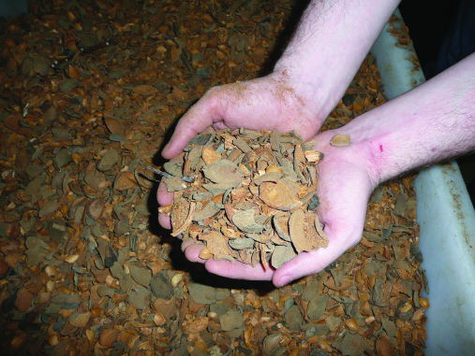

Apple pomace
Apple pomace is the by-product of apples used for cider or vinegar production. It can be fed fresh, ensiled or dried.
Two problems have hampered feeding of apple pomace. Pesticide contamination has been a problem in some areas, making the pomace unacceptable in dairy and (occasionally) sheep and beef rations. A second difficulty is that urea or other non-protein nitrogen compounds should not be fed with apple pomace due to the possibility of abortions or abnormalities in offspring.
Apple pomace is a highly palatable feed, medium in energy but very low in protein and fibre. In a balanced ration, it can replace up to about one-third of the concentrates used, and make up 15–20 per cent of complete feedlot rations.

Bakery waste
Large amounts of unsold bread, doughnuts, cakes and other pastries are available in some areas and are excellent energy sources for ruminant rations. Bakery waste, however, may potentially contain meat or other animal protein and so should be used with caution and in accordance with ruminant feed ban legislation.
It is usually high in fat and low in crude fibre. Protein levels (on a dry-matter basis) in the range of 10–12 per cent are typical. The low fibre content of the baked material and the baking process itself result in a feed that tends to stimulate ruminal propionate and reduce ruminal acetate production. This is desirable for feedlot livestock being fattened for market.
Up to about 10 per cent can be included in feedlot rations when supplies and economics are favourable. Supplies should be fed quickly to prevent spoilage.

Brewers’ grains
Brewers’ grains have 20–25 per cent crude protein (on a dry matter basis), making them a good protein source in addition to their energy value. They do increase the likelihood of acidosis due to a combination of low fibre, soluble carbohydrate and being naturally acid.
The brewing process makes the protein less soluble than that from many protein supplements. This could be valuable in rations, such as silage supplement with non-protein nitrogen, that contain large amounts of soluble protein.
Brewers’ grains are fed both wet and dried. Dry, they have about 80 per cent of the energy value of barley grain (the energy value varies depending on the brewery and additives used in the brewing process). They are not as palatable in the dried form as the original grain and usually are included as 25 per cent or less of a dairy concentrate mix and 1–20 per cent in feedlot rations.

Citrus pulp
Citrus pulp is classified as a concentrate but is also valuable as a partial roughage replacement because of its high level of digestible fibre.
It commonly contains about 15 per cent crude fibre in the dry matter. Its energy value is about 94 per cent the value of barley grain. It has only about 7 per cent crude protein in the dry matter.
Citrus pulps can be fed fresh or as silage. Both are very acceptable to stock but pulp and peels from lemons are somewhat more acceptable than those from oranges and grapefruit.
Transportation costs preclude the wet pulp being fed at a distance from processing plants.
Citrus pulp is usually fed dehydrated. It must be introduced gradually into a ration to let stock get accustomed to its distinctive smell and taste. Levels up to 15–20 per cent are acceptable in feedlot rations.
Citrus pulps are high in calcium and low in phosphorus, and aggravate the high calcium-to-phosphorus ratio in a ration when fed with legumes such as lucerne. Feeding citrus pulp to ewes close to lambing may predispose them to hypocalcaemia.
Figure 8.2: Citrus pulp.
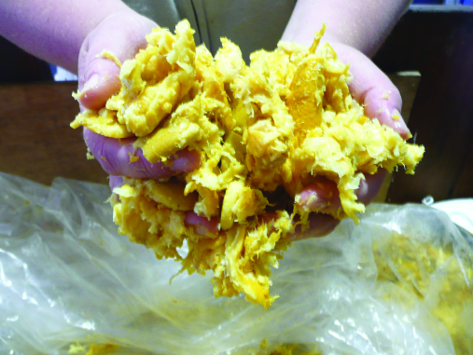

Fats and oils
Fats and oils have an energy value about 2¼ times that of carbohydrates. Fats are also used to settle the dust and as a lubricant for feed processing.
About 2–5 per cent fat is an acceptable level in commercial feedlot rations. Take care to ensure the fats and oils are not contaminated with extraneous chemical during collection, storage and use. Tallow and used cooking oil may only be used in accordance with ruminant feed ban regulations.

Grain screenings
Grain screenings result from the cleaning of small grains before they are milled for human consumption. The best grade of screenings consists primarily of broken and shrunken kernels of grain, wild oats and other palatable weed seeds. When ground, good screenings approach grain in feeding value and have been used as 25 per cent or more of concentrate mixed and 15–20 per cent in feed rations. However, light, chaffy screenings are much higher in fibre and resemble straw more than grain in feeding value. Such screenings should be restricted to 10 per cent.

Molasses
All types of molasses are good energy sources but are low in protein. In feedlot rations, up to 15 per cent is an acceptable level.
Molasses and urea have been added to poor-quality straw to improve both palatability and protein levels when straw is the main component of a diet, but should be viewed only as a maintenance feed for adult dry stock.

Onions
Onions have been fed successfully to sheep and cattle and they eat them readily. They can cause anaemia in sheep so introduce them over a period of time and only up to 50 per cent of the total ration.

Rice bran
Rice bran results from the processing of rice grain for human consumption. Besides the bran itself, it contains the germ from the grain and fragments of the hull not removed in milling. Levels of up to 15 per cent have been fed successfully to livestock. At these levels, it is roughly equivalent to wheat bran in nutritional value.

Tomato pomace
Tomato pomace is comparable to good-quality hay, on a dry matter basis. Variability, especially in moisture content is one of the main problems associated with the use of this by-product feed. Dry matter has been shown to vary between 11.9 and 27.5 per cent. Pesticide contamination can also be a problem with tomato pomace.

Wheat bran and other wheat by-products
Wheat bran consists of the coarse outer coatings of wheat kernels. It is a bulky feed that is relatively high in protein and phosphorus. It is highly palatable to livestock and is utilised efficiently when included up to 25 per cent of the concentrate mix. About 10–20 per cent of wheat bran and other wheat by-products can be used in feedlot diets.

By-product protein concentrates
Many crops grown for oil production also produce by-products high in protein. These by-products are sometimes included as a protein source in livestock rations. Some have high fat levels and should not be fed as the whole diet. Inclusion rates in rations are limited by protein requirement of the class of stock being fed.
By-products include: coconut meal, corn gluten meal, cottonseed meal, linseed meal, safflower meal, soybean meal and sunflower meal.
Other by-products such as distillers’ grains are used extensively as protein supplements in livestock rations. Brewers’ grains, previously discussed as an energy feed, are also relatively high in protein. Having been through a manufacturing process, the protein is often denatured, making them useful sources of by-pass protein suitable for high-performing dairy cattle or higher growth rates in growing cattle and lambs.

Canola meal
Canola meal has become available with the increase in plantings of canola, and is commonly used in rations for high-producing dairy cattle. The protein level ranges from 32 to 40 per cent.

Coconut (copra) meal
Coconut meal, popularly known as copra, is one of the most palatable feeds available for livestock.
It is high in energy and contains about 20 per cent protein. Rancidity can be a problem during storage if the meal is high in fat but high-fat copra contains considerably more energy than copra produced by the solvent process.

Cottonseed meal
Cottonseed meal is a by-product of the production of cotton lint and cottonseed oil. It contains about 40 per cent protein and is well liked by livestock.
The amount of oil left in the meal influences its energy value (amounts vary according to the method of processing). However, energy levels are somewhat lower than those found in some other protein supplements such as coconut meal, soybean meal and linseed meal.
Cottonseed meal contains gossypol which interferes with many cellular processes, and poisoning is cumulative over time. Young calves are particularly sensitive, but the total amount in the ration for ruminants (over 4 months) should be limited to 1,000 ppm. Goats appear to be more sensitive than cattle or sheep.
Figure 8.3: Whole cottonseed.
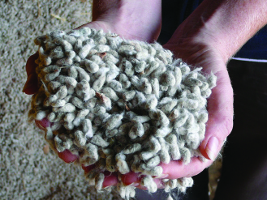

Linseed meal
Linseed meal, the by-product of the extraction of linseed oil from flaxseed, is an excellent protein supplement for livestock. Protein content varies from about 30 to 38 per cent, depending on the source and processing method. When reasonably priced, it can be used as the only protein supplement in livestock rations because it is very palatable.
Occasionally the meal may contain excessive levels of prussic acid, resulting in cyanide poisoning in ruminants.

Poultry litter and manure
Feeding of poultry waste (litter and or manure) to stock is prohibited under the Australian ruminant feed ban.
The ruminant feed ban prevents the feeding of ruminant products such as meat, bone meal, feather dust and litter back to ruminants, to limit the possible transmission of the prions of Transmissible Spongiform Encephalopathy (‘mad cow disease’ and ‘scrapie’ in sheep). Pig and poultry feeds contain animal protein to supply the essential amino acids not found in plants: ruminants make these themselves.

Safflower meal
Safflower meal has increased in availability and importance as a protein supplement in recent years because of the popularity of safflower oil in human diets. Safflower meal from unhulled seeds has about 20 per cent protein, is high in fibre and relatively low in energy. Meal made from well-hulled seeds has about 40 per cent protein and is much higher in energy.
However, safflower meal from either source is not as palatable to livestock as the more common protein supplements and is usually restricted to 20 per cent or less of concentrate mix.

Soybean meal
Soybean meal contains 40–50 per cent protein, is high in energy and is highly palatable to livestock.

Sunflower meal
Protein levels vary from 20 to 25 per cent, depending on the processing method and whether the seed is hulled or not. It is roughly equivalent to cottonseed meal as a protein supplement for livestock.

Whey
Whey is the residue from cheese production and consists primarily of lactose, minerals and water. It can be fed dry or liquid. Pollution control regulations and the high cost of drying have resulted in increasing amounts being used as liquid feed where transport costs are not prohibitive.
Dried whey is a major component of many dry milk replacers fed to calves. It is usually too expensive to be included in rations for older animals, but sometimes is included at low levels in pelleted feeds because of its binding characteristics and nutrients.
Liquid whey contains only 6–7 per cent solids and must be fed quickly or it will spoil. In cool climates, it can be stored for 3–4 days before feeding. In warm climates, it should be fed the same day it is delivered.
Liquid whey is frequently available for only the hauling costs, making it an inexpensive source of nutrients for animals near cheese plants. However, supplies are often variable and storage of whey attracts fly problems.

By-product roughage

Canola hay and silage
Canola hay and silage are likely to be available as a fodder source in droughts where there has been frost damage. In these situations it is likely that lengthy withholding periods will apply (15 weeks in some situations, e.g. when pre-emergent herbicides have been used). Commodity Vendor Declarations must be sought from feed suppliers to manage the risks.
There have been reports of nitrate poisoning from canola products and it is recommended that canola hay or silage is not fed as a sole ration or to hungry animals.

Rice hay
Rice hay is generally a good, palatable roughage of equivalent feed value to cereal hays. It contains significant levels of silica and oxalate, both of which may predispose animals to urinary calculi.
If rice hay is fed as the roughage in a hay and grain diet, feed 1.5 per cent limestone and 1 per cent salt to correct the calcium:phosphorus balance in the ration and promote water intake.
Rice hay can contain a range of weeds, such as umbrella sedge, barnyard grass, star-fruit and wild millet.

Seaweed
Kelp is the most common type of seaweed that might be available for feeding. The dry matter of kelp contains about 30 per cent minerals (compared to 5–6 per cent in hay, pasture, etc). Seaweed is sometimes used as a mineral source for livestock. Kelp contains 0.15–0.2 per cent iodine.
Kelp can be fed quite satisfactorily at up to about 25 per cent of the diet of livestock. The rich mineral content of seaweed, especially salt, can make the material quite palatable to livestock.

Poor quality by-products

Grape pomace or marc
Grape pomace or marc is the refuse in the production of grape juice and wine. It consists mainly of grape seeds, stems and skins. It has low feed value and is variable in energy, protein and dry matter so is considered only as a filler to reduce the price of a concentrate mix. With new harvesting and winery techniques, grape pomace containing few or no stems can be produced. This waste feed has been fed successfully to a 15–20 per cent level in complete feedlot rations.
Grape marc has been found to be extremely palatable to sheep. Lambs in pen trials have consumed 350 g/head/day when fed with straw. This diet was effective in reducing weight loss only.
Studies have shown that oil-soluble chemicals in grape seeds may appear at levels that would result in excessive residues in animal fat when fed. There are also concerns about residual levels of copper, which can be toxic to stock (especially sheep), used in fungicides on grapes.
Figure 8.4: Grape pomace.
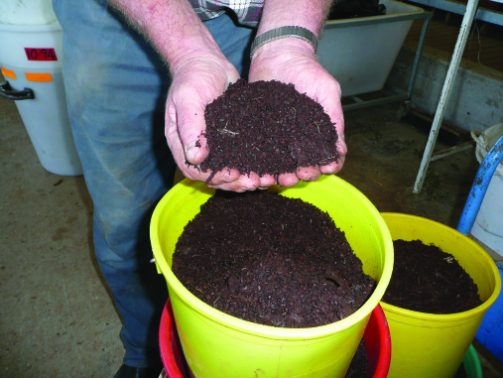

Rice hulls
Rice hulls have practically no feed value but can be useful as bedding material for livestock.
They are high in crude fibre and silica, and the fibre is largely indigestible. However, up to 15 per cent of unground rice hulls can be included as a roughage source in drought rations being fed to livestock.

Sawdust
Sawdust has virtually no feed value for sheep or cattle due to its high level of lignification, although it has been shown to be useful when feeding high-concentrate diets to sheep or cattle during droughts. Sheep survival rates in drought have been shown to be better when 15–20 per cent sawdust (hoop pine and spotted gum) was included in the wheat rations. Coarse sawdust was better than fine sawdust in maintaining rumen function. Sawdust from treated timber should not be used.

Treating straw with urea
Where straw is widely available and relatively cheap there has been some success in improving the nutritional value by adding urea. This can improve the protein level significantly (e.g. 2–14 per cent) but the urea-treated straw is low in energy and will require supplementation with grain or other high-energy ration.
To treat 1 tonne of straw, dissolve 50 kg of urea fertiliser in 850 litres of water and spray the solution onto the straw. The straw needs to be contained airtight (covered in plastic) and left for 7–10 days in summer (longer in winter). Animals will take a while to adapt and caution must be exercised to avoid urea toxicity.

Waste paper
Waste paper has little or no feed value for sheep or cattle. Due to its poor feed value and the risk of contaminants such as lead, cadmium, polychlorinated biphenyls and other toxic substances, feeding waste paper to sheep or cattle is not recommended.
Table 8.1: Feed quality values, feeding risks and management of less commonly used forage supplements.
Fodder  (No. of samples) | Quality Values (Range in brackets) DM% | Quality Values (Range in brackets) MJ ME/ kg DM | Quality Values (Range in brackets) CP% | Quality Values (Range in brackets) NDF% | Risks | Management
Canola silage  (135) | 47.2  (22.8–88.1) | 10.2  (6.9–12.4) | 17.9  (8.8–33.4) | 38.0  (23.4–58.7) | Potential nitrate and sulphur (S) toxicity. S-methyl cysteine sulphoxide (SMCO) toxicity causing haemolytic anaemia.  Occasional ‘brassica-type’ problems. Oil content high if pods forming. | Introduce slowly to well-fed animals, i.e. not hungry. Limit intake to ¼–1/3 of diet to avoid toxicity-related problems. Watch stock for ‘brassica-type’ signs of respiratory distress, photosensitisation, blindness and sudden excitability, digestive problems, pulpy kidney and bloat. Total S intake to be less than 0.4% of diet DM. If silage is very dark in colour and foul smelling, probably too wet at ensiling. Note potential for low (and high) quality.
Canola hay  (708) |  | 9.5  (3.9–13.1) | 15.1  (5.9–27.7) | 41.1  (21.7–69.1) | Fire risk and mouldy hay.  Thicker stems may not be eaten. Rumoured to be capable of puncturing rumens. Oil levels high if pods forming. | Visually inspect hay for mould. Stems may have been too wet at baling. Inspect hay for high levels of leaf loss.  Rumen damage unlikely. Preferable if hay was roller/super conditioned prior to baling to crush stalk or if chopped short at feed out.
Chicory (fresh) | NA | 10.3  (8.0–12.3) | 20.0  (7.6–32.4) | 37.5  (27.2–48.4) | May become diseased if moisture is held in hollow freshly chewed/cut stems. | Avoid grazing during wet winter weather to avoid disease build up from water held in plant crowns. Graze before stems become hollow. Do not slash/cut plants if stems becoming hollow.
Millet silage  (31) | 41.2 | 9.7  (8.5–11.6) | 14.4  (5.9–26.6) | 58.2  (44.0–65.0) | Nitrate poisoning. | No sorghum prussic acid-type problems but nitrate poisoning can still occur in stressed plants.
Millet hay  (34) | 79.9 | 8.5  (5.5–10.6) | 8.7  (2.5–23.3) | 66.2  (48.3–80.1) | Nitrate poisoning. | No sorghum prussic acid type problems but nitrate poisoning can still occur in stressed plants.
Native pastures  (63) | 72.9  (30.5–93.6) | 5.8  (3.9–9.4) | 5.5  (0.5–18.9) | Not Available | Low nutritive value. | Best quality if cut when leafy very early in season.
Pea hay  (40) | 84.9 | 9.7  (5.1–11.6) | 14.9  (4.5–21.6) | 42.9  (29.1–70.8) | Mould in pods. | Quality will vary according to leaf loss, presence of disease and mould.
Sorghum silage  (64) | NA | 8.1  (3.2–10.5) | 9.8  (2.1–18.2) | 62.3  (52.7–79.1) | Potential nitrate poisoning and prussic acid (actually hydrogen cyanide or HCN) poisoning in stressed plants. Sorghum plants are low in sulphur content. | Drought, frost, high nitrogen and low phosphorous levels increase risk of prussic acid poisoning. Greater risk in fresh regrowth. Avoid cutting/grazing under about 0.75–1 m height. Crops mower-conditioned and chopped into silage will have reduced levels of prussic acid but slightly higher levels in baled silage. Stress can cause nitrate poisoning, being highest in bottom 1/3 of stem. Ensiling will reduce N levels substantially but be wary. Introduce partly gut-filled animals slowly to sorghum forage or silage slowly. Add sulphur salt blocks when ration is largely sorghum only.
Sorghum hay  (132) | NA | 9.0  (6.8–10.4) | 9.9  (1.7–18.7) | 62.2  (45.3–75.8) | Potential nitrate poisoning and prussic acid (actually hydrogen cyanide or HCN) poisoning in stressed plants. Sorghum plants are low in sulphur content. | See comments for sorghum silage for causes of prussic acid and nitrate poisoning. Haymaking will not markedly reduce prussic acid or nitrate poisoning risks. Super-conditioning may reduce prussic acid poisoning slightly. Introduce partly gut-filled animals slowly to sorghum forage or silage slowly. Avoid making hay with stressed plants. Add sulphur salt blocks when ration is largely sorghum only.
Straw: rice  (7) | 85.2  (52.2–93.5) | 6.7  (5.3–8.9) | 4.0  (1.9–5.0) | 63.4  (53.4–68.5) | Low nutritive value. Contains silica and oxalate. | High levels of silica can predispose animals to urinary caculi.

Table 8.2: Feed quality values, feeding risks and management (where available) of less commonly used feed supplements.
By-Product Energy/ Protein Concent-rates  (No. of samples) | Quality Values (Range in brackets) DM% | Quality Values (Range in brackets) MJ ME/ kg DM | Quality Values (Range in brackets) CP% | Quality Values (Range in brackets) NDF% | Risks | Management
Acorns | 70 | 7 | 5
Almond hulls  (milled or unmilled) | 90  (88–92) | 10  (8.5–10.5) | 5  (4–6) | 35  (30–45) | Low effective NDF | By-product of almond processing. Consists of the outer covering but not the hard shell. Higher NDF values refer to higher proportion of outer hull. Lower effective NDF if milled. Can be fed up to ~10% of total DM intake.
Apple pomace |  |  |  |  | Pesticide contamination. Do not feed with urea or other non-protein nitrogen compounds as can cause abortions or abnormalities in the offspring. | Can make up to one third of the concentrates in a ration and 15–20 per cent in a complete feedlot ration.
Apples | 17 | 10 | 3
Apricots, dried | 90 | 12 | 6
Bakery waste  Bread | 61 | 14 | 16 | Low | Risk of acidosis (grain poisoning). Often high in fat and low in fibre. Do not feed breads that contain meat or animal protein (e.g. pizza breads) | Introduce slowly to avoid acidosis. Limit intakes to about 10% of diet. Other wastes, e.g. donuts, cakes, biscuits may differ slightly in nutrient value so obtain a feed analysis. Feed supplies quickly to avoid spoilage.
Bananas | 24 | 13 | 4
Brewers’ grain  (105) | 31.7  (13.9–93.0) | 10.5  (7.7–11.9) | 21.9  (16.9–35.2) | 755.1  (41.6–61.6) | Fat 8.0% (3.7–12.2) | Introduce slowly at less than 25% of a ration. May be expensive to transport due to low DM%. May be difficult to store and feed. Fat levels can be high but not normally a problem.
Broccoli | 11 | 10 | 33
Brussel sprouts | 15 | 11 | 33
Buckwheat | 87 | 11 | 12
Cabbage | 9 | 13 | 25
Cabbage leaves | 15 | 10 | 14
Canola meal | 91 | 12  (10–16) | 38  (27–42)
Carrot pulp  (9) | 10.0  (8.0–15.5) | 12.7  (8.8–14.2) | 9.8  (6.5–15.3) | 27.6  (26.1–29.1) | Potential risk of acidosis. | May be expensive to transport due to low DM%.
Carrots | 13 | 12 | 10
Cauliflower | 9 | 10 | 30
Citrus pulp (19) | 14.3  (10.6–17.3) | 12.7  (9.6–14.5) | 8.6  (6.0–11.9) | 25.1  (17.9–34.1) | High Ca:P ratio | Introduce slowly. Composition varied depending on fruit type and whether peels and seeds included. High-energy feed but can be low in CP, NDF and DM content. Commonly mixed with silage, hay and grain as a fully balanced ration. Ideally fed in troughs or on a feed-pad. Can be difficult to store and feed unless set-up for it. Distinctive smell and taste. Can be expensive to transport. High in calcium (Ca) and low in phosphorus (P) so should be counter-balanced by other feeds low in calcium and high in phosphorus.
Citrus pulp Silage (3) | 15.6  (15.1–16.5) | 11.9  (10.5–13.1) | 9.5  (8.9–9.8) | NA |  | As per citrus pulp comments. Can be unstable after opening so feed out quickly. Use inhibitor additive at ensiling. Can be ensiled with other products
Chocolate by-products (9) | 91.3  (53.4–98.1) | 15.6  (14.1–17.9) | 7.0  (0.1–11.0) | NA | Fat % 18.7 (7.0–29.8)  Note wide range in DM, ME and CP and potential of very low CP and high fat content. | Potential risks of acidosis unless feed is introduced slowly and feeding rate is increased slowly. Must be fed in conjunction with a fibre source and some additional protein. Feed no more than 5% oil in total DM ration. Note potential of wide variation in fat content depending on chocolate source
Choc malt mix | 94 | 14 | 24 | 35 | May be difficult to manage, store and feed out. Potential risk of acidosis. | High-quality blend of sugar, starch, protein and fibre. Introduce and increase feeding rates slowly. Very palatable, but may be difficult to manage, store and feed out, particularly under warm conditions.
Corn cobs, ground | 90 | 7 | 3
Cottonseed meal, 41% protein, mechanically extracted | 93 | 3 | 44
Cottonseed meal, 41% protein, solvent extracted | 91 | 11 | 46
Cottonseed, whole | 92 | 14 | 23
Dried Distillers’ Grain with Solubles (DDGS) (1) | 88–90 | 13.7 | 24 | 30 |  | By-product of distiller industries. Is condensed and dried stillage remaining after starch fermentation of wheat to produce for bio-fuels in combination with yeast and enzymes. From this process DDGS is the coarse grain + condensed thin stillage (syrup) dried. Can make to 20% by DM of ration.
Dried Distillers’ Grain (DDG) | 90–92 | 12.5–13.6 | 27–30 | 27–29 | Very high crude protein  Low NDF | By-product as above. DDG is coarse grain particles only dried without the condensed thin stillage. Very high protein so useful when pasture protein is low, etc. Be mindful of slightly low NDF value. Can constitute ~20–30% of ration DM.
Condensed Distillers’ Solubles/ Syrup) (CDS) | 42 | 15 | 18 | 2.1 | Risk of acidosis (grain poisoning). | By-product as above. CDS is the syrup material left after wheat (mainly) fermentation product (stillage) has been evaporated. Very high ME and negligible fibre (NDF) so ensure enough fibre in ration.
Grape marc: Raw (117) | 55  (19.6–93.9) | 6.5  (2.3–12.1) | 12.2  (5.4–18.5) | 47.6  (20.3–60.6) | 6–10% oil.  May contain high copper levels. | Note huge range in DM, ME, CP and NDF. This data probably also contains some Pressed grape marc data. High tannins in grape marc tend to bind much of the protein so allow for lower CP levels in rations. May be difficult to store and feed. May contain fungicide residual. Feed up to ~10% DM of whole ration.
Grape marc: Pressed | 50 | 10 | 13 | 33 | May contain high copper levels. | Excess alcohol (ethanol) removed by distillation compared to raw grape marc from wine industry. See other comments for raw grape marc.
Grape marc silage: Raw (3) | 35.8  (28.1–46.4) | 8.1  (4.3–11.1) | 17.9  (11.7–23.3) | NA | May contain high copper levels. | See comments for raw grape marc.
Grapefruit | 14 | 13 | 8
Kelp, dried | 91 | 5 | 7 |  |  | Rich mineral content. Contains 0.15–0.2 per cent iodine.
Lemon pulp, dried | 93 | 12 | 7
Lettuce | 5 | 8 | 22
Linseed meal, 36% protein, solvent extracted | 90 | 12 | 38 |  | May contain excessive levels of prussic acid, resulting in cyanide poisoning in ruminants.
Linseed meal, 37% protein, mechanically extracted | 91 | 12 | 38 |  | May contain excessive levels of prussic acid, resulting in cyanide poisoning in ruminants.
Melons | 4 | 11 | 11
Milk (cattle), skim, dried | 94 | 13 | 36
Milk (cattle), whole, dried | 94 | 15 | 27
Milk, colostrum | 25 | 15 | 46
Molasses, cane | 75 | 11 | 6
Oat hulls | 93 | 5 | 4
Oats, sprouted 5 days | 13 | 10 | 18
Onions | 11 | 13 | 10 |  | Anaemia | Slow introduction.
Orange pulp. dried | 88 | 12 | 8
Orange pulp, wet | 25 | 12 | 9
Oranges | 13 | 12 | 7
Palm kernel expeller meal (PKE) | 94  (92–96) | 11.1  (9.3–12.4) | 15.7  (14.8–16.3) | 65  (55.4–74.2) | 7–9% oil, but unsaturated and low potential for problems. Potential for compaction in rumen. Ca:P ratio is low as is sodium (Na). Has high copper levels. Low effective fibre. | Introduce slowly to stock to enable adaptation. May be unpalatable initially so mix with other feeds. May be mixed with grain prior to feeding. Store in silos with smooth sides and steep coned with large opening to avoid blockages. NDF is ineffective so ignore high value in table. Place water + hay/straw well apart from PKE to reduce potential for rumen compaction. Ca and Na may need to be supplemented if PKE is fed at high levels.
Peaches | 10 | 12 | 9
Peanut meal, mechanically extracted | 93 | 12 | 52
Peanut meal, solvent extracted | 92 | 12 | 52
Peanut skins | 94 | 10 | 17
Pears | 17 | 13 | 6
Pineapples | 15 | 12 | 3
Potato mash (45) | 23.1  (10.9–62.3) | 13.3  (10.8–14.8) | 11.2  (6.7–25.8) | NA | About 2% oil. Potential risk of acidosis | Wide range in moisture, ME and CP. Very high in starch and therefore highly digestible. Potential risks of acidosis unless levels introduced and increased slowly. Must be fed in conjunction with a fibre source and some additional protein.
Potato meal, dried | 91 | 12 | 11
Potato slivers | 20 | 14 | 6 | 11 | Potential risk of acidosis. | See comment for potato mash.
Pumpkins | 9 | 13 | 16
Raisin pulp, dried | 89
Raisins, cull | 85 | 7 | 4
Rice bran | 90 | 14  (9–15) | 16  (13–20) |  |  | Levels of up to 15 per cent have been fed successfully to livestock. Roughly equivalent to wheat bran.
Soyabean meal | 85  (12–94) | 15  (13–16) | 44  (30–54)
Sunflower meal | 91 | 10  (8–14) | 34  (20–39)
Tomato pulp (9) | 27.3  (16.6–30.2) | 7.7  (4.1–9.3) | 19.4  (5.0–22.6) | 58.8  (1 sample) | Pesticide residues | Wide range in moisture and ME.
Whey | 8  (2–27) | 14  (12–14) | 30  (20–40) |  |  | Liquid whey is very low in dry matter and needs to fed the same day delivered in warm climates.

Further information
- SAFEMEAT website – Risk assessments of a number of feed sources (and other information on safe meat): SAFEMEAT Alternative Fodder Residue Risks
- Australian Fodder Industry Association – Vendor Declaration
- Vendor declaration form available from Integrity Systems.
- Mineral content of common stock feeds: Mineral content of common ruminant stockfeeds, crops and pastures
- FeedTest website – Services for other services that include minerals, heavy metals, pesticides, residues, etc.
Nutrient Requirements of Domesticated Ruminants. Edited by M. Freer, H. Dove and J.V. Nolan. CSIRO.

Appendix I – Humane killing
The recommended methods of humane killing of sheep and lambs are either the use of close-range firearm or captive bolt to the brain, or lethal injection. Bleeding-out of unconscious (stunned) animals) is permitted.
The poll method is the preferred method for sheep (see Figure A1). The brainstem should be targeted and it is midway along an imaginary line drawn between the base of the ears.
Note: A firearm should deliver at least the muzzle energy of a standard a 0.22-long rifle cartridge.
Figure A1: Recommended position and direction of fire for humane killing of sheep.
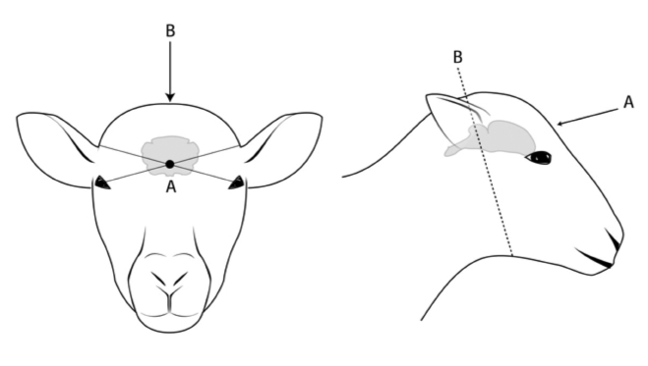
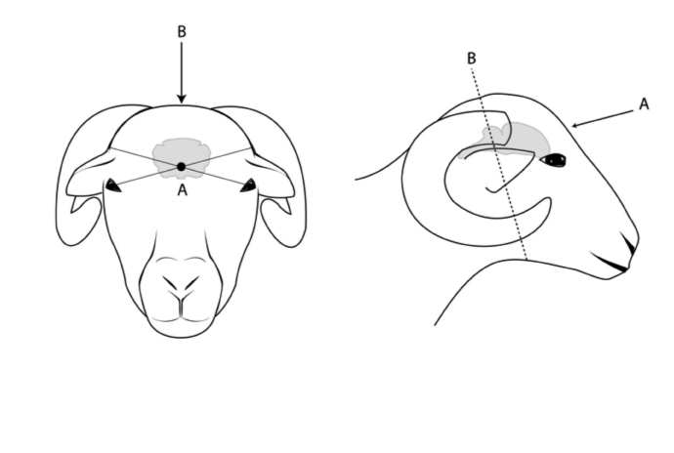
Note: Close-range firearm use or captive bolt is recommended to be applied to the poll position (B) of the head of sheep.
(A) indicates the frontal method and (B) indicates the poll method. The dots indicate the point of aim and the arrows indicates the direction of aim for the positions.
For the poll method (B), sheep are shot through the skull just behind the base of the horns. The line of fire should be directed slightly forward of the angle of the jaw of the sheep, depending on the point of impact.
For the frontal method (A), the firearm should be directed at a point midway across the forehead where two imaginary lines from the topside of the base of the ears and top of the eyes intersect.
For blunt trauma in lambs less than a day old use the frontal position (A).
The diagrams are representational and individual anatomical differences should be taken into account.
A person must only use bleeding out by a neck cut to kill a conscious sheep when there is no firearm, captive bolt or lethal injection reasonably available. This method is done by cutting the main blood vessels in the neck (neck cut) with a suitable, sharp knife. The neck cut is the only method to be used where permitted in conscious sheep. When sheep are bled out, it is not necessary to sever spinal cord or to pith.

Confirming death in sheep after humane killing
Three or more signs must be observed to determine whether the method used for humane killing has caused death.
Signs of death include:
- loss of consciousness and deliberate movement including eye movement
- absence of a corneal ‘blink’ reflex when the eyeball is touched
- maximum dilation of the pupil
absence of rhythmic respiratory movements for at least five minutes.
Return of rhythmic breathing, corneal reflex, vocalisation or deliberate movement are the main signs that an animal is only stunned and requires the application of an approved method to ensure death.
If it is not certain that an animal is dead, an approved method should be used immediately to ensure death in a rapid and humane manner. If necessary, bleeding-out or another technique should be used to ensure death in unconscious livestock.
From the Australian Animal Welfare Standards and Guidelines – Livestock at Saleyards and Depots (Edition 1) & Australian Animal Welfare Standards and Guidelines for Sheep (Edition 1).

Appendix 2: Drought Action Plan template
Use this template to clarify your farm situation and help develop your Drought Action Plan
Farm Name: | Farm area (ha): | Month/Year:
Locality: | Time of calving: | Time of lambing:

Livestock (cattle) (if you have more than one mob in each animal class add extra rows)
Class of stock | Herd Name | Number | Current fat score | DSE rating | Total DSE (number x DSE) | High priority (feed for production) | Medium priority  (feed for maintenance) | Low priority (hold or sell) | Market options | Comments
Weaners
Calves at foot
Heifers
Steers
1st calf heifers
3-5 year-old cows
6-year-old plus cows
Bulls
Total

Livestock (sheep) (if you have more than one mob in each animal class add extra rows)
Class of stock | Mob Name | Number | Current condition score | DSE rating | Total DSE (number x DSE) | High priority (feed for production) | Medium priority  (feed for maintenance) | Low priority (hold or sell) | Market options | Comments
Weaners
Lambs at foot
Wethers
Maiden Ewes
Adult (>2 yr) Ewes
Old age 6 yr plus Ewes
Rams
Total

Other livestock
Class of stock | Group Name | Number | Current condition score | DSE rating | Total DSE (number x DSE) | High priority (feed for production) | Medium priority  (feed for maintenance) | Low priority (hold or sell) | Market options | Comments
Horses
Goats
Alpaca
Other
Total

What feeds are on hand
Storage type and location | Feed type (grain or hay) | Quantity: (number of bales) | Weight of bales (kg) | Total quantity (tonnes) | Estimated energy (ME) | Crude protein % | Fibre NDF % | Comments
Silo 1
Silo 2
Silo 3
Hayshed 1
Hayshed 2
Hayshed 3
Silage pit 1
Silage pit 2
Silage pit 3
Total

Paddock feed on hand
Paddock name | Area | Average kg DM/ha | Estimated quantity | Comments
Total of farm

Paddock feed summary
Number of hectares | X | Quantity of pasture | = | Total kg pasture on hand | divide by 1,000 | = | Tonnes DM/farm
 | X |  | = |  | divide by 1,000 | =

What water supplies are on hand
Water Source | Current Volume (ML) | Access  Yes/No | Quality suitable  Yes/No | Salinity  suitable  Yes/No | Estimated weekly use | Estimate number of weeks | Estimated run out date | Comments
Dam 1
Dam 2
Dam 3
Dam 4
Bore 1
Bore 2
Creek
River
Town supply
Neighbouring supply
Total

Weekly water consumption
Number of cattle | X | Daily consumption | X | 7 days | = | Weekly consumption for cattle
 | X | litres/day | X | 7 days | = | litres/week
Number of sheep | X | Daily consumption | X | 7 days | = | Weekly consumption for sheep
 | X | litres/day | X | 7 days | = | litres/week
House and garden | X | Daily consumption | X | 7 days | = | Weekly consumption for house
 | X | litres/day | X | 7 days | = | litres/week
Total weekly water consumption litres/week

Drought action planning check list
Discuss options with:
Family members | Yes/No
Accountant | Yes/No
Bank manager | Yes/No
Stock agent | Yes/No
Farm staff | Yes/No
Neighbours | Yes /No
Meat and wool extension staff | Yes/No
Feed merchant | Yes/No

