

Drought Feeding and Management of Beef Cattle

A Guide for Farmers and Land Managers 2025
Contents
Acknowledgements 4
Abbreviations 5
Chapter 1: Preparing for drought 6
Drought Action Plan 6
Tips from past droughts 8
Management options to consider 9
In summary 12
Drought Action Plan template 14
Drought action planning check list 21
Chapter 2: Water during a drought 22
Will you have enough water? 22
How to calculate how much water you have 24
Water quality 26
Options to reduce water requirements 28
Actions to address a water shortage 30
When seasonal conditions improve 30
Farmer tips from past droughts 31
Chapter 3: Pasture management during drought periods 33
Assessing pasture availability 33
Pasture quality 34
Stock and pasture management at the end of a drought 36
Chapter 4: Monitoring stock condition 42
Fat score descriptions 43
Visual assessment 44
Muscling 45
Target fat scores 45
Managing cattle condition 46
Chapter 5: Choosing feeds 48
Understanding the components of a feed 48
How to sample for a feed analysis 52
Costing fodders on energy value 56
Other factors to consider when buying fodder 60
Tips for buying hay 61
Drought feeding of stock – the risk of chemical residues 62
Chapter 6: Feeding cattle 63
Nutritional requirements of beef cattle 63
Energy and protein requirements of various classes of cattle 65
Using the figures – feed budgeting 70
Other considerations 76
Improving the feed value of low-quality feeds 78
Chapter 7: Feeding grain to cattle 81
Introducing cattle to grain 81
Roughage (fibre) 83
Other grain additives 83
Processing grain 83
Grain poisoning 84
Other grain feeding problems 85
Chapter 8: Feeding in stock containment areas 87
Why use stock containment areas 87
When to use a stock containment area 88
Site selection 89
Design 91
Construction 93
Water 93
Feed 94
Stressful weather conditions 95
Releasing cattle 95
Animal health 95
Other considerations 96
Chapter 9: Animal health and welfare 97
Health and welfare problems in beef herds in a drought 97
Classes of livestock affected 97
Grain feeding problems 98
The effect of disease on drought-affected cattle 99
Welfare considerations of drought 101
Chapter 10: Options for young stock management 102
Early weaning of beef calves 102
Creep feeding of beef calves 106
The type and level of feed 108
Chapter 11: The feed value of unusual feedstuffs 109
High moisture content feeds 110
Blending and levels of feeding 110
Types of feeds 111
Appendix I – Weight of hay and silage bales 122
Appendix II – Energy tables and calculations 123
Appendix III – Tactical feed budget 125
Appendix IV – Pearson’s Square worksheet 127

We acknowledge and respect Victorian Traditional Owners as the original custodians of Victoria’s land and waters, their unique ability to care for Country and deep spiritual connection to it.
We honour Elders past and present whose knowledge and wisdom has ensured the continuation of culture and traditional practices.
DEECA is committed to genuinely partnering with Victorian Traditional Owners and Victoria’s Aboriginal community to progress their aspirations.
© The State of Victoria Department of Energy, Environment and Climate Action January 2025.
This publication is copyright. No part may be reproduced by any process except in accordance with the provisions of the Copyright Act 1968.
Authorised by the Victorian Government 1 Spring Street, Melbourne Victoria 3000 Australia
First edition 2002
Revised and reprinted March 2007
Revised and reprinted September 2015
Revised and reprinted April 2018
Revised and reprinted January 2025.
ISBN 978-1-74199-055-3 (print)
ISBN 978-1-74199-035-5 (internet)
Disclaimer
This publication may be of assistance to you but the State of Victoria and its employees do not guarantee that the publication is without flaw of any kind or is wholly appropriate for your particular purposes and therefore disclaims all liability for any error, loss or other consequence which may arise from you relying on any information in this publication.

Acknowledgements
Agriculture Victoria thanks the following people and organisations for their contribution to this publication:
Phil Franklin, Fiona Baker, John Gibney, John Bowman, Heather Field, Belinda Pritchard, Ralph Behrendt, Dr Robert Suter, Kate Sargeant, Dougal Purcell, Cheryl Graham, Ross Batten, Tim Hollier, Dr Karin Morgan, Dr David Champness, Emma Weatherly, Meat & Livestock Australia.

Abbreviations
BoM | Bureau of Meteorology
cm | centimetre
CP | crude protein
CS | condition score
DM | dry matter
DSE | dry sheep equivalent
EC | electrical conductivity
FOO | food on offer (in kg DM/ha)
g | gram
IOD | Indian Ocean Dipole
kg | kilogram
L | litre
m2 | square metre
ME | metabolisable energy (energy units)
MJ | megajoule
MLA | Meat & Livestock Australia
mm | millimetre
NDF | neutral detergent fibre
NLIS | National Livestock Identification Scheme
PIC | Property Identification Code
ppm | parts per million
SOI | Southern Oscillation Index
t | tonne

Chapter 1: Preparing for drought
Droughts are part of life for farming communities. Early planning and decision making is important. If decisions are left until a drought worsens, many of the management options available early may no longer be possible.
This chapter looks at how to prepare your farm, including:
- making plans early
- knowing feed supplies and stock requirements
- understanding farm water levels and stock needs
discussing your drought strategy with your family.
The first step is to prepare a Drought Action Plan.
By listing the farm’s financial and physical resources the effects of various strategies, both short and long term, can be calculated.
The next step is to estimate when you think the weather pattern is likely to change. This will affect your calculations on how long you will be feeding cattle, how much it will cost and whether you will decide to sell stock or not. It is best to over-estimate the time you expect to hand-feed stock to be on the safe side. For example, you need to add a few weeks beyond an expected autumn break to allow for the new pasture to germinate and grow, plus continue supplementation to allow for the transition from dry feed to green pasture. In previous droughts, cattle have survived the dry summer months only to be lost with the sudden change to a green feed diet after the autumn break.
For long-term weather predictions see the following Bureau of Meteorology
Useful information can also be found at The Break newsletters

Drought Action Plan
Think about the following questions when developing your Drought Action Plan.

What is your current financial situation?
- Cost out various feeding or selling scenarios.
- Prepare a 12-month cash flow budget.
Use partial budgeting to explore various options.

Do you need financial advice?
- See a rural financial counsellor (see Rural Financial Counselling Service).
- Discuss your plans with your accountant.
Contact your bank manager.

How widespread is the drought?
- Is suitable agistment available? You need to check fences, water supplies and health status of potential agistment properties.
Is droving an option? What are the regulations on droving in your local councils?

Water supplies (see Chapter 2)
- What is your farm’s current water storage capacity?
- What are the stock water requirements over the summer months?
- Do you have adequate water supplies to survive a drought?
Can you seek water from other sources before supplies dry up (e.g. creeks, bores or outlying dams)?

Will you feed for maintenance or production targets (see Chapters 4, 5 and 6)?
- What are your fat score targets for the cow herd for joining, calving and weaning?
- What are the feeding needs of various classes of cattle?
- Which are the priority mobs for the best feed?
Which classes of cattle do you consider selling?

Can you feed cattle for long periods? (see Chapters 7, 8, 10)
- Do you have the equipment to feed cattle: silos, feed wagons, grain feeding equipment or can you improvise, borrow or buy equipment?
- Do you have the labour or time to feed?
- How long will you have to feed and what will it cost? Are grain, hay, silage, pellets or other feedstuffs available?
- Can you construct a stock containment area for some or all of your cattle?
Do you have the feed budget skills?

Should you reduce your cattle numbers?
- What prices are cattle making now?
- What prices will cattle be after the drought?
What effect will reduced stock numbers have on your overall feeding costs and your long-term restocking costs?

Sustainability and protection of pastures and soil (see Chapter 3)
- What effect will your strategy have on your pastures and soils?
- What effect will your action plan have on your long-term viability?
How do you protect native vegetation from cattle damage during the drought?
Cattle need to be adequately fed, have continual access to clean fresh water, have access to shelter if required, be kept healthy and allowed to express their natural behaviour. Allowing stock to starve is not an option and is an offence under Victorian law.
Your Drought Action Plan should be flexible to allow for changes in circumstances. For example, you may sell a certain class of stock or buy fodder only if conditions do not improve by a certain date.
Having a plan of action will greatly reduce the stress on you and your family as you will all be working towards specific aims.

Tips from past droughts
Farmers who successfully survived the 1982 and 1994 droughts were asked what they did to ensure they got through. In summary, they:
- made plans and took actions early
- did simple budgets for various feeding and selling options
- knew their hay supplies and were prepared to ration roughage
- prepared cash flow budgets for 2-3 years
- obtained advice on current market prices for fodder, grain and livestock to enable them to make informed decisions
- reviewed decisions regularly
- acted quickly and decisively
- looked for opportunities
- remained positive
- planned a holiday
- looked out for family and friends
were prepared to use stock containment areas to preserve their pastures and soil.

Management options to consider

Agistment
Sending cattle away on agistment can be a cheap solution to the feeding problem; any cattle left at home will have less competition for feed.
Before agisting cattle check that the property they are going to has:
- secure fencing and cattle-handling facilities
- a good quantity of quality feed
- good water supply
supervision to minimise theft and identify health problems.
Only cattle strong enough to travel should be agisted. It is an advantage to have the agistment area close to markets so cattle do not have to be brought home again.

Sell stock
If you choose this course of action, the crucial management decisions will be the timing of the sale and the type and number of cattle to be sold.
Any drought inevitably triggers a period of intense selling with large saleyard yardings and resultant depressed prices. Plan to sell as early as possible to avoid the most depressed prices and while the cattle are still in good condition.
The best policy is to sell the less-productive animals, so that at the end of the drought you will still have a herd of high-producing animals.
Generally, the best cattle to retain through a drought are young breeders of good quality because these will be difficult and expensive to replace at the end of a prolonged drought. They will also provide the basis for bringing a beef herd back into production.
The following sets out the steps of a selling policy to retain a breeding herd:
- Pregnancy test and sell all empty, late-calving and low-producing cows.
- Sell inferior bulls.
- Sell aged cows, aged bulls and lightweight heifers.
- Sell non-breeding cattle: weaners, yearling steers and bullocks. Growing stock can be expensive to feed because of their high energy and protein demands.
- Wean calves over three months of age and sell or feed separately.
Progressively reduce the breeding cow herd. Reassess the cow herd and sell the poorest performing cows and heifers. Young breeders (2-5 years) are the most important to retain.
Feed costs, saleyard prices and expected stock water supplies need to be assessed each time you decide how many stock to sell.
Vendor declarations must be provided with all cattle sold. Vendor declaration form available from Integrity Systems at National Vendor Declaration (NVD).
Taxation can have an important bearing on your selling plans. Its impacts, especially if a large part of the herd is to be sold, need to be determined before the stock are sold, particularly where low ‘cost price’ valuations are used for taxation purposes. Speak to your accountant about the possibility of spreading the income over a five-year period if the cattle sale was forced due to drought conditions.

Feed stock
Drought feeding of cattle is most efficient if the stock are segregated into various classes so that they can be fed according to their nutritional requirements.
These classes could be:
- early-weaned calves (less than six months)
- weaners (6-12 months)
- yearlings (12-18 months)
- cows with calves at foot
- dry cows
- bulls
steers and bullocks (over 18 months).
Stock requirements are discussed in Chapter 6.
Developing feed budgets before and during a drought is key to minimising the financial impact on your enterprise.
It is usually more efficient to maintain stock at a productive level than feed to increase their weight and fat score. Cows maintained in fat score 3 or better will be more fertile come joining time and result in more live calves on the ground when the season improves.
Short-term finishing rations may be justified for stock suitable for sale, such as weaners or steers for domestic markets. However, budgets need to be carefully calculated as the profit margins are generally small during droughts.
Monitoring and recording cattle liveweight and fat scores gives a guide to the success of your feeding program and allows for ration adjustment and cost savings.
Planning is needed for when the drought finally breaks to ensure the cattle are slowly transitioned from a drought ration to the emerging green feed diet. For the benefit of both the cattle and the emerging pastures, the drought ration should be maintained for a few weeks, gradually transitioning the stock to the green feed, which allows the rumen microbes and the animals’ digestive systems to adjust to the new diet.

Other considerations

Requirements for stock leaving the farm
All cattle in Victoria must be tagged with an NLIS cattle tag before leaving their property of birth. All movements must be accompanied by a properly completed National Vendor Declaration (Available at: National Vendor Declaration (NVD) or ring 1800 023 100.
Property-to-property movements need to be recorded on the NLIS database.

Fit to travel
Stock must be in a fit condition if they are to be transported, whether for slaughter or to another farm. An animal is not fit if it:
- is not strong enough to undertake the journey
- cannot walk normally, bearing weight on all legs
- is severely emaciated or visibly dehydrated
- is suffering from severe visible distress or injury
- is blind in both eyes
is in late pregnancy.
For the full publication ‘Is it fit to load’ go to: Is the animal fit to load?

Droving
Another source of off-farm feed is along roadsides.
Only some councils allow droving stock. Legal restrictions and local environmental considerations applying to this practice vary between councils and may change. The risk of disease spread also needs to be considered. Check with the councils involved before starting this option.

Humane destruction
If some classes of stock are unsaleable, and no other option is feasible, the animals should be humanely destroyed. In past droughts, councils have made facilities available to dispose of carcasses.
Information on appropriate methods of destruction can be obtained from animal health staff from your local Agriculture Victoria office.

Purchasing cattle after the drought
To minimise the risk of introducing disease, cattle should be accompanied by an animal health statement. completed by the person you are buying the cattle from. The animal health statement pro forma can be downloaded from proforma download link. The statement will give you information on the cattle’s pestivirus and Johne’s disease status, treatments they may have received such as worm and liver fluke drenches and any current vaccinations they have received.

In summary
It is your legal responsibility to ensure that livestock do not starve or become distressed during a drought. Doing nothing is not an option open to you in the long term. Even in the short term, it is of questionable value.
You may be tempted to do nothing in the hope that a poor season will not turn into a drought. In the meantime, paddock feed diminishes, the condition and value of stock slip and feed prices soar. These changes close off many of the options available to you earlier in a drought.
The message is to plan early and set deadlines to activate specific actions.
Remember, it is better to plan ahead. If the season happens to improve or was not as dry as predicted, you can always put the plan to one side and continue with a normal season program.

Drought Action Plan template
Use this template to clarify your farm situation and help develop your Drought Action Plan
Farm Name: | Farm area (ha): | Month/Year:
Locality: | Time of calving: | Time of lambing:

Cattle
Class of stock | Herd Name | Number | Current fat score | DSE rating | Total DSE (number x DSE) | High priority (feed for production) | Medium priority (feed for maintenance) | Low priority (hold or sell) | Market options | Comments
Weaners
Calves at foot
Heifers
Steers
1st calf heifers
3-5 year-old cows
6-year-old plus cows
Bulls
Total

Sheep
Class of stock | Mob Name | Number | Current condition score | DSE rating | Total DSE (number x DSE) | High priority (feed for production) | Medium priority (feed for maintenance) | Low priority (hold or sell) | Market options | Comments
Weaners
Lambs at foot
Wethers
Maiden Ewes
Adult (>2 yr) Ewes
Old age 6 yr plus Ewes
Rams
Total

Other livestock
Class of stock | Group Name | Number | Current condition score | DSE rating | Total DSE (number x DSE) | High priority (feed for production) | Medium priority (feed for maintenance) | Low priority (hold or sell) | Market options | Comments
Horses
Goats
Alpaca
Other
Total

What feeds are on hand
Storage type and location | Feed type (grain or hay) | Quantity: (number of bales) | Weight of bales (kg) | Total quantity (tonnes) | Estimated energy (ME) | Crude protein % | Fibre NDF % | Comments
Silo 1
Silo 2
Silo 3
Hayshed 1
Hayshed 2
Hayshed 3
Silage pit 1
Silage pit 2
Silage pit 3
Total

Paddock feed on hand
Paddock name | Area | Average kg/DM/ha | Estimated quantity | Comments
Total of farm

Paddock feed summary
Number of hectares | X | Quantity of pasture | = | Total kg pasture on hand | divide by 1,000 | = | Tonnes DM/farm
 | X |  | = |  | divide by 1,000 | =

What water supplies are on hand
Water Source | Current Volumn (ML) | Access  Yes/No | Quality suitable Yes/No | Salinity suitable Yes/No | Estimated weekly use | Estimate number of weeks | Estimated run out date | Comments
Dam 1
Dam 2
Dam 3
Dam 4
Bore 1
Bore 2
Creek
River
Town supply
Neighbouring supply
Total

Weekly water consumption
Number of cattle | X | Daily consumption | X | 7 days | = | Weekly consumption for cattle
 | X | litres/day | X | 7 days | = | litres /week
Number of sheep | X | Daily consumption | X | 7 days | = | Weekly consumption for sheep
 | X | litres/day | X | 7 days | = | litres /week
House and garden | X | Daily consumption | X | 7 days | = | Weekly consumption for house
 | X | litres/day | X | 7 days | = | litres /week
Total weekly water consumption litres/week

Drought action planning check list
Discuss options with:
Family members | Yes/No
Accountant | Yes/No
Bank manager | Yes/No
Stock agent | Yes/No
Farm staff | Yes/No
Neighbours | Yes /No
Meat and wool extension staff | Yes/No
Feed merchant | Yes/No

Chapter 2: Water during a drought
This chapter will help you determine stock water needs across a year and the options for managing on-farm water resources.
Key messages
- Do water budgets early, based on your experience with water supplies, how much water you have available and how much your stock will need.
- Have a water plan that considers the worst case scenarios.
- Evaporation rates can be very high over dry summers and small dams are inefficient water storages.
- Consider water reticulation systems and transfer requirements between storages, particularly for containment areas.
- The major threat to water quality during drought is high levels of salt, although algae and animal manure can foul water following heavy summer rains or strong winds.
- Water can be tested for salinity and other minerals to check suitability for various classes of stock, as well as for toxicity of algal blooms.
Cows will drink up to 100 litres of water a day.
Water is essential for animal survival and performance. Poor water quality is a common cause of under-preforming animals. Cattle must be provided with access to good quality water (preferably from troughs) at all times.

Will you have enough water?
Knowing your property and how water supplies perform in times of drought is essential information for the planning phase.
Calculating the total water available and the total required by stock will tell you how many stock, and of what class, you can carry through a dry period.
To do a water budget, list all the dams by paddock and calculate the water available in each one.

Animal requirements
The amount of water an animal requires will depend on a number of factors, including:
- the class of animal (a lactating cow will require significantly more water than a dry cow or yearling steer)
- the temperature and season (cattle consume significantly more water in summer and during high temperatures)
- the feed on offer (grains are a dry feed, while pasture contains some moisture)
the quality of the water (water with higher salt levels will increase consumption).
Periods of high temperatures (>38°C) will increase an animal’s water requirements beyond the levels in Table 2.1. Complete the template on page 14 to estimate weekly water consumption.
Table 2.1: Water requirements, litres/animal/day.
Stock type | Consumption (L/day)
Sheep
Weaners | up to 4
Adult dry sheep | up to 6
Ewes with lambs | up to 10
Cattle
Weaners (250-300 kg) | up to 55
Dry stock | up to 80
Lactating first calf heifers (350-400 kg) | up to 90
Lactating cows (500 kg) | up to 100
Horses | up to 50

For daily average and yearly as well as winter and summer stock drinking requirements for cattle and other livestock types refer to ‘Managing farm water supplies’.

How to calculate how much water you have

Step 1
To calculate how much water you have stored in your farm dams at any given time requires you to know the volume of water. To do this you need to know:
- The length of the dam at water level.
- The width of dam at water level.
The depth of the dam.
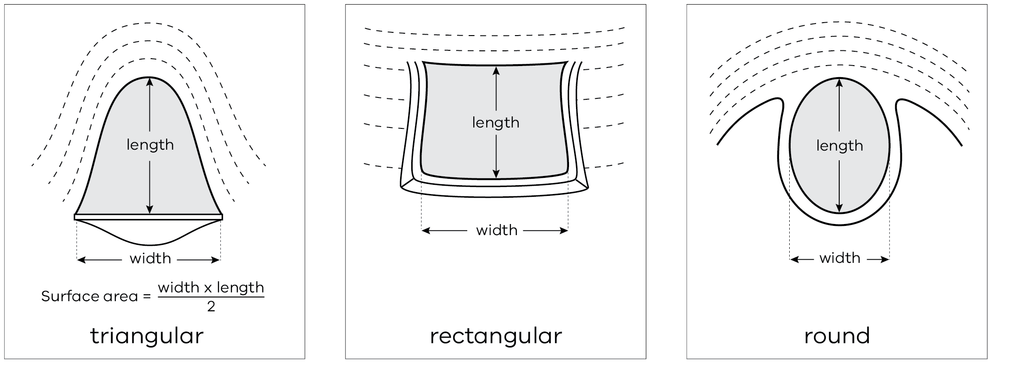
Picture source – Office of Water Factsheet (2010) Dams in NSW – What size are your existing dams?
Link to Assessment of quantity of dam water, livestock demand and loss factors pdf download

Step 2
Once you have these measurements you can use tables 2.2 and 2.3 to estimate how much water you have in each dam. Complete the template on page 13 to estimate what water supplies are on hand.
Table 2.2. Volume of water in a small rectangular dam (megalitres). Batter slope 3:1
Water dimensions (metres) Length | Water dimensions (metres) Width | Depth of water (metres)  0.5 | Depth of water (metres)  1.0 | Depth of water (metres)  1.5 | Depth of water (metres)  2.0 | Depth of water (metres)  2.5 | Depth of water (metres)  3.0
5.0 | 5.0 | 0.01
5.0 | 10.0 | 0.02
10.0 | 10.0 | 0.04 | 0.05 | 0.06
10.0 | 15.0 | 0.06 | 0.09 | 0.10
10.0 | 20.0 | 0.08 | 0.12 | 0.14
15.0 | 15.0 | 0.09 | 0.15 | 0.18 | 0.19 | 0.19
15.0 | 20.0 | 0.13 | 0.21 | 0.25 | 0.28 | 0.28
15.0 | 25.0 | 0.16 | 0.27 | 0.33 | 0.37 | 0.38
15.0 | 30.0 | 0.19 | 0.33 | 0.41 | 0.46 | 0.47
20.0 | 20.0 | 0.17 | 0.29 | 0.37 | 0.42 | 0.44 | 0.44
20.0 | 25.0 | 0.22 | 0.38 | 0.49 | 0.56 | 0.59 | 0.61
20.0 | 35.0 | 0.31 | 0.55 | 0.72 | 0.84 | 0.91 | 0.94
20.0 | 40.0 | 0.36 | 0.63 | 0.84 | 0.98 | 1.06 | 1.10

Table 2.3. Volume of water in a small gully dam (megalitres). Batter slope 3.1
Water dimensions (metres) Length | Water dimensions (metres) Width | Depth of water (metres)  0.5 | Depth of water (metres)  1.0 | Depth of water (metres)  1.5 | Depth of water (metres)  2.0 | Depth of water (metres)  2.5 | Depth of water (metres)  3.0
5.0 | 5.0 | 0.01
5.0 | 10.0 | 0.01
10.0 | 10.0 | 0.01 | 0.02 | 0.03
10.0 | 15.0 | 0.02 | 0.03 | 0.05
10.0 | 20.0 | 0.02 | 0.04 | 0.06
15.0 | 15.0 | 0.02 | 0.05 | 0.07 | 0.09 | 0.11
15.0 | 20.0 | 0.03 | 0.06 | 0.09 | 0.12 | 0.15
15.0 | 25.0 | 0.04 | 0.08 | 0.11 | 0.15 | 0.19
15.0 | 30.0 | 0.05 | 0.09 | 0.14 | 0.18 | 0.23
20.0 | 20.0 | 0.04 | 0.08 | 0.12 | 0.16 | 0.20 | 0.24
20.0 | 25.0 | 0.05 | 0.10 | 0.15 | 0.20 | 0.25 | 0.30
20.0 | 30.0 | 0.06 | 0.12 | 0.18 | 0.24 | 0.30 | 0.36
20.0 | 35.0 | 0.07 | 0.14 | 0.21 | 0.28 | 0.35 | 0.42
20.0 | 40.0 | 0.08 | 0.16 | 0.24 | 0.32 | 0.40 | 0.48
25.0 | 40.0 | 0.10 | 0.20 | 0.30 | 0.40 | 0.50 | 0.60

Step 3
Allow for evaporation and seepage.
Evaporation can be one of the biggest losses from farm dams, especially small or shallow dams. The smaller dams less than 3 meters deep can lose up to 60% of their water over summer This can be up to 1 meter of water depth or more.
Example: A paddock with a 20 m X 20 m X 2 m deep dam with 80 spring-calving cows consuming
100 litres a day will consume 8,000 litres/day.
Divide the total dam capacity by the daily water usage.
Example: 420,000 litres/8,000 litres = 52 days of water available.
Download the Summer Water Calculator via Farm water calculator to determine how much water you have, how long it will last and how to make and use DAMDEEP measuring the depth of your dam.

Water quality
Having water of a quality that is ‘fit for purpose’ is important. Water quality can affect plant growth, livestock health, soil quality, farm equipment and infrastructure and domestic use.
The quality of a water source depends on the season and weather conditions. Evaporation increases the concentration of salts while a flush of water dilutes salts but may increase sediment, and runoff of fertilisers, manure or nutrients.
Water quality should generally be visually monitored weekly to check for any algal blooms, clarity of the water (how cloudy or muddy the water appears) and dead wildlife (such as ducks) or livestock that may have become stuck in unfenced water sources. In hotter weather or periods of prolonged moisture stress, daily visual checks are preferable.
The major threat to water quality during drought is high levels of salt, although algae and animal manure can foul water following heavy summer rains or strong winds.

Salt content
Salinity is a major water quality issue in areas where accumulated salts are mobilised in the landscape and make their way into waterways and dams. Salinity refers to all the mineral salts present in the water, including sodium, calcium, magnesium, chloride, sulphate and carbonate. Evaporation of water sources increases the concentrations of salts and the problems associated with them. During a drought year, low water levels can result in doubling of salt concentrations over summer.
Table 2.4 lists salt levels in drinking water that can be tolerated by various classes of stock. In general, the salt content of water should not exceed 9,600 ppm and the magnesium level should not exceed 600 ppm.
Table 2.4 Salt tolerance in drinking water for various classes of cattle presented as parts per million (ppm) and units of electrical conductivity (EC units).
Water Category | Classes of stock | EC Units  (µs/cm) | Total soluble salts (ppm) | Magnesium (ppm)
1 | Suitable for cattle of all ages | <5,000 | <3,200 | <400
2 | Generally unsuitable for calves and weaner stock if they are unaccustomed to the water.  Suitable for dry, mature cattle. | 5,000–10,000 | 3,200–6,400 | <600
3 | Caution needed with cattle if they are unaccustomed to the water. | 10,000–15,000 | 6,400–9,600 | <600
4 | Generally unsuitable for all cattle. | >15,000 | >9,600 | Any level
5 | Generally unsuitable for all cattle. | Any level | >9,600 | >600

Pollution
During the 1982-83 and 2015-16 droughts, many dams in Victoria were severely polluted by manure and dried vegetation blowing from bare paddocks or by summer rainfall run-off. The water turned black and gave off a putrid smell. Stock stopped drinking it.
Retention of ground cover on paddocks adjacent to dams will help avoid this problem developing.

Algal blooms
Algal blooms are common over summer months when water temperatures rise as dams become shallow and the levels of phosphorus and nitrogen in the water build up.
Most algal blooms are not toxic. Some blue-green algae, however, produce toxins that can have serious health implications for humans, animals and birds drinking or coming in contact with the water. It can kill animals within a few hours of ingestion.
Blue-green algae forms a scum that looks like green acrylic paint and leaves sky blue marks on rocks or plants around the edge of the dam.
If you suspect you have a blue-green algal bloom:
- Isolate all stock from the dam or water supply.
- Collect a sample for testing by a water laboratory (use gloves – don’t allow the water to come in contact with skin).
- Contact a veterinarian if animals show symptoms of poisoning (sudden death, loss of appetite, breathing difficulties, muscle twitches, weakness, scours, photosensitisation – any white areas of skin become swollen and reddish). In cases of blue-green algal poisoning, green staining may be seen on the muzzle, feet or legs of poisoned stock.
Contact Agriculture Victoria for further advice on controlling blue-green algae. Go to Managing blue-green algae in farm water supplies for further information.

Options to reduce water requirements

Reducing stock numbers
- What are your core stock numbers?
- How many do you want to keep?
- How many do you need to keep?
- How many can you afford to keep?
Can you agist some?

Relocating stock
Reducing the energy stock expend accessing feed can reduce their water requirements. To reduce this energy expenditure, it may be necessary to relocate the stock to a smaller paddock or a stock containment area where movement is more restricted and deliver the herd’s daily feed requirements to them. If water is not troughed to this area, you will need to provide enough water daily for stock requirements – use Table 2.1 to calculate stock water requirements.

Minimising evaporation
To conserve water and maintain good water quality, one large deep dam is better than numerous shallow dams.
It may be advantageous to pump the contents of a number of smaller dams into a single larger dam to minimise evaporative loss and save water.

Reticulating from dams rather than allowing animals direct access
Reticulating from dams avoids pugging and bogging problems and allows a more efficient use of the water. Reticulation systems must be simple, reliable and have sufficient capacity to meet peak demands.
Site new troughs, tanks and pipes to suit future needs.

Protecting dams from wind-borne contamination
If possible, keep adequate ground cover on adjacent paddocks to prevent material blowing into the dam.
If ground cover is already low, fencing can be used to trap blowing material before it reaches the water. A close-wired fence on the windward side is a worthwhile investment.
Once material is in the dam, aeration of the water is necessary to improve its condition and make it more acceptable to stock. This is best done by pumping to a tank and reticulating to a trough. If aerated water is returned to the dam, the organisms growing on the organic material will quickly use all the oxygen again.

Actions to address a water shortage

Carting water
Due to the volumes of water required and the frequency it needs to be supplied (usually daily), carting water is a labour-intensive operation. Consider whether you have the labour, equipment and time available to commit to this option.
Seepage and evaporation from earthen dams during extended dry periods means it is not generally feasible to put carted water into these dams. It is best to put carted water into a tank system and reticulate the water to troughs for the stock to access.
Be aware of the quality of the water source the water is being carted from. During droughts, water sources such as bores and streams may become quite salty, affecting the stock’s willingness to drink the water. Stream sources may also become quite stagnant resulting in contamination from algae and animal manures, particularly following heavy summer rains.
A dam that cannot provide enough drinkable stock water five or more years out of 10 is not considered a reliable water source.

Sinking bores
Investigate likely water yields and quality before drilling emergency bores. Consult your relevant water authority if you are considering sinking a bore as you will need a bore construction licence. For more information and to apply for a licence and permission to take and use ground water, visit My Water or contact your relevant Rural Water Corporation.

Digging new dams
Do not dig a new dam when soil moisture is low.
Only build earth dams when soil is moist enough for maximum compaction. A permit is required to dig a new dam on a waterway.
Seek advice and permission before construction from your Catchment Management Authority.

When seasonal conditions improve
Build a contingency plan for the next dry period so you don’t get caught unprepared. Take steps to drought-proof your property and its enterprises.

Farmer tips from past droughts
- Have a water plan and undertake a water audit, taking into consideration the worst case scenario.
- Calculate stock water requirements and water available using the online farm water calculator.
- Assess reliability of all your water sources. A dam that cannot provide enough drinkable stock water five or more years out of 10 is not considered reliable.
- Have a large, fenced catchment dam on your property and reticulate from this to troughs.
- Set up your reticulation system properly from the start. Do it in stages if necessary.
- Prepare early and ensure you have any necessary permits in place well before summer.
Decreasing wind velocity across your dam will help to reduce evaporation from dams.

Water testing
The best way to be certain about the quality of your water is to have it tested. On farm this is recommended for both human and animal consumption. Check that the laboratory you use is accredited by the National Association of Testing Authorities (NATA) for the test you are requesting. NATA is the authority that provides independent assurance of technical competence through a network of best practice industry experts.
Domestic, stock and irrigation packages available (includes pH, electrical conductivity, turbidity, calcium, potassium, magnesium, hardness, sodium, iron, manganese, nitrate, chloride, sodium absorption ration) and blue-green algae.

Online resources

Water
Farm water solutions

Dams
Managing dams
Organic pollution in farm dams

Farm water calculator
Farm water calculator
Summer Water Calculator

Water quality
Water quality for farm water supplies

Water supply for stock containment areas
Water supply in stock containment areas

Chapter 3: Pasture management during drought periods
This chapter looks at methods of assessing pastures to determine how much feed is available and also at management considerations to get the best from the pasture system during tough times.
Key Messages:
- Availability of pasture needs to be assessed in kg DM/ha for use in feed budgets.
- Defer grazing after the drought breaks. Grazing too early further damages the grasses and will affect their persistence.
- Weed management is important in the first few months after the drought breaks, otherwise they may significantly reduce future pasture production.
- Assess perennial pastures after the drought breaks for the percentage of perennial grass, annual grass, broadleaf weeds and bare ground. This will give an indication of whether pastures need resowing.
If sowing into pasture, apply a small amount of phosphorus fertiliser, 10-20 kg/ha phosphorus, the equivalent of 114-227 kg super/ha.
The need for supplementary feeding and the quantity required will depend on the availability and quality of the pasture. The following section provides a simple guide to help you estimate pasture quantity and quality to determine the contribution of the pasture as part of a ration.

Assessing pasture availability
The quantity of pasture in a paddock is measured in kilograms of dry matter per hectare (kg DM/ha). It is the weight of pasture from a hectare if it was cut to ground level and completely dried to remove all moisture.
Pasture quantity is determined by measuring the average height of the pasture in centimetres (using a stick or ruler) and calibrating the height to kg DM/ha using Figure 3.1 as a guide. When using this method, the first 0.5 cm should be excluded from the measurement.
Figure 3.1: The relationship between green pasture height and pasture availability.
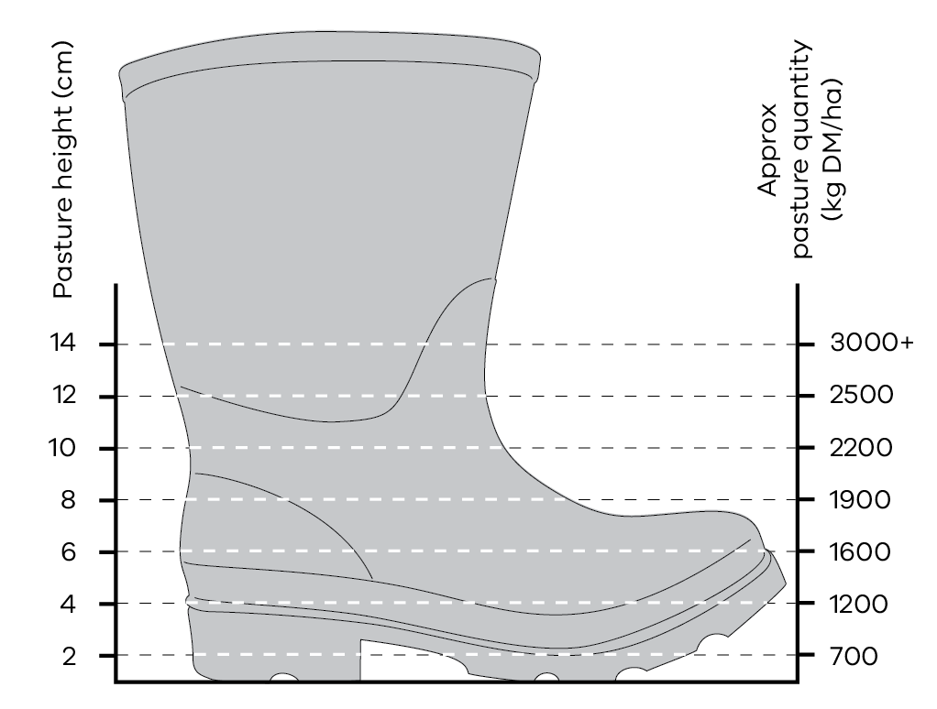
The pasture quantity figure can then be used in feed budgets. Feed budgets allow you to use the energy content (or quality) of the pasture to help determine if enough feed is available to meet production targets (maintenance or growth or lactation, etc).
Another way to assess pasture quantity is the ‘cut and dry’ method. This will give the most accurate estimate of quantity:
- make a square 33 x 33 cm (you could use wire or PVC pipe or small gauge poly pipe using corner joiners)
- take 10, 33 x 33 cm pasture cuts (to the ground) from the paddock
- dry each sample in a paper bag in the microwave – place a glass of water in the microwave during the drying process to stop bag/sample from burning
- dry sample for 1 minute, remove and weigh
- dry for another minute, remove and weigh
- continue drying and weighing until there is no change in weight
multiply the average weight (g) of the sample by 100 to get the kg DM/ha.

Pasture quality
Pasture quality is determined by the digestibility of the green and dead herbage, clover content and the proportion of dead herbage.
Digestibility is the proportion of the pasture eaten that is retained by the grazing animal. For example, if green pasture has a digestibility of 70%, it means 70% of the pasture eaten will be used by the cattle and 30% will pass out as faeces, so if the cattle eat 10 kg of pasture, 7 kg will be utilised and 3 kg excreted. A highly digestible feed will be digested faster, allowing for greater intake and greater animal production.
Protein content of the pasture is also important. If it is too low it can limit the performance of some classes of stock. The protein level of dry pasture will range from 5% to 8% of dry matter. The protein level of green pasture ranges from 12% to 30% of dry matter (depending on the stage of growth and the amount of clover present).
Pastures with high digestibility will also be high in energy (see Table 3.1). Other factors that influence quality of pasture include:
- proportions of dead and green herbage of the same species (quality gradually declines as pasture ages from the vegetative to reproductive state
differences between pasture species.
There is often little difference between annual and perennial grasses early in the growing season. Towards the end of the growing season, however, annuals such as silver grass and barley grass quickly decline in quality when they produce seed heads and die. Perennial grasses maintain higher quality longer and usually have some green material present.
Legumes are particularly high in protein and usually have roughly the same energy value as perennial grasses. Animals gain weight faster when grazing legume pastures compared to a grass pasture with the same pasture availability.
Figure 3.2: 1,700 kg dry matter, 55% digestibility.
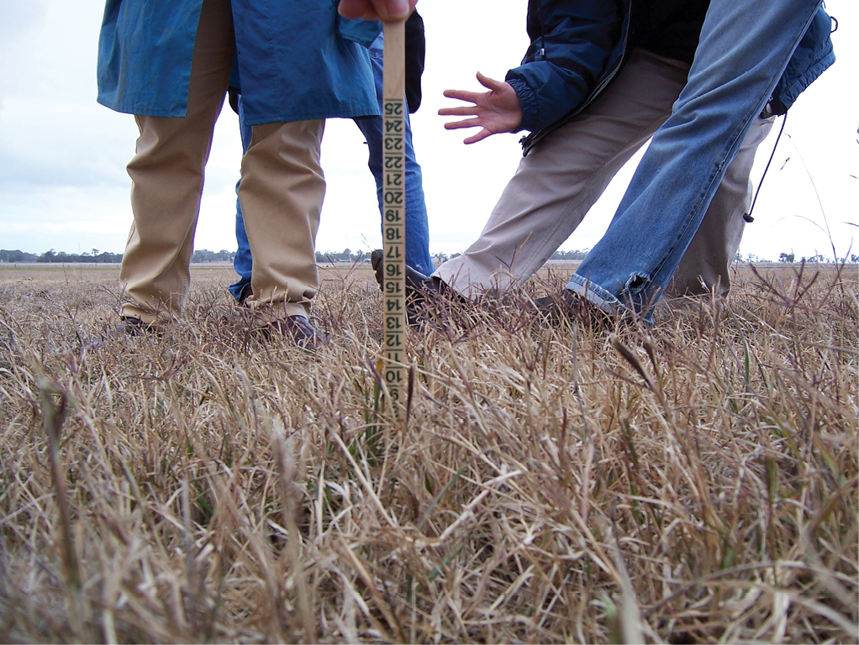
Figure 3.3: 1,000 kg dry matter, 60% digestibility.
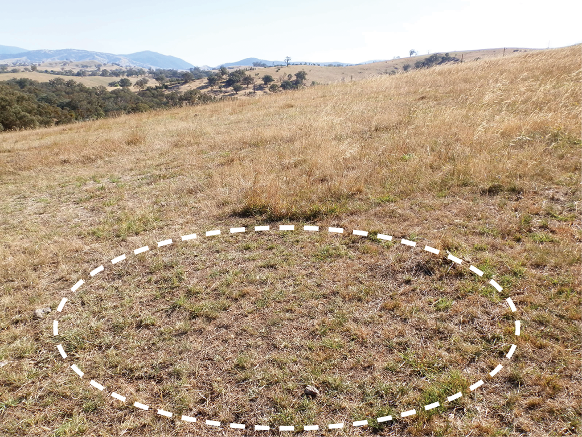
Table 3.1: Metabolisable energy (MJ ME/kgDM) supplied by different pasture qualities.
Pasture Description | Digestibility | Energy (MJ ME/kgDM)
Dry stalks | 50% | 6.5
Dry grass and leaf | 55% | 7.5
Late flowering | 60% | 8
Mid flowering, green and dead | 65% | 9
Late vegetative | 70% | 10
Active green growth | 75% | 10.5

Stock and pasture management at the end of a drought
In previous droughts, some of the worst stock losses have occurred immediately after the drought has broken. It is important that the feeding management of sheep and cattle is carefully planned and supervised over the weeks following the end of the drought.
Stock will spend a lot of energy roaming around paddocks chasing the short ‘green pick’ that quickly appears. Although this green pick is highly nutritious, the quantity that stock can eat soon after germination is not great and may be far less than their maintenance requirements.
Stock need time to adapt from grain feeding to eating pasture. It takes 2-3 weeks for the population of digestive organisms in the rumen of cattle to adjust to digesting pasture rather than grain. Sudden changes from high grain rations to green pasture can cause digestive disturbances.
There may be stock problems if the pasture is dominated by particular weeds. Nitrate poisoning is common in pastures dominated by capeweed and clover early in the season. Do not allow hungry stock free access to these types of pastures. Strip graze the paddock where practical and ensure stock have ad lib access to hay.
The arrival of drought-breaking rains can also be accompanied by cold and windy weather. These conditions place added stress on stock that are already suffering from a lengthy drought.

Feeding management
Feeding should be continued for 2-3 weeks beyond the end of the drought. Stock should be restricted to small areas for that time to allow a wedge of feed to grow ahead of them.
Wean stock off grain over 2-3 weeks and give them access to some green pick to enable their digestive systems to readjust to the green feed.
Cold and windy conditions associated with drought-breaking rains may increase the maintenance requirements of the stock. The rations fed over the 2-3 week period should be increased by about 20% above drought rations.

Pasture recovery
The effect of drought on a pasture will depend on the management and grazing pressure to which it is subjected relative to the rainfall. There are significant differences between species in their ability to withstand the combined effects of heavy grazing pressure and reduced rainfall.
The extent to which pastures recover after a drought depends largely on when the drought-breaking rains are received. If the drought breaks with a ‘normal’ autumn break, the pasture should recover quickly – providing there are adequate numbers of viable seeds to germinate or there are drought-tolerant perennial species present. Sufficient follow-up rains are needed to keep pastures growing vigorously. A delayed break, or lower-than-average rainfall in the autumn, will impair the pasture recovery rate. The effect of drought on irrigated pastures will depend on the availability and frequency of watering.

Annual species
Annual grasses, such as annual ryegrass, will have reduced seed set during a drought, resulting in lower density in pastures the following year.
Lack of competition from favourable species may allow undesirable annual grasses such as silver grass and barley grass to come back strongly, even if there is less seed available for germination.
Spray programs later in the year may be required to control undesirable annual grasses.
Sub clover or medic should have sufficient residual hard seed in the soil to produce a good sward after drought, unless the clover or medic content has been poor for some years before. Bare soil conditions and an early break will favour their germination and it is not uncommon for these annual legumes to return to a similar or greater percentage of the sward than before the drought.
Annual weeds such as capeweed, erodium, Patterson’s curse and thistles will be more prominent after a drought. These broadleaf weeds tend to grow bigger with less competition. If capeweed is dominant, there is a possibility of nitrate poisoning of stock. This can be prevented by not introducing hungry stock to capeweed-dominant pastures.
These species are favoured by bare ground at germination and reduced competition from other species. They also cope better with ‘false’ breaks than more favourable species.

Perennial species
Perennial grass species are likely to suffer considerable reductions in plant numbers during a drought. The longer the dry conditions last, the more severe the effect.
Perennial ryegrass is the least tolerant of drought, followed by cocksfoot, tall fescue and phalaris. A dormant bud in the phalaris plant is its mechanism for survival, supplying the plant with water and nutrients throughout the dry period. By allowing phalaris to set seed in spring, the dormant bud can be fully developed, enhancing the chances of survival.
Take care when grazing phalaris pastures soon after the autumn break. Short phalaris pastures can produce a toxin that causes phalaris staggers and death. The risk can be minimised by allowing plants to establish three leaves before grazing, and feeding the animals hay before they are introduced to phalaris.
Paspalum is relatively drought tolerant and will increase its dominance in under-irrigated pastures.
Lucerne has a deep taproot and can survive drought, provided it is given regular spells from grazing to allow it to recover.
White clover survival is likely to be severely affected, particularly in marginal areas (which includes ‘irrigated’ areas where the watering has been stopped).

Opportunity to improve pastures
Pasture productivity will not necessarily fall drastically after a drought, even though some species will have declined. A ‘wait and see policy’ for up to two years after the drought can allow sufficient time to gauge the actual effects and allow some species, for example perennial ryegrass, to thicken up from seed produced in the post-drought year.
For the best result, a good weed control program should precede all pasture establishment work. Broadleaf weeds, for example, are likely to be a problem in newly germinated pastures unless they are controlled.

Opportunity to control weeds
For any weed control program to be successful, it must include a method for replacing the weeds with more desirable species. Methods may include chemical control followed by re-sowing and/or grazing management programs. Grazing management combined with chemical control can be successful if the desirable species makes up 50% or more of the pasture composition.
The following spray programs may be considered. Always read the product label and follow all directions. Product labels contain helpful information and critical precautions for the safe and responsible use of these techniques.
- Spray grazing for broadleaf weeds. Conducted in autumn or early winter after the break. Spray with a broadleaf herbicide such as MCPA, wait two weeks and graze off the pasture.
- Winter cleaning for annual grasses (particularly silver grass). Conducted in late winter. Spray with simazine, which prevents the annual grasses from seeding.
- Spray-topping for annual grasses such as barley grass. Conducted in mid-spring (when plants are in the ‘milky dough’ stage). Spray with sub-lethal dose of glyphosate and graze off the pasture.
Pre-sowing knock down spray. Spray with a lethal dose of glyphosate before sowing a new pasture or fodder crop.

Need for fertiliser
There may be a larger-than-usual residual effect from fertiliser applied at the start of the drought as a consequence of reduced leaching of nutrients because of the dry conditions and reduced pasture growth.
Areas that have been used for intensive feeding will have increased in fertility due to the nutrients supplied by the feed and recycled through the animal. Soil testing post-drought is the key to ensuring the correct nutrient applications.
In circumstances of reduced stock numbers and restricted finances, it may be necessary to defer or reduce fertilisers for the year.
Nitrogen fertilisers can be used early after the autumn break to boost autumn/winter feed availability. Nitrogen fertiliser is best used on improved plant species and may be wasted if pasture composition has been seriously compromised by the drought.

Fodder crops
In some circumstances, it is useful to grow a winter fodder crop to boost feed supplies after the drought. In most cases there is no need to do so, particularly if there is a good early break and stock numbers are down, or if water is available to irrigate pasture.
Fodder crops can help control weeds prior to re-sowing pasture in the following year and can provide feed more rapidly than a newly sown pasture.

Estimated pasture survival
It is important to assess what recovery might be expected when rain falls so early action can be taken.
A simple procedure is to water (with a watering can) a square metre in several places within the paddock and see what grows. In previous droughts, the results of this procedure have shown a close relationship to what subsequently germinates.
If stock are in the paddock, it may be necessary to use a fence to protect the watered areas.

Assessing the need for resowing a perennial pasture
Resowing does not always mean a total renovation of the pasture. If there is still a reasonable amount of desirable species present, but it needs to be thickened up, direct drilling into the existing pasture is generally the best method.
Ryegrass seed, for example, is generally drilled in at lower rates, such as 15 kg/ha for an oversow, while a full resow generally has sowing rates of 20-25 kg/ha. Other seed types will have different recommended rates.
Assessing composition of the perennial pasture can be completed using the stick method. Walk across the paddock in a diagonal transect. Randomly throw a pen or stick in front as you walk. Note what the end of the stick is touching and record. Complete this 50 times along the transect. Record whether it touches a perennial grass, annual grass, weed or bare ground. If 50 records are collected, simply multiply the number in each category by two to get a percentage composition for the paddock.
If desirable perennial grass species are above 70%, the pasture will still be productive. If the desirable grass species are below 50%, reseeding will increase yields, increase the feed value on offer to stock and increase the response that pasture will have to applications of nitrogen should you choose to use it.
When assessing perennial pastures before the break has arrived, a significant amount of bare ground may be encountered. If this bare ground is 30% or lower, this will not significantly affect pasture production across the year. Clover will germinate and fill some of the bare ground areas, but weed control may be needed to control capeweed growth early in the season (generally about six weeks after the break).
If reseeding, it is a good idea to apply a small amount of phosphorus-based fertiliser to ensure new emerging pasture can readily access phosphorus from the soil. Phosphorus is important for healthy, strong root formation, giving the pasture a kick start to life.
Rates of 10-20 kg/ha of phosphorus will be adequate (114-227 kg super/ha). The phosphorus can either be drilled in with the seed (best response) or broadcast around the time of sowing.

Chapter 4: Monitoring stock condition
This chapter covers the tools for assessing, managing and monitoring cattle condition.
Key Messages
- Assessing fat cover is an important guide for feeding strategies and sale decisions.
Target fat scores are critical for matching feed rations.
The body fat reserves of beef cattle are important at critical stages of the production cycle (growth, reproduction and lactation) and need to be considered when developing drought feeding rations. By assessing the stock and the amount of available pasture, you can calculate the rate of supplementary feeding needed for animals to reach desired production targets.
The weight of cattle varies with the breed, sex, age and pregnancy status, so when feeding for survival during a drought, fat score is used as the standard. Fat scoring can be assessed manually and visually.
The aim of fat scoring is to obtain a simple and reliable estimate of the body fat reserves of live cattle.
Two areas of the animal’s body are palpated to assess fat cover (see Figure 4.1):
- the short ribs
around the tail head.
Fat is the only tissue laid down at these sites, which makes them ideal for assessment. Other sites on the body are harder to assess because of the difficulty of determining the difference between fat and muscle.
The short ribs
The degree of fat deposition can be gauged by placing the fingers flat over the short ribs and pressing the thumb into the end of the short ribs (see Figure 4.2). A fat score is given according to the ease with which the individual short ribs can be felt with the thumb.
The tail head
The degree of fat cover around the tail head is assessed using the fingers and thumb, and should be done at the same time as assessing the short ribs.
A score is given depending on the degree to which palpable fat can be felt.
Figure 4.1: The two areas palpitated to assess fat cover.
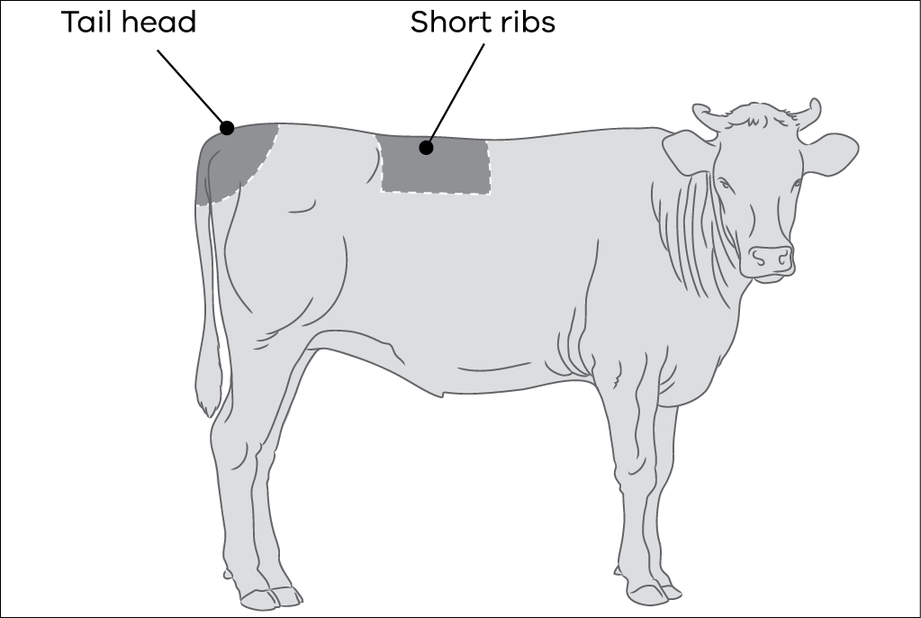
Figure 4.2: The degree of fat cover over the short ribs is assessed using the fingers and thumb.
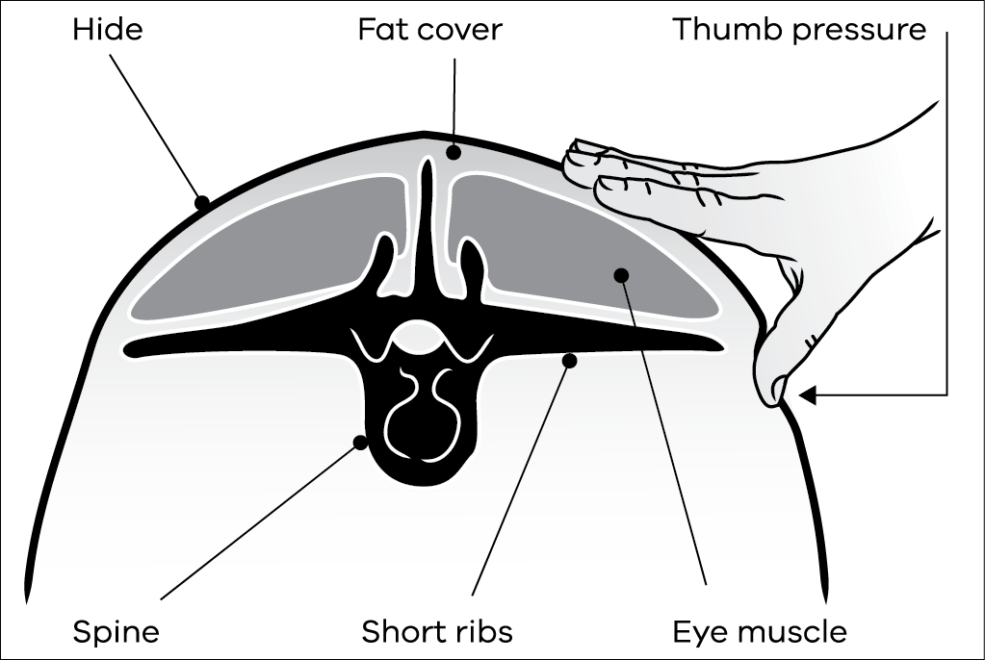

Fat score descriptions
Table 4.1: Fat score descriptions for manual fat scoring.
0 | Emaciated
1 | The individual short ribs are sharp to the touch; no tail head fat. The hip bones and ribs are prominent.
2* | There is some tissue cover around the tail head. Individual ribs are no longer visually obvious. The individual short ribs can easily be felt, but feel rounded, rather than sharp.
3* | The short ribs can only be felt with firm thumb pressure. Areas either side of tail head have fat cover which can be easily felt.
4* | The short ribs cannot be felt and fat cover around the tail head is easily seen as slight mounds, soft to touch. Folds of fat are beginning to develop over ribs and thighs.
5 | The bone structure of the animal is no longer noticeable and the tail head is almost completely buried in fatty tissue.
6 | Bone structure is hard to distinguish. Tail head buried in fat. All other sites show obvious soft fat deposits.
* The score can be varied half a score depending on the amount of tail head fat with half scores reported as low (L) or high (H) within a fat score descriptor.
The scores in Table 4.1 can be varied half a score depending upon the amount of tail head fat. The half scores are reported as low (L) or high (H) within a fat score descriptor. If manual assessment of the short rib area feels like a fat score 2, but an assessment of the fat cover around the tail head fits into the category description of a fat score 3, the score given to the animal would be 2H.
If a manual assessment of the short rib area feels like a fact score 3, but an assessment of the fat cover around the tail head fits into the category description of a fat score 2, the score given to the animal would be a 3L.

Visual assessment
Visual assessment is less accurate but will give a good indication during a paddock inspection. The two main factors associated with cattle condition and finish are fat and muscle. These are assessed visually at three main sites – the rear, brisket and flank (Figure 4.3).
As cattle become fatter:
- the ribs become less visible
- the tail head softens with rounds of fat increasing behind the tail
- muscle seams on the hindquarters become less evident
brisket, flank, cod and twist all fill out, giving a squarer appearance.
There is no muscle in the tail head, flank, brisket and cod. If these areas are filled out, they will be filled with fat, which makes them ideal sites to assess fat cover.
The same description of fat scores is used for manual and visual assessment.
Figure 4.3: Reference points for visual assessment.
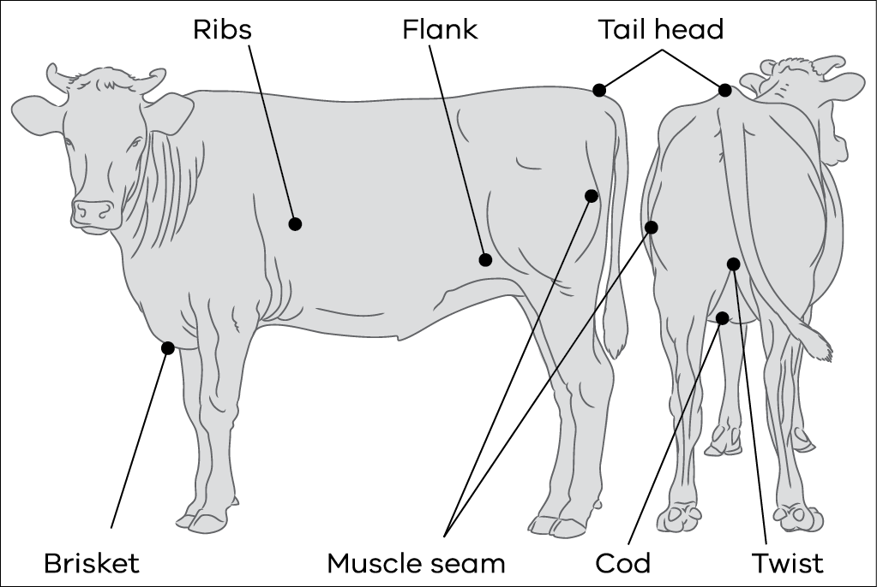

Muscling
Indicators of muscling in order of importance are:
- thickness and roundness of the hindquarters
- width through the stifle (lower hindquarter)
- width across the back and the loin
stance – how wide apart the animal stands, i.e. the width between the hind legs and width between the forelegs.
Fat cattle look ‘blocky’ and square, well-muscled cattle look rounded.
Observe cattle from behind to assess thickness through the lower hindquarters (stifle area). Heavily muscled stock are thickest here; they also stand with their legs further apart than lightly muscled stock.

Target fat scores
There will always be a range of fat scores within a mob of cattle. If the range is wide, splitting mobs according to fat score is common practice and a good idea. This will enable you to specifically match rations for each class of animal to achieve target fat scores.
Select a number of poorer animals in the mob to monitor regularly and then assess their progress towards the desired fat score every week to gauge the direction of the mob. If the animals’ progress is too quick or too slow, you can adjust the ration to compensate.
Table 4.2: Minimum and desired fat scores for different classes of stock.
Stock | Minimum fat score | Fat score ideal for production
Dry cows | 2 | 3
Cows – point of calving | 3L (autumn)  2H (spring) | 3H (autumn)  3L (spring)
Cows – joining | 2H | 3-3H
Cows – mid lactation | 2H | 3
Weaners | 2 | 2-3
Bulls at joining | 3 | 3H

Managing cattle condition
Adult cattle gain and lose condition across the year, depending on the feed available for consumption compared to their needs. Adult cattle that are in forward condition (fat score above 3½) present an opportunity to utilise some of the condition they are carrying to offset supplementary feed costs.
Important notes to consider before reading further:
- Managing cattle condition requires a high degree of management, more frequent supervision of the stock and protection from the elements to ensure their welfare is not compromised.
- Pregnant cows must be fed to allow them to calve without complications.
- Early weaning should be considered so the cows can be treated as dry adults that will have considerably lower nutritional requirements than lactating cows; calves will need a high-protein, good-quality feed.
Cattle less than 12 months of age should not be allowed to lose weight – young growing stock should be managed to ensure they are maintaining or gaining weight.
The rate of weight loss should be controlled to ensure cows do not lose more than 0.5 kg/day – failure to control the rate of loss will cause the cattle to be prone to starvation ketosis. Starvation ketosis is a metabolic disorder that occurs in cattle when energy demand exceeds energy intake and results in a negative energy balance.
If the negative energy balance is too large, body fat (as an energy source) may be mobilised faster than the liver can metabolise it, resulting in a product called ketone building up in the animal’s system. Cattle suffering ketosis will lose weight and have a reduced appetite. This depressed appetite will result in further weight loss and, left untreated, death. A 500 kg dry cow requires 55 MJ ME/day to maintain her bodyweight (see Chapter 6 for information on stock requirements). If the feed she was consuming had an energy of 9 MJ ME/kgDM, the cow would need (55 ÷ 9) 6.1 kgDM to maintain her current weight.
When cattle lose weight, for each kilogram they lose, 28 MJ ME is released back to the animal. When losing 0.5 kgLW/day, 14 MJ ME is released back to the animal.
If you allowed her to lose 0.5 kgLW/day, instead of requiring the 55 MJ ME/day for maintenance she would only require (55-14) 41 MJ ME/day, equating to 4.5 kgDM of the above feed.
One fat score is the equivalent of 70 kg liveweight. At a rate of 0.5 kgLW loss per day, it would take 140 days for a cow to lose one fat score – drop from a fat score 3H down to 2H. Dry beef cows should not be allowed to fall below a fat score 2.
The fat score that cows calve down in has a significant impact on their subsequent fertility. The better the fat score they are in at calving, the quicker they will return to oestrus, with a better chance of getting in calf within the joining period. Feed quality and quantity post-calving will also have an impact.
Impact of fat score if cows are on good feed post-calving:
- If a cow is in fat score 3 at calving and is on good feed post-calving it will take her about 30 days to first heat.
If a cow is in fat score 2 at calving and is on good feed post-calving it will take her about 40 days to first heat (extra 10 days due to lower fat score).
Impact of fat score if cows are on poor feed post-calving:
- If a cow is in fat score 3 at calving but is on poor feed post-calving it will take her about 65 days to first heat (an extra 35 days due to poor feed levels).
If a cow is in fat score 2 at calving and on poor feed post-calving it will take her about 90 days to first heat (an extra 60 days due to the combination of poor condition and poor feed).
This could cause a substantial shift in your calving pattern and result in a high empty rate in your cows.

Chapter 5: Choosing feeds
This chapter discusses the use and interpretation of feed analyses in costing and balancing rations.
Key Messages
- A feed analysis is the only accurate way to determine the value of the feed being offered to your cattle.
- Feed analysis samples should be taken and sent to arrive at the laboratory as quickly as possible (e.g. avoid them being held in transit over a weekend).
- Key figures to know are energy, protein, fibre and dry matter of the feed.
If purchasing feeds, compare the feed costs based on the component you are buying the feed for – energy, protein or fibre.

Understanding the components of a feed
It is important to provide stock with a ration that will enable them to achieve a desired level of performance. When developing a feed budget, the main feed components to know the value of are energy, protein, fibre and dry matter. Other components that are tested and reported in a feed analysis, such as minerals and vitamins, should also be taken into consideration.
It is difficult to judge feed quality visually. To ensure cattle are properly fed, it is important to get an objective measure of the feed components.

Energy
The metabolisable energy (ME) values of different feeds are important for two main reasons:
- The ability of the animal to maintain their weight and production level (growth, reproduction and lactation) is highly dependent on meeting specific energy requirements. It is only possible to calculate the amount of feed required to meet production targets when you know the energy value of the feeds that make up a ration.
The decision to buy a feed should be based on the cost per unit of energy rather than the cost per tonne. See later in this chapter for details on costing feeds on an energy basis.
One problem with feeding based on energy values alone is getting the stock to physically eat enough. Feeds high in fibre (such as mature pasture hay, cereal hay and straw) cannot be eaten in large enough quantities to provide the required energy because they are digested slowly and stock physically can’t fit enough in. This shortfall in energy requirements results in the animal using body fat to meet its needs. To avoid this, do not use low energy feeds as a sole ration. Mix high-fibre feeds with higher-energy feeds, such as pasture, silage, good quality hay or grain, to meet overall requirements. The higher the energy requirement, the smaller the amount of low-quality feed that can be used in the diet.
A feed analysis report will report back on metabolisable energy (ME), expressed as megajoules per kilogram dry matter (MJ/kgDM), sometimes also written as MJ ME/kgDM.
ME is the amount of energy in the feed that is available to cattle for use. It involves the measurement of energy excreted in faeces, urine and exhaled as methane. This requires specialised equipment so in Australia it is calculated based on the digestibility of a feed.
As an example of the importance of knowing the variability in feed quality, the ME of pasture hay can vary from 6.5 MJ ME/kgDM for very poor, mature grass hay to 9.5 MJ ME/kgDM for top-quality clover-dominant hay. Grains can range from 9 to 13 MJ ME/kgDM.

Protein
Protein contains nitrogen, which is used to estimate the protein content of feeds. It is typically measured as crude protein and expressed as a percentage of dry matter. It is called crude protein because it measures both the true protein (amino acids) and a portion of the nitrogen in feed that is non-protein nitrogen (nitrates, ammonia and urea).
The protein requirements of cattle vary according to the weight and type of animal, as well as the level of production (growth, reproduction and lactation). Crude protein values give a good indication of whether a particular foodstuff will satisfy the protein needs of an animal.
Green pasture is typically high in protein (leafy pasture is 25-30% crude protein). Short green pasture can go a long way in lifting the level of protein in the diet. When no green pasture is available, protein intake may fall below requirements. Failing to meet protein requirements will result in the energy in the diet not being completely used and may even result in stock using the breakdown of muscle to overcome the shortfall of protein.
Growing stock have high demands for protein. Steers and heifers weighing between 180 kg and 400 kg require 13% crude protein in their diet to grow 1 kg/day. Early-weaned calves have even higher requirements of 16% protein.
Some supplements, such as processed grain and pellets, are medium to high in protein and will be useful if they are cost effective and practical. Supplements that are likely to be low in protein include cereal hays, straws, low-quality pasture hays and some cereal grains.
Crude protein values can range from 6% to 19% in hay. Silage can show similar variation, and in the case of cereal grains, protein can vary from 5% to 16%.
Lupins are very high in protein and are often added to a cereal grain to increase the protein level of the diet.
Forms of non-protein nitrogen such as urea can be used to increase the rate of digestion of high-fibre feeds such as hay and straw, but caution is needed as urea can be toxic if consumed in high quantities. In general terms, at least two-thirds of an animal’s total protein intake should be provided as true (natural) protein. That is, not more than one-third of the protein should be represented by non-protein nitrogen (NPN). These nitrogen additives should not be included in levels above 2% of the diet.

Fibre
Cattle need a certain amount of fibre to ensure the rumen functions properly. Generally, cattle grazing pasture will get enough fibre in their diet.
Neutral detergent fibre (NDF), as reported in a feed analysis, is a measure of the total fibre (the digestible and indigestible parts) and indicates how bulky the feed is. It is reported as a percentage of dry matter.
A high NDF will result in a lower intake. Conversely, lower NDF values lead to higher intakes. The minimum level of fibre required in the diet is 30% NDF for all classes of cattle.
Too little fibre can result in acidosis, as the feed is digested too quickly and the rumen isn’t able to function properly. Low-fibre, high-starch diets (such as grains) cause the rumen to become acidic. These feeds include cereal grains, some by-products and certain vegetables, such as potatoes. These feeds need to be introduced into the diet slowly. See Chapter 7 for more detail on how to introduce cattle to grain.
If you are using low-fibre supplements, ensure there is adequate fibre elsewhere in the diet. Hay, straw, silage and pasture all have a lot of fibre and can be used to keep fibre at the desired level. Oats are the safest and highest fibre grain with 29% NDF, compared with barley at 14% NDF and wheat at around 11% NDF.
Too much fibre limits the amount an animal can eat. For example, if cows with young calves are grazing poor pasture and fed a supplement of low-quality hay, their energy intake would be too low. This would result in cow weight loss and poor calf growth. In these instances, a low-fibre, high-energy supplement (such as grain or pellets) should be provided.

Dry matter
It is important to know the dry matter (DM) content of the feed. All measurements of energy and protein are made on a DM basis so feeds of different moisture contents can be compared.
DM is the amount of feed left after all the water in the sample has been removed by oven drying. It is expressed as a percentage of the original sample.
Silage has a high moisture content and is around 45% DM. This means 1 tonne of silage has only 450 kg of dry matter and 550 kg of water. Grain has a much lower moisture content and is about 90% DM. This means 1 tonne of grain has 900 kg of dry matter and only 100 kg of water.
Knowing the DM percentage enables you to work out how much to feed to provide to meet the energy requirements of the stock.
Example: If silage has an energy level of 11 MJ ME/kg DM, how much silage do you need to feed 50 MJ ME of energy?
Silage required:
50 MJ ME ÷ 11 MJ ME/kgDM = 4.5 kgDM
4.5 kgDM ÷ 0.45 (silage 45% dry matter)
= 10 kg as fed

Other components of a feed analysis
- Moisture is the amount of water in the feed and is measured as a percentage of the original sample.
- Digestibility can be seen on a feed analysis report as DDM or DMD (depending on the company completing the analysis), and is reported as a percentage of dry matter. It is the percentage of the dry matter actually digested by the animal. High-quality feeds will have a figure over 65%. Feeds below 55% are of poor quality and even if cattle are given unlimited access, they will be unlikely to be able to maintain their liveweight.
- Digestibility of organic matter (DOMD) is a calculated figure and is expressed as a percentage of dry matter. It is a measure of the digestibility of the organic component of the feed and takes into account the inorganic component (referred to as ash) such as sand, dirt and clay that may be present in the sample.
- Acid Detergent Fibre (ADF) is reported as a percentage of dry matter. It estimates the proportion of feed that is indigestible to stock (mainly cellulose and lignin). Feeds with a low ADF are high in energy; those with a high ADF are low in energy.
- Ash is reported as a percentage of dry matter and is the inorganic portion that is not utilised by the stock. It is any sand, dirt and clay in the sample.
- Fat is expressed as a percentage of dry matter and is a measure of the lipid content of the feed. If the diet of cattle is too high in fat correct rumen function can be impaired.
Water soluble carbohydrate (WSC) is reported as a percentage of dry matter and is a measure of the total naturally occurring sugars in the feed. The sugars are a source of energy for the rumen bacteria and therefore the cattle.
Note: Not all companies test and report on the same components. Ensure these key components are tested: metabolisable energy, protein, neutral detergent fibre and dry matter.

How to sample for a feed analysis
The first step is to select the feed analysis company you wish to use. The company websites have details about how to sample, costs involved, how to access sampling kits and payment methods.
The following companies offer feed analysis:
- FEEDTEST®, PO Box 728, Werribee Victoria 3030 Ph: 1300 655 474 Email
- Feed Central, 10775 Warrego Highway, Toowoomba Queensland 4350 Ph: 1300 669 429, Email
Forage Lab Australia, 12 Gildea Lane, Bendigo East, Victoria 3550 Ph: 03 54439665.

Sampling and sample submission
The analysis is only as good as the sample taken, which must adequately represent the feed being tested. Hay and silage in particular are quite variable, so take great care when sampling them.

Sampling hay and bale silage
Use a coring device, made from 32 mm steel tubing about 450 mm long, and attached to an electric drill or hand brace. The cutting edge should be slightly scalloped and must be kept sharp. Each sample should consist of cores taken at random from 15-20 bales, with each core taken from the ‘butt’ end of a bale.
Take separate samples to represent different paddocks, cutting times, clover content, weather damage, etc.
Hay and silage can be sampled by hand as described in the silage section. This method, however, is much less accurate.

Sampling pit silage
Sample by hand from 10-20 spots across a freshly cut face of the stack, mix thoroughly and sub-sample, to yield a total amount not exceeding 500 g. Alternatively, use a hay corer.
Seal the sample in a strong airtight plastic bag. Send the sample immediately. If a delay is unavoidable, refrigerate the sample until it is sent, especially in hot weather.

Sampling pasture
Walk through the paddock and cut a sample to residual grazing height (height cattle normally graze down to) from near the toe of your right boot, every 10 steps. Ensure that the same sized area is cut every time (about 30 square centimetres) and that you sample from at least 15 locations in the paddock. Combine these samples into one and thoroughly mix to obtain an amount not exceeding 500 g. Be careful not to contaminate the sample with soil or faeces. Seal the sample in a strong airtight plastic bag. Send the sample immediately. If a delay is unavoidable, refrigerate the sample until it is sent, especially in hot weather.

Sampling grains and pellets
Select several sub-samples from different areas. Thoroughly mix them and send 300-400 g of this mix for testing.
Use one bag for each sample. Fill out the analysis company’s sample information sheet with details of the feed and its intended use.
Samples should be posted as soon as possible after collection.
Table 5.1: Energy and protein compositions of common livestock feeds (pasture, hay, silage, straw).
Feed | Approx dry matter (DM) % | Energy MJ ME/kg DM Average | Energy MJ ME/kg DM Range | Crude protein % dry matter Average | Crude protein % dry matter Range
Grazed pastures
Grass-dominant pasture |  |  | 3-14 |  | 1-37
Young, immature | 23 | 11 |  | 25
Mature | 40 | 7 |  | 5
Clover-dominant pasture |  |  | 4-12 |  | 1-35
Immature | 15 | 11 |  | 30
Mature | 30 | 4 |  | 7
Lucerne |  |  | 4-13 |  | 3-41
Young, immature | 17 | 11 |  | 30
Full bloom | 24 | 8 |  | 15
Grazed cereal crops
Barley/oats |  |  | 7-13 |  | 3-33
Early vegetative | 19 | 9 |  | 20
Post-bloom | 21 | 10 |  | 8
Hay
Pasture hay, grass dominant |  |  | 5-11 |  | 1-30
Flowering | 80 | 10 |  | 9
Two weeks after flowering | 85 | 9 |  | 8
Pasture hay, sub clover dominant Flowering | 80 | 9 | 7-11 | 13 | 8-26
Lucerne hay |  |  | 5-11 |  | 6-28
Pre-flowering | 85 | 9 | 5-12 | 15
Flowering | 90 | 8 |  | 14
Oaten/wheaten hay |  |  | 5-11 |  | 1-16
Flowering | 85 | 9 |  | 7
Milk stage | 87 | 8 |  | 5
Ripe seed | 90 | 8 |  | 3
Canola hay | 70 | 11 | 8-13 | 17 | 4-27
Silages
Grass dominant | 45 | 10 | 7-11 | 14 | 4-23
Legume dominant | 44 | 10 | 8-12 | 15 | 8-28
Lucerne | 51 | 10 | 7-11 | 19 | 11-27
Cereal | 46 | 9 | 6-11 | 11 | 4-21
Canola | 60 | 9 | 6-10 | 17 | 9-26
Cereal straws
Barley, oaten, wheaten | 90 | 5 | 4-7 | 2 | 1-4

Table 5.2: Energy and protein compositions of common grains (whole and processed).
IMPORTANT – Note the difference in approximate dry matter (DM) % (ME) Metabolisable energy (MJ/kg DM)
Grain | Approximate dry matter  (DM) % | When fed whole to cattle  Average | Energy MJ ME/kg DM  When fed rolled or coarsely milled to cattle  Average | Energy MJ ME/kg DM  When fed rolled or coarsely milled to cattle  Range | Crude protein % dry matter  Average | Crude protein % dry matter  Range
Wheat | 90 | 9 | 13 | 12-15 | 12 | 8-23
Barley | 90 | 8.4 | 13 | 11-13 | 11 | 6-17
Triticale | 90 | 10.4 | 13 | 12-15 | 12 | 9-15
Oats | 90 | 10 | 11 | 9-13 | 9 | 6-12
Lupins | 90 | 11 | 13 | 12-14 | 30 | 26-40
Peas | 90 | 11 | 13 | 10-13 | 23 | 18-29
Maize | 90 | 13 | 13.5 | 12-14 | 9 | 8-13
Safflower seeds | 90 |  | 13 | 7-12 | 25 | 20-37
Rice (dehulled) | 90 |  | 12 | 11-14 | 7 | 7-9
Rye | 90 |  | 14 |  | 11
Sorghum | 90 | 10 | 13 |  | 11
Pellets | 90 | N/A | 12 | 10-14 | 12 | 11-16
WARNING: As can be seen from the table, feeds vary considerably in nutritional value depending on growing conditions, stage of harvesting and storage conditions. The only way to be sure of the nutritional value of a particular batch of feed is to have it tested for energy, protein, fibre and dry matter.

Costing fodders on energy value
Fodders such as grain and hay are usually bought and sold on a price per tonne (or some other unit of weight or size). Feeds contain moisture and need to be converted to dry matter figures before they can be compared.
The most important basis for comparison of feedstuffs is their energy content. Tables 5.1, 5.2, 11.1 and 11.2 list the energy and protein values of a range of foodstuffs. It is important to note that those values are all expressed on a dry matter (DM) basis.
The following section aims to help calculate which feed is the best value for money. To make comparisons you must first look at the energy and dry matter content of the feedstuff.

How to calculate the cost of feed on an energy basis
Example: Which feed is the best value on an energy basis?
Feed | Cost/tonne | Dry Matter % | Energy  MJ ME/kgDM
Feed A | $195 | 85% | 10
Feed B | $230 | 90% | 13

Feed A
Step 1 – Calculate the price of the feed on a dry matter basis at 85% dry matter
$/tonne as fed | x 10 | ÷ | % DM | = | Cents/kgDM
195 | x 10 | ÷ | 85 | = | 23

Step 2 – Calculate the cost per MJ of energy
Cents/kgDM | ÷ | MJ ME/kgDM | = | Cents/MJ ME
23 | ÷ | 10 | = | 2.3

Feed B
Step 1 – Calculate the price of the feed on a dry matter basis at 85% dry matter
$/tonne as fed | x 10 | ÷ | % DM | = | Cents/kgDM
230 | x 10 | ÷ | 90 | = | 25.6

Step 2 – Calculate the cost per MJ of energy
Cents/kgDM | ÷ | MJ ME/kgDM | = | Cents/MJ ME
25.6 | ÷ | 13 | = | 1.97

Therefore, Feed B is better value per unit of energy, costing 1.97¢/MJ ME, compared to 2.3¢/MJ ME for Feed A.

Table 5.3: Quick lookup table for costing fodder based on energy value – costs are calculated on a cents/megajoule basis.
$/tonne
Fodder | MJ ME/kg DM | 125 | 150 | 175 | 200 | 225 | 250 | 275 | 300 | 325 | 350 | 375 | 400 | 425 | 450 | 475 | 500
Grain/pellets  (assuming 90% DM) | 14.0 | 1.0 | 1.2 | 1.4 | 1.6 | 1.8 | 2.0 | 2.2 | 2.4 | 2.6 | 2.8 | 3.0 | 3.2 | 3.4 | 3.6 | 3.8 | 4.0
Grain/pellets  (assuming 90% DM) | 12.0 | 1.2 | 1.4 | 1.6 | 1.9 | 2.1 | 2.3 | 2.5 | 2.8 | 3.0 | 3.2 | 3.5 | 3.7 | 3.9 | 4.2 | 4.4 | 4.6
Grain/pellets  (assuming 90% DM) | 10.0 | 1.4 | 1.7 | 1.9 | 2.2 | 2.5 | 2.8 | 3.1 | 3.3 | 3.6 | 3.9 | 4.2 | 4.4 | 4.7 | 5.0 | 5.3 | 5.6
Grain/pellets  (assuming 90% DM) | 8.0 | 1.7 | 2.1 | 2.4 | 2.8 | 3.1 | 3.5 | 3.8 | 4.2 | 4.5 | 4.9 | 5.2 | 5.6 | 5.9 | 6.3 | 6.6 | 6.9
Hay  (assuming 85% DM) | 10.0 | 1.5 | 1.8 | 2.1 | 2.4 | 2.6 | 2.9 | 3.2 | 3.5 | 3.8 | 4.1 | 4.4 | 4.7 | 5.0 | 5.3 | 5.6 | 5.9
Hay  (assuming 85% DM) | 8.0 | 1.8 | 2.2 | 2.6 | 2.9 | 3.3 | 3.7 | 4.0 | 4.4 | 4.8 | 5.1 | 5.5 | 5.9 | 6.3 | 6.6 | 7.0 | 7.4
Hay  (assuming 85% DM) | 6.0 | 2.5 | 2.9 | 3.4 | 3.9 | 4.4 | 4.9 | 5.4 | 5.9 | 6.4 | 6.9 | 7.4 | 7.8 | 8.3 | 8.8 | 9.3 | 9.8
Silage  (assuming 40% DM) | 14.0 | 2.2 | 2.7 | 3.1 | 3.6 | 4.0 | 4.5 | 4.9 | 5.4 | 5.8 | 6.3 | 6.7 | 7.1 | 7.6 | 8.0 | 8.5 | 8.9
Silage  (assuming 40% DM) | 12.0 | 2.6 | 3.1 | 3.7 | 4.2 | 4.7 | 5.2 | 5.7 | 6.3 | 6.8 | 7.3 | 7.8 | 8.3 | 8.9 | 9.4 | 9.9 | 10.4
Silage  (assuming 40% DM) | 10.0 | 3.1 | 3.8 | 4.4 | 5.0 | 5.6 | 6.3 | 6.9 | 7.5 | 8.1 | 8.8 | 9.4 | 10.0 | 10.6 | 11.3 | 11.9 | 12.5
Silage  (assuming 40% DM) | 8.0 | 3.9 | 4.7 | 5.5 | 6.3 | 7.0 | 7.8 | 8.6 | 9.4 | 10.2 | 10.9 | 11.7 | 12.5 | 13.3 | 14.1 | 14.8 | 15.6
Straw  (assuming 90% DM) | 6.0 | 2.3 | 2.8 | 3.2 | 3.7 | 4.2 | 4.6 | 5.1 | 5.6 | 6.0 | 6.5 | 6.9 | 7.4 | 7.9 | 8.3 | 8.8 | 9.3
Straw  (assuming 90% DM) | 4.0 | 3.5 | 4.2 | 4.9 | 5.6 | 6.3 | 6.9 | 7.6 | 8.3 | 9.0 | 9.7 | 10.4 | 11.1 | 11.8 | 12.5 | 13.2 | 13.9
Straw  (assuming 90% DM) | 2.0 | 6.9 | 8.3 | 9.7 | 11.1 | 12.5 | 13.9 | 15.3 | 16.7 | 18.1 | 19.4 | 20.8 | 22.2 | 23.6 | 25.0 | 26.4 | 27.8

Other factors to consider when buying fodder
The cost of feeding cattle is not just the cost to buy feed. There are also costs associated with labour, freight, extra storage and handling, and the likely amount of wastage.

Grain processing
Cattle only derive the full value from grains such as wheat, triticale and barley if the grain is rolled or coarsely milled (Table 5.2). Processing equipment can be expensive, but may be worth the investment if used on a large enough scale.
Feed companies sell rolled or crushed grain, but at a higher price than whole grain. Remember to calculate the cost (in ¢/MJ ME) for both the whole and the crushed grain.

Storage, handling, feeding out
Ask the feed company about storage requirements for the feed you are looking at buying. Consider what equipment and infrastructure you will need to be able to store and feed out purchased feed. If you are using self-feeders, ask how well the feed will flow through them.

Availability
The microbes in the rumen, which provide the cattle’s main digestive capacity, take up to two weeks to adjust to a new feed source and fully utilise that feed. As a result, feeding cattle for less than two weeks is uneconomic. There is little use starting cattle on a feed that you are not able to source for longer than a two-week period.
Switching cattle too quickly from one feed source to another every couple of weeks carries with it a high risk of digestive upsets and the bugs in the rumen try to constantly adapt to differing feed sources.

Cost of freight
The bulkiness and handling difficulties of some feedstuffs (for example, feeds high in moisture such as carrot pulp) mean higher freight costs compared to concentrated feeds such as grains.

Noxious weeds
Take care to buy fodder that is free from noxious weeds. Weeds such as Paterson’s curse, Bathurst burr, variegated thistle, etc, can be a problem for years after a drought has ended if they are accidentally introduced onto a property. It is important to inspect all samples for weed seeds, however it is not always possible to detect a potential problem or even to refuse delivered feed on these grounds.
One way to minimise potential weed problems is to restrict feeding out suspect fodder to a limited number of paddocks. Stock can be boxed together in large mobs on stable soils. This can have the added advantage of preserving some vegetation on de-stocked areas of the farm, reducing the likelihood of severe erosion.

Tips for buying hay
Hay can be a good management option in some situations, but it can be expensive and often hard to find a quality supply.
An average dry cow requires 8.5 kg DM/day of hay (depending on the quality of the hay) to maintain herself (which is almost half a small bale). If high rates of grain are fed, the diet will need to contain good-quality hay to maintain adequate fibre levels.
If you are buying hay from other districts, transport costs will be higher. Aim to buy only high quality hay to avoid paying transport on low-value feed.
Buying locally has the advantage of low transport costs and knowing the quality of the hay.
When buying, find out the feed value, how long it has been stored, the amount of legume or clover, and whether there are any weeds present. Ask the vendor if any has been sold into your district so that you can inspect hay from the same batch before buying.
It is also a good idea to ask about the pasture species, the type of shed where the hay is stored and the stage of maturity the hay was baled. If the vendor has good knowledge of their hay they are more likely to be a genuine seller rather than a dealer in hay.
If buying lucerne, be aware that first cut lucerne will have a lower nutritive value and more annual weed seeds. If you do buy lucerne, make sure it has a fine stalk. It is also important to have a method of feeding that will avoid the loss of leaf. The best method is to feed lucerne in a feeder, or to mill the hay and feed in a feed trough. Dampening the lucerne hay the day before feeding will help to hold the leaf on the stem and reduce losses.
When buying hay try to purchase by weight so you can calculate a price per tonne delivered to your property. It is a good practice to request a feed analysis for the hay, which will give an accurate measure of the metabolisable energy (MJ ME/kgDM), crude protein and fibre content. This will enable you to price your hay on a ¢/MJ ME basis and compare the value of the various feeds on offer.

Drought feeding of stock – the risk of chemical residues
Many producers are tempted to try a variety of alternate feedstuffs. Chapter 11 presents information on the feed value of a range of unusual feedstuffs. Alternative feedstuffs can range from waste plant products and vegetable matter from manufacturing processes – such as potatoes, citrus pulp, cabbage leaves and carrots – to manufacturing by-products – such as cotton waste and sawdust.
Apart from their generally poor nutritional value, these ‘unusual’ feedstuffs could also be contaminated with high levels of chemical residue. Potentially all supplementary feeds may contain chemical contaminants, but ‘unusual’ feedstuffs, not normally used for feeding livestock, pose a much greater risk.
Agricultural chemicals used on fruit and vegetable crops are typically designed to be eliminated from the edible parts of the plant at harvesting. Some residues, however, may still be present in the waste plant material after processing and problems can occur when this is fed to stock.
These agricultural chemicals are not designed to be ingested by livestock, and little is known about either their effect on livestock or the persistence of chemical residues in animal tissues.
There is a very real possibility that the meat from animals that are fed products containing chemical contaminants will itself become contaminated with these chemicals. Producers should be aware of the Export Slaughter Interval (ESI) and the Withholding Period (WHP).
The ESI is the time that should elapse between administration of an agricultural or veterinary chemical to animals and their slaughter for export.
The WHP is the minimum period that must lapse between last administration or application of an agricultural or veterinary chemical, including treated feed and the slaughter of the animal for human consumption. WHPs are mandatory for domestic slaughter and on the label of every registered product.
Chemical-withholding periods must be observed for any chemical used in a crop. In some instances chemical use earlier on in the season may preclude the option of cutting the crop for hay. It is essential that withholding periods be observed.
The best policy is not to feed unusual feedstuffs to stock without first establishing that the material is suitable.
Producers should ask the supplier of unusual feedstuffs to certify that the material they are supplying is suitable for the purpose for which it will be used.
Where possible, producers should obtain a commodities vendor declaration on any feedstuffs they buy.

Chapter 6: Feeding cattle
This chapter discusses the energy and protein needs of different classes of cattle and examples of feed budgets to assist in determining feed requirements.
Key Messages
- A feed budget will help determine the amount of supplementary feed required.
- Feed budgets are best completed using the energy requirements of stock and the energy content of feeds, then converted back to kilograms of dry matter consumed.
- Completing feed budgets using kilograms of dry matter estimates for cattle intakes can lead to large errors due to highly variable energy contents of feed, particularly grasses – 1 kgDM grass in spring could have an energy value of 11 MJ ME/kgDM, whereas in summer 1 kgDM grass could have a value of 6 MJ ME/kgDM.
- Even if the energy of the diet is adequate, the desired level of production (maintenance, growth, etc) will not be achieved if there is not enough protein.
Cattle have an upper limit to appetite that is influenced by the fibre level of the feed being offered.

Nutritional requirements of beef cattle
Beef cattle production can be affected by a whole range of dietary mineral and vitamin deficiencies (or excesses), but by far the most important nutritional limitations are energy and/or protein.
It is important to know the approximate weight of each animal and the level of production (e.g. growth rate or stage of reproduction) that is expected for, say, a 300 kg steer to grow at 0.5 kg/day or a mature, dry cow that is seven months pregnant.

Explanation of the terms used in the following tables

Liveweight, growth rate
To precisely plan feeding management, you need to have some idea of liveweights and expected growth rates of cattle. This can only be achieved by weighing cattle.

Maximum intake
Cattle have an upper limit to their appetite. This can be defined either in terms of a percentage of their liveweight or as a weight of feed. One of the most common issues in a drought is that animals are physically not able to consume enough supplement to meet a required level of nutrition each day. Intake is influenced by the fibre level of the feed being consumed, the higher the fibre levels in the feed, the less the animal is able to consume. See Tables 6.1-6.4 for approximate maximum intake for different rations.

Metabolisable energy (ME) requirement
The ME value of a foodstuff is the amount of energy a ruminant animal (sheep or cattle) is able to use, per kilogram that it consumes. The units of ME are megajoules (MJ) per kilogram of dry matter (DM) of the particular foodstuff.
The ME requirement of an animal can be accurately estimated, as long as its weight and level of production (for example growth rate or stage of reproduction) are specified.

Minimum ME concentration of diet
The minimum ME concentration of the diet is calculated from the relevant values for maximum daily dry matter intake and metabolisable energy requirement.
To achieve the stated level of production, it is necessary to ensure that the cattle have access to a diet that has an energy level at least as high as the minimum value shown in the sixth column in Tables 6.1-6.4.
As an example of how these values could be used, a 300 kg steer requires a diet with a minimum of 10 MJ ME to grow at 1 kg/day. This is possible on young, growing green pasture (energy value of 11 MJ ME), but not on mature, dry pasture (energy value of 7 MJ ME). See Tables 5.1, 5.2 and 11.2 for the value of different feeds.

Crude protein percentage of dietary dry matter
Tables 6.1-6.4 show that the protein requirements of cattle vary according to the weight and type of animal, as well as the expected level of production.
Even when the ME concentration of the diet is adequate, if the protein percentage is inadequate, the desired level of production will not be achieved.
If protein is the limiting nutrient in a diet, cattle may not be able to eat enough to satisfy their maintenance requirements. In some situations, non-protein nitrogen (NPN) supplements, such as urea, can significantly stimulate appetite. See later in the chapter for further information on urea.
When pasture dries off, there can be plenty of dry-standing feed of low quality. Feeding animals NPN stimulates rumen microbes and increases feed intake, so cattle consume more dry feed than they otherwise would.
Animals can be fed a NPN source such as urea in the form of blocks, licks or urea fortified molasses. However, adequate dry-standing feed or fodder must be available or these supplements will simply be an extremely expensive source of energy.

Energy and protein requirements of various classes of cattle
Table 6.1 Steers and heifers (after weaning) (See table 10.1 for early weaned, lighter calves)
Liveweight (kg) | Growth rate (kg/day) | Maximum daily dry matter (DM) intake  % of liveweight | Maximum daily dry matter (DM) intake  (kg) | Metabolisable energy (ME) requirement  (MJ ME/day) | Minimum ME concentration of diet  (MJ ME/kgDM) | Crude protein % of dietary dry matter
150 | 0 | 2.9 | 4.3 | 22 | 5.2* | 8
150 | 0.5 | 2.9 | 4.3 | 37 | 8.6 | 12
150 | 1 | 2.9 | 4.3 | 48 | 11.2 | 13
200 | 0 | 2.8 | 5.6 | 26 | 4.6* | 8
200 | 0.5 | 2.8 | 5.6 | 44 | 7.9 | 11
200 | 1 | 2.8 | 5.6 | 57 | 10.2 | 13
300 | 0 | 2.5 | 7.5 | 35 | 4.7* | 8
300 | 0.5 | 2.5 | 7.5 | 56 | 7.5 | 10
300 | 1 | 2.5 | 7.5 | 73.5 | 9.8 | 13
400 | 0 | 2.4 | 9.6 | 45 | 4.7* | 8
400 | 0.5 | 2.4 | 9.6 | 72 | 7.5 | 10
400 | 1 | 2.4 | 9.6 | 94.5 | 9.8 | 13
500 | 0 | 2.1 | 10.5 | 55 | 5.2* | 7
500 | 0.5 | 2.1 | 10.5 | 82.5 | 7.9 | 10
500 | 1 | 2.1 | 10.5 | 110 | 10.5 | 12
600 | 0 | 2.1 | 12.6 | 65 | 5.2* | 7
600 | 0.5 | 2.1 | 12.6 | 97.5 | 7.7 | 10
600 | 1 | 2.1 | 12.6 | 130 | 10.3 | 12
700 | 0 | 2.1 | 14.7 | 75 | 5.1* | 7
700 | 0.5 | 2.1 | 14.7 | 112.5 | 7.7 | 10
700 | 1 | 2.1 | 14.7 | 150 | 10.2 | 12
* Cattle on these diets may not eat to full appetite because of the very poor quality (high fibre levels in low quality feeds can limit intake) of these particular diets.
Table 6.2: Cows dry, pregnant mature.*
Liveweight (kg) | Growth rate (kg/day) | Maximum daily dry matter (DM) intake  % of liveweight | Maximum daily dry matter (DM) intake  (kg) | Metabolisable energy (ME) requirement (MJ ME/day) | Minimum ME concentration of diet  (MJ ME/kgDM) | Crude protein % of dietary dry matter
450 | 0 | 2.2 | 9.9 | 59-95 | 5.9-9.6 | 6
500 | 0 | 2.1 | 10.5 | 64-100 | 6.1-9.5 | 6
550 | 0 | 2.0 | 11 | 69-105 | 6.3-9.5 | 6
600 | 0 | 2.0 | 12 | 74-110 | 6.2-9.2 | 6
650 | 0 | 2.0 | 13 | 79-115 | 6.1-8.8 | 6
* Range of values for cows which are 6 months pregnant to point of calving, assuming a 40kg calf birthweight. Note: when determining the energy requirement for your cows, if the cows are 6 months pregnant, use the lower figure in the column for MJME/kgDM. If cows are at the point of calving, use the upper range for energy requirements.
Table 6.3: Cows with suckling calves 1-4 months old, assuming eventual calf weaning weight of 250 kg.
Liveweight (kg) | Growth rate (kg/day) | Maximum daily dry matter (DM) intake  % of liveweight | Maximum daily dry matter (DM) intake (kg) | Metabolisable energy (ME) requirement (MJ ME/day) | Minimum ME concentration of diet  (MJ ME/kgDM) | Crude protein % of dietary dry matter
450 | 0 | 2.2 | 9.9 | 100-127 | 10.1-13 | 10
500 | 0 | 2.1 | 10.5 | 105-132 | 10-12.5 | 10
550 | 0 | 2.0 | 11 | 110-137 | 10-12.4 | 10
600 | 0 | 2.0 | 12 | 115-143 | 9.6-12 | 10
650 | 0 | 2.0 | 13 | 120-148 | 9.2-11.4 | 10
Note: When determining the cow/calf unit energy requirements, use the lower figure in the energy column if the calf is 1 month old. Use the higher figure in the energy column if the calf is 4 months old.
Table 6.4: Bulls.
Liveweight (kg) | Growth rate (kg/day) | Maximum daily dry matter (DM) intake % of liveweight | Maximum daily dry matter (DM) intake (kg) | Metabolisable energy (ME) requirement (MJ ME/day) | Minimum ME concentration of diet  (MJ ME/kgDM) | Crude protein % of dietary dry matter
400 | 1 | 2.4 | 9.4 | 94 | 10 | 13
500 | 0.5 | 2.1 | 10.7 | 88 | 8.2 | 11
500 | 1 | 2.1 | 10.7 | 115 | 10.7 | 12
600 | 0 | 2.0 | 11.7 | 65 | 5.5 | 10
600 | 0.5 | 2.0 | 11.7 | 97 | 8.3 | 11
600 | 1 | 2.0 | 11.7 | 130 | 11.1 | 12
800 | 0 | 1.8 | 14.4 | 85 | 5.9 | 10
800 | 0.5 | 1.8 | 14.4 | 127 | 8.8 | 10

See Appendix II for calculations and equations used to derive the figures in Tables 6.1-6.4.
Note: These tables are a guide only. With natural variation between cattle, responses to feed levels will differ. It is important to monitor stock condition regularly and adjust the diet accordingly. If stock are losing condition, increase the energy on offer. Check they can eat enough of the diet on offer to satisfy their maintenance needs.

Table 6.5: Quantities for full hand feeding (kg/hd/day) for common classes of stock.
Stock | Growth Rate  kg/day | Metabolisable energy (ME)requirement  MJ ME/day | Hay  kg hay | Grain: Hay  50:50  kg grain | Grain: Hay  50:50  kg hay | Grain: Hay  70:30  kg grain | Grain: Hay  70:30  kg hay | Hay: Grain  70:30  kg hay | Hay: Grain  70:30  kg grain | Grass Silage  kg silage
Adult Dry Stock (450 kg) | Nil | 59 | 8.2 | 3.3 | 3.3 | 4.3 | 1.9 | 5 | 2.1 | 12.6
Pregnant cow point of calving (450 kg) | Nil | 95 | 13.2* | 5.3 | 5.3 | 6.7 | 3.1 | 7.9 | 3.5 | 20.3
Pregnant heifer point of calving (400 kg) | 0.5 | 106 | 14.7* | 5.9 | 5.9 | 7.6* | 3.4* | 8.8 | 3.9 | 22.7*
Lactating cow (450 kg) plus calf (4 months) | Nil | 127 | 17.6*# | 7.1 | 7.1 | 9.1* | 4* | 10.6 | 4.6 | 27.2*#
Lactating heifer (400 kg) plus calf (4 months) | 0.5 | 149 | 20.5* | 8.3 | 8.3 | 10.7* | 4.6* | 12.3 | 5.5 | 31.8*#
Weaner steer/heifer  (250 kg) | 0 | 30 | 4.2 | 1.7 | 1.7 | 2.2 | 0.9 | 2.5 | 1.1 | 6.5
Weaner steer/heifer  (250 kg) | 0.5 | 51 | 7.1# | 2.8 | 2.8 | 3.7 | 1.6 | 4.3 | 1.9 | 10.9#
Weaner steer/heifer  (250 kg) | 1 | 66 | 9.2*# | 3.7# | 3.7# | 4.4# | 1.8# | 5.6*# | 2.4*# | 14.2#
Yearling steer/heifer  (350 kg) | 0 | 40 | 5.5 | 2.2 | 2.2 | 2.9 | 1.2 | 3.4 | 1.4 | 8.6
Yearling steer/heifer  (350 kg) | 0.5 | 64 | 8.9# | 3.5 | 3.5 | 4.6 | 2 | 5.5 | 2.3 | 13.7#
Yearling steer/heifer  (350 kg) | 1 | 84 | 11.7*# | 4.7# | 4.7# | 6.1# | 2.6# | 7.1*# | 3*# | 18#
The figures in this table are ‘as fed’ rather than on a dry matter basis.
Assumptions: Grain 12 MJ ME/kgDM, 90% DM; Hay 8.5 MJ ME/kgDM, 85% DM; Grass silage 10.4 MJ ME/kgDM, 45% DM.
Heifers are assumed to be growing at 0.5 kg/day giving birth to a 30 kg calf
# These rations will not meet the protein requirements to achieve the stated level of performance.
* Stock may not be able to physically consume this much feed in a day.

Using the figures – feed budgeting
Feed budgets help manage risk and allow more accurate planning of the feed resources. They allow for a better estimation of the supplementary feed required and allow a comparison of feed costs. They are an essential tool for helping make good decisions in regards to feeding cattle.
The following pages contain two worked examples of feed budgets. There are blank versions in the appendix section of this book. The first, a tactical feed budget, is best used if there is still some pasture available for the cattle to consume. The second, Pearson’s Square, is good for calculating a balanced diet where no pasture is available.

Tactical feed budget for use when some pasture is available
The tactical feed budget can also be used throughout the season to help respond to changes in pasture growth conditions and changes in feed demand.
The information needed to complete the tactical feed budget and where you can source it is:
- Number and class of cattle.
- Cattle liveweight – use the average liveweight the animals will be during the budget period. For mature cows, you wouldn’t expect a change in weight over the budget period, but for young stock, you may. If you expected them to grow from 300 kg to 350 kg over the budget period, use the liveweight of 325 kg.
- Current Feed on Offer (FOO) – measured in kilograms of dry matter per hectare (kg DM/ha). For information on assessing FOO, see Chapter 3.
- Estimate of the quality of the pasture they have access to – young, green pasture in the growing season usually has an energy value of 10 MJ ME/kgDM. During late spring with seed heads visible, the pasture may have an energy value of 9 MJ ME/kgDM. During early summer, as the pasture starts to dry off, the pasture may have an energy value of 8 MJ ME/kgDM and in mid-late summer if pastures are completely dry, the energy value could be as low as 6 MJ ME/kgDM.
- Grazing area in the rotation – expressed in hectares.
- Time frame of the budget, in days – it can be as short as one month or as long as four months.
- Required performance of the cattle – is it just maintenance (0 kg/day growth) or are you looking at achieving a growth rate in young stock of 0.5 or 1 kg/day?
- Energy requirement of the stock you are including in the budget based on their liveweight and their expected performance. Energy requirements can be found on the previous pages in Tables 6.1, 6.2, 6.3 and 6.4.
- Minimum pasture cover – expressed as kg DM/ha. This is the feed level you don’t want the cattle to graze below. Generally in drought conditions, 1,000 kg DM/ha is recommended for cattle. During dry, but not drought periods, 1,200 kg DM/ha is recommended to help protect the grass plants from damage. In normal pasture growth situations, it is recommended that cattle don’t graze below 1,400 kg DM/ha for young growing stock to ensure good animal growth rates.
Estimated growth rates of pasture for the budget period, expressed as kg DM/ha/day – it is better to underestimate pasture growth rates than over estimate. Annual pastures will generally have a zero growth rate over summer. Perennial pastures are influenced by summer rainfall events, so their growth rates may be 0-10 kg DM/ha.
A blank copy of the tactical feed budget can be found in Appendix III.
Tactical feed budget
Scenario: 200 (300 kg liveweight start weight) steers, want to grow at 0.5 kg/day. 80 cow/calf units (cow 500 kg liveweight, calves start age 3 months) on 200 ha, and what impact would grazing to 1,000 kg DM/ha have compared to grazing to 1,200 kg DM/ha
Step 1 – Where are we now?
No. of animals (a) | Liveweight (kg) | Current FOO  (kg DM/ha) (b) | Pasture quality  (MJ ME/kgDM) (c) | Grazing Area (ha) (d)
200 steers  80 cow/calves | 325  500 | 1,400 | 8 | 200

Step 2 – Where do we want to get to?
Time frame (days) (e) | Required liveweight gain (kg/day) | Energy Requirement  (MJ ME/day) (f)
90 | Steers 0.5  Cow/calf units 0 | Steers 60  Cow/calf units 132
Animal feed requirement  (kgDM/day)  (g) g = f ÷c | Herd pasture intake (kgDM/day)  (h) h = a x g | Total timeframe pasture intake (kgDM)  (i) i = h x e
Steers 60 ÷ 8 = 7.5  c/c units 132 ÷ 8 = 16.5* | = 200 x 7.5 = 1,500  = 80 x 16.5 = 1,320  = 1,500 + 1,320 = 2,820 | = 2,820 x 90 = 253,800

Step 3 – How do we get there?
Month | Days in month  (j) | Pasture Growth rate  (kg DM/ha/day)(k) | Area (ha)  (l) | Total grown/month  (kgDM) = j x k x l
Future Growth
January | 31 | 5 | 200 | = 31 x 5 x 200 = 31,000
February | 28 | 5 | 200 | = 28 x 5 x 200 = 28,000
March | 31 | 10 | 200 | = 31 x 10 x 200 = 62,000
Total Growth (m) |  |  |  | 121,000

Minimum pasture cover (kg DM/ha) (n) | Provision from current pasture (kgDM) (o)  o = (b – n) x d
at 1,200 residual or 1,000 residual | @1,200 = (1,400 – 1,200) x 200 = 40,000 or  @1,000 = (1,400 – 1,000) x 200 = 80,000
Provision from current pasture (kgDM) (o) | @1,200 = 40,000  @1,000 = 80,000
Provision from future growth (kgDM) (m) | 121,000
Total pasture intake (kgDM) (i) | 253,800
FEED BALANCE (kgDM) = (o + m)– i | @1,200 (40,000 + 121,000) – 253,800 = – 92,800 (deficit)  (92.8 tDM)^  @1,000 (80,000 + 121,000) – 253,800 = – 52,800 (deficit)  (52.8 tDM)^

Step 4 – Options for achieving feed balance
* A quick check using Table 6.2 shows the cow/calf unit requirement of 16.5 kgDM pasture is in excess of maximum daily dry matter intake. Without supplementation, the cow will lose weight and may stop producing milk. The cow/calf units will need to be supplemented with a feed that has a higher energy value than the pasture, that is a supplementary feed with an energy value greater than 8 MJ ME/kgDM
^ The deficit is the tonnage of feed short at the equivalent energy value of the pasture (8 MJ ME/kgDM). If purchasing supplementary feed of a higher energy value, this needs to be taken into consideration. See following form to convert pasture deficit into supplementary feed requirement.

Converting pasture deficit into supplementary feed requirement
Following on from the tactical feed budget, the option of grazing the pastures down to 1,000 kg DM/ha is selected in this case, resulting in an apparent deficit of 52,800 kgDM. It has been decided that pellets will be purchased to fill this feed gap. The pellets have an energy value of 12 MJ ME/kgDM and have a dry matter of 90%. How much pellet needs to be purchased?
Determine total energy shortage
Energy in pasture*  MJ ME/kgDM  (c)  8 | x | Feed Balance Deficit  kgDM  52,800 | = | Total energy shortage  MJ ME  422,400

Determine kgDM of supplement required
Total energy shortage  MJ ME  422,400 | ÷ | Energy value of supplement  MJ ME/kgDM  12 | = | Supplement required  kgDM  35,200

Determine ‘as bought’ amount of supplement
Supplement required  kgDM  35,200 | ÷ | Dry Matter % of supplement  (expressed as a decimal)  0.9 | = | ‘As Bought’ supplement required  kg  39,111
* This figure comes from box (c) on the Tactical Feed Budget
So, if purchasing pellets that are 12 MJ ME/kgDM and 90% dry matter, 39.11 tonnes would be required to fill the deficit calculated on the tactical feed budget.

Pearson’s Square – for use when no pasture is available
It is important to consider both the energy and protein levels of the feed on offer to stock. Buying in feed that doesn’t meet the needs of the cattle or feeding at the wrong levels can quickly become a costly mistake.
A method called Pearson’s Square allows two supplements being fed to be balanced in the diet in terms of both energy and protein.

Pearson’s Square – Balancing the diet for energy and protein
Example: 500 kg cows with 1-month-old calves at foot.
From Table 6.3, we can see that these cow/calf units require 105 MJ ME/day in energy and 10% crude protein and can eat a maximum 10.7 kgDM in a day.
The following feed is available:
Feed 1 | Barley | 13 MJ ME/kgDM | 12% Crude Protein | 85% dry matter
Feed 2 | Hay | 9 MJ ME/kgDM | 9% Crude Protein | 85% dry matter

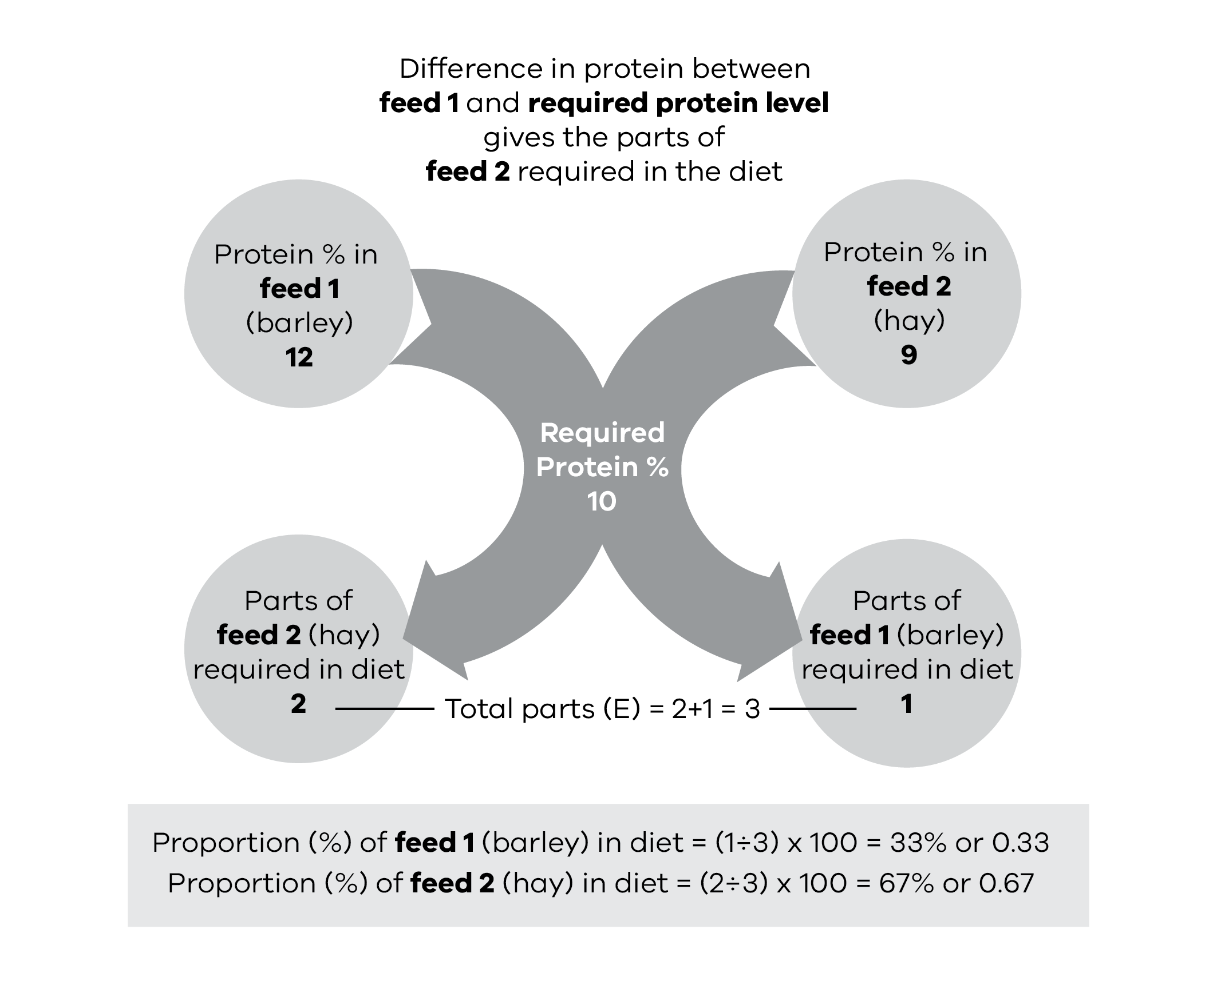
Amount of energy needed from feed 1 (barley)
Proportion of barley in diet  0.33 | x | Animal requirements  MJ ME/day  105 | = | Amount of energy needed from barley  MJ ME/day  35 MJ ME/day

kgDM required of feed 1 (barley)
Amount of energy needed from barley  MJ ME/day  35 | ÷ | Energy value of feed 1 (barley)  MJ ME/kgDM  13 | = | Amount required of  feed 1 (barley)  kgDM  2.7

Amount of feed required on an as fed basis (barley)
Amount required of feed 1 (barley)  kgDM  2.7 | ÷ | Dry matter of feed 1 (barley)  (expressed as a decimal, i.e. 90% = 0.9)  0.9 | = | Kg as fed per head per day of feed 1 (barley)  3.0

Amount of energy needed from feed 2 (hay)
Proportion of hay in diet  0.67 | x | Animal requirements  MJ ME/day  105 | = | Amount of energy needed from hay  MJ ME/day  70 MJ ME/day

kgDM required of feed 2 (hay)
Amount of energy needed from hay  MJ ME/day  70 | ÷ | Energy value of feed 2 (hay)  MJ ME/kgDM  9 | = | Amount required of feed 2 (hay)  kgDM  7.8

Amount of feed required on an as fed basis (hay)
Amount required of feed 2 (hay)  kgDM  7.8 | ÷ | Dry matter of  feed 2 (hay)  (expressed as a decimal, i.e. 85% = 0.85)  0.85 | = | Kg as fed per head per day of feed 2 (hay)  9.2

Each cow calf unit requires 3.0 kg barley as fed (2.7 kgDM) and 9.2 kg hay as fed (7.8 kgDM) to meet the energy requirements of 105 MJ ME/head/day and to supply the required protein level.
It is important to check if the calculated diet can be consumed by the cow-calf unit. In this case, the cow-calf unit can consume 10.7 kgDM and the formulated diet will be providing 10.5 kgDM (2.7 kgDM from the barley and 7.8 kgDM from the hay).
This diet is balanced for protein and energy and will allow the cow to maintain body condition and the calf to grow.
Note: With natural variation between cattle, responses to feed levels will differ. It is important to monitor stock condition regularly and adjust the diet accordingly. If stock are losing condition, increase the energy on offer. Check they can eat enough of the diet on offer to satisfy their requirements.
See Appendix IV for a blank Pearson’s Square worksheet.

Other considerations

Minerals
When animals are removed from pasture and rely solely on a drought ration, mineral supplementation may be required. Calcium (agricultural lime) and sodium (salt) are the most commonly required mineral supplements.

Calcium
Diets that have high grain percentages (greater than 50%) are generally calcium deficient.
To prevent calcium deficiency, add ground agricultural limestone to cereal grain at a ratio of 2 parts limestone per 100 parts grain (2%). If roughage represents 50% or more of the diet, calcium is generally not required.

Sodium
Diets that contain high grain percentages may require sodium (salt) to be added to the ration to prevent a sodium deficiency.
Add 1 parts of salt to 100 parts grain (1%).
If stock water contains high levels of salt then additional supplementation may not be required.

Buffers
As a precaution against grain poisoning (acidosis), buffers such as sodium bentonite or sodium bicarbonate can be mixed with the grain. Sodium bentonite or sodium bicarbonate should be mixed at a ratio of 2 parts of powder per 100 parts of grain (2% or 2 kg per 100kg grain). After the first 30 days of grain feeding, the amount of buffer can be reduced to 1% (see Chapter 7).

Vitamins
Vitamins A and E are the most common vitamin deficiencies that develop when there is no green feed. A single intramuscular injection of A, D and E will protect against both deficiencies.

Vitamin A
Cattle that have not had access to green pasture, green coloured hay or yellow maize for an extended period (3 months) will be deficient in Vitamin A. Cattle will develop a Vitamin A deficiency in a shorter time off green feed than sheep. An injection of A, D and E will correct a deficiency for around 3 months.

Vitamin E
The amount of Vitamin E in grain, hay and straw can vary significantly. A deficiency may develop in some drought rations. An injection of Vitamins A, D and E will correct any deficiency.

Improving the feed value of low-quality feeds

Treating straw with urea to improve the protein level of the diet
Straw can be a cheap and available source of roughage (fibre) during a drought, however, it is a poor quality feed for ruminants. Being very high in fibre, low in energy and very low in protein, makes straw slow to digest. Cattle physically can’t eat enough to satisfy even their maintenance energy requirements.
Treating straw with urea can lift the feed value of the straw and, when fed in conjunction with low quantities of grain or pellets, can provide a low-cost maintenance diet for cattle.
Treating straw with urea provides the microbes in the rumen with a protein source resulting in improved rates of digestion of the straw.
As the straw is digested more rapidly, appetite is increased, allowing the animal to consume a volume of feed that more closely meets their needs.
As with any new feed, animals will take 3-7 days to adjust to eating the urea-treated straw, which will smell different to untreated straw.
Feed analysis results have shown that treating straw with urea can increase protein levels by 2-14%. However, the straw’s metabolisable energy value is not improved. To provide the extra energy required it is important to continue a low level of grain feeding.
Figure 6.1: Urea-treated straw being fed out in hay racks.
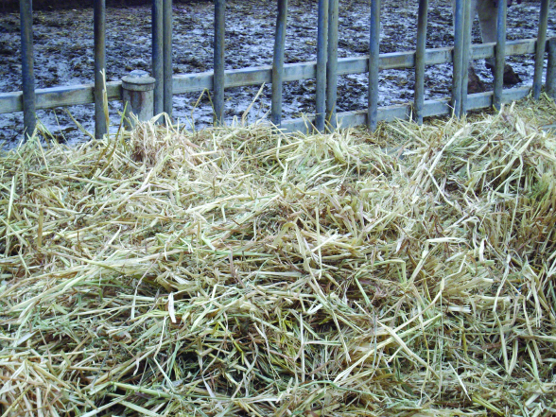

How to treat the straw
Treated straw is obtained by the addition of 5% weight to weight (w/w) of urea plus 80-85% w/w water.
To treat 1 tonne of straw, dissolve 50 kg of urea fertiliser in 800-850 litres of water. The solution should be mixed in a large container, such as a drum or an old water tank and sprayed onto the straw using a pressure pump and hose.
A big square bale weighing 400 kg will need 20 kg of urea dissolved in 320-340 litres of water.
After spraying, it is critical that the treated straw is contained in a reasonably airtight condition (e.g. covered in polythene or old bunker tarpaulin) to facilitate the chemical reaction. The straw should be kept covered for 7-10 days in the summer months or 2-3 weeks in winter after treatment.
Figure 6.2: Urea-treated straw covered with tarp for 7-10 days in summer.
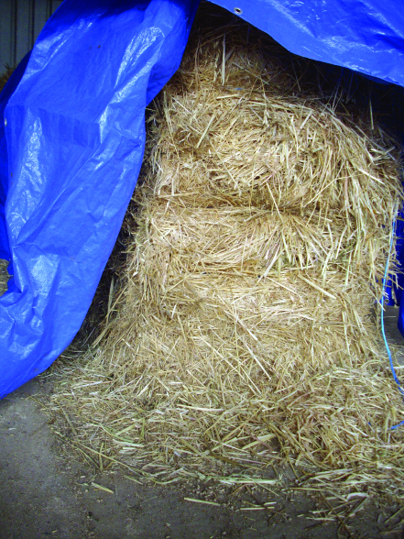
The urea on treated straw is non-toxic. Urea is only toxic to animals if they drink the urea solution or consume a mouthful of urea granules.
When urea is diluted with water at the rates recommended and sprayed over straw in the method described here, the risks are eliminated.
Urea poisoning can occur with malfunctioning of liquid urea feeders or with homemade urea blocks. After rain or heavy dew, the blocks may become soft and stock are able to eat them too quickly and consume too much.

Molasses as an energy source
Molasses has a good level of energy (11 MJ ME) but is very low in protein. It can be added to the urea-water mixes and sprayed on poor quality straw to improve both palatability and protein levels when straw is the main component of a diet.
When molasses is added in quantities, up to 12% of total DM, the sugars in the molasses assist with the digestion of fibre.
In feedlot rations, it is added at levels up to 12-14%. This level of molasses increases the palatability, binds fine dust particles and assists with rumen function.
The energy value of cane molasses decreases rapidly when it is added at levels above 30% of the total ration. Too much molasses causes digestive upsets and reduces animal performance.
Another use for molasses is as a carrier for feeding urea. Urea-molasses products come in block or liquid form and can be bought or homemade.
The nitrogen in urea assists animals to digest very fibrous feeds, such as standing dry paddock feed.
The sugars in the molasses can also assist in this digestion.

Economics of molasses feeding
Molasses can be an expensive form of energy. Animal performance would be higher and achieved more economically if grain or pellets were fed with poor quality roughage instead of molasses.

Chapter 7: Feeding grain to cattle
This chapter looks at the precautions that need to be taken when feeding grain to cattle.
Key messages
- Grain can be a cost-effective source of energy in drought rations.
- Introduce cattle to grain gradually.
- Ensure roughage (fibre) levels are adequate.
- Buffers will reduce the risk of grain poisoning (acidosis).
- Processing (such as cracking or rolling) can markedly increase the grain’s energy availability.
Monitor grain fed cattle carefully for signs of acidosis.
Grain is a common supplementary feed during a drought. It can have higher energy and protein levels than hay, making it an attractive supplement for animals that have higher nutritional requirements, such as young growing stock or cows and calves.
There are some risks when feeding grain to cattle, but they can generally be minimised by careful management.

Introducing cattle to grain
Take care when introducing cattle to a grain ration to avoid potential grain poisoning (acidosis).
Grain contains high carbohydrate levels and should be introduced gradually so the bacteria in the animal’s rumen have time to adapt to the new feed. Shy feeders and younger animals may need to be separated from more dominant animals to reduce uneven consumption.
Cattle should be accustomed to being fed with hay before grain is introduced to the ration. The hay can then be reduced over 2-3 weeks, as the amount of grain in the ration is increased. Importantly, roughage (hay, straw or dry pasture) should always make up 30% of the total ration.
Where there is some roughage left in the paddock, the amount of hay in the ration can be reduced accordingly. Once paddock roughage is depleted, however, some hay will have to be fed.
Introduce grain by feeding 0.5 kg/head/day. Maintain this amount until all cattle are eating some grain (1-3 days). During the initial feeding, place the grain on top of the hay to ensure animals consume some roughage.
Increase the amount of grain by 0.5 kg/head every second day until the desired amount in the ration is reached.
Watch closely for sickness and other health problems when feeding grain, particularly during the introductory phase.
Symptoms of grain poisoning (acidosis) include reduced or absent appetite, weakness, staggering, diarrhoea, bloat and lameness. In severe cases, the animal can become dehydrated and may be unable to stand. Severely affected animals should receive veterinary treatment, while more moderately affected animals should be removed and fed a hay-only diet until they appear healthy. These animals can be re-introduced to grain using the same principles applied during the initial introduction.

Frequency of feeding
Feed cattle daily during the build-up of grain rations. As soon as cattle are on a full ration and accustomed to eating grain, feed every second day (ensuring twice the daily quantity is supplied).
Experience has shown that every two days is about the longest acceptable feeding interval. Early weaned animals in poor condition or animals being fed for weight gain should be fed daily.

How to feed – trough or on the ground?
It is best to feed grain in troughs to prevent wastage and minimise intake of soil. Various forms of troughs can be improvised. For example, two rows of logs can be placed on the ground about 450-600 mm apart and joined with old corrugated iron as flooring. Other options include 200 litre drums split down the middle or tractor tyres cut in half.
If the grain is fed out on the ground, place the grain in heaps rather than trailing it out.
Feeding processed grain (rolled or crushed) on the ground is not recommended, as too much is likely to be wasted.

Changing a ration
Take particular care when changing sources or batches of grain, particularly changing from one type of grain to another, e.g. barley to wheat. The new batch of grain ideally would be ‘shandied’ together with the old batch for about a week. If it is not possible to mix the two grains together for a week, the rate of feeding of the new type of grain should be halved and gradually increased back up to target levels by increasing the rate of feeding by 0.5 kg/head/day.

Roughage (fibre)
Roughage (dry paddock feed, hay, straw, etc) is a key ingredient in drought rations for healthy rumen function. It should make up at least 30% of a ration.
When grain is the source of energy and protein in a diet, the roughage need not be of a high quality. Often straw and low-quality hay will suffice. Around 30% neutral detergent fibre (NDF) is an ideal amount of fibre in a diet. The NDF level of a ration can be determined from a feed analysis.

Other grain additives
Where grain makes up most of an animal’s daily ration, 1% (1 kg/100 kg of grain) of ground agricultural limestone should be added to the ration. This makes up for a shortage of calcium in the grain.
For lactating or young animals on grain rations, 1% (1 kg/100 kg of grain) of common salt (sodium chloride) should be added to correct a potential sodium deficiency.

Processing grain
Feeding processed (cracked or rolled) grain to cattle has significant nutritional benefits compared to whole grain. Table 7.1 illustrates the impact of processing on the digestibility of wheat, barley, oats and lupins.
A kilogram of processed grain will provide more energy to an animal than a kilogram of whole grain.
Table 7.1: Digestibility of whole versus processed grain.
Grain | Whole  % digestibility | Processed  % digestibility | Increased digestibility  from processing
Wheat, Triticale | 63 | 86 | 36%
Barley | 53 | 85 | 60%
Oats | 77 | 81 | 5%
Lupins, Peas | 76 | 86 | 13%
(Reference: Toland, P.C. (1976) The digestibility of wheat, barley or oat grain fed either whole or rolled at restricted levels with hay to steers. AJEAA 16: 71-75)
Deciding whether to process grain for cattle depends on several factors:
- The grain used: Processing markedly increases the digestibility of wheat and barley, whereas the digestibility of oats and lupins is only slightly increased.
- The availability of equipment to process grain and at what cost: The coarse crush achieved with a roller mill is superior to the dusty result from a hammermill.
- Ease of feeding: Whole grain can be fed on the ground; crushed grain should be fed in troughs.
Grain poisoning: Where grain is fed separately from roughage, whole grain is considerably safer to feed than crushed grain. When grain is mixed with chopped roughage however, crushed grain can be fed more safely.

Grain poisoning
Grain poisoning, or acidosis, is the main problem associated with feeding grain to cattle.
Grain poisoning occurs when the digestion of sugars and starch in the feed cause a rapid accumulation of acid in the rumen. If the acid accumulates faster than the body can handle there will be reduced rumen function and potentially a loss of important rumen bacteria.
Severe acidosis will result in death, while milder cases will cause a loss of appetite and production.
The type and treatment of grain will influence its potential to cause grain poisoning. Whole grain is less likely to cause grain poisoning than processed (crushed or rolled grain) of the same type, such as barley. Coarsely crushed grain is less likely to cause grain sickness than finely crushed grain. Fibrous grains, such as oats, are safer to feed than grains with little fibre, such as wheat. A feed analysis will indicate the level of fibre a ration or feed contains.
A number of measures can be taken in addition to the controlled introduction of grain into a ration to minimise the threat of grain poisoning.
Grain poisoning – or lactic acidosis – can result from:
- introducing cattle too quickly to high levels of grain, or feeding too much grain too soon
- insufficient trough space or feed area resulting in aggressive cows overeating
- changing from a lower energy grain to one of higher energy (for example, changing from oats at 10 MJ ME/kgDM to wheat at 13 MJ ME/kgDM, is a 30% increase in energy, sometimes different batches of the same type of feed will cause problems
- feeding grain-based pellets, which are usually 90% processed grain; when introducing them to cattle take the same precautions as when feeding grain
- insufficient roughage fed with grain
- insufficient access to roughage by shy feeders
accidents – storage areas are not sealed to prevent stock access.
Treatment for grain poisoning depends on the severity of the symptoms shown:
- mild lactic acidosis – still eating, mild bloat, with or without porridgy faeces
- moderate to severe lactic acidosis – not eating, porridgy scours, obviously sick with dehydration evident
severe lactic acidosis – down and unable to rise, dehydration, watery scour.
Treatment of grain poisoning may involve a range of responses:
- Mild lactic acidosis may simply require removal of grain feeding, a drench with 120 g of sodium bicarbonate orally and hay feeding only.
- Severe acidosis will require intensive veterinary attention; contact your local veterinarian.
As with many animal health issues, prevention is better than cure. Adding a buffer such as sodium bicarbonate or sodium bentonite to a grain-based ration reduces the likelihood of grain poisoning.

Buffers
Buffers are chemicals that counter the acidity of grain in the rumen and help to prevent grain poisoning.
To reduce the risk of grain poisoning during the introductory period, add 2% (2 kg/100 kg of grain) of either sodium bicarbonate or sodium bentonite to the grain being fed out with roughage. After one month of feeding grain the amount of buffer can be reduced to 1%.

Other grain feeding problems

Calcium deficiency
Feeding grain over a prolonged period can result in calcium deficiency due to the low calcium and high phosphorus levels in grain. This is overcome by adding ground limestone to the feed (up to 1.5% of the ration by weight).

Vitamin A deficiency
Vitamin A deficiency can occur after a prolonged shortage of green feed. This is unusual in southern Australia as sufficient Vitamin A can be stored in the liver to satisfy animal requirements for at least six months. A Vitamin A, D and E injection can be given to prevent this problem.

Urolithiasis
Urolithiasis (bladder and urinary stones) can be a problem in steers fed grain for long periods.
Addition of ground limestone balances the excessive phosphorous levels likely to predispose cattle to this condition. Adding 1% salt to the ration will encourage higher water consumption, thus reducing the risk of urolithiasis problems.

Polioencephalomalacia
Polioencephalomalacia (PEM) occurs due to an induced deficiency in thiamine (Vitamin B1). It can occur in feedlot cattle and cattle on high-concentrate diets, especially when minimal roughage is available. Typical signs include blindness, aimless wandering and a ‘star gazing’ appearance. Seek veterinary attention for diagnosis and treatment.

Chapter 8: Feeding in stock containment areas
This chapter covers why and when to use stock containment areas. It also provides information on how to design and construct a stock containment area and how to manage stock during containment.
Key messages
- It is important to remove stock from paddocks while around 70% ground cover remains.
- Stock containment areas can be part of a farm management system outside of droughts.
- Containing stock helps to protect vegetative cover on pastures or failed crops and allows pastures to recover rapidly after the break.
- It is important to consider your own site and method of operation in designing a containment area.
- Soil type, slope and proximity to other handling facilities are important considerations.
Animals in containment need to be provided with 100% of their diet, including roughage, energy requirements and minerals. They require regular monitoring.

Why use stock containment areas
A stock containment area (SCA) is a carefully selected, fenced section of the property that is set up to intensively hold, feed and water livestock to protect soil and pasture resources during adverse seasons. This may be following a fire, during drought or late autumn breaks, or for other farm management activities, such as quarantining new stock and holding stock ready for other handling tasks.
Feeding in stock containment areas should be considered:
- to protect vegetative cover on pastures or failed crops, and to allow pastures to recover rapidly after the break
- where weeds in brought-in feed are a concern
- to protect areas vulnerable to erosion
- where stock are losing weight on full drought rations in paddocks
to facilitate stock feeding, watering, monitoring and handling.
Lot feeding for production is a separate issue and is not covered in this chapter. If you are considering feedlotting, seek specialist advice from your local stock adviser. Feedlots must meet local government planning requirements and the Australian Animal Welfare Standards and Guidelines for Cattle.
Stock containment areas are for short term use during adverse seasons when seasonal conditions restrict or prevent the animals from grazing.

When to use a stock containment area
During a drought there is a high risk of losing valuable soil as pasture cover reduces. It is important to remove stock while around 70% ground cover remains. If pasture cover drops below about 70%, wind will start to blow away soil particles, causing erosion and loss of valuable nutrients and topsoil. Bare areas will also be more prone to washing, when rain does come. Refer to Figures 8.1, 8.2 and 8.3 for how to identify the amount of groundcover.
Before deciding when to remove stock from pastures, consider the factors that will affect potential pasture loss and erosion, such as slope and soil type. Allow for the fact that once stock have been removed, ground cover is likely to decrease further as a result of wind erosion, particularly in pastures dominated by annual species.
Improved pastures – established at considerable cost in money and time - are easily lost if continuously overgrazed. They should be among the first paddocks to consider destocking.
Figure 8.1: About 50% groundcover. A paddock that has been grazed this low is prone to considerable topsoil losses through wind and water erosion.
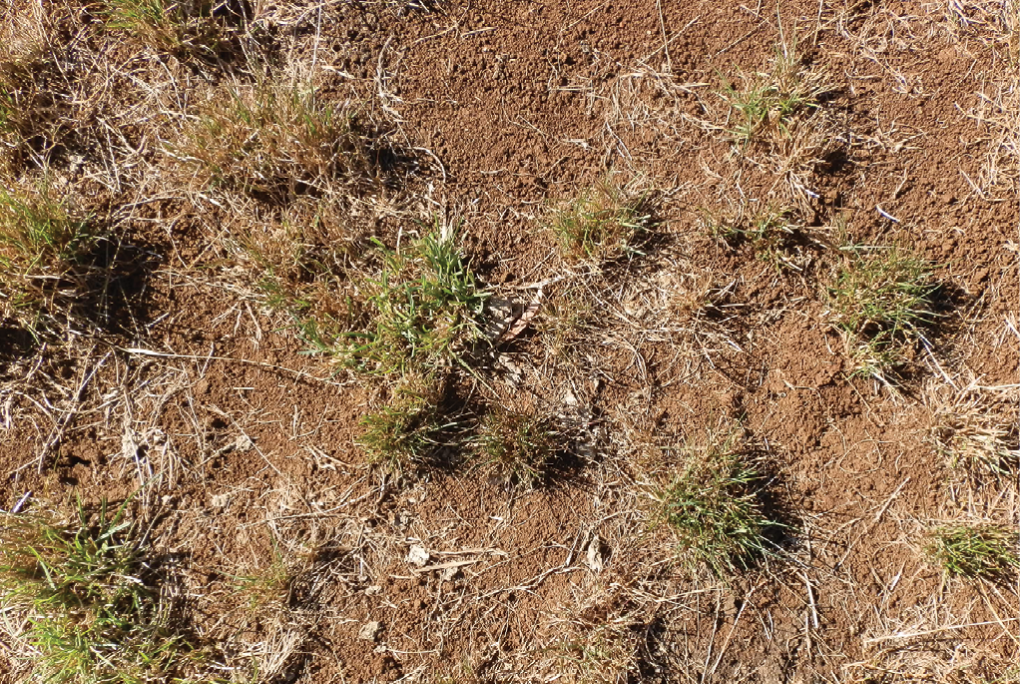
Figure 8.2: About 70% groundcover. Bare patches are quite large and start to join up, creating opportunities for soil movement.
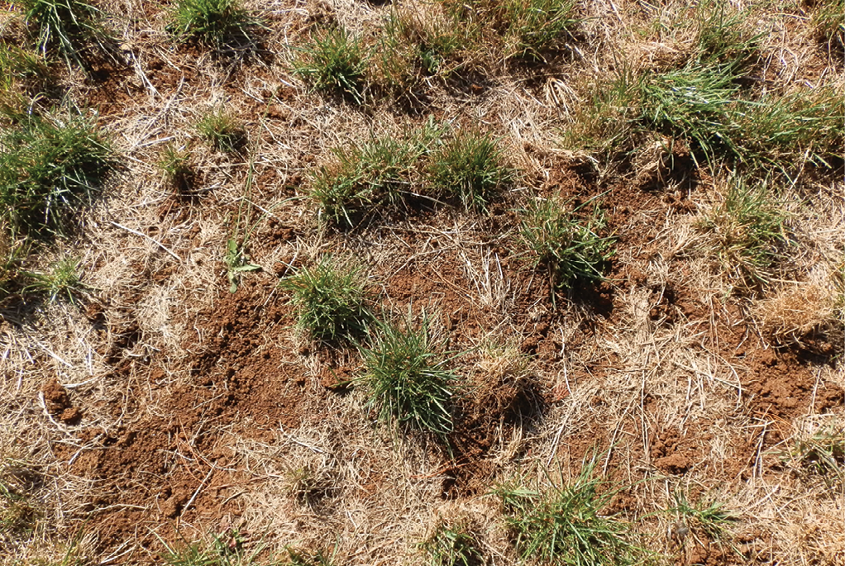
Figure 8.3: About 85% groundcover.
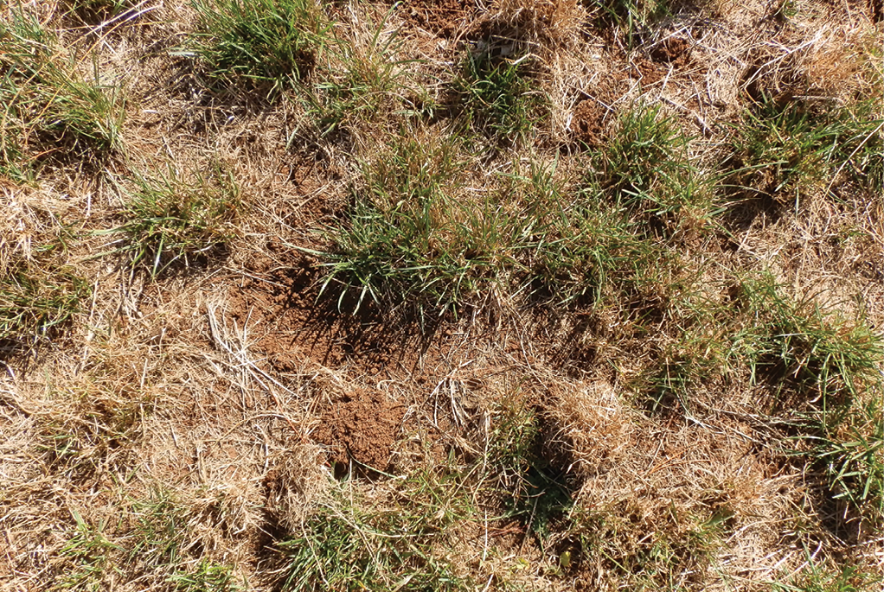

Site selection
The location of the containment area is important and it should be set up as a permanent structure, like cattle yards, for future emergencies (drought, fire or flood) or other management opportunities. The site should be accessible all year round. Avoid sites adjacent to public roads (particularly high traffic roads) or close to property boundary fences.
The site should:
- have a moderate slope and well-drained, stable soil such as a clay or clay loam
- be easily monitored
- contain no important remnant vegetation
- have shade, shelter and good drainage
- have access to good quality water and clean facilities
minimise problems with noise and smell that will cause concern to you or your neighbours.
Yards should be constructed across the slope and aligned with the natural contour of the land to avoid yard-to-yard drainage. Shade and shelter must be provided. If possible site yards adjacent to existing shelter belts or vegetation.
Dust can be an issue, so consider shelter from prevailing winds.
Stock need to be checked daily, so the site should be easy to reach to save time. Proximity to other stock-handling facilities is helpful.
No more than 20% of the site should contain remnant vegetation. Any existing trees in the containment yard/s should be fenced at least one metre around the tree. This will prevent animals ringbarking the trees and reduce the impact of compaction and nutrient loads (if native trees). Existing trees are valuable in providing shade; you don’t want to lose them.
Consider water quality in terms of runoff. The stock containment area should be set back from watercourses and water storages to protect against risk of nutrient run-off. A nutrient filter should be established on the down slope side of the site to prevent runoff into farm water storages and watercourses if applicable. The filter may be provided by a vegetation buffer strip or by constructing sediment traps from wire netting or straw bales.
Figure 8.4: Nutrient filter to prevent contamination of watercourses or storages.
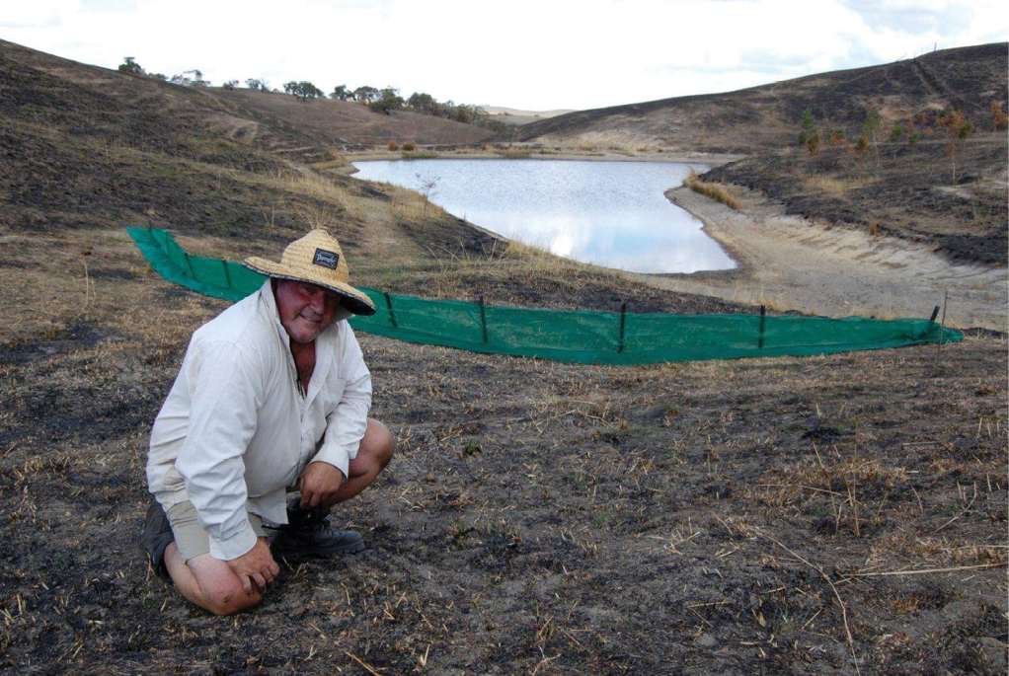

Design

Size
Adult cows, yearlings and early-weaned calves should all be yarded and fed separately because of their different feed requirements. Allow 10-15 m²/head. Stocking heavier rather than lighter has the advantage of increasing soil compaction in the containment area to reduce dust, particularly on lighter soils.
For optimal animal welfare and husbandry, the maximum desirable mob size is 160 head.

Layout
It is important to consider your own site and method of operation in designing a containment area, including the number of containment yards you require.
A number of different layouts have been used successfully, including yards with adjacent laneways for feeding and stock movement.
One feeding yard (with separate holding yards) can be used for the different classes of stock if they can be fed at different times. This can reduce the need for extra feeding troughs.
A separate yard for grain feeding troughs will allow you to mix feeds and additives before stock start to eat. Also consider vehicle access, ease of filling feed troughs, water and ease of cleaning. Avoid driving into the yard while animals are present.
Make sure you provide adequate subdivision to enable different classes of stock to be separated, including shy feeders or sick animals. If you are considering containing more than one group, you will need good subdivisional fencing as well as containment site boundary fencing.
Feed troughs or feeders (including hay) should be located on the opposite side of the yard to water troughs to minimise the contamination of the water source from food carried by the animals.
Consider your preferred method of feeding grain – trail feeding, lick feeders or self-feeders. Lick feeders and self-feeders can be installed in the yard, but consider locating them on the boundary to enable filling from outside.
If using a feeding laneway the use of iron, purlins, raised feeders, rubber or raised shade cloth troughs for feeding grain are options – do not feed directly onto the soil.
Figure 8.5: SCA design suggestions.
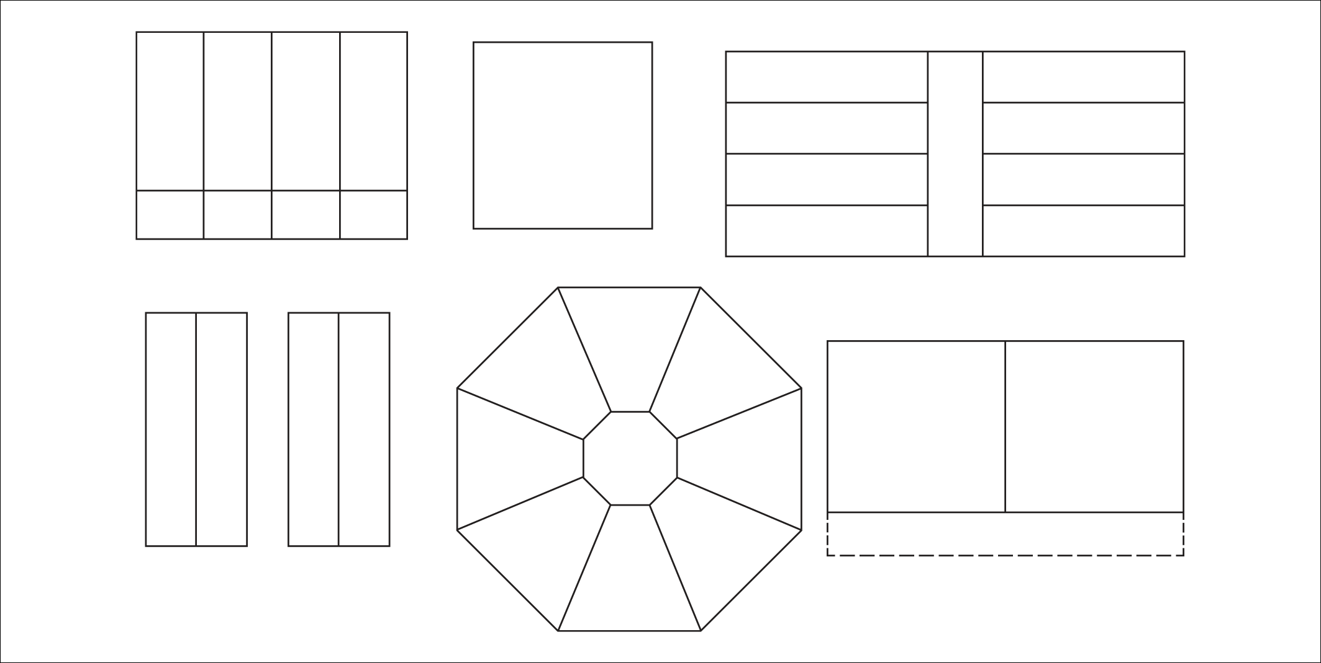

Shade and shelter
Heat and cold stress both increase an animal’s energy requirements. Shade and shelter should be provided to minimise exposure to the extremes of heat and cold and to reduce exposure to mid-summer radiation. However, shade structures should not impede the drying of the yard surface or ventilation beneath the structure. There is currently no minimum shade requirement for cattle.
Plan to plant shade trees outside the containment area for long-term protection. Consider prevailing winds and locate shade in the western half of the pen – angle shade structures to the north-west to maximise the shade provided during the hottest part of the day.
Unprotected trees within containment yards will die. If there are trees in the area you propose to use, protect them with guards to stop ringbarking. All existing trees should be protected at a minimum of one metre around the tree using the same standard of fencing as the boundary fences.
If there are no trees to provide shade, construct your own. Shade cloth, stacked hay bales (secured and fenced), galvanised sheeting and sheds are all options that have been used.

Access and safety
Personal safety is of the utmost importance. Design and construct facilities to minimise the risk of injury.
Vehicle and trailer access to feeders or troughs is easier when using feeding pens or laneways. Ensure a vehicle can access the yards (when stock are absent) to allow for cleaning and maintenance.
Also consider the ease of moving stock in and out of containment from paddocks or into feeding laneways.

Construction
Containment yards should be constructed as permanent long-term facilities. Seven horizontal wires and a plain top and bottom wire is recommended. Fences should not contain any barbed wire. Posts should be no more than five metres apart and strainers should be stayed. The use of metal or concrete strainers and posts is recommended due to fire resistance and longevity.
Keep in mind that stock are likely to push up against fencing or run into it – ensure it is constructed to withstand this treatment.

Water
A good, reliable water supply is essential in stock containment areas. Generally, stock will be fed diets with very low water content and must be supplied with water at all times.
Maximum desirable salt and magnesium levels for stock water are given in Table 2.2.
Bore water should also be tested for minerals that can be toxic at higher levels, such as magnesium.
Plan for a daily water consumption of 55 litres/head/day for weaners and up to 100 litres/head/day for lactating cows. Trough space is less important than flow rate. Water trough allowances do not need to be more than required in a paddock – cattle will adjust and take turns to drink at the trough. A good rule of thumb is that the flow rate should pump enough water for the herd in 2-3 hours.
Troughs need to be checked daily and cleaned regularly.
Good quality water is critical – stock perform better when they have access to fresh, clean and cool water. Water should be low in salt, low in organic matter, low in suspended clay and free of other toxic substances such as blue-green algae (see Chapter 2).

Feed
Allow 400-600 mm of trough space per animal.
Feed troughs can be bought or made cheaply from materials like tractor tyres cut in half or 200 litre drums split down the middle. Two rows of logs can be placed on the ground about 450-600 mm apart and joined with old corrugated iron as the flooring.
Table 6.5 lists quantities for full hand feeding (kg/head/day) for common classes of stock.
As stock will not have access to any pasture, it is important to include roughage. Ideally, 30% hay should be included but, as hay can be very expensive and often simply not available during droughts, the proportion can be reduced to an absolute minimum of 20%. Hay in the diet will reduce the risk of grain poisoning, especially with grains of low fibre content, such as wheat and barley. Oats has about 29% Neutral Detergent Fibre (NDF) compared with barley at 14% NDF and wheat at only 11% NDF.
Hay is the safest way to increase energy quickly in cold or wet conditions.
As outlined in Chapter 7, the deficiencies likely to occur with high grain diets during drought or lot feeding are sodium, calcium, fibre and Vitamin A.
Adding 2% feed-grade sodium bicarbonate or sodium bentonite for the first month and 1% after that will lessen the risk of acidosis. In addition, 1% feed-grade limestone to provide calcium and 0.5% salt to provide sodium will be required.
It is better to start cattle on grain in the paddock before introducing them to a feedlot situation (two weeks). If you cannot do this, make sure that most of the diet in the first two weeks is hay and then increase the grain ration gradually. Start at 0.5 kg/head/day of grain and make up the rest of the ration with hay.
Increase the amount of grain by 0.5 kg/head/day every two days until the desired level of grain is reached. Feed your best hay first and feed hay before grain. Feed daily (see Chapter 7).
It may take a while to get the ration right and, as the cost of feed is especially high during a drought, consider weighing 20 or so cattle regularly. Over and under feeding is costly. Aim to keep older stock at a minimum fat score 2.5.
There will always be a number of cattle that do not take to a containment feeding situation. They should be identified early, removed and fed hay or sold.

Stressful weather conditions
Cold windy weather increases the cattle’s need for energy-giving feed. Under such conditions, drought rations should be increased by about 20%. The increase should be made up with roughage (hay) if possible. Replace any feed wasted as a result of rain damage with new feed.

Releasing cattle
Ruminants do best when their diets are changed gradually. A sudden change from a grain diet to short green feed when a drought breaks will result in digestive upsets and weight loss as their rumen adjusts to the new feed.
If the break is accompanied by cold, wet and windy weather, this may reduce an animal’s inclination to graze, which will further reduce their intake.
Release cattle from the containment area when they have a full stomach. Continue feed for a few weeks, gradually reducing the quantity.
Cows below fat score 3 with young calves have high feed requirements and may need feeding (both hay and grain) to continue until there is adequate pasture available to meet their needs.
Pastures are likely to recover faster and provide more winter feed if they are allowed to produce some leaf area before the first grazing. See Chapter 3 for information on pasture recovery after a drought.

Animal health
Health issues during droughts are outlined in Chapter 9. Experiences with stock containment areas have shown that grain poisoning is the most common cause of death. For more information on how to prevent grain poisoning refer to Chapter 7.
There have been problems with changes in batches of processed feeds and with new sources of grain. Some caution is needed when changing to a new load of feed.
One option would be to mix the new and old over a number of feeds. If this is not practical, when a new batch of grain is being introduced, cut back the quantity and gradually increase it to enable the animals to get used to it. During this process make up the remainder of the ration with hay.
Cattle should receive a booster vaccination against clostridial diseases such as enterotoxaemia (pulpy kidney) at least three weeks before entering a containment area.
Vaccines such as 5-in-1 or 7-in-1 can be used. Talk to your vet about the most appropriate vaccine for your district. Remember, cattle that have not been vaccinated before require two vaccinations four weeks apart to provide protection, then an annual booster.
They should be drenched before coming into the containment area and ideally drenched again before being released.
Stock need to be monitored daily and sick animals removed. Avoiding stress such as boggy ground, overcrowding, dust and irregular feeding will help reduce diseases such as salmonellosis, coccidiosis, pinkeye and respiratory diseases such as pneumonia.
Regular cleaning of feed and water troughs will help prevent disease.

Other considerations
Although there are benefits in reduced labour when feeding animals in a stock containment area versus the paddock, regular monitoring is still a time commitment. This can be somewhat alleviated by locating the yards in an accessible location. It may be possible to release stock if livestock managers are away for an extended period of time, providing the appropriate care is taken and enough feed is made available to the animals in the paddock.
It is important to consider your own circumstances when deciding to use containment areas, particularly whether you can access the appropriate feed, the cost of feed in relation to the cost of production for the class of stock, and whether you can regularly check on the animals during their time in containment.
Managing a stock containment area involves a transition from a broadacre manager to an intensive manager. Farmers who fed in containment areas in previous droughts reported that it was a worthwhile exercise and have now made it part of their future drought management strategies.
Feeding in a containment area means you can have better control over weight loss and gain and come out of a drought with valuable land assets and stock numbers intact.
Further information is available at Managing resources in a drought.

Chapter 9: Animal health and welfare
This chapter outlines some key management factors and diseases that need to be considered.
Key messages
- You are obliged to provide proper and sufficient food, water and shelter to stock at all times.
Many diseases affecting cattle can be a greater problem in drought due to the stressed condition of stock.
If you have any concerns about the health and welfare of your stock during a drought, contact your local veterinarian or District Veterinary Officer.

Health and welfare problems in beef herds in a drought
Droughts inevitably result in less-than-adequate amounts of paddock feed. The effects of this shortfall on animal health will depend on the class of livestock (e.g. steers versus pregnant cattle), the body condition of the cattle as they enter a drought and the length of time feed is short.

Classes of livestock affected

Breeding stock
Cows in late pregnancy should receive priority in feeding programs as the growing foetus greatly increases the cow’s energy requirements. A breeding cow’s energy intake needs to continue to rise after calving and peak at six weeks into lactation.
Information on energy and protein requirements of breeding cattle can be found in Chapter 6, Tables 6.2 and 6.3.
A fat pregnant cow encountering an energy deficiency will burn its own body fat to supply energy. This will work for a short time, but if the energy shortfall continues, the cow may suffer from pregnancy toxaemia or ketosis. A sudden decrease in energy in a heavily pregnant cow can lead to pregnancy toxaemia; a more gradual or chronic decrease in energy can predispose the cow to ketosis.
In both conditions, the liver becomes affected by the mobilised fat and the cow becomes sick due to liver failure and the effect of the breakdown products of the fat. Cows become staggery and go down, are unable to rise, refuse to eat or drink and eventually die. Prevention by supplementary feeding is preferable to treatment, which is often unsuccessful.
A light-conditioned pregnant cow, encountering a drought, will continue to lose condition, become weak and go down. Compared to the cow affected with pregnancy toxaemia, this cow is not sick, but physically lacks the strength to rise. Pay attention to feeding these cows in early to mid-pregnancy; they will become a real problem with this condition if the drought extends into their last three months of pregnancy.
The two most important factors affecting pregnancy rates in cows are body fat score at calving and the level of nutrition after calving. See Chapter 4 for further information on impact of nutrition and fat score at and post calving.
It is a good management practice when pregnancy testing, to request your veterinarian to identify cows expected to be early and late calvers (this will require relatively early pregnancy testing from about six weeks after the end of joining).
In times of drought, early calvers have higher conception rates in the following joining than late calvers.
If the late calvers are identified, it is possible to sell them or preferentially feed them to improve their body condition score at calving and consequently increase their conception rates.
Similarly, bull fertility is related to body condition. Semen quality is determined about two months before joining, so it is essential to maintain bulls in good body condition well before mating starts.

Dry stock
Dry stock have the lowest feed requirement and should not be overfed at the expense of breeding stock.

Grain feeding problems
There are many advantages in using grain to feed cattle in drought, however there are also some potential animal health problems (see Chapter 7).

Poisoning and chemical residues
Poisoning can be a problem as hungry animals will eat plants they would not normally eat (e.g. bracken fern) and find other poisons, such as arsenic and lead, in their pursuit of feed.
Take care with garden trimmings, which are often poisonous, and lawn clippings with organochlorine (e.g. heptachlor, chlordane), as these may result in unacceptable residues in meat at slaughter. Refer to the end of Chapter 5 for information on chemical residues.
Hungry stock, including transported or yarded cattle, should be fed some hay before being released onto a fresh paddock or ‘failed’ crop to minimise the risk of some poisonings and photosensitisation.

Urea poisoning
Urea is a useful supply of non-protein nitrogen for the rumen microbes but take care when supplementary feeding. For example, poisoning occurs when excess urea is consumed:
- as a result of inadequate mixing of feed or roller drum mixes
when lick blocks crumble or develop a dish from licking that can hold rain water and dissolve urea.
Signs of toxicity include abdominal pain, shivering, salivation, bloat and death.
Diagnosis and treatment is best made by a vet, but an emergency treatment that may give relief is oral vinegar at a dosage of four litres for an adult beast.

The effect of disease on drought-affected cattle
Conditions that afflict normal cattle can have more serious effects on cattle in poor body condition.

Internal parasites (worms and fluke)
Those classes of cattle that may not normally be treated (e.g. mature cows that are not normally worm drenched) may need treatment during feed shortages.
An increase in the rate of pick up of larvae (e.g. by cattle grazing short green pasture) and the reduced nutrition of the stock can increase susceptibility to the effects of a parasite burden.
By the time scouring is visible, the animal’s gut will have already been severely damaged, adding to the problems of an animal already under nutritional stress.
Severe parasite burdens will reduce the effectiveness of an expensive drought-feeding program. The basis for an appropriate program during dry times is monitoring for worm burdens and effective drenching. See your local animal health adviser for more advice.

Lice
Lice will have a worse effect on cattle when they are in poor condition. The amount of damage to hides, trees, fences, gates and troughs is proportional to the number of lice. Cattle lice numbers build up in the cooler months reaching a peak toward the end of winter.

Bottlejaw
Bottlejaw or fluid under the jaw is normally caused by low blood protein. This may occur in association with liver fluke, and can also occur in worm-infested stock and stock in poor condition. It can also be a symptom of Johne’s disease (paratuberculosis).

Coccidiosis
Coccidiosis is another disease that can occur in cattle under stress and congregating to be hand fed. Severe scouring of blood-stained faeces will occur. This condition is normally seen in younger stock.

Pulpy kidney (enterotoxaemia)
Pulpy kidney is an acute toxaemia caused by clostridial bacteria in the intestine. A change of diet and thus a slowing of the movement of food through the gut – such as during grain feeding, lot feeding, periods of time off feed when yarding and transporting – provides the ideal environment for pulpy kidney to occur.
Cattle under 2-3 years old are most susceptible to pulpy kidney. Generally, the best conditioned, fastest growing stock are the ones most likely to develop the condition.
There is no practical treatment and most affected stock will die.
The disease can be prevented by vaccination.
Previously vaccinated stock should be vaccinated with a pulpy kidney or 5-in-1 or 7-in-1 booster two weeks before the start of hand feeding or before a major change in feed type. Unvaccinated stock require two doses – six weeks and two weeks before starting to feed. Pregnant cows should have a booster about two weeks before calving is expected to start. This will protect the calf for six to eight weeks. Calves need two vaccinations – one at marking, and the second about four weeks later.
In high-risk circumstances, vaccine protection may only last for three months, so repeated vaccination should be considered.

Pneumonia and calf diphtheria
Nutritionally stressed stock and early-weaned calves are more susceptible to respiratory diseases, including pneumonia and calf diphtheria. These diseases can be exacerbated when stock congregate around feed troughs. Veterinary attention should be sought if you suspect any disease.

Pinkeye
Pinkeye can be a greater problem in drought, with increased dust and stock congregating around feed troughs.

Welfare considerations of drought
The welfare of animals is always of the utmost importance. Stock owners and managers have an obligation to, at all times, provide proper and sufficient food, water and shelter for stock under their care. Failure to do so contravenes the Prevention of Cruelty to Animals Act (1986) and may result in prosecution and, in extreme cases, seizure of affected livestock.
Where sufficient food and/or water requirements cannot be met, cattle should be moved or agisted where feed and water is sufficient or they should be sold or humanely slaughtered.
Producers should act early while stock are fit and strong, as delays usually reduce the number of choices available. Any decisions must be humane and reasonable.

Chapter 10: Options for young stock management
Young stock need careful management during droughts for the benefit of young cattle and for cow health and productivity. Options for managing young stock are outlined in this chapter.
Key messages
- Early weaning can provide significant feed cost savings.
Creep feeding enables supplementation of calves while still suckling their mothers.

Early weaning of beef calves
Early weaning is a strategy to consider to deal with a feed and water shortage. If you plan to feed grain to early-weaned calves, you should review the information in Chapter 7.

Key reasons for early weaning

Maintain herd fertility
Early weaning helps maintain cow fat score and fertility of the breeding herd during and after a drought. For example, weaning spring-calving herds before cows fall below fat score of 3 will mean they only need maintaining to calving for acceptable post-calving return (interval) to oestrus and conception rate. Cows down in condition are more likely to cycle and conceive sooner after calving if the calves are weaned prior to joining. See Chapter 4 for additional information on cow condition and the impact on cycling.

Save your pasture
It is more efficient to convert feed directly into calf weight than milk for a cow and calf unit. Providing the appropriate quality and quantity of feed to dry cows and weaned calves, rather than cows with calves at foot, can significantly reduce feeding costs.
For example, a 500 kg liveweight cow, with a 7-month-old (240 kg liveweight) calf at foot would require 150 MJ ME/day. If the feed they were consuming had an energy value of 9 MJ ME/kgDM, as a ‘unit’ they would require (150 MJ ME ÷ 9 MJ ME/kgDM) 16.7 kg dry matter of that feed.
If the calf was early weaned, the cow’s energy requirement returns to maintenance. For the 500 kg cow, that means she would only require 55 MJ ME/day or (55 MJ ME ÷ 9 MJ ME/kgDM) 6.1 kgDM of the feed.
The calf needs to continue to grow, so if its energy requirement is budgeted for 0.5 kg liveweight growth/day, the 240 kg calf would require 49.3 MJ ME/day or (49.3 MJ ME ÷ 9 MJ ME/kgDM) 5.5 kgDM of the feed.
So, instead of the 16.7 kgDM, they would require as a cow/calf unit, the total for feeding them separately becomes 11.6 kgDM (6.1 kgDM for the cow and 5.5 kgDM for the weaned calf), a saving of 5.5 kgDM/day.
For a mob of 100 cows and calves, this becomes a feed savings of 550 kgDM/day.
Cows that have had their calves weaned early can be shifted to more marginal country so only growing stock is run in the best paddocks.
Cows will need less feeding later on because they will have lower weight loss once calves are weaned.
See Chapter 6 and Appendix II for additional information on the energy and protein requirements of cattle.

Better utilise supplementary feed
Early weaning will enable better allocation of supplements to different classes of animals. By weaning the calf early, the cow returns to maintenance requirement energy levels. This separation can provide a 30% saving in energy across the farm, as seen above.
High energy and protein feeds can be fed to young growing stock and lower quality feeds
(i.e. poorer quality hay) to the dry cows. This will reduce the overall cost of supplements during the drought.

Save water
Early weaning can reduce water requirements of cows by up to 60%. Lactating cows require up to 100 litres/day. Although a calf’s water intake approximately doubles when it is weaned and no longer getting liquid via its mother’s milk, there is a significant net saving in water from early weaning.

Sell cull females earlier
Early weaning will enable earlier sale of non-productive, cull or aged animals.

Deciding when to wean
Cow condition is a major consideration when deciding when to wean. Wean early in order to maintain cow herd productivity.
The appearance of calves should be considered. Calves with dry, coarse coats (woody calves) are almost certainly not receiving adequate milk from their mothers. Early weaning is the best policy in this situation. Calves with glossy coats are receiving an adequate diet and early weaning can be delayed.
In most cases, it is preferable to wean calves at 12 weeks or around 120 kg because they will then require less protein and be easier to feed. However, calves can be weaned onto high-quality dry rations at five weeks of age or around 50 kg.
If cow survival is of concern, calves can be weaned earlier than this, but a milk replacer will be required if calves aren’t going to be sold as bobby calves.
In a drought, all calves older than 5-6 months should certainly be weaned and fed separately.

Pre-weaning
Expose calves to the post-weaning supplement while they are still on the cow. For example, if calves are going to be given silage post-weaning, feed silage to the cow-calf mobs a few times.
Rumen microbial populations can require up to 14 days to completely adapt to a new diet. Consider introducing calves to post-weaning supplements slowly via creep-feeding two weeks before weaning.

Weaning
Avoid combining stressful procedures like castration and dehorning with early weaning.
If yard weaning, where possible keep the yards damp to minimise pink-eye. Fly traps and backline insecticides will also reduce flies, a vector for the disease. Eye ointments and patches of heavy material will provide relief for affected calves and prevent fly access.
When penning calves, allow at least 4 m²/calf, increasing to 6-8 m² for calves approaching 150 kg.
Provide high-quality hay, such as lucerne hay, and clean water troughs.
The high-quality ration required by early-weaned calves will increase their risk of developing pulpy kidney so vaccination for clostridial diseases is important.

Post-weaning

Post-weaning nutrition
The younger the weaning age of the calf, the higher its energy and protein requirements.
The energy and protein requirements of calves at various growth rates are presented in Table 10.1. Some possible diets for early-weaned calves are shown in Table 10.2.
Unless the feed has adequate energy density, feed intake and animal performance may be restricted by small rumen capacity. Much of the pasture hay and silage made in Australia is by itself unsuitable for early-weaned calves.
Introduce any concentrate (e.g. grains) slowly. Introduce it initially to calves at 300 g/head/day and increase the amount by 100 g/head/day with access to hay. Supplement the mix with a buffer to prevent acidosis.
Insufficient protein in the ration of early-weaned calves will result in short, dumpy cattle. Likely sources of protein to use are lupin grain, peas, linseed meal, canola meal and soybean meal.
Ideally, roughage should be chopped and mixed with the other components of the calves’ diet before feeding. Palatability is important to get calves to eat sufficient fibre. Consider adding a sweetener such as molasses or grape marc to a mixed ration for young calves.
Calcium is the mineral most likely to be needed in a diet for calves. Generally, calcium carbonate (such as ground limestone) should be added to a grain-based diet at the rate of 1½ parts per 100 (1.5%) by weight of the grain in the diet.
Although good-quality roughage (lucerne or clover hay) provides a reasonable supply of Vitamin A, some supplementary Vitamin A is usually necessary for early-weaned calves if they only have access to a dry ration and have not had access to green pasture for some time (e.g. three months).
This can be included in the feed, given orally or by injection. Alternatively, complete rations in the form of pellets are available from commercial suppliers.

Post-weaning management
Rather than letting calves roam barren paddocks, consider weaning into containment areas where they will tend to rest and feed, conserve energy and minimise damage to paddocks.
Six weeks after weaning, draft off tail-enders into a separate management group. Repeat this process four months after weaning.

Post-weaning health program
Administer a booster 5-in-1 or 7-in-1 vaccination.
Young calves are vulnerable to worms and so a worm management program is particularly important.
Table 10.1: Energy and protein requirements of calves of various liveweights.
Liveweight (kg) | Growth rate (kg/day) | Maximum daily % of liveweight | Dry matter intake (kg) | Metabolisable energy (ME) requirement (MJ ME/day) | Crude protein % of dietary dry matter
50 | 0 | 3.2 | 1.6 | 14 | 12
50 | 0.5 | 3.2 | 1.6 | 23 | 18
100 | 0 | 3.0 | 3.0 | 18 | 10
100 | 0.5 | 3.0 | 3.0 | 29 | 16
150 | 0 | 2.9 | 4.3 | 22 | 8
150 | 0.5 | 2.9 | 4.3 | 37 | 12
150 | 1.0 | 2.8 | 4.3 | 48 | 13
200 | 0 | 2.8 | 5.5 | 26 | 8
200 | 0.5 | 2.8 | 5.5 | 44 | 11
200 | 1.0 | 2.8 | 5.5 | 57 | 13

Creep feeding of beef calves
Creep feeding is a useful management practice that enables supplementation of calves while still suckling on their mothers. Creep feeding allows unweaned calves to be fed a supplement that is not accessible to the cows.

The creep enclosure or creep gateway
Creep feeding simply involves a barrier that blocks adult cattle, but allows calves to pass through and gain access to better nutrition than is available on the other side of the barrier.
The better nutrition can be in the form of grain or pellets and some hay available in troughs or self-feeders. Alternatively, the creep may allow calves access to better quality grazing, such as a lucerne stand or irrigated pasture.
Whether the creep feeding allows calves into an enclosure or through into an adjacent paddock, the critical factor is the width of the creep openings that allow the calves, but not the cows, to pass through. See Figures 10.1 and 10.2 for creep enclosure examples.
The openings should be 400-450 mm wide. Ideally, these vertical spacings should be adjustable and there should be a number of them.
A gate frame about one metre high, with several adjustable openings, is the most practical arrangement as it can be used either as the entrance to a creep enclosure or in a gateway that allows calves access to more nutritious grazing.
Table 10.2: Example diets for early-weaned calves.
Diet A | % | Diet B | %
Barley* | 55 | Wheat* | 65
Lupins | 25 | Linseed meal | 15
Hay | 20 | Lucerne hay | 20
* Plus calcium and a ‘buffer’.
Figure 10.1: Semi-permanent creep in a paddock corner for supplementary feeding of calves (aerial view).
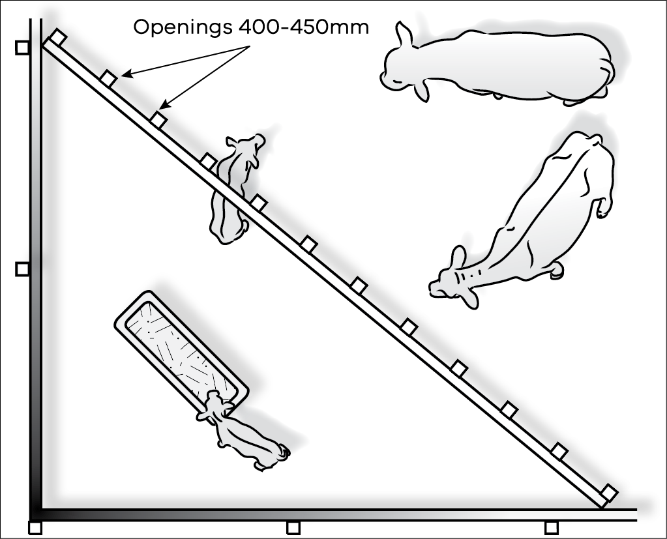

Feeders
A wide range of self-feeders are available for the feeding of grain, pellets or hay. Alternatively, the feed in the creep can be fed out in troughs. Feeding on the ground will result in considerable wastage.
The best self-feeders are covered and protect the feed from rain. Self-feeders that have an adjustment on the opening between the hopper and the feeding tray also have advantages.
This adjustment enables some control over daily rates of consumption, which can be particularly important in the introductory feeding period. However, be aware these block up regularly and will need daily scraping to keep the feed flowing.
Figure 10.2: A permanent calf creep is useful where a concentrate ration is fed to calves. The trough should be covered to prevent rain damaging the feed.
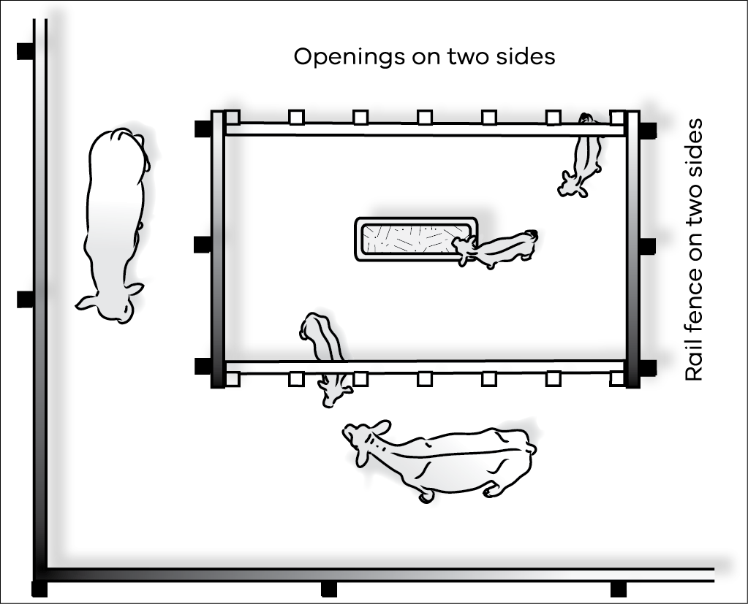

The type and level of feed
Deciding which feed to use should be based on price, availability and convenience. The choices include oats, barley, wheat, triticale, maize, lupins, peas, pellets or a combination of some of these.
Pellets are a convenient and flexible concentrate to feed and are available with a range of protein levels to suit the particular animals being fed and the pasture available at the time. Calves have high protein requirements.
Oats are the safest cereal grain to feed. All other grains should be coarsely rolled before feeding to improve their digestibility.
To get the calves used to entering the creep, feed hay only for the first few days – up to a week if need be. Make sure all calves are using the creep.
Start feeding concentrates (grain or pellets) at a level of 250 g/calf/day. When most of the calves are feeding in the creep, increase the level of concentrate by 250 g every second or third day. The upper level of feeding will depend on paddock conditions and the weight of the calves but it should be around 2 kg/calf/day.
Alternatively, cows and calves can be fed small quantities of grain or pellets in the paddock. In this way, the mothers will train their calves to eat the grain. After a couple of weeks the creep system can be put in place and the cows excluded.

Chapter 11: The feed value of unusual feedstuffs
During droughts, it is common to look for feed sources other than hay, silage and grains as feed prices increase. This chapter looks at the energy and protein value of some alternative feeds and issues to consider before purchase and feeding.
Key messages
- Unusual feedstuffs can pose a higher risk of chemical residues and contaminates.
Ensure a feed analysis is provided for the feed that is being considered for purchase as quality can be quite variable.
A wide range of unusual feedstuffs can be fed to livestock safely and effectively. However, apart from them being of poor nutritional value, they can also contain chemical residues that can contaminate meat and animal products when used as livestock feed.
All supplementary feeds may contain chemical residues, but feedstuffs not normally fed to livestock pose a much greater risk as the residue transfers are unlikely to have been assessed. The same applies to imported feedstuffs, which may have high feed value to stock but an unknown chemical use history.
Agricultural chemicals used on fruit and vegetable crops are typically designed to be eliminated from the edible parts of the plant at harvesting, however some residues may still be present. In some cases they may be concentrated in the waste plant material after processing. Feeding this waste plant material to stock may cause problems.
Residue problems can also emerge because stock have the capacity to eat a greater quantity of the fruit/vegetable than humans.
Agricultural chemicals are not designed to be ingested by livestock. Unless animal residue studies have been conducted, little is known about the effect of these chemicals on stock and their persistence in animal tissue.
There is a very real possibility that the meat and animal products from stock fed unusual feedstuffs containing chemical contaminants will themselves become contaminated with the chemicals. This can have a severe impact on trade and market access as well as animal and human health.
The best policy is to not feed unusual feedstuffs to stock without first establishing the material is suitable.
Producers should ask the supplier of unusual feedstuffs to certify the material they are supplying is suitable for the purpose for which it will be used. Ask for a by-product vendor declaration to verify this information. This will allow you to see the full chemical-use history of the potential feed.
Tests for chemical contamination by an accredited testing laboratory may not provide a satisfactory guarantee of suitability because analytical tests typically only screen for a narrow range of chemicals. The chemical content of unusual feedstuffs may vary from batch to batch.
The composition of many feedstuffs varies widely because of differences in climate, soil conditions, maturity, variety, management and processing. The data in this chapter is a guide rather than a precise statement of nutrient composition.
Before finalising plans to feed any by-product or unusual feedstuff to livestock, it is advisable to have a sample analysed by an accredited feed analysis service. See Chapter 5 for further details.
Most by-products and unusual feedstuffs should be used with caution and introduced into rations gradually, even when low prices favour their use. Factors to consider about unusual feedstuffs are their nutritive value, palatability, possible toxicity or contamination with pesticides or heavy metals, and the effects upon digestion and utilisation of the total ration. The use of by-product stockfeed needs to be declared when completing National Vendor Declaration (NVD) forms.
SAFEMEAT, a partnership between the red meat and livestock industries and Commonwealth and State Governments has prepared residue risk information sheets on the use of unusual feedstuffs. Producers can obtain copies of these risk assessments from the SAFEMEAT website at Alternative Fodder Residue Risks.

High moisture content feeds
Stock can eat up to 3.5% of their liveweight per day when the feed is in a dry form, such as hay or grain, but they cannot eat as much dry matter if the feed has a high moisture content.
Fresh, high-moisture feeds are often quite palatable to livestock but most such feeds will ferment and sour quickly unless they are dried or ensiled.

Blending and levels of feeding
It is important that any new feedstuff is gradually introduced to livestock over a period of about two weeks.
As a rule of thumb, most unusual feedstuffs can be effectively incorporated into the rations of livestock to a maximum of about 30% of the total ration without any significant influence on the health of livestock.

Types of feeds
Stock feed is usually categorised as either concentrates (high in energy) or roughage (higher in fibre but lower in energy).
Concentrates can be high in either energy or protein content. Protein concentrates generally contain more than 20% crude protein.

By-product energy concentrates

Almond hulls
Almond hull products vary considerably due to varietal differences and harvesting procedures. Soft almond hulls have about 85% of the energy value of barley grain. Some supplies of almond hulls are contaminated with sticks, dirt, hard shells and other foreign materials at harvest time. This greatly reduces their feeding value and acceptability by livestock.
Almond hulls can be used as a partial roughage replacement when roughage supplies are short and forage prices are high.
When mixed with other ingredients in commercial concentrate mixes, almond hulls usually are restricted to 20% or less in order to maintain high nutrient levels and palatability of the concentrate mix. In complete feedlot rations, almond hulls are limited to about 30% or less.

Apple pomace
Apple pomace is the by-product of apples used for cider or vinegar production. It can be fed fresh, ensiled or dried.
Two problems have hampered feeding of apple pomace in recent years. Pesticide contamination has been a problem in some areas, making the pomace unacceptable in dairy and (occasionally) sheep and beef rations. A second difficulty is that urea or other non-protein nitrogen compounds should not be fed with apple pomace because of the possibility of abortions and/or abnormalities of offspring. The reason for this is unknown.
Apple pomace is a highly palatable feed, medium in energy but very low in protein. When properly supplemented, it can replace up to about one-third of the concentrates in rations and 15-20% in complete feedlot rations.

Bakery waste
Large amounts of unsold bread, doughnuts, cakes and other pastries are available in some areas and are excellent energy sources for ruminant rations. Bakery waste may contain meat or other animal protein and should be used with caution and in accordance with ruminant feed ban legislation. The feeding of any meat product to ruminants (including cattle and sheep) is prohibited in Australia
Bakery waste is usually high in fat and low in crude fibre. Protein levels (on a dry-matter basis) of 10-12% are typical. The low fibre content of the baked material and the baking process itself result in a feed that tends to stimulate ruminal propionate and reduce ruminal acetate production. This is desirable for feedlot livestock being fattened for market.
Up to about 10% can be included in feedlot rations when supplies and economics are favourable.
Supplies should be used quickly while still fresh.

Brewer’s grains
Brewer’s grains have 20-25% crude protein (on a dry matter basis), making them a good protein source in addition to their energy value.
The brewing process makes this protein less soluble than many protein supplements. This could be valuable in rations, such as silage supplement with non-protein nitrogen that contain large amounts of soluble protein.
Brewer’s grains are fed both wet and dried.
In the dry form they have about 80% of the energy value of barley grain (the energy value varies depending on the brewery and additives used in the brewing process). They are not as palatable in the dried form as the original grain and are usually included as 25% or less of a dairy concentrate mix and 1-20% in feedlot rations.

Citrus pulp
Citrus pulp is classified as a concentrate but is also valuable as a partial roughage replacement because of its high level of digestible fibre.
It commonly contains about 15% crude fibre in the dry matter. Its energy value is about 94% of the value of barley grain. It has only about 7% crude protein in the dry matter.
Citrus pulp is usually fed dehydrated. It must be introduced gradually into a ration to let stock get accustomed to its distinctive smell and taste.
Levels of up to 15-20% are acceptable in feedlot rations.
Citrus pulp can also be fed fresh or as silage. Both are very acceptable to stock but pulp and peels from lemons are somewhat more acceptable than those from oranges and grapefruit. Transportation costs preclude the wet pulp being fed very far from processing plants.
Citrus pulp is high in calcium and low in phosphorus, and can aggravate the high calcium- to-phosphorus ratio in a ration when fed with legumes such as lucerne. Unless counter- balanced by other feeds low in calcium and high in phosphorus, citrus pulp can result in higher incidences of milk fever in cattle at, or soon after, parturition.

Fat
Fats and oils have energy values of about 2¼ times that of carbohydrates. Fats are also used to settle the dust and as a lubricant for feed processing. Levels of 2-5% fat are acceptable in commercial feedlot rations. Care must be taken, however, to ensure the fats and oils are not contaminated with extraneous chemicals during collection, storage and use. Tallow and used cooking oil may only be used in accordance with Ruminant Feed Ban Regulations.

Grain screenings
Grain screenings result from the cleaning of small grains before they are milled for human consumption. The best grade of screenings consists primarily of broken and shrunken kernels of grain, wild oats and other palatable weed seeds. When ground, good screenings approach grain in feeding value and have been used as 25% or more of concentrate mixed and 15-20% in feed rations.
Light, chaffy screenings are much higher in fibre and resemble straw more than grain in feeding value. Such screenings should be restricted to 10%.

Grape pomace or marc
Grape pomace or marc is the refuse in the production of grape juice and wine. It consists mainly of some combination of grape seeds, stems and skins. It has little feeding value, being very variable in both energy and protein and highly variable in dry matter.
When included in a concentrate mix, it can be considered only as a filler to reduce the price of the mix. With new harvesting and winery techniques, grape pomace containing few or no stems can be produced. This waste feed has been fed successfully at up to 15-20% of complete feedlot rations.
Grape marc has been found to be extremely palatable to sheep and lambs in pen trials where they consumed 350 g/head/day when fed with straw. This diet was effective in reducing weight loss only.
Studies have found partitioning of oil-soluble chemicals in grape seeds at violative levels, which would readily transfer to animal fat upon ingestion.
There are also concerns about residual levels of copper, which can be toxic to stock, from fungicides used on grapes.

Onions
Onions have been fed successfully to cattle and sheep and they eat them readily. They can, however, cause anaemia in sheep so introducing onions over a period of time is recommended and only up to 50% of the total ration.

Rice bran
Rice bran results from the processing of rice grain for human consumption. Besides the bran itself, it contains the germ from the grain and fragments of the hull not removed in milling.
Levels of up to 15% have been fed successfully to livestock. At these levels, it is roughly equivalent to wheat bran in nutritional value.

Wheat bran and other wheat by-products
Wheat bran consists of the coarse outer coatings of wheat kernels. It is a bulky feed that is relatively high in protein and phosphorus. It is highly palatable to livestock and is utilised efficiently when up to 25% is included in the concentrate mix. From 10% to 20% of wheat bran and other wheat by-products can be used in feedlot diets. The bulky nature of wheat bran and its high phosphorus content make it a popular by-product feed for livestock.

Whey
Whey is the residue from cheese production and consists primarily of lactose, minerals and water. It can be fed dry or liquid. Pollution control regulations and the high cost of drying have resulted in increasing amounts being used as feed liquid in recent years.
Dried whey is a major component of many dry milk replacers fed to calves. It is usually too expensive to be included in rations for older animals but it is sometimes included at low levels in pelleted feeds because of its binding characteristics as well as its nutrients.
Liquid whey contains only 6-7% solids and must be fed quickly or it will spoil. In cool climates it can be stored for 3-4 days before feeding. In warm climates it should be fed the same day it is delivered.
Liquid whey is frequently available for only the hauling costs, making it an inexpensive source of nutrients for animals near cheese plants. Supplies are often variable, however, and storage of whey attracts fly problems.

Tomato pomace
The feeding value of tomato pomace on a dry basis is comparable to good-quality hay.
Variability (especially moisture content) is one of the main problems associated with the use of this by-product feed. In one study, dry matter varied from a high of 27.5% to a low of 11.9%. Pesticide contamination can also be a problem with tomato pomace.

By-product protein concentrates
Many crops grown for oil production also produce by-products high in protein. These by-products are the primary source of supplemental protein in livestock rations.
They include coconut meal, corn gluten meal, cottonseed meal, linseed meal, safflower meal, soybean meal and sunflower meal. Some of these have high fat levels and should therefore not be fed as the whole diet.
Additionally, such by-products as distiller’s grains are used extensively as protein supplements in livestock rations. Brewer’s grains, previously discussed as an energy feed, are also relatively high in protein content.

Coconut meal/copra
Coconut meal, popularly known as copra, is one of the most palatable feeds available for livestock. It is high in energy and contains about 20% protein. Rancidity can be a problem during storage if the meal is high in fat but high-fat copra contains considerably more energy than copra produced by the solvent process.

Cottonseed meal
Cottonseed meal is a by-product of the production of cotton lint and cottonseed oil. It contains about 40% protein and is well liked by livestock. The amount of oil left in the meal will affect its energy value (amounts vary according to the method of processing). Energy levels are somewhat lower than those found in some other protein supplements, such as coconut meal, soybean meal and linseed meal.

Linseed meal
Linseed meal, the by-product of the extraction of linseed oil from flaxseed, is an excellent protein supplement for livestock. Protein content varies from about 30% to 38%, depending on the source of processing method. When reasonably priced, it can be used as the only protein supplement in livestock rations because it is very palatable.

Poultry litter and manure
Poultry waste (litter and/or manure) has been included in the diets of sheep and cattle in previous droughts but is now prohibited under the Ruminant Feed Ban.

Rendered products
The Ruminant Feed Ban also bans rendered products such as blood meal, meat meal, meat and bone meal, fish meal, poultry meal, feather meal, and compounded feeds made from these products.

Safflower meal
Safflower meal has increased in availability and importance as a protein supplement in recent years because of the popularity of safflower oil in human diets. Safflower meal from unhulled seeds, has about 20% protein, is high in fibre and relatively low in energy. Meal made from well-hulled seeds has about 40% protein and is much higher in energy.
Safflower meal from either source, however, is not as palatable to livestock as the more common protein supplements and is usually restricted to 20% or less of concentrate mix.

Soybean meal
Soybean meal contains 40-50% protein, is high in energy and is highly palatable to livestock.

Sunflower meal
Protein levels vary from 20% to 25%, depending on the processing method and whether the seed is hulled or not. It is roughly equivalent to cottonseed meal as a protein supplement for livestock.

By-product roughage

Canola hay and silage
Canola hay and silage are likely to be available as a fodder source in droughts where frost damage has occurred. In this situation, it is likely that lengthy agricultural chemical withholding periods will apply, up to 15 weeks in some situations (e.g. pre-emergent uses). Vendor declarations must be sought from feed suppliers in these situations to manage the risks.
Both hay and silage can be of good quality but this can vary and there are some livestock considerations.
Table 11.1 is a summary of results in Victoria on canola hay and silage samples analysed during 2022–24.
Canola hay that has not been aggressively conditioned may have sharp stalk ends and these can pose a problem by piercing an animal’s rumen. There have been reported instances of nitrate poisoning from canola products. It is recommended that canola hay or silage is introduced slowly and not fed as a sole ration or to starving animals.
Table 11.1 Mean and range of canola hay and silage samples from the 2022–23 and 2023–24 season (Source – FEEDTEST™).
Description | Crude Protein (CP)  (%) | Dry Matter Digestibility (DMD)  (%) | Metabolisable Energy (ME)  (MJ ME/kgDM) | Neutral Detergent Fibre  (NDF)
Hay, canola | 10.8 | 57.3 | 8.3 | 47.2
(2022–23) | (8.6-14.1) | (49.7-68.5) | (6.9-10.2) | (40.9-50.6)
Silage, canola | 9.5 | 46.3 | 7.4 | 52
(2023–24) | (7.3-11.3) | (34.4-57.9) | (5.8-8.9) | (44.5-56.1)
More recent season averages can be sourced from: FeedTest

Rice hay
Rice hay is generally a good palatable roughage of equivalent feed value to cereal hays. Rice hay, however, is known to contain significant levels of silica and oxalate, both of which may cause problems to livestock. High dietary silica levels can predispose animals, especially steers, to urinary calculi.
If rice hay is fed as the roughage in a hay and grain diet, it is suggested that 1.5% limestone and 0.5% salt is fed to correct the calcium: phosphorus balance in the ration. Rice hay can contain a range of weeds such as umbrella sedge, barnyard grass, starfruit and wild millet.

Rice hulls
Rice hulls have practically no feed value but can be useful as bedding material for livestock. They are very high in crude fibre and silica and the fibre is largely indigestible. Up to 15% of unground rice hulls can be included as a roughage source in drought rations being fed to livestock.

Sawdust
Sawdust has virtually no feed value for sheep or cattle because of its high level of lignification. It has been shown to be useful, however, when feeding high concentrate diets to sheep or cattle during droughts. Sheep survival rates in drought have been shown to be better when 15-20% sawdust (hoop pine and spotted gum) was included in the wheat rations.
Sawdust has also been successfully used as a diluent for adapting cattle to a concentrated diet. The inclusion of 5-15% sawdust in maize-based diets for cattle was found to maintain better rumen function, as evidenced by fewer cases of bloat and liver lesions and less ruminal parakeratosis.
Coarse sawdust was better than fine sawdust in maintaining rumen function.
Sawdust from treated timber should not be used.

Seaweed
Kelp represents the most common type of seaweed that might be available for feeding. The dry matter of kelp contains about 30% minerals (compared to 5-6% in hay, pasture, etc). Kelp contains 0.15-0.2% iodine. Seaweed is sometimes used as a mineral source for livestock.
Kelp can be fed quite satisfactorily at up to about 25% of the diet of livestock. The composition of dried kelp is dry matter 91%, crude protein 6%, minerals (ash content) 30%. ME value of kelp is about 5 MJ/kg DM.
The rich mineral content of seaweed, especially salt, can make the material quite palatable to livestock.

Waste paper
Waste paper has poor feed value and there is the risk of the paper containing contaminants such as lead, cadmium, polychlorinated biphenyls and other toxic substances. The feeding of waste paper to cattle is not recommended.
Table 11.2: Energy and protein compositions of unusual feedstuffs. (If known, ranges in feed values are given in brackets. It is likely that most of these feedstuffs will vary and values are a guide only.)
Feed | Approx. dry matter (DM) % | Metabolisable energy (ME) (MJ ME/kg DM) | Crude protein % dry matter
Acorns | 70 | 7 | 5
Almond hulls, 15% CF | 90 | 8 | 2
Almond hulls and shells, 20% CF | 90 | 7 | 2
Apple pomace, dried | 89 | 10 | 5
Apple pulp silage | 21 | 11 | 8
Apples | 17 | 10 | 3
Apricots, dried | 90 | 12 | 6
Bakery waste, dried | 92 | 13 | 11
Banana skins, dried, ground | 88 | 9 | 8
Bananas | 24 | 13 | 4
Bread, dried | 92 | 13 | 13
Brewers dried grains | 92 | 9 | 22
Brewers dried grains, 25% protein | 92 | 10 | 25
Brewers grains, wet (range) | 28 (14-61) | 11 (8-14) | 22 (10-29)
Broccoli | 11 | 10 | 33
Brussel sprouts | 15 | 11 | 33
Buckwheat | 87 | 11 | 12
Cabbage | 9 | 13 | 25
Cabbage leaves | 15 | 10 | 14
Canola meal (range) | 91 | 12 (10-16) | 38 (27-42)
Carrot pulp (range) | 10 (8-16) | 13 (9-14) | 10 (6-15)
Carrots | 13 | 12 | 10
Cauliflower | 9 | 10 | 30
Citrus pulp (range) | 14 (11-17) | 13 (10-15) | 9 (6-12)
Copra (coconut) meal | 90 | 11 | 21
Corn cobs, ground | 90 | 7 | 3
Cottonseed meal,  41% protein mech-extd | 93 | 3 | 44
Cottonseed meal,  41% protein, solv-extd | 91 | 11 | 46
Cottonseed, whole | 92 | 14 | 23
Grape marc or pomace (range) | 55 (20-94) | 6 (2-12) | 12 (5-17)
Grape/pear/apple pomace, dried | 92 | 6 | 7
Grapefruit | 14 | 13 | 8
Kelp, dried | 91 | 5 | 7
Lemon pulp, dried | 93 | 12 | 7
Lettuce | 5 | 8 | 22
Linseed meal,  36% protein, solv-extd | 90 | 12 | 38
Linseed meal,  37% protein, mech-extd | 91 | 12 | 38
Melons | 4 | 11 | 11
Milk, cattle, skim, dried | 94 | 13 | 36
Milk, cattle, whole, dried | 94 | 15 | 27
Milk, colostrum | 25 | 15 | 46
Molasses, cane | 75 | 11 | 6
Oat hulls | 93 | 5 | 4
Oat straw | 92 | 7 | 4
Oats, sprouted 5 days | 13 | 10 | 18
Onions | 11 | 13 | 10
Orange pulp, dried | 88 | 12 | 8
Orange pulp, wet | 25 | 12 | 9
Oranges | 13 | 12 | 7
Palm kernel meal | 88 | 11 | 17
Pea hay | 88 | 9 | 14
Peaches | 10 | 12 | 9
Peanut meal, mech-extd | 93 | 12 | 52
Peanut meal, solv-extd | 92 | 12 | 52
Peanut skins | 94 | 10 | 17
Pears | 17 | 13 | 6
Pineapples | 15 | 12 | 3
Potato meal, dried | 91 | 12 | 11
Potatoes | 23 | 12 | 9
Pumpkins | 9 | 13 | 16
Raisin pulp, dried | 89 | 8 | 11
Raisins, cull | 85 | 7 | 4
Rice bran | 90 | 14 (9-15) | 16 (13-20)
Soyabean meal | 85 (12-94) | 15 (13-16) | 44 (30-54)
Sunflower meal | 91 | 10 (8-14) | 34 (20-39)
Whey | 8 (2-27) | 14 (12-14) | 30 (20-40)

It is important to assess the risk of these feedstuffs and take appropriate precautions to ensure the quality and integrity of the meat or other end product is not jeopardised.

Appendix I – Weight of hay and silage bales
Bale type | Wet weight  (kg) | Dry Matter  (%) | Dry Weight  (kg)
Hay
Small square | 23 | 85 | 20
4 x 4 round | 250 | 85 | 215
5 x 4 round (15 small bale equivalents) | 350 | 85 | 300
5 x 6 round (20 small bale equivalents) | 500 | 85 | 425
8 x 3 x 3 square | 300 | 85 | 255
8 x 4 x 3 square | 600 | 85 | 510
8 x 4 x 4 square | 750 | 85 | 640
Silage
4 x 4 round | 700 | 35 | 245
1 cubic metre (wilted) | 580 | 30 | 175
1 cubic metre (direct cut) | 830 | 18 | 115
1 cubic metre maize silage | 500 | 35 | 175

Appendix II – Energy tables and calculations
Calculation for maintenance: Maintenance MJ ME = (0.1 x liveweight) + 5
Calculations for daily energy requirements of growing cattle:
< 300 kg LW | 0.5 kg/day | MJ ME = 1.7 x maintenance
< 300 kg LW | 1.0 kg/day | MJ ME = 2.2 x maintenance
< 300 kg LW | 1.5 kg/day | MJ ME = 2.7 x maintenance
300 – 500 kgLW | 0.5 kg/day | MJ ME = 1.6 x maintenance
300 – 500 kgLW | 1.0 kg/day | MJ ME = 2.1 x maintenance
300 – 500 kgLW | 1.5 kg/day | MJ ME = 2.6 x maintenance
500 + kgLW | 0.5 kg/day | MJ ME = 1.5 x maintenance
500 + kgLW | 1.0 kg/day | MJ ME = 2.0 x maintenance
500 + kgLW | 1.5 kg/day | MJ ME = 2.5 x maintenance

Lookup tables for daily energy requirements of pregnant and lactating cattle:
Requirements for pregnancy – add to maintenance of cow
Expected calf birth weight (kg) | Weeks before calving  -12 MJ ME/cow/day | Weeks before calving  -8 MJ ME/cow/day | Weeks before calving  -4 MJ ME/cow/day | Weeks before calving  0 MJ ME/cow/day
30 | 6 | 11 | 20 | 34
40 | 9 | 15 | 26 | 45
50 | 11 | 18 | 32 | 55

Requirements for lactation – add to maintenance of cow
Normal calf weaning weight (kg) | Months after calving  + 1 MJ ME/cow/day | Months after calving  + 3 MJ ME/cow/day | Months after calving  + 5 MJ ME/cow/day | Months after calving  + 7 MJ ME/cow/day
150 | 35 | 45 | 55 | 55
200 | 40 | 55 | 65 | 75
250 | 50 | 70 | 85 | 95
300 | 60 | 80 | 100 | 115

Appendix III – Tactical feed budget
Scenario:

Step 1 – Where are we now?
No. of animals (a) | Liveweight (kg) | Current FOO  (kg DM/ha) (b) | Pasture quality  (MJ ME/kgDM) (c) | Grazing Area (ha) (d)

Step 2 – Where do we want to get to?
Time frame (days) (e) | Required liveweight gain (kg/day) | Energy requirement  (MJ ME/day) (f)

Animal feed requirement  (kgDM/day)  (g) g = f ÷c | Herd pasture intake (kgDM/day)  (h) h = a x g | Total timeframe pasture intake (kgDM)  (i) i = h x e

Step 3 – How do we get there?
Future Growth
Month | Days in month  (j) | Pasture growth rate  (kg DM/ha/day) (k) | Area (ha)  (l) | Total grown/month  (kgDM) = j x k x l
Total Growth (m)

Minimum pasture cover (kg DM/ha) (n) | Provision from current pasture (kgDM) (o)  o = (b – n) x d
Provision from current pasture (kgDM) (o)
Provision from future growth (kgDM) (m)
Total pasture intake (kgDM) (i)
FEED BALANCE (kgDM) = (o + m) – i

Step 4 – Options for achieving feed balance
Converting pasture deficit into supplementary feed requirement
Determine total energy shortage
Energy in pasture*  MJ ME/kgDM  (c) | x | Feed balance deficit  kgDM | = | Total energy shortage  MJ ME

Determine kgDM of supplement required
Total energy shortage  MJ ME | ÷ | Energy value of supplement  MJ ME/kgDM | = | Supplement required  kgDM

Determine ‘as bought’ amount of supplement
Supplement required  kgDM | ÷ | Dry matter % of supplement | = | ‘As Bought’ supplement required  kg
* This figure comes from box (c) on the Tactical Feed Budget

Appendix IV – Pearson’s Square worksheet
Amount of energy needed from feed 1
Proportion of  feed 1 in diet | x | Animal requirements  MJ ME/day | = | Amount of energy needed from feed 1  MJ ME/day

kgDM required of feed 1
Amount of energy needed from feed 1  MJ ME/day | ÷ | Energy value of feed 1  MJ ME/kgDM | = | Amount required of feed 1  kgDM

Amount of feed required on an as fed basis (feed 1)
Amount required of feed 1  kgDM | ÷ | Dry matter of feed 1  (expressed as a decimal, i.e. 90% = 0.9) | = | Kg as fed per head per day of feed 1

Amount of energy needed from feed 2
Proportion of  feed 2 in diet | x | Animal requirements  MJ ME/day | = | Amount of energy needed from feed 2  MJ ME/day

kgDM required of feed 2
Amount of energy needed from feed 2  MJ ME/day | ÷ | Energy value of feed 2  MJ ME/kgDM | = | Amount required of feed 2  kgDM

Amount of feed required on an as fed basis (feed 2)
Amount required of feed 2  kgDM | ÷ | Dry matter of feed 2  (expressed as a decimal, i.e. 85% = 0.85) | = | Kg as fed per head per day of feed 2

