Sheep Notes newsletter

Autumn 2025

Table of Contents

Editorial 2

Water first 2

Seasonal reminders and resources 8

`To resow or not to resow…that is the question 9

Dry seasonal conditions 13

Trace elements revisited 16

Campylobacteriosis - how can it affect my farm this lambing? 19

Lambing in 2024 in southwest Victoria 22

Digital tip 27

Knowing how many lambs – gold! 28

Emission intensity 35

Feeding Livestock – Not so hard quiz 40

BetterBeef and Bestwool Bestlamb 42

Agriculture Victoria animal health and sheep industry contacts 43

Publication information 46

# Editorial

Image 1: A herd of sheep in a field at sunset

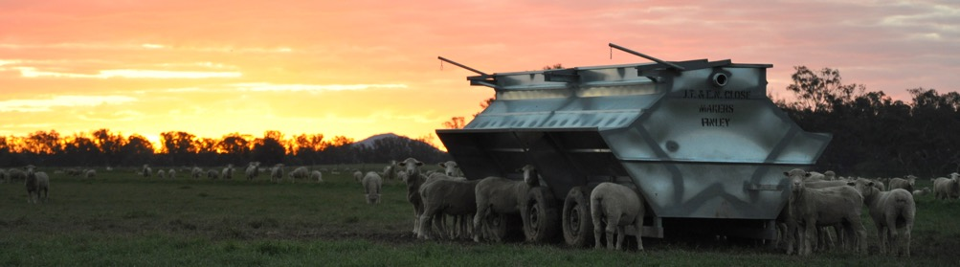

Welcome to an autumn edition of SheepNotes. We hope that between writing this and it reaching your mailboxes, some good rain has fallen across the state to relieve feeding and water shortages. Feeding stock has been ongoing for many, but at least lamb prices have held up and provided some good returns and cash flow.

We hope that you find something useful, of interest and enjoyment in this edition.

Jane Court

Email: [jane.court@agriculture.vic.gov.au](mailto:jane.court@agriculture.vic.gov.au)

# Water first

**Article author: David Mckenzie, Yea**

David Mckenzie farms merinos and Angus cattle in North East Victoria near Yea. The home block is 200 ha with another 170 ha at Murrindindi and 240 ha leased locally.

David started leasing the Yea block in 2003. The farm was very run down and the owner was interested in making improvements, so was open to suggestions and negotiating lease costs to do this.

David decided the first priority was water, then soil fertility and then pasture improvement. The farm had a large 8-9 ML dam at the bottom of the farm and some scattered small ‘sheep’ dams. The local belief was the soil type didn’t allow for bigger dams as the soil is ‘gritty’ gravel and leaks if dams are made too deep, hence numerous small dams.

Figure 1: David by electric pump

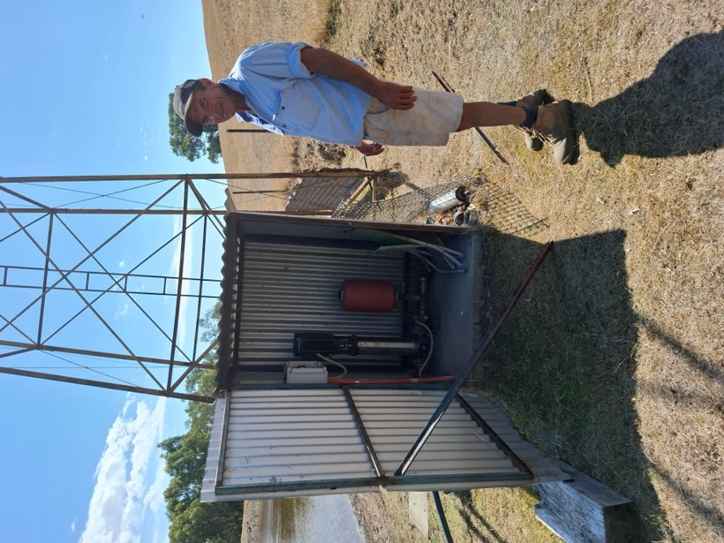

## Stock

Most farmers in the area run cattle, but David has always and still does have, a love for merinos. This is despite having laboured through footrot, lice and Ovine Johnes disease. He shears 2000 merinos and runs 130 Angus cows. Some of the best steers are kept and grown out as bullocks to sell at 390-420 kg carcase weight. Both cattle and sheep start lambing/calving on July 10

Image 2: Merino ewes on grain trail in dry paddock

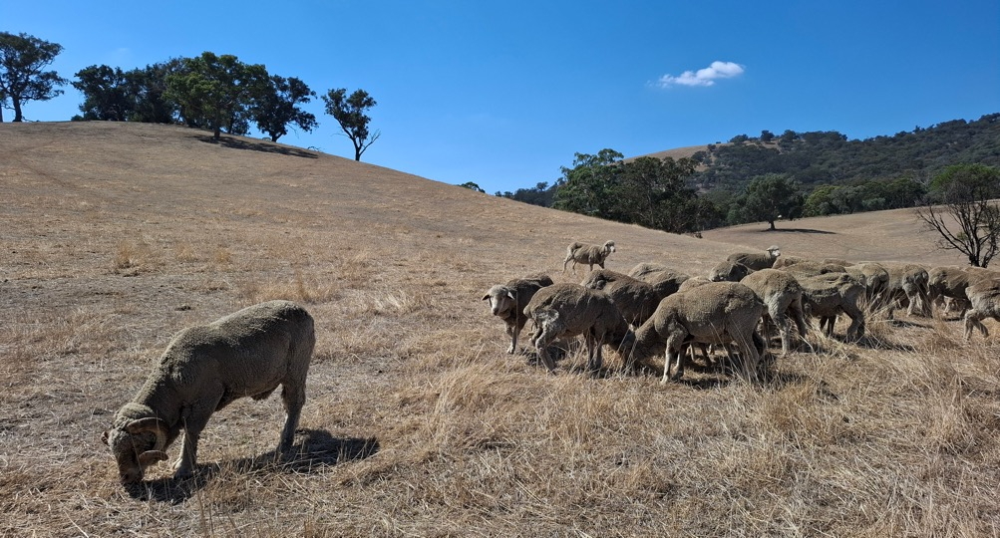

## Water

The first improvement was to install tanks with 37,000 L capacity on a hill above the house. Water is pumped up from the large dam and gravity fed to troughs across the farm. The tanks also provide water for the garden. The house is at 270 m and the tank at 330 m above sea level. The pump is electric and can be set to automatic with a timer and shuts off when tanks are full. The pump can run for about 4 -7 hours/day depending on cattle numbers and time of year. Troughs are spread across paddocks to reduce track formation, leading to erosion. David prefers the concrete troughs as these, and the inflows, are less likely to be damaged by cattle. Though the system is working really well, things can still go wrong and need to be monitored regularly. A broken pipe or inflow valve could lead to a big loss in water if not picked up and fixed quickly.

## Tanks on the hill

In Figure 2, the red circle marks the location of a trough on the opposite hill from the tanks, only just below the height of the troughs but has good water pressure.

David purchased the property in 2017 and has installed another tank (total capacity of both tanks is 64,352 l and new dams as back up. He has cleaned out some of the existing dams to be 25 to 50% bigger.

Kerri Goschnick, Agriculture Victoria, has provided advice on improving the water supply for the farm. David has learnt he can build bigger dams without them leaking, despite the gravelly soil, if he does this in the wet years. He has since built 5 new deeper dams which don’t leak.

Figure 2: Trough on far hill from tanks (red circle)

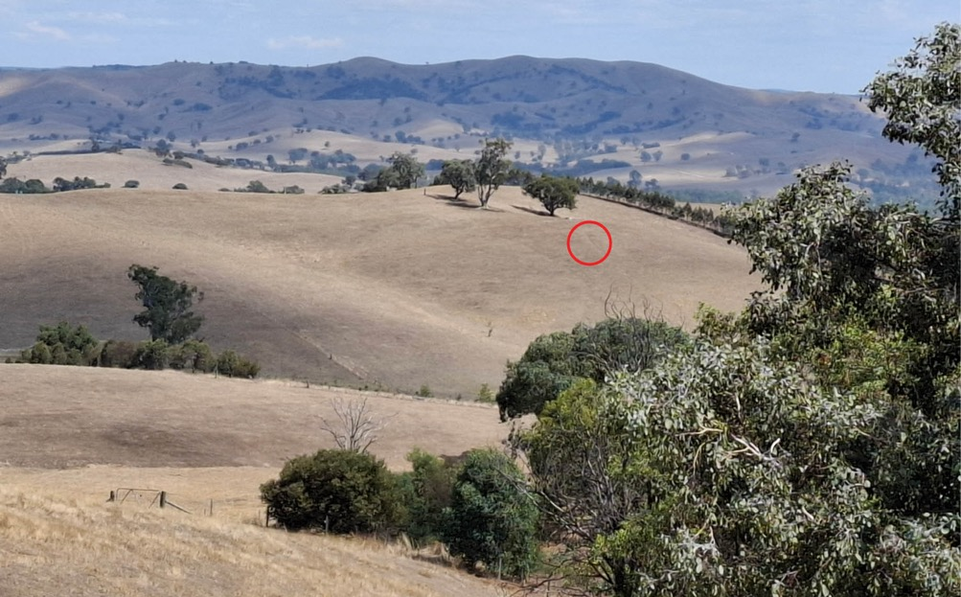

Paddocks are quite small – 2 are 30-40 ha but the rest about 10 ha. The gravity fed trough system and back up dams have therefore allowed him to have more smaller paddocks with reliable clean water. This helps with grazing management and in reducing erosion. Research also indicates cattle may have better growth rates when water is provided in troughs rather than dams.

The most recent dam is about 3 Ml and is situated with a huge catchment, so on advice he installed a trickle pipe which releases water before it overflows the bank. This reduces erosion of the banks when there are high inflows.

Figure 3: Main dam

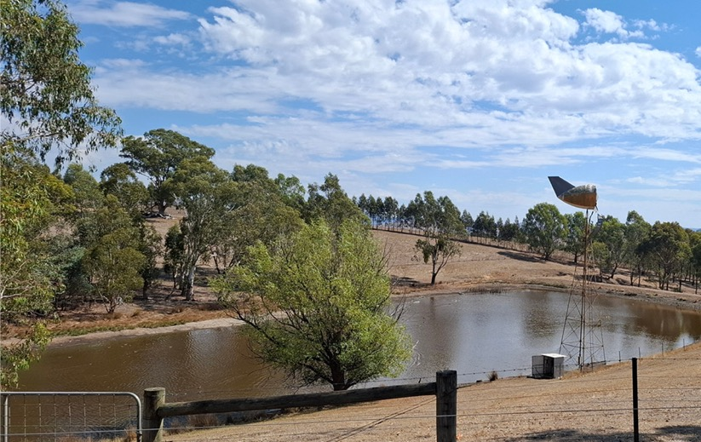

Figure 4: Trickle pipe in dam wall

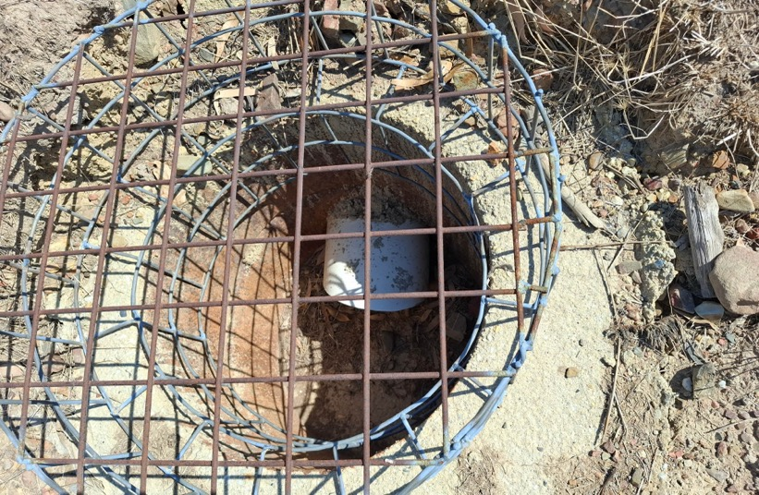

## Pastures

David improved soil fertility with superphosphate, starting when he was leasing the property, and maintaining since. Improved pastures are cocksfoot and Phalaris, and some Wimmera ryegrass (when he can get it). Cattle are useful in pasture management and establishment as they don’t graze as low as sheep, but also good at managing dry feed (in the good years).

## Erosion

The country is prone to erosion, so David has been planting trees in shelterbelts and also as single trees in erosion gullies. Running cattle means the guards have to be robust. Subdividing hilly paddocks also helps in managing the erosion as they can be grazed more strategically.

## Summary

* The hilly country provides plenty of opportunity to capture large amounts of water
* Gravity fed troughs have enabled smaller paddocks, so with increased soil fertility and improved pastures, grazing management and pasture production has improved whilst limiting soil erosion
* The installation of the tanks and gravity fed troughs has allowed accessibility to good clean and fast flow water to many paddocks across the farm

Building the infrastructure is certainly costly but initiating some of the core parts in the lease phase has helped to build this up over time.

# Seasonal reminders and resources

Below is a reference to some past articles that may be useful over the coming months. For past editions of SheepNotes look on the Agriculture Victoria website (agriculture.vic.gov.au and search for ‘Sheep Notes’). For many feed and water articles, tools and webinars visit the FeedingLivestock website.

Details of past articles that may be useful over the coming months

| Topic | Content | Where is it |
| --- | --- | --- |
| What to sow for quick winter feed | A review of pasture options and sowing times for boosting winter feed | SheepNotes Autumn 2024 |
| Perennial ryegrass and Phalaris staggers | Identify and reduce the risk of stock getting staggers | SheepNotes Autumn 2021 |
| Farmer tips for autumn saving | Farmers share their tips for confining sheep to build autumn feed | SheepNotes Autumn 2021 |
| Options for improving winter pasture growth | Lisa Warn presents the options for boosting winter growth to achieve late winter and spring pasture and the tools and triggers to achieve best results | [Bestwoolbestlamb conference presentations 2019 (YouTube)](https://agriculture.vic.gov.au/support-and-resources/networks/bestwoolbestlamb/bestwoolbestlamb-conference-videos/2019-conference-presentations) |
| Soil temperature for sowing decisions | Critical soil temperatures for pasture sowing | SheepNotes Autumn 2022 |
| Hypocalcaemia in sheep | Guidelines for reducing the risk of hypocalcaemia. Distinguish between hypocalcaemia and pregnancy toxaemia | SheepNotes Spring 2023 |
| Wormboss Drench decision guide |  | WormBoss website |
| Nutrition and health of ewes after the break | Guides on ewe requirements - pasture, health and Condition | SheepNotes Autumn 2015 |
| Condition Scoring | This site outlines the when and how to Condition Score sheep (including link to a ‘how to’ video). Many other resources for ewe management here. | Lifetimewool website [lifetimewool.com.au/ conditionscore.html](http://lifetimewool.com.au/conditionscore.html) |
| Targets for maternals | Outlines results from research to develop guidelines for condition scores for crossbred ewes | SheepNotes Autumn 2020 |
| Calcium disorders of ewes and lambs | Colin Trengove outlines hypocalcaemia, risks and potential treatment | SheepNotes Spring 2016 |

# To resow or not to resow…that is the question

**Article author: Fiona Baker, Agriculture Victoria, Ellinbank**

With an extended dry summer this year, some perennial pastures may be looking a little worse for wear. With autumn rains just hitting some or just around the corner for others, now is a good time to consider the condition of your perennial paddocks.

So how do you assess whether a pasture needs to be resown, or whether it has the potential to thicken up and tiller out after the break has hit?

Assessing the composition of the pasture for the proportion of perennial grasses is one of the best methods. If the desirable perennial grass species are above 70%, then the pasture is still productive. If the desirable perennial grass species are below 50%, then reseeding will increase yields, the feed value on offer to stock and the response that pasture could have to applications of nitrogen should you choose to use it. It is important to identify why the pasture has thinned out – is it soil fertility, grazing management issues or just tough seasonal conditions? If soil fertility or grazing management are the issue and it is not addressed, the same problem will keep on happening down the track.

There are a number of methods for assessing the composition of a pasture – stick, transect, motorbike, quadrat and boot method. They all follow similar principles of observing what is growing (if anything) at the assessment point. Details on how to do a composition assessment and record sheets can be found at <http://mbfp.mla.com.au/pasture-growth/tool-27-field-based-pasture-measurements/>

Choosing not to reseed once perennial grass levels have decreased significantly, increases the risk of weed invasion to both broadleaf weeds and annual grasses. Weed species tend to be both lower in feed value and have a shorter growing season, resulting in lower than expected animal performance.

When assessing perennial pastures early in the season before the break has arrived, a large portion of bare ground may be encountered. If the amount of bare ground is no higher than 30% it is unlikely that pasture production will be significantly impacted - particularly if it is clover that germinates and fills the bare ground areas.

If there is a large proportion of annual grasses invading the perennial pasture, it is important to be able to identify which species they are to be able to determine the best method for control. The most common annual grass invaders are barley grass, silver grass and winter grass.

## Resources

The pasture paramedic booklet is a good resource for identifying different species and can be found via the Agriculture Victoria Feeding Livestock website: [feedinglivestock.vic.gov.au/2021/10/06/pasture-id-resources/](http://feedinglivestock.vic.gov.au/2021/10/06/pasture-id-resources/)

## Barley

Barley grass seedlings tend to be a lighter green colour and **lightly haired** on the leaf and stem. Where the leaf joins the stem they have well developed **auricles**. The emerging leaf is **rolled**.

Image 3: A Barley grass seedling

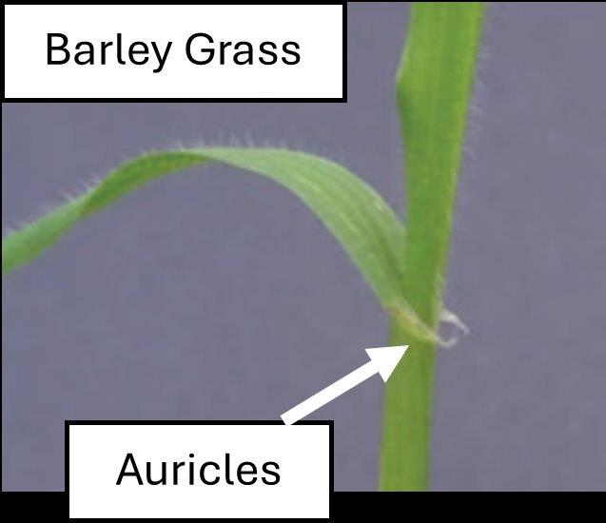

## Silver grass

Silver grass is a very fine leaved grass. The leaves are hairless and the newly emerging leaf is **rolled**. It has a small membranous ligule but no auricle.

Image 4: A Silver grass seedling

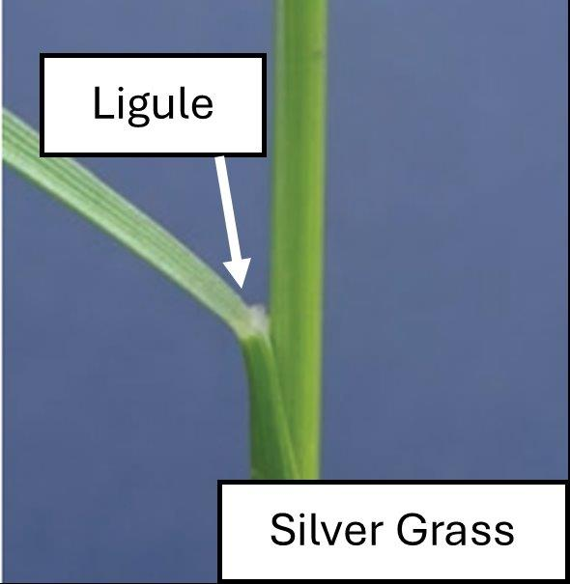

## Winter grass

Winter grass tends to be a slightly lighter green colour, with the leaf and stem being hairless. The emerging leaf is **folded** rather than rolled.

If you find a large proportion of any of these annuals in your pasture, speak to your local agronomist or chemical reseller to find out your options for control prior to undergoing reseeding.

Resowing does not always mean a total renovation of the pasture. If there is still a reasonable amount of desirable species present, but you believe it needs to thicken up to minimise weed invasion, direct drilling into the existing pasture is generally the best method. Just be sure to graze out the pasture hard first and spray out any broad leaf weeds prior to drilling to minimise competition for the new emerging pasture. A lower cost option can be to broadcast new grass seed just prior to grazing and allow the stock to work the seed into the ground with their feet as they graze – just note, this option is generally not as successful as direct drilling.

Don’t forget to apply a small amount of phosphorus based fertiliser to ensure the new emerging pasture can readily access phosphorus from the soil. Phosphorus is important for healthy, strong root formation. Rates of 10-20 kg/ha phosphorus (114-227 kg/ha superphosphate/ha) would be adequate. The phosphorus can either be drilled in with the seed (best response) or broadcast around the time of sowing. Annual applications of phosphorus, potassium and sulphur to maintain soil fertility at adequate levels will help strengthen the pasture base.

As much as possible graze pastures according to readiness to graze based on leaf stage. Perennial ryegrass or fescues should be grazed at the 3-leaf stage, Phalaris, cocksfoot or prairie grass pastures at the 4-leaf stage. This will help with the persistence of these species and minimise the risk of weed invasion into the pastures down the track.

# Dry seasonal conditions

While farmers look to the ‘autumn break’, Agriculture Victoria continues to support farmers to prepare and plan for a potential continued dry season.

The past 12 months across many areas of the state have been very dry and we understand the effects this has on businesses, particularly with increased supplementary feeding and depletion of on-farm water supplies.

In the south west, dry seasonal conditions have been ongoing since winter 2023 and given the cumulative impacts, the Victorian government announced a $13.53 million Drought Support Package on 30 September 2024.

As part of this package, Agriculture Victoria has trialled a new innovative approach to support south west farmers in making good timely and informed decisions to ease what is acknowledged as an increasingly stressful situation.

The program comprises technical decision-making support in the form of a one-on-one technical advisory service, which has had great uptake, and a targeted group events program, delivered in partnership with service providers.

A range of dry seasonal conditions preparedness and management resources are also available to Victorian farmers across the state. These include a suite of water and feed calculators to support planning and decision making available on the Agriculture Victoria website.

Farm business and planning support is also available through workshops run as part of the Farm Business Resilience Program, as well as services offered through the Rural Financial Counselling Service.

## One-on-one advisory service

The one-on-one advisory service for the south west offers eligible farmers a free three-hour consultation with a trusted consultant to develop a drought action plan specific to their farm’s needs. A follow-up phone call ensures ongoing support, allowing farmers to adjust plans as conditions evolve.

To date, over 70 farmers have benefited from this service, seeking advice on critical areas such as feed and water budgeting, as well as broader business management strategies. A panel of 19 consultancy businesses, featuring 21 experienced advisors, is available to provide tailored support. After registering their interest, farmers are connected with their preferred consultant by Agriculture Victoria to arrange the on-farm consult.

Figure 5: Top 4 most common themes for one-on-one consultations

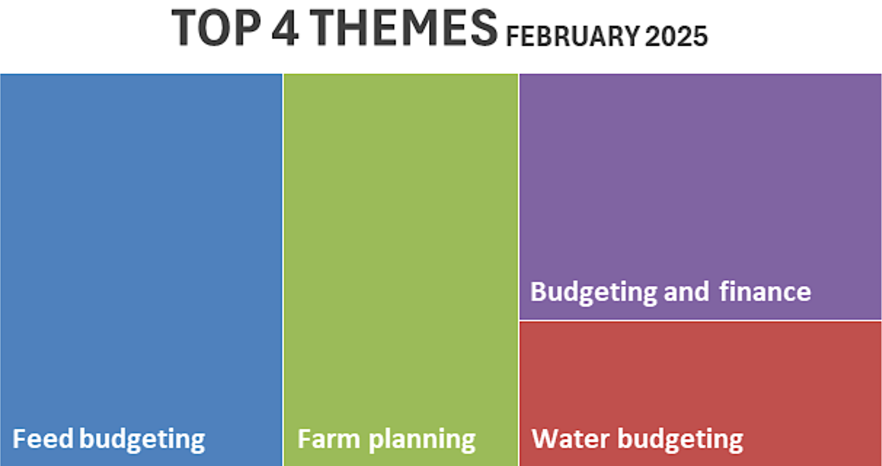

## Group-based learning

In addition to individual consultations, the program is funding over 40 group-based learning activities across the region. Running from February the workshops, designed to complement the usual program delivery in the region, have been developed by expert consultants with regional knowledge, with a focus on 4 key areas:

* technical decision-making
* digital tools (for farm management)
* mental health and wellbeing
* business management and planning

The events program has proved successful, with a range of options available to farmers. As at mid-March 196 farmers had attended 10 events across the region.

To view the full listing of drought support events **scan the QR code** below:

Image 5: QR code that links to the full listing of drought support events

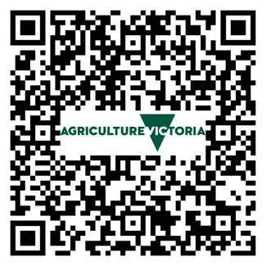

Individual event listings are available at [agriculture.vic.gov.au/events](http://agriculture.vic.gov.au/events)

The novel approach to design and delivery ensures Agriculture Victoria can ensure ready access to practical, innovative and targeted support to drought-affected farmers.

Through one-on-one advisory services, group workshops, and digital resources, farmers have access to tools and knowledge to navigate challenging conditions and build resilience for the future.

For more information on managing dry seasonal conditions visit: [agriculture.vic.gov.au/dryseasons](http://agriculture.vic.gov.au/dryseasons)

**This edition is supported by the Victorian Government’s Drought Support Package for south west Victoria.**

# Trace elements revisited

**Article author: Jim Shovelton, Meridian Agriculture**

Trace element requirements of pastures are often overlooked.

The discovery of the need for trace elements in Australia revolutionised pasture production in the 1950s. However, deficiencies are still widespread. Clover samples analysed by Nutrient Advantage over the last 5 years showed about 50% were deficient in molybdenum.

The photo shows a test strip site in the upper Murray which had been receiving annual applications of single superphosphate for around 40 years, most of which were ineffective because of the molybdenum deficiency.

Often trace elements are not added because of the perception of cost.

The cost of adding molybdenum to superphosphate is currently $35/t. At an application rate of 50 gm/ha this is cost of about $9/ha. Molybdenum reapplication periods vary, but assuming reapplication is required every 5 years, the annualised cost is $1.80/ha. If pasture dry matter was valued at $200/t, a response of only 9 kg dry matter/ha/yr would be required to cover the extra cost of the molybdenum.

Molybdenum is not the only trace element missing in parts of Victoria. Others include boron, copper, cobalt, selenium, iodine and zinc.

Figure 6: Fertiliser test strips showing clover response to molybdenum

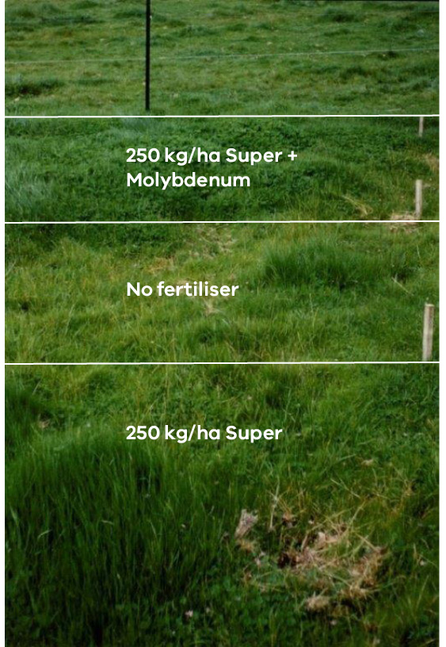

The understanding of the role of trace elements in Victorian grazing systems was summarised in the 1986 Agriculture Victoria publication ‘Trace Elements for Pastures and Animals in Victoria’. Since that time there have been changes in farming practices, such as liming, which will have affected trace element availability. The information needs updating to confirm the extent and distribution of trace element deficiencies in Victoria and update diagnostic, treatment and management recommendations.

MLA have funded a program to improve and update our knowledge of trace element requirements in Victorian pastures. The project is looking for involvement by producers. A key activity will be the opportunity for producers to establish simple test strips on their farm to look for responses. Through the support of group co-ordinators or agronomists, these strips will be assessed for changes in growth and pasture composition and sampled for herbage analysis. Test kits will be distributed through grower networks such as Bestwool/Bestlamb and BetterBeef. Other groups or networks will also be encouraged to participate.

Regional workshops for producers and service providers will be held during the duration of the project. The Trace Element Book will be updated and made available for farm advisers, agronomists and farmers. The project will be managed by Meridian Agriculture in conjunction with Agriculture Victoria and the Mackinnon Project.

**Further information contact:** Jim Shovelton, Meridian Agriculture  
Email: [jshovelton@meridian-ag.com.au](mailto:jshovelton@meridian-ag.com.au)

# Campylobacteriosis - how can it affect my farm this lambing?

**Article author: Dr Frankie Collett (Rochester Vets)**

Ovine Campylobacteriosis caused by Campylobacter fetus subsp fetus (the most common) and Campylobacter jejuni is an infectious bacterial abortion agent that can lead to ewe reproductive wastage through foetal reabsorption and abortions. It has been ranked as Australia’s most common disease that cause abortions in sheep. When first introduced it can lead to losses of up to 40% of lambs.

Symptoms can be silent with carrier ewes (ewes that have been infected in the past) intermittently shedding the bacteria in their faeces without showing any signs of illness. Naïve ewes (that haven’t been exposed before) then ingest the bacteria when eating from the ground and become infected. Infected ewes that are pregnant will abort and shed the bacteria in large amounts in their aborted material which is a high risk for pasture contamination. Ewes that are not pregnant that become infected are thought to have an immune response without showing signs of illness.

Image 6: A dead lamb

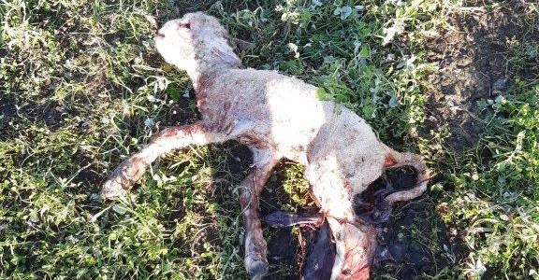

## Husbandry and environmental conditions can increase the risk

* Maiden ewes/ewe lambs are at increased risk of becoming infected as they have had less time in their life to be exposed to the bacteria and thus may lack immunity.
* High stocking rates in paddocks with pregnant ewes and/or lambing paddocks can also increase the risk of exposure as animals will have increased pressure to graze closer to one another increasing the risk of ingestion. Similarly, ewes in containment pens are also at increased risk especially if hand feeding on the ground.
* Cool wet seasons also provide the right situations for spread as this allows the bacteria to survive.
* Ewes lambing in high rainfall zones are therefore also at higher risk.

## How will I know if Campylobacteriosis is having an effect?

* You may have reduced scanning/lambing/marking percentages in comparison to previous years.
* A large difference in results between scanning and lamb marking data that indicates high lamb losses, making scanning a very important tool to use.
* There may be an increased number of weak/unviable lambs.
* In severe cases you may have abortion storms in the last 6 weeks pre-lambing (although they can occur earlier).

## How can I reduce the impacts?

* Vaccinate maiden ewes/ewe lambs prior to joining (Coopers Ovilis CampyvaxTM). It is recommended to give 2 initial vaccinations to be effective prior to joining (always check labelled instructions for the most up to date information).
* Once the initial and booster vaccinations have been given, annual vaccinations can then be continued for adult ewes before joining. It is particularly important to do this for ewes who are at greater risk such as ewes in containment pens/high stocking rates/high rainfall areas.
* Manage maiden ewes/ewe lambs separately from older ewes from joining time until lambing has finished to help reduce the risk of exposure at a time when they could have foetal losses.
* Make sure to monitor your lambing ewes and if you have any concerns for abortions or reproduction losses, contact your local vet to investigate further.

## What should I do if I start to see abortions?

* Ewes can abort for many different reasons including campylobacteriosis, salmonella and listeriosis. Therefore, having the correct diagnosis is crucial for prevention management. Contact your local vet to start the investigation.
* Some causes of abortions are zoonotic (infectious disease that can spread from animals to humans). These include Salmonella and Campylobacter jejuni. Therefore, avoid coming into direct contact with aborted lamb/fluid etc and always wear gloves, wash hands after contact, avoid skin/mucosa (eyes, mouth) and avoid altogether if you are immunocompromised or pregnant.
* Depending on the cause, removal of the ewe and abortive material (placenta, foetus) from the lambing paddock may be necessary to help reduce the spread of disease. Ewes can shed bacteria up to 6 weeks after aborting and the abortive material has a high bacteria load. However, doing this in a manner that considers risks of mismothering and reducing ewe movement through the infected area is vital.

# Lambing in 2024 in southwest Victoria

**Article authors: Sue and Bugs Maconachie**

Sue and Ian (Bugs) Maconachie run a sheep and cropping farm at Ballyrogan, 23 km southeast of Ararat. They run a 50:50 sheep and cropping operation. The sheep enterprise is a self-replacing Bond Corriedale flock, with half joined to White Suffolk rams for terminal lamb production. In 2024 they joined 1800 ewes and 400 ewe lambs.

Crops are red wheat, beans and canola.

Figure 7: Sue and Ian Bugs Maconachie

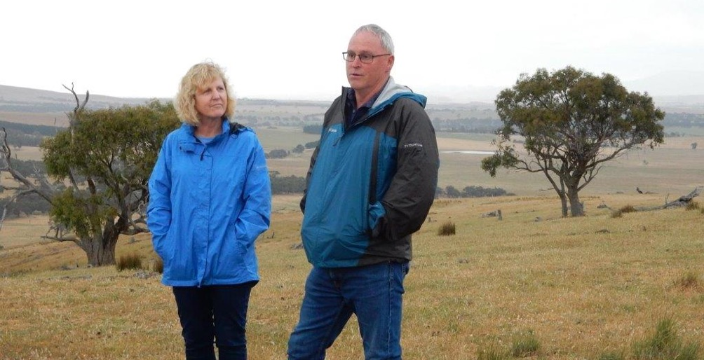

## The season

The long-term average rainfall for Ararat is approximately 500 mm. In 2024 the rainfall was 350 mm but 75 mm of this fell in January then another lot in December, so the growing season rainfall was much lower (i.e. 200 mm). The January rain meant there was green feed for ewes at joining which led to a phenomenal scanning percentage. 62% of ewes were scanned with multiples; 3.5% dry and the rest singles.

Ewe lambs were scanned for wet and dry with 85% scanned in lamb. So, like most sheep farmers in the southwest (and elsewhere) they started the season with heaps more lambs than usual in utero, but very poor follow up rain to produce pasture for pregnancy and lambing.

The main ewes start lambing on 21 May and the ewe lambs on 20 August.

Figure 8: Farm view

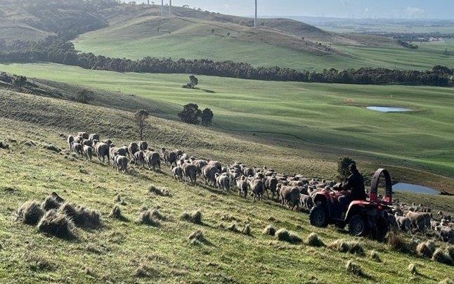

## Managing pregnancy to weaning

Due to the lack of follow up rain from January and a late and disappointing autumn break, Ian and Sue fed through most of mid pregnancy to current (March 2025). The grazing crops however meant they did not have to use containment areas over pregnancy as they did provide some feed and ground cover. Ewes went on grazing canola and wheat over lambing and then to pastures and back to crops.

They fed out home grown beans (and hay) through lambing. The ewes were trail fed 3 times/week (plus ad lib hay) and usually later in the day. They found the ewes were not hungry so any that were lambing stayed with their lambs rather than rush to the grain.

They also feel the ewes do better with trail feeding than self feeders when there is some dry pasture. They would not usually feed through lambing but found a system that worked, and the lambs did really well.

The weather over lambing was dry with no bad weather events so lamb survival was exceptional (marked 160% across the flock). The hay they fed was self grown wheat hay, which they tested and were surprised at how good it was (Crude Protein of 8.1% and Dry Matter Digestibility of 65% so approximately 9 megajoules of energy/kg).

Sue and Bugs would have liked to have kept the ewes and lambs on the crops for longer, but the season meant otherwise. Lambs were weaned early off the crops – the youngest lambs were only about 7 weeks and ranged up to 13 weeks of age.

They then made the decision to sell 1000 of the smaller lambs (25-32 kgLWt) on AuctionsPlus. These lambs made $132/head which provided cash flow and income. It also freed up paddocks and feed for the rest of the lambs. and returned the flock to their usual number of lambs.

Retaining these additional lambs would also have used a lot of grain, hay and labour to get them up to the 25 kg carcase weight (CWt) that the rest of the first cross lambs were sold at. A rough estimate would be that it would take about 152 kg of grain to get a 25 kg lamb to 53 kg LWt plus all the other associated labour, selling, health costs etc to do this.

The rest of the lambs were weaned onto feeders with beans and oats plus hay. 1500 lambs were on 4 feeders which did really well. 500 first cross lambs were sold over the hooks in November and 1000 in January at carcase weights of up to 25 kg. Good prices for lambs over this period meant good returns.

The ewes have recovered from the high lambing rates. They have been fed constantly since at least mid-pregnancy but the grazing crops and early weaning have paid off. The ewe lambs needed a huge amount of feed to get through and so in hindsight they would not have joined them.

Figure 9: Ewes have recovered well – late March 2025

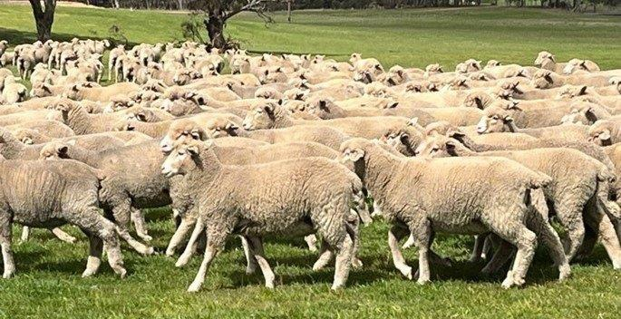

## Crops

Yields were down but they grew enough beans to feed the sheep and sold some wheat and canola. They harvested frost affected wheat with yields of 2-3.5 t/ha but had some up to 6 t/ha.

## Water

All water is supplied by dams as bore water is quite brackish. 35% of the farm is hilly and the remaining flat. Water availability has been fine until the last few months. The flat country, which is where the sheep are on stubbles, is starting to run out. Some of this country was purchased recently and doesn’t have the water infrastructure in troughs, pipes and good dams which the rest of the farm has. They are currently waiting on contractors to set this up.

## Reflections – what would do again and what differently

Worked well:

* Having half sheep and grazing crops (initiated in the last few years) has worked well for Ian and Sue, providing some good grazing feed over pregnancy and lambing.
* Trail feeding ewes over lambing when there was some dry pasture feed. Feeding 3 times/week and usually later in the day. This plus feeding enough - 150g/head of beans per day, meant they had no problems with mismothering and ewes and lambs did well.
* Early weaning and selling small lambs provided extra income and meant they could focus resources into bigger lambs and ewe recovery.
* Ian and Sue are both active members of the Ararat BestwoolBestlamb (BWBL) and Perennial Pasture Systems groups and found the discussions with other farmers very helpful. The BWBL group used local nutritional adviser, Jess Revell, which was invaluable.
* Also – they are lucky to have their son Ash, who works as an agronomist with GroundupAg Services and loves the farm so this has been another great resource for them.

What didn’t work:

* They would have installed trough infrastructure sooner, ready for the dry season.

They would not have joined ewe lambs, but it is always hard to read the season ahead!

# Digital tip

**How to make your cursor a different size and colour.**

1. Right click on the desktop and go to ‘Display settings’ or ‘Settings’ and then ‘Display’



1. Start typing ‘change mouse’, and a few options will come up



1. From there it is pretty self-explanatory. Size 3 seems to work well – if it gets too big, when you are editing documents it’s a bit hard to see exactly where you are placing your cursor.



# Knowing how many lambs – gold!

**Article author: Alison Desmond, Agriculture Victoria, Benalla**

Last year saw some very high scanning numbers due to green feed at joining, followed (for most) by low pasture availability for lambing. It was a stark example of how knowing what ewes were bearing multiples, singles and none – was like gold- to help make management decisions. This year (as with most) this information will also be invaluable, with scanning rates to date, at much lower numbers.

Image 7: Pregnancy scanning to increase farm profitability

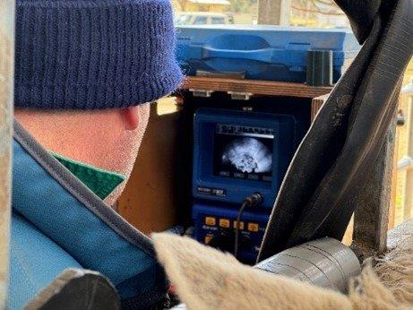

*‘The greatest improvement in profit from investing in pregnancy scanning comes from scanning for multiples, removing the passenger (dry) ewes and managing the needs of single and multiple-bearing ewes based on the number of lambs they are carrying.’*

Pregnancy scanning for multiples is a vital management tool for optimum ewe and lamb survival, through managing nutritional demands with differential feed and paddock allocation and condition targets. It also enables you to understand where the biggest opportunity is to improve the reproductive performance of your flock – conception rate, scanning percentage or marking percentage.

Scanning for multiples will:

* forecast potential lamb numbers for both financial and feed budgeting
* identify dry ewes to remove (may provide some cash flow) and increase reproduction rates
* allow more flexibility in poor conditions, by prioritising resources (feed, shelter and labour) to the different groups of ewes
* in good years, identifying and managing single bearing ewes can reduce lamb loss from dystocia
* troubleshoot for possible causes of failed reproduction

enable allocation of resources to optimise lamb and ewe production.

## Does it pay?

Australian Wool Innovation (AWI) and Meat and Livestock Australia (MLA) have produced new extension material that clearly demonstrates the value in pregnancy scanning to increase farm profitability.

A benefit-cost-analysis (conducted in 2024) demonstrated that pregnancy scanning for multiples (and implementing optimal management to ewes based on this) is profitable across all regions, breeds and times of lambing. The average benefit was estimated at $5.55 per ewe scanned, and an average return on investment of 400%. Scanning for pregnancy status only returned an average of $2.65 per ewe scanned.

In the winter dominated rainfall regions, the value of scanning was higher when lambing in autumn and slightly less if lambing in spring. This is because empty ewes in the earlier lambing flocks are identified before the main feed shortage, which increases the value of adjusting their nutritional management or from selling them after scanning. The lower value of scanning associated with later lambing does not equate to lower profit overall, as these flocks are often the most profitable because of the better match of pasture supply with the nutritional requirements of the ewes.

To capture the benefits of pregnancy scanning, producers need to use information collected at scanning and make management changes based on this. This includes removing the dry ewes (passengers) from the breeding flock and managing singles and multiple bearing ewes differently to meet their separate nutritional needs. Table 1 shows the breakdown of where the benefits can be made.

Table 1: The value of management options from scanning ($/ewe)

| Management  options | Scanning for  multiples | Scanning for pregnancy status | $/ewe |
| --- | --- | --- | --- |
| Sell the passengers | Yes | Yes | $1.85 |
| Feed allocation: |  |  |  |
| to pregnant ewes | Yes | Yes | $0.80 |
| to multiples | Yes | No | $1.00 |
| Paddock allocation | Yes | No | $0.95 |
| Replacement selection | Yes | No | $0.95 |
| **Total value per ewe** | **$5.55** | **$2.65** |  |

**Source:** The value of pregnancy scanning: A benefit-cost analysis.

## Capitalising on the results

### Removing passengers

Identification of passengers (ewes scanned empty) is essential, as it allows those that have failed to conceive to be managed differently to those scanned with single or multiple lambs.

By removing passenger ewes from the breeding flock, feed resources can be prioritised to pregnant ewes. Ewes may scan empty due to the impacts of management factors such as poor ewe and ram nutrition prior to joining or condition score (CS) at joining. If more than 15% of ewes are not pregnant in the target joining time, an investigation to determine the reason for ewes failing to conceive is necessary. Offloading dry ewes may supply some needed cash flow.

### Managing nutritional requirements

The nutritional requirements between single and twin bearing ewes are quite different, therefore you are essentially managing very different animals. For example, feeding single bearing ewes too much during pregnancy can lead to large lambs and problems with dystocia.

Feeding twin bearing ewes too little can lead to low lamb survival (due to low birth weight and milk production), low growth rates, poor ewe recovery and potential pregnancy toxaemia.

Figure 10 shows the energy requirements of single and twin bearing ewes (60kg ewes in CS 3) from the beginning of pregnancy (dry) to day 50 of lactation (Source Lifetime Ewe). The higher energy needs of the twin bearing ewes increase in late pregnancy and during lactation to 25-28% more than single bearing ewes. Or compared to dry ewes, in late pregnancy (last 6 weeks), single bearing ewes need almost 40% more energy and twin-bearing ewes need 76% more.

Figure 10: Reproductive stages of the ewe

The reproduction cycle of the ewe from joining:
Joining to day 30 – fertilisation, embryo development and implantation.
Day 30-90 – Placental development and primary follicle development from day 60-90.
Fetal growth and secondary follicle development occurs between day 90 and day 150. Udder development and colostrum production is between day 120 and day 155. Lamb growth and  ewe milk production day 150 to 250. Follicle maturation occurs between day 150 and about day 220.
 Pregnancy scanning to be done between day 80-90 (from joining); lambing at day 150 and weaning at day 250.


Figure 11: Energy requirements of 60 kg ewes in CS3 from early pregnancy to 50 days of lactation.

The energy requirements of single and twin bearing ewes (in CS 3) from the beginning of pregnancy to day 50 is shown
 

This is why is why scanning for multiples and managing the reproductive potential of your ewes can make such a difference. The more you know about your sheep the better the results can be.

**Figure 11** shows the reproductive stages of the ewe and key events i.e. scanning should occur between 80-90 days after joining (when rams go out with the ewes).

### Condition score (CS) targets

The Lifetime Ewe project developed some clear targets for CS of ewes over pregnancy for good lambing performance. Condition scoring is a quick and reliable tool for managing ewes to meet production targets and enable timely decisions to optimise reproduction rates. The essential times to condition score are at weaning, pre-joining, pregnancy scanning and lamb marking. The autumn 2024 edition of SheepNotes works through how to condition score plus resources listed at the end.

In the lead up to scanning, producers should be targeting a CS of 3 for all ewes from joining to scanning.

The CS during early to mid-pregnancy (Day 1-90) affects lamb birth weight, fleece weight and fibre diameter, and these effects on the developing lamb are permanent. Ewe nutrition in early pregnancy will affect the ability of the ewe to reach late pregnancy condition targets.

Starting from a very low condition in early pregnancy will not give the ewe enough time to gain condition in time for lambing, potentially reducing the chances of lamb and ewe survival. It’s much more cost effective to maintain CS than to put CS on, so if your ewes are in good condition make sure you keep them there.

When ewes have been scanned, assess single and multiple bearing ewes separately for condition score. Targets from scanning through to lambing is CS 3 for single bearing ewes and CS 3.3 or better for multiple bearing ewes.

### Other factors

Other key factors for lamb survival especially of multiples include shelter and privacy. Twins and triplets are generally born lighter and so are more at risk in poor weather. Choosing paddocks that have better feed availability and/or shelter is always a balance.

Ewes that give birth to twins in close proximity to each other can get interrupted during the bonding period leading to mismothering of lambs. Mismothering can also occur due to disruption when feeding. Producers can manage paddock and mob size to reduce the risk of this. Mob sizes of twin bearing ewes has been recommended to be between 100-250 ewes per paddock.

Regular feed budgets and monitoring ewe condition will help to ensure targets are being met between scanning and lambing.

### Resources:

This article references information from the recently released AWI MLA pregnancy scanning extension material on pregnancy scanning. You can find more information, guides and a ewe management and pregnancy scanning checklist at   
[www.wool.com/pregscanning](http://www.wool.com/pregscanning)

Agriculture Victoria Feeding Livestock: sheep energy and protein requirements  
[www.feedinglivestock.vic.gov.au/sheep-resources/](http://www.feedinglivestock.vic.gov.au/sheep-resources/)

Lifetime Wool  
[lifetimewool.com](http://lifetimewool.com/)

Lifetime Ewe Management   
[wool.com/training-extension/lifetime-ewe-management/](http://wool.com/training-extension/lifetime-ewe-management/)

# Emission intensity

**Article authors: Jane Court, Richard Eckard, Ralph Behrendt and Graeme Anderson**

Total greenhouse gas (GHG) emissions are measured in kilograms or tonnes of carbon dioxide equivalents (CO2e). The main GHG on farms are carbon dioxide, methane and nitrous oxide. The CO2e takes into account the different global warming potential of these gases.

An emission audit splits emissions into scope 1, 2 and 3. Scope 1 are all emissions produced on the farm (such as from livestock production); scope 2 covers emissions from energy use, and scope 3 are the emissions produced by inputs that come into the farm (such as feed supplements and fertilizers).

Figure 12: Methane emissions from livestock farms is driven by livestock numbers

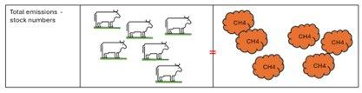

Greenhouse gas (GHG) emissions from livestock farms are a numbers game. The more stock, the higher the GHG emissions, as the main source (>70%) is methane from digestion in the animal and breakdown of manure. How much animals eat is directly related to the amount of methane produced.

So the number and weight, or dry sheep equivalents/adult equivalents run on a farm are the primary driver of emissions. There are currently few cost-effective technologies for farmers to substantially reduce methane without reducing stock numbers, so research will be required to achieve significant reductions.

There is potential for some farmers to make significant reductions through carbon sequestration in trees and soil, but these will reach a plateau over time so provide temporary carbon solutions but other long term benefits.

## Emission intensity (EI)

Emission intensity (EI) is estimated as total GHG in kilograms CO2e divided by the units of product produced. For livestock the units of product can be measured in kilograms of liveweight (LWt) or wool produced from a farm. For example, this means EI is reported as kg CO2e per kg LWt.

EI is a more useful measure for agriculture as it is a measure of efficiency of production rather than size. If farms were currently compared, or products sourced, on lowest total farm emissions, then small farms would be selected which would be a perverse outcome. Strategies that improve production efficiency will generally drive down emission intensity and improve profitability.

Figure 13: Emission intensity from livestock is the tonnes of CO2e divided by the tonnes of product from the livestock

Farmers currently have more options to reduce this number than they do to reduce total emissions. As farm value chain targets are all EI based, incentives or demand for lower EI products is likely to increase.

Think of emissions intensity as a ratio (kg CO2e/kg liveweight or wool). To reduce EI, you can either reduce total GHG emissions (for the same production), or increase total product produced (for the same emissions).

Either way, the ratio decreases. Greenhouse gas farm calculators, like the Melbourne University Sheep-Beef Greenhouse Accounting Framework (SB-GAF) and the MLA carbon calculator, generate an EI value for beef and sheep meat (as live weight LWt) and greasy wool. The EI can include sequestration in trees. For grain crops, the EI is a measure per tonne of grain and for dairy as emissions per kg milk solids.

## Benchmarking

Emission intensity values allow for comparison and benchmarking between farms of different sizes. The emission intensity for beef, sheep meat and wool differ because of fundamental differences in the systems. It is therefore unhelpful to compare EI between products.

Potential improvements or reductions in EI will also depend on the local environment/climate. For example, high rainfall improved pastures may have more potential to reduce EI, due to quicker turn off times and higher fecundity associated with better pasture production. Sheep systems are typically more efficient with regards to EI as their emissions are divided over two products (wool and meat), plus have higher twinning, which generally results in lower emissions intensities for sheep meat than for beef.

Table 2 provides a common range of EI figures for beef, sheep and wool for southern Australia.

Table 2: Common emissions intensities for Australian beef and sheep production (based on calculations from SB-GAF calculators).

|  | Beef  (kgCO2e/kgLWt) | Sheep (kgCO2e/kgLWt) | Wool  (kg greasy  fleece weight) |
| --- | --- | --- | --- |
| **High  rainfall** | Average: 12.1  (Range: 8.7-13.8) | Average: 7.9  (Range: 4.5-8.6) | Average: 29  (Range: 19-32) |

## Allocation between products on farm and for meat and wool

If a farm produces several products e.g. beef, hay and grain, then total farm emissions will be spread across the enterprises to reflect the inputs used for each. As sheep produce meat and wool, emissions need to be allocated between the two.

This is done in emission calculators according to the protein required to produce each. Wool is always the larger number in terms of percentage protein – but wool and meat cannot be compared on their EI as they are quite different products.

Also, as fibre diameter (micron) is the main determinant of price and end product, and is negatively correlated to weight, efficiency of wool production is not recognised in the EI number.

Comparing EI from wool of similar fibre diameter would be a better way to compare farms. Note that if you have a shedding flock and there is no wool harvested, all emissions are allocated to meat production.

## What practices reduce EI

Reducing EI can therefore be done by reducing the total emissions (without reducing the amount of product sold) or by increasing the amount (kg) of product sold from the same number/weight of animals. Because EI relates to efficiency of production, many strategies that reduce EI can lead to increased production and/or profitability.

Profitability and farm goals will be the main driver of making changes, but if EI also improves, this can be a bonus.

## What else affects EI?

Total emissions and EI will vary from year to year on most farms. If the farm is in a build-up phase (and therefore do not sell many animals) or sell down (e.g. in a drought) then EI could be much higher or lower (respectively) than in a more normal or stable year.

If this is the case, this needs to be taken into consideration when looking at or comparing your EI numbers to other farms and within the farm over time. Looking at a year that is in a steady state or a 5-year average may be more useful. When making comparisons, ensure that scope 3 emissions are included in the EI and clarify whether sequestration is included, as both can have significant effects on the number.

## Why is emissions intensity important?

With International Financial Reporting Standards now including climate-related disclosures, plus most agricultural value chain companies setting GHG targets, value chains are increasingly being required to account for their emissions. Some are also looking to promote low carbon products.

Australian farmers have continuously improved livestock productivity and efficiency to increase profitability and respond to climate and market variability. Many of these practices will directly reduce EI. As an example, a study in 2009 showed how methane per unit production had been trending downwards over the previous couple of decades in the beef industry, due to improvements in animal breeding, diet and management.

This article is an abridged form of a fact sheet produced as part of the MLA CN30 project. The full version will be available on the [MLA website](https://www.mla.com.au/).

# Feeding Livestock – Not so hard quiz

We have started a simple 1 question quiz that showcases how some of the tools and resources on the Feeding Livestock website can help answer feed or water questions.

It was set up as a digital quiz i.e. in digital media, so if you clicked on the picture below, it would take you to the page on the website with the answer. As we can’t do this in print, we have included the table that provides the answer below.

## The question

I have a mob of 500kg cows. I bought some hay which is at least average quality. I assume it has a energy value of 8 MJME/KgDM and NDF (Neutral Detergent Fibre) of 55%. **How much hay can each cow eat per day?**

[Feeding Livestock – Not so hard quizz.
I have a mob of 500 kg cows. I bought some hay which is at least average quality. I assume it has an energy value of 8 MJME/kgDM and NDF (neutral detergent fibre) of 55%  How much can my cows eat per head per day?
](https://www.feedinglivestock.vic.gov.au/2025/03/18/welcome-to-our-feeding-livestock-not-so-hard-quiz/)

## The answer

**Table showing approximate kilograms of Dry Matter intake**

A useful table for estimating how much stock can eat (intake) based on the fibre content of the diet. Fibre is measured as Neutral Detergent Fibre (NDF) as a percentage.

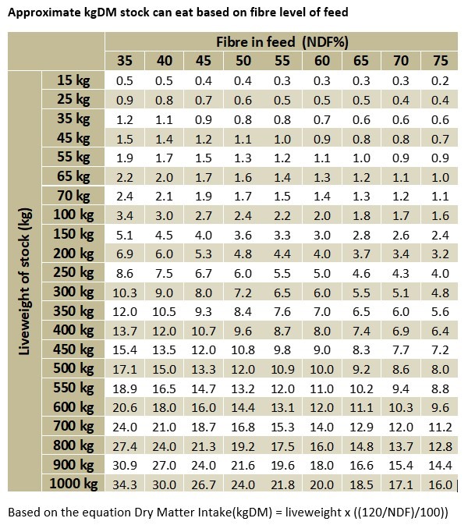

The most my cows can eat of this hay is 10.9 kg/head/day

If you want to try the digital option or explore further go to [feedinglivestock.vic.gov.au](http://feedinglivestock.vic.gov.au/)

# BetterBeef and Bestwool Bestlamb

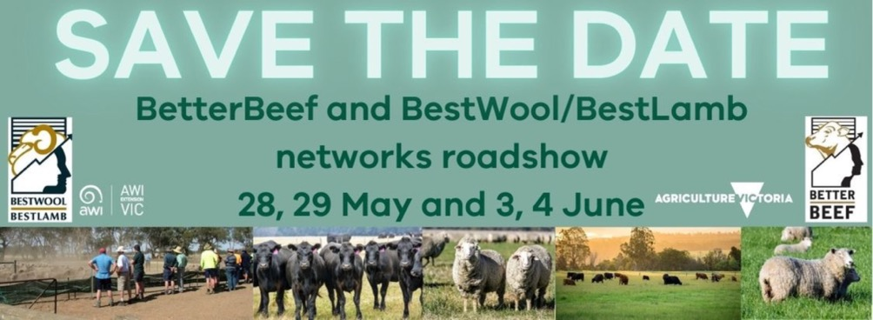

Agriculture Victoria’s BetterBeef and Bestwool Bestlamb (BWBL) networks are hitting the road! The 2025 Beef & Sheep Networks Roadshow will bring top industry experts to 4 locations across Victoria, delivering the latest insights on pastures, livestock and farm business management.

In response to seasonal challenges, we’re taking a fresh approach in 2025. Instead of one big BWBL and BetterBeef state-wide conference, we’re bringing the knowledge to producers with a series of half-day events, making it easier for producers to attend without spending a whole day off-farm. Same high-quality content—just more accessible and closer to home.

Roadshow Dates & Locations:

* South West Victoria – **28th & 29th May**
* Gippsland – **3rd June**

North East Victoria – **4th June**

This format ensures more producers can connect, learn, and plan for the seasons ahead—without the travel commitment of a conference.

Mark one (or more) of the Roadshow events on your calendar.

## Event details

Full event details will be published on the Agriculture Victoria events website [agriculture.vic.gov.au/support-and-resources/event-listing](http://agriculture.vic.gov.au/support-and-resources/event-listing), and the Beef and Sheep Networks Newsflash email newsletter

To subscribe visit [agriculture.vic.gov.au/support-and-resources/newsletters/newsflash](http://agriculture.vic.gov.au/support-and-resources/newsletters/newsflash).

Further information contact: [Beef.sheepnetworks@agriculture.vic.gov.au](mailto:Beef.sheepnetworks@agriculture.vic.gov.au)

# Agriculture Victoria animal health and sheep industry contacts

Although our offices are currently closed, the office numbers provided below are diverted to staff who can assist you. Alternatively, you can contact Agriculture Victoria on 136 186.

**South-West region**

| Location | Office  Contact | Meat and Wool Services: Livestock Industry Development Officers | Meat and Wool Services: Land Management Officers | Animal  health |
| --- | --- | --- | --- | --- |
| Ararat | 136 186 | No | Yes | No |
| Ballarat | 5336 6856 | No | Yes | Yes |
| Colac | 5233 5504 | Yes | No | Yes |
| Geelong | 5226 4878 | No | Yes | Yes |
| Hamilton | 5573 0900 | Yes | No | Yes |
| Horsham | 0343 443 111 | No | No | Yes |
| Warrnambool | 5561 9946 | Yes | No | Yes |

**South-East region**

| Location | Office  Contact | Meat and Wool Services: Livestock Industry Development Officers | Meat and Wool Services: Land Management Officers | Animal  health |
| --- | --- | --- | --- | --- |
| Attwood | 9217 4200 | No | No | Yes |
| Bairnsdale | 136186 | Yes | Yes | Yes |
| Cranbourne | 136 186 | No | Yes | Yes |
| Ellinbank | 5624 2222 | Yes | Yes | Yes |
| Leongatha | 5662 9900 | No | Yes | Yes |
| Maffra | 5147 0800 | Yes | No | Yes |
| Swifts Creek | 5159 5134 | Yes | Yes | No |

**Northern region**

| Location | Office  Contact | Meat and Wool Services: Livestock Industry Development Officers | Meat and Wool Services: Land Management Officers | Animal  health |
| --- | --- | --- | --- | --- |
| Alexandra | 5772 0200 | No | Yes | No |
| Benalla | 5761 1611 | Yes | Yes | Yes |
| Bendigo | 5430 4444 | Yes | Yes | Yes |
| Echuca | 5482 1922 | No | No | Yes |
| Rutherglen | 02 6030 4500 | Yes | No | No |
| Seymour | 5735 4300 | No | No | Yes |
| Swan Hill | 5036 4800 | No | Yes | Yes |
| Tatura | 5833 5222 | No | Yes | Yes |
| Wangaratta | 5723 8600 | No | No | Yes |
| Wodonga | 02 6043 7900 | No | Yes | Yes |

**Note:** Land Management Officers assist with: Farm planning, soil health, soil conservation, and dryland water planning.

# Publication information

## Acknowledgements

We acknowledge and respect Victorian Traditional Owners as the original custodians of Victoria’s land and waters, their unique ability to care for Country and deep spiritual connection to it.

We honour Elders past and present whose knowledge and wisdom has ensured the continuation of culture and traditional practices.

DEECA is committed to genuinely partnering with Victorian Traditional Owners and Victoria’s Aboriginal community to progress their aspirations.

## Copyright

© The State of Victoria Department of Energy, Environment and Climate Action, 2024.

## Creative Commons

This work is licensed under a Creative Commons Attribution 4.0 International licence, visit the [Creative Commons website](http://creativecommons.org/licenses/by/4.0/) (<http://creativecommons.org/licenses/by/4.0/>).

You are free to re-use the work under that licence, on the condition that you credit the State of Victoria as author. The licence does not apply to any images, photographs or branding, including the Victorian Coat of Arms, and the Victorian Government and Department logos.

ISSN 1326-4559

ISSN 1836-4756 (Online)

## Disclaimer

This publication may be of assistance to you but the State of Victoria and its employees do not guarantee that the publication is without flaw of any kind or is wholly appropriate for your particular purposes and therefore disclaims all liability for any error, loss or other consequence which may arise from you relying on any information in this publication.

## Accessibility

To receive this document in an alternative format, phone the Customer Service Centre on 136 186, email [customer.service@delwp.vic.gov.au](mailto:customer.service@delwp.vic.gov.au), or contact National Relay Service on 133 677. Available at DEECA website ([www.deeca.vic.gov.au](http://www.deeca.vic.gov.au/)).

**End of document.**