Sheep Notes

Spring 2024

Table of Contents

Editorial 2

Frost affected crops as hay 2

Culling ewes 3

Wet and dry 3

Udder defects and Fit to Join project 4

Age 6

Get on top of worms 7

Vaccination – good insurance 8

Specialist forages for opportunistic summer feed 11

Soil temperature 11

Millet and sorghum 11

Forage brassicas and summer canola 12

Spring sown canola 13

Forage comparisons 13

Chicory 14

Plantain (Plantago lanceolata) 16

Further information 17

Getting water infrastructure for stock containment sorted 17

Peak demand 17

Water supply design 17

Troughs 18

Digital Tip 19

Next generation Lambing Planner app 19

On-farm Drought Infrastructure Grants for south west Victoria 20

Do you have enough water for your stock? 21

How much do you need? 21

How much have you got? 22

Resources 25

Will feedlotting lambs make cents? 25

Industry overview 25

Store versus trade price trends 27

So does feedlotting make ‘cents’? 28

Findings: 30

Discussion 31

Take home messages are many 31

Extreme weather changes 32

Agriculture Victoria animal health and sheep industry contacts 33

Contact 35

# Editorial

Jane Court and Jeff Cave

Welcome to the spring edition of Sheep Notes. At the time of compiling this newsletter, there has been some welcome spring rainfall, but most areas are behind for October totals. Seasonal forecasts have provided poor guidance for decision making of late with model predictions of a La Nina formation failing to develop. Few places started spring with a full soil moisture profile and in many areas, rainfall to date hasn’t filled dams or led to significant pasture growth. On the bright side, sheep prices are better than last year and there will be some grain harvested and hay cut. In this issue, we have aimed to provide something useful for all levels of producers, with articles to assist informed decisions over the coming months. Don’t forget, there are a range of support services available from Agriculture Victoria to prepare for and respond to difficult seasons.

# Frost affected crops as hay

With recent severe frost event/s, there may be more cereal and other crops cut for hay. As hay is in short supply, this could supply some good shortfalls for livestock farmers. There are some risks to be aware of before purchasing.

Crops that are cut for hay rather than harvested for grain may be within withholding periods for chemicals used for producing crops and not initially intended for stock. Commodity Vendor Declarations must be sought from feed suppliers to manage the risks.

Nitrate toxicity in canola hay can also be a concern for livestock, particularly during drought or when canola plants are stressed by frost, drought, or other environmental factors. Under such conditions, canola may accumulate high levels of nitrates, which when consumed by livestock, can be converted to nitrite in the rumen. Nitrite interferes with the ability of red blood cells to carry oxygen, leading to symptoms like rapid breathing, muscle tremors, bluish mucous membranes, and in severe cases, death. Proper testing of canola hay for nitrate levels is essential before feeding it to livestock. Gradually introducing the hay and mixing it with other low-nitrate forages can help minimize the risk of nitrate poisoning.

Otherwise, generally feed value of frosted cereals will likely be the same as any sort of cereal hay. Low yielding will have better feed value and high yielding will be normal cereal quality.

**Download a Commodity Declaration Form:** [integritysystems.com.au/on-farm-assurance/stock-foods-fodders-crops-grain-and-pasture-treatments](https://www.integritysystems.com.au/on-farm-assurance/stock-foods-fodders-crops-grain-and-pasture-treatments/)

# Culling ewes

Compiled by Jane Court, Agriculture Victoria

This may be an opportune year to cull less productive ewes from your flocks.

Strategic culling of lower production animals will reduce feed requirements while maintaining production into next year. There has recently been some good work done on the impact of poor udders on future lamb survival/performance. There is also the need to have the most appropriate age structure of your flock balancing the genetic gain from bringing in young ewes versus getting the most productive years from older ewes.

## Wet and dry

Wet and drying ewes at or soon after weaning will help identify ewes that have not reared a lamb. If all ewes have been preg scanned before lambing, the dry ewes will be those who failed to rear a lamb. You will have your own criteria as to how strict you are at keeping on dry ewes or ewes that failed to rear (e.g. you might be easier on young ewes or if you had a very tough lambing period). This year did see some high scanning rates due to green feed at joining, but the lack of follow up rain to grow the required feed may have led to more lamb losses. If looking to reduce ewe numbers, taking out those that failed to rear a lamb are an obvious first choice.

## Udder defects and Fit to Join project

A project called ‘Fit to Join’ looked at the impacts of udder defects on future lamb/ewe performance. They also found a surprising proportion of udder defects in the flocks they investigated. Mothers with a ‘bad’ udder had 21% higher lamb losses from scanning to marking. The farmers involved in the project were surprised at the number of ewes in the flock that had bad udders and results indicated that 8-10% could be culled in the first year. Interestingly, the timing of udder assessment is critical and can not be done when wet and drying at marking. The ideal time to assess udders is approximately one month after weaning as some ewes will develop mastitis from being weaned.

The project developed a simple ewe assessment tool to identify sheep that are at a high risk of failing to get in lamb and/or raise a lamb. Some simple videos and pictures to help with the assessment are available on the ‘Fit to Join’ website.

### 1. Assess the udder

Any ewe with an udder abnormality is an immediate cull. Abnormalities include malformed teats and abscesses/lumps around the teat or mammary glands. One of the farms involved in the trials found for every 100 ewes with ‘good’ udders there were 32 more lambs marked than from the ewes with ‘bad’ udders.

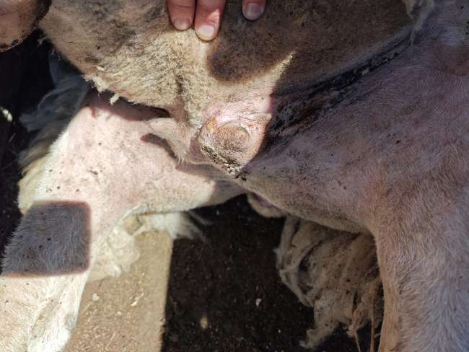

Figure 1 Udder showing mastitis scars. Source Stuart Barber, University of Melbourne

### 2. Assess ewe condition

For other traits they used a 2 strike out system to decide whether to cull based on body condition, lameness, age and mouth. For example, if an older ewe has a sound udder, is more than half a body condition score lighter than the mob average and her teeth are poor, then she would be considered a cull. However, if the ewe is in light condition and has no other problems then she can be kept for another year to give her the opportunity to improve.

Culling on mouths (dentition and teeth wear) has been shown to have a poor correlation to production. A better criterion is on body condition, as ewes that have been run in the same condition, have good body condition are obviously coping well whether or not they have teeth wear. Clearly ewes that have reared twins or multiples rather than singles will come out of lambing in lower condition, so it is important to cross check with scanning records to ensure twin bearing ewes are not compared to single bearing or dry ewes. The 2 strike system will help reduce the risks associated with culling otherwise productive ewes on the back of one criteria such as low body condition.

## Age

Deciding on what age to cull ewes before they drop in production, is a balance between bringing in younger better genetics and optimising performance of the ewe flock (plus the cost/benefit if purchasing ewes).

Generally (and individual flocks will vary) mortality of ewes tends to increase at and beyond 7 years of age. As ewes get older, they are more prone to metabolic conditions such as hypocalcaemia and pregnancy toxaemia. Peak body weight is reached at about 6 years old in merinos and about a year earlier in maternal breeds. Wool production in merinos generally peaks around 3-4 year old.

When considering age profiles of your flock, the age at which ewes have their greatest lactation potential is worth considering. Ewes tend to increase milk production as they get older, generally peaking at around 3-4 years of age.

Noting that a 5 year old ewe would generally produce more milk than a maiden ewe. So, the maternal environment provided by a 5 year old ewe would be expected to foster higher lamb weaning weights than from a maiden ewe. To that end, if you are culling all the 5 year old ewes you are possibly impacting overall lamb turnoff weight – but that needs to be balanced against the rate of genetic gain, and improvements in growth potential from younger stock. Therefore, the age structure to maintain is a farm by farm decision.

In summary if considering culling ewes this year, there may be opportunity to strategically cull specific ewes to reduce feed requirements over summer/autumn, while maintaining higher levels of production into next year. Be sure to consider:

* did the ewe rear a lamb/s
* has she got a functional udder
* condition; lameness and age
* balance improved genetics of young stock versus production of mature animals
* wool production – if important
* visit the Fit to Join on MLA website to learn more about the project and how to assess ewes for future productivity and profit.

# Get on top of worms

Jeff Cave, Senior Veterinary Officer, Northern Region

Worm infection costs the Australian sheep industry an estimated $436 million per year, most of which comes from lost production. One of the predominant sheep health issues of the past few years has been worms.

The life cycle of the worm involves both your pasture and the animal. Whilst an effective drench temporarily fixed the animal problem, the conditions of the past few years has meant worms survived in the environment. In time, paddocks that were clear of worms became scarcer meaning newly drenched animals quickly became reinfested with worms. The forecasted hot, dry summer may provide an opportunity to address this issue.

Strategic summer drenching involves an effective drench at the beginning and end of the season. This is to take advantage of the destruction of worm larvae on pasture by heat and lack of moisture. Drenching is expensive and time consuming therefore pre drench faecal egg counts (FECs) should always be considered as this will put some science and evidence into whether to drench.

Furthermore, ineffective chemicals and/or an inadequate drench procedure can reduce the effectiveness of summer drenching. FECs following drenching can also provide information of how effective treatment has been thus providing information about possible drench resistance. Worm resistance, particularly to the white and clear drenches, is common in Victoria and unnecessary overuse and the incorrect use of drenches just add to the problem.

After drenching, you should try to put your sheep onto low-risk pastures. These may be paddocks previously grazed by cattle, cut for hay or silage, or grazed by low-risk sheep such as older wethers. Large reinfestations of worms can occur in as little as three weeks if your drenching program is ineffective.

WormBoss, a website which deals with all facets of worm control in sheep and goats in Australia and provides several tools to assist with decision making including a regional Drench Decision Guide. The regional Drench Decision Guide is available both as a step-by-step online tool or as a decision tree, which can be printed. The regional Drench Decision Guide asks questions, and the answers you provide help it produce an advisory report.

The first question relates to whether your sheep are showing clinical signs of worm infection with scouring and/or weight loss being suggestive of the scour worms, and anaemia and lethargy being suggestive of Barber’s pole worm.

The second question relates to whether the sheep are lambs or weaners since weaners are amongst the most susceptible sheep to the effects of worms due to their low immunity, and their worm control needs to be managed strategically at critical times. The third question relates to whether the sheep are rams at the point of joining since the stress of joining lowers immunity and the potential for build-up in worm numbers.

The final question covers all other scenarios and includes ewes at the point of lambing in which worm control is important since pregnant ewes often suffer a breakdown in immunity to worms at around the time of lambing for up to two months after lambing. It also includes the months of November/December and January/February, which are typically the times of the first and second summer drenches respectively. These drenches are important in reducing worm numbers the following winter but also potentially increase the risk of drench resistance.

In each scenario, the regional Drench Decision Guide will give management advice related to that scenario and drench advice based on the results of worm testing. Effective worm control can be a complex subject so in addition to the guides and tools that WormBoss provides it is recommended that you seek advice from your veterinary advisor.

# Vaccination – good insurance

Dr Jeff Cave, Senior Veterinary Officer, Northern Region

Do you keep a calendar of key farm management dates? If you do, when does ‘vaccinate’ feature? For which classes of stock? How often? Then with what?

Knowing some fundamental principles of the immunity acquired through vaccination can help add rigour in formulating a vaccination schedule for your flock.

A newborn lamb acquires immunity to disease for around the first six weeks of its life through the maternal or passive immunity that it receives through its mother’s colostrum. Colostrum is the antibody rich milk that a ewe produces for around 24 hours following the birth of its lamb. It therefore makes sense to vaccinate ewes around one month prior to lambing to help ensure their colostrum transfers a high level of immunity.

Maternal immunity lasts for around six weeks after which lambs need to be vaccinated to gain an active immunity. This is achieved by giving two vaccinations at least four weeks apart. The first vaccination primarily sensitises the lamb’s immune system. The second vaccination causes the lamb’s primed immune system to mount a protective immune response. There is therefore little benefit in a first vaccination if it isn’t followed by a second vaccination.

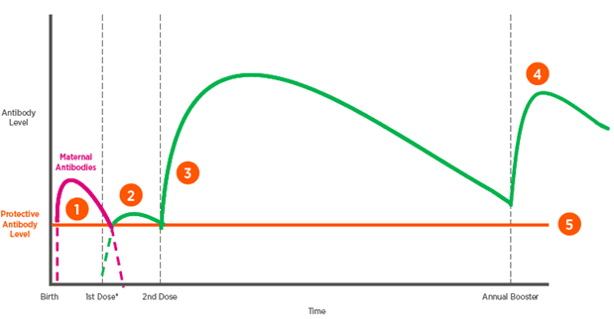

**Figure 2 Best practice vaccination for lambs**  
[zoetis.com.au/livestock-solutions/sheep/maximize-lamb-productivity/best-practice-vaccination-for-lambs](http://zoetis.com.au/livestock-solutions/sheep/maximize-lamb-productivity/best-practice-vaccination-for-lambs)

The timing of these vaccinations may seem quite rigid, so it makes sense to fit them in with other management practices. For example, ewes are often vaccinated at the same time as a pre-lambing drench, the first vaccination is often given at marking and the second vaccination is often given at weaning.

The duration of immunity that a vaccine gives varies depending upon the disease that is being vaccinated against. A feature of the enterotoxaemia (pulpy kidney) vaccine, found in 5-in-1 vaccine, is the duration of immunity that it provides is quite short. It may only give three or four months of protection.

Figure 3 illustrates correct vaccination technique. The vaccination gun and needle need to be at 45O angle and not go into the muscle.

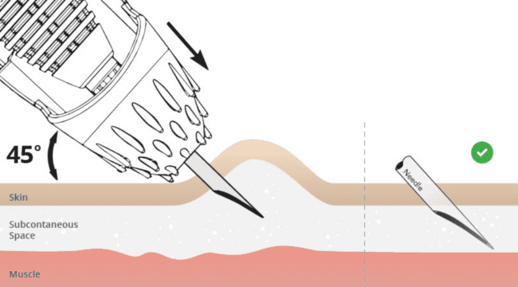

Figure 3 Best practice vaccination technique. Source: Zoetis

It therefore makes sense to ensure immune protection, and if necessary to give a booster dose, before a high-risk period. A high-risk period could be defined as any time sheep are being fed energy rich feeds. This could include energy rich pastures but equally the supplementary feeding of grain and pellets.

Typically, young stock in good condition up to two years of age are most affected by enterotoxaemia. However, deaths in older stock may also occur. Due to the rapid progression of the disease, an animal affected by enterotoxaemia will typically simply be found dead.

There is a range of other diseases of sheep for which prevention through vaccination is available. It is best to formulate a recommended vaccination schedule of your flock in consultation with your veterinary advisor.

# Specialist forages for opportunistic summer feed

There are a number of fodder options that can provide some quick feed over summer – if summer rains fall. This article has been updated from a lamb finishing article in 2022 to include further comments and options for this situation.

Options for summer crops will depend on the region, soil moisture and summer rainfall. They include maize, millet, sorghum, chicory, brassicas and legumes. These can also be useful in a pasture renovation program and/or for providing quality feed for growing out or finishing stock.

## Soil temperature

The soil temperature requirements for summer crops such as brassicas/forage rape, maize, millet or sorghum are in Table 1. (*Source: Article by Laura Forward in autumn 2022 SheepNotes*)

When measuring soil temperature in preparation for sowing, there are two very easy methods

1. Use a temperature probe/soil or meat thermometer – put this into the ground to about 10cm deep, in an area that is representative of your paddock (not under a tree, etc.) at around 10am for three consecutive days. The average of those three measurements is the temperature that you will use to make a decision.
2. If you have a soil moisture probe, or one near you on the network, this will give you a live reading of the current soil temperature. Soil moisture probes and real time information is available at: [extensionaus.com.au/soilmoisturemonitoring/](http://extensionaus.com.au/soilmoisturemonitoring/)

## Millet and sorghum

(Source Dairy Australia)

Millet and sorghum are summer forage options due to their potential to rapidly accumulate dry matter in warm conditions. They perform better than most other annual summer crops when soil moisture is limited, making them a good option when water is scarce. Millet and sorghum have a high tolerance to water stress and low risk of insect attack and as a result produce more feed than most broad leaf summer crop options. However, yields can be affected by low temperatures in summer.

The nutritional value of millet and sorghum tends to be less than other summer crops. Both are lower in crude protein (6–9%) than other summer crop options and higher in fibre concentration which will affect dry matter intake. If managed properly they can have moderate metabolisable energy (ME) but they rapidly lose quality once they get past the ideal grazing height. Brassicas or herbs such as chicory or plantain are a better alternative in this regard.

Toxicity risks: Sorghum especially has the risk of prussic acid poisoning of stock if grazed at certain stages of growth.

Table 1: Top-soil temperature requirements for spring-sown species

|  |  |  |  |  |
| --- | --- | --- | --- | --- |
|  | Brassica | Maize | Millet | **Sorghum** |
| Below 8 | Will begin to  strike, but slow  and not ideal | x | x | x |
| Between 8 and 12 | ✓ | Will strike,  but will be slow | x | x |
| Between 12 and 15 | ✓ | ✓ | x | x |
| Between 15 and 18 | ✓ | ✓ (2) | Ideal is 15  and rising | x |
| Above 18 | ✓ | ✓ | ✓ | ✓ |

## Forage brassicas and summer canola

Forage brassicas (particularly forage rape species) are a popular option for providing quality feed in summer/autumn. They are suited to a range of soil types of varying fertility and have the capacity to produce a good quantity of feed with high nutritive value over an extended period, when winter active grass-based pastures are generally declining in quantity and quality. They can support good growth rates for lambs, however, it can take 2-3 weeks for animals to adapt before feed consumption and growth rates increase. Some results for lamb performance with other forages are provided below.

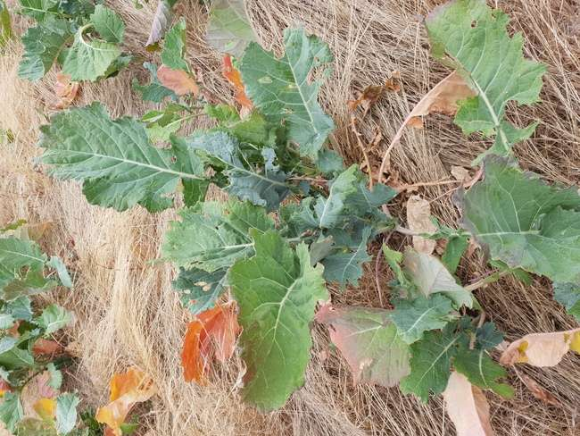

Figure 4 Forage rape

## Spring sown canola

Spring sowing of winter-type canola varieties can be used as replacement for the spring sowing of a brassica/forage rape crop for sheep production and produce similar levels of dry matter to traditional brassica forages. It can produce three to four t DM/ha of feed with high nutritive value (~12 MJ /kg DM and 14% CP) over summer and autumn and into winter. If adequate growth occurs the crop can be grazed a number of times until the following winter, when it can then be locked up for seed/oil production. This system should be considered in regions with longer growing seasons suitable for spring sowing and where there is a reasonable incidence of summer rainfall events. Studies at Agriculture Victoria Hamilton SmartFarm have shown lamb growth rates ranged from 100 to 240 g/day once the lambs adapted to canola.

All winter-type canola varieties can be used for spring sowing where they have a vernalisation requirement and a longer flowering date. Spring-type canola varieties are not suitable for spring sowing, as they will try to flower early and reach maturity too soon.

## Forage comparisons

A field experiment at Hamilton SmartFarm, in 2014 and 2016 tested seven forage treatments – canola (two different cultivars), forage brassica, lucerne, chicory, plantain and perennial ryegrass. Herbage mass and nutritive characteristics of the canola varieties were similar to forage brassica. Herbage mass in March 2014 was 3.35–3.64 t DM/ha for brassicas; 1.05–1.37 t DM/ha for perennial ryegrass, plantain and chicory; and 2.94 t DM/ha for lucerne. In March 2016, herbage mass was 1.86–2.05 t DM/ha for brassicas and 2.14–2.49 for the other forage treatments. Brassicas had higher ME concentrations and lower neutral detergent fibre (NDF) concentrations on most sampling dates compared to chicory, plantain, lucerne and perennial ryegrass. The crude protein concentration of the brassica treatments was not different from that of the other forage treatments.

Ewe lamb growth rates and conception rates were assessed for an autumn mating in 2014 and 2016. The grazing canola and brassica produced similar live weight gains (in the mating and pre-mating period) of 140 g/head/day compared to 60 g/hd/day on perennial ryegrass. Note that sheep grazing perennial ryegrass were fed additional supplement in order achieve positive growth rates. Table 2 shows the reproduction rates (as foetuses scanned) for the forages, with the highest rates for the lucerne, canola and chicory respectively. In the 2016 experiment, there were no difference in reproductive rate between the forage options grazed.

## Chicory

There are two types of chicory – perennial which are bred to last 3 years plus and biannual which last 12-18 months. Chicory requires a minimum annual rainfall of 500-600 mm and will tolerate a lower soil pH. It has high nutritive value and mineral levels, with a crude protein level of 14 – 24 % and an energy value of 10.3 – 12.1 MJME/kg DM in the leaves. But care should be taken when grazing as a crop, as it can have quite low fibre levels. Hay or access to a grass paddock, or on off grazing may need to be provided to minimise the risk of acidosis. As a summer fodder crop, chicory should be sown when soil temperatures are at least 12 degrees and rising. Chicory can be sown in a mix, although this reduces chemical weed control options as broadleaf herbicides cannot be used. Red legged earth mite attack can be an issue during germination. While an after sowing insecticide can be used, it is recommended to use a treated seed which contains an insecticide to protect emerging seedlings.

Table 2. Reproduction rate (as foetuses scanned) on different forages with an autumn mating in 2014 (Hamilton)

|  |  |  |  |  |  |  |
| --- | --- | --- | --- | --- | --- | --- |
|  | Canola | **Forage**  **brassica** | Lucerne | Chicory | Plantain | **Perennial**  **ryegrass** |
| Reproduction rate (%) | 145 | 130 | 150 | 140 | 130 | 100 |

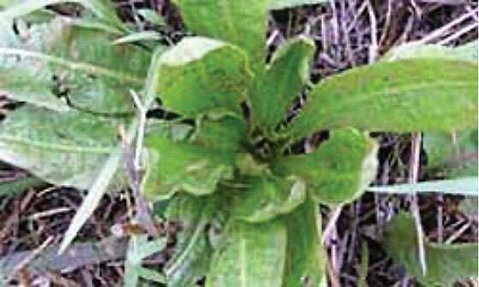

Figure 5 Chicory (Chicorium intybus)

Chicory is a warm season growing plant, so is most productive during late spring, summer and into early autumn. With high levels of tannins, chicory does not cause bloat in stock. It can be oversown with grasses or cereals in the autumn if needed to provide winter feed. Look to graze chicory at the 7-8 leaf stage. Soil moisture data from the EverGraze project indicates it dries the soil to three metres, which is comparable to lucerne and it responds well to summer rain events.

Performance of lambs grazing chicory can have growth rates of 190-370 g/day compared with ryegrass at 160-230 g/day or lucerne at 170-300 g/day (Chicory factsheet, NSW DPI 2011). This may be important in areas where summer rainfall is unreliable and faster turn-off of lambs is required. In a lamb finishing experiment in New South Wales, lambs were finished on either lucerne based pasture or on chicory swards. Lambs grazing chicory grew faster than lambs grazing lucerne in three out of five groups with average growth rates of between 172-312 g/day (Holst et al 1998). In the Central Tablelands region of NSW, chicory produced lamb growth rates of 125 g/day during finishing, allowing greater opportunities for producers in an environment where summer rainfall is unreliable (Holst et al 2006).

## Plantain (Plantago lanceolata)

Plantain is a perennial herb requiring 550 – 650 mm annual rainfall. It is adapted to a wide pH range (pH CaCl2 4.2 – 7.8) and can tolerate low fertility soils and drought. Plantain typically has a nutritive value of 16% crude protein in the vegetative stage, and an energy level of 10-12 MJME/kg DM with dry matter digestibility of 72% (leaf) and 59% (stems), and fibre levels of 35-50% NDF. It can have lower palatability compared with other forage species, particularly in the seed head stage, or when the plants have low nitrogen status, or the grazing rotations become too long. Plantains growing season is fairly similar to perennial ryegrass, but does provide additional growth into the shoulders of summer and autumn.

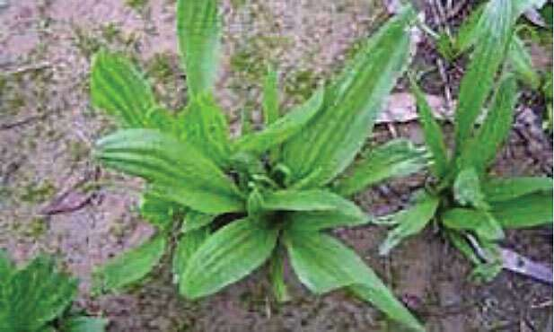

Figure 6 Plantain

Newer varieties of plantain also show improved winter production, providing valuable feed during that period. It has a relatively high concentration of magnesium (Mg) and calcium (Ca) which may assist in reducing the risk of grass tetany in mixed pastures. Plantain can be included in pasture mixes containing grasses and legumes but needs careful management to ensure it isn’t smothered by other species.

Lamb performance on pure plantain has generally been poorer than on chicory and brassicas but better than perennial ryegrass and much better than barley and silver grass in the summer/ early autumn.

Sowing chicory and plantain in spring for an opportunistic grazing if and when rain falls and then over sowing in autumn with a cereal may be an option worth considering.

## Further information

EverGraze website - [evergraze.com.au/](http://evergraze.com.au/)

Visit [Feedinglivestock.vic.gov.au](http://feedinglivestock.vic.gov.au/) to view a webinar on summer forage crop opportunities for lambs or a factsheet on canola Dairy Australia website – summer crops.

Further information contact: Neil James, Agriculture Victoria, 0417 353 929.

# Getting water infrastructure for stock containment sorted

Clem Sturmfels and Brad Costin, Agriculture Victoria

Getting the infrastructure required for supplying adequate quality water to stock that are confined, is critical to ensure continual access.

## Peak demand

Knowing the daily peak demand is essential when designing a reticulated water supply system. This information is needed to ensure the correct size of pumps, tanks, troughs and pipelines.

A reticulated water supply system needs to deliver the daily peak demand in 4 hours. This is to ensure all stock have a chance to drink on a regular basis.

As an example, the minimum flow rate required in a stock containment area is:

* 21L per minute for 500 dry sheep
* 67L per minute for 160 dry cattle.

## Water supply design

When planning for a stock containment area it is important to consider:

* quality
* quantity
* reliability.

The water supply system should ideally be fed by gravity and have at least 4 days of storage in reserve. A typical set-up consists of 1 or more tanks located on a nearby hill or adjacent to the stock containment area. In flat country, tanks can be placed on a mound of earth to provide adequate pressure. The pipes and fittings need to be large enough to ensure peak flow rates can be met simultaneously at all outlets within the stock containment area.

## Troughs

Well-designed water troughs are an essential component of a stock containment area. Troughs and associated fittings need to be high quality, durable and livestock proof.

### Size

Troughs need to be a sufficient size to allow all stock to drink on a regular basis. Typically a suitable trough for 500 sheep or 160 cattle would have 8 to 10 metres of accessible trough edge, with a storage capacity of 400 to 600 litres.

### Maintenance

Troughs need to be emptied and cleaned every 1 to 2 days.

A long shallow trough with a smooth internal profile, gate valve and large outlet bung will make cleaning quick and efficient.

### Water levels

The water level in the trough must be kept close to full at all times. This requires a well-designed water supply system along with a suitable trough outlet or float valve. The float valve must be high quality, have an appropriate capacity and pressure rating and be fully protected with a durable, stock-proof cover.

### Construction

Stock troughs are commonly constructed from steel, concrete and polyethylene. Concrete is the preferred material because of its durability, strength and ability to maintain water at a more constant temperature.

Plumbing fittings such as taps, risers and elbows can be easily damaged by stock. These fittings need to be high quality, securely fixed to the trough or be protected with a suitable cover. The preferred option is to select a trough where all the fittings are fully enclosed within the trough design.

### Location

Troughs should be placed on a raised pad of gravel, stone or concrete to ensure good drainage and stability. They should also be located away from feeding areas to minimise water contamination.

For further information on water supply for stock containment areas, visit [agriculture.vic.gov.au/farm-management/water/managing-dams/water-supply-in-stock-containment-areas](http://agriculture.vic.gov.au/farm-management/water/managing-dams/water-supply-in-stock-containment-areas)

# Digital Tip

Rather than an office based tip, this digital tip outlines a simple app that quickly allows you to set and plan all dates and activities relating to ewe joining dates (i.e. pregnancy scanning, vaccinations etc).

## Next generation Lambing Planner app

The Lambing Planner is a simple tool that allows you to change a lambing date or a joining date to see the impacts of that on other key times in the reproductive year. It also features a short best-practice guide for lambing. It is available as a hand-held, paper based tool or as an App in both Android and iOS formats. The free app helps producers plan and assess the effect of joining dates and lambing dates on key management activities during the reproductive cycle. The calendar displays the current activities and stages of pregnancy or lactation with more detailed information at the click of a button.

New upgrades have improved the functionality of the app, and allows users to register, save plans to the cloud, be notified of upcoming tasks, share plans with others and save plans to their calendar.

Features such as registering an account, allowing reminders for key dates and saving the plans to the cloud to allow access on other devices. Tasks can also be marked as complete, notes can be added, and plans can be uploaded to digital calendars, or shared via PDF. The app still has the key nutrition and condition scoring information included as well as best practice guides, with the addition of an instructional explainer video.

For more information and links to download visit [agric.wa.gov.au/apps/lambingplanner](http://agric.wa.gov.au/apps/lambingplanner). The paper-based tool is still available from DPIRD’s Katanning office by emailing [katanning.csc@dpird.wa.gov.au](mailto:katanning.csc@dpird.wa.gov.au) or telephoning 9821 3333

# On-farm Drought Infrastructure Grants for south west Victoria

Applications for the On-Farm Drought Infrastructure Grants Program are now open.

The grants program is part of a $13.53 million package announced by the Victorian Government on 30 September to support farming communities affected by the drought in south west Victoria.

Eligible drought-affected farmers in Victoria’s south west can now apply for up to $5,000 in co-contribution grants to support on-farm improvements such as:

* Water infrastructure upgrades (pipes, tanks, troughs, dams)
* Stock containment areas
* Grain and fodder storage.

The $12.1 million grants program is open to farmers in Local Government Areas in the south west that have been most severely impacted by ongoing drought conditions.

These Local Government Areas include Glenelg, Southern Grampians, Warrnambool, Moyne, Corangamite, Colac Otway, Surf Coast, Ararat, Pyrenees, Golden Plains and Greater Geelong, as well nominated postcodes in the southern half of West Wimmera Shire (primary production enterprises located in postcodes 3312, 3317, 3318, and 3319).

Information on the guidelines, including specific areas of eligibility, and the application process is available from Rural Finance at [ruralfinance.com.au](http://ruralfinance.com.au/) or by calling 1800 260 425 during business hours.

The grants will be available until program funds are fully allocated.

In addition to the infrastructure grants, other support services available for farmers include the Rural Financial Counselling Service, The National Centre for Farmer Health, and technical decision-making support including workshops and field days.

Visit the [Agriculture Victoria website](https://agriculture.vic.gov.au/) (https://agriculture.vic.gov.au) for more information, including [upcoming events](https://agriculture.vic.gov.au/events) (https://agriculture.vic.gov.au/events).

# Do you have enough water for your stock?

Greg Bekker, Agriculture Victoria

Rainfall and runoff into dams and rainwater tanks has been in short supply this year. Doing a quick water budget will give you more confidence on how your water situation will hold up this summer. Carting water for domestic use may be a given but to do the same for stock becomes expensive and can be mentally and physically draining when you do not know how long you will have to do it. Most producers do financial, feed and fodder budgets but quite often overlook budgeting for water.

To do a water budget, list the dams by paddock and calculate the water available in each one. Remember the last 300mm of water in the dam may be unusable as animals may get stuck or it may be of very poor quality. The following are examples using figures from the beef cattle and sheep drought feeding and management books:

* [feedinglivestock.vic.gov.au/beef-resources/beef-cattle-drought-feeding-book/](http://feedinglivestock.vic.gov.au/beef-resources/beef-cattle-drought-feeding-book/)
* [feedinglivestock.vic.gov.au/sheep-resources/sheep-drought-feeding-book/](http://feedinglivestock.vic.gov.au/sheep-resources/sheep-drought-feeding-book/)

## How much do you need?

For a sheep farm that has 1000 ewes and 25 rams and 500 lambs to finish before Christmas the water requirement for animals would be:

* 1000 ewes x 6l/head = 6000 litres per day (150 days till end of March) 900,000 L
* 25 rams x 10l/head = 250 litres (150 days till end of March) 37,500 L
* 500 lambs x 4l/head = 2000 litres per day (70 days of water required before sale) 140,000 L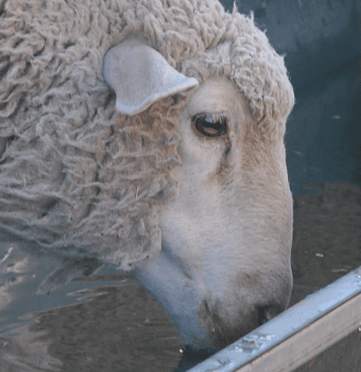

**Total water needed for sheep to drink 1,077,500 L**

If you have a self-replacing flock, you would need to add these animals. This example budget is until the end of March. When will your dams fill up?

For a beef farm with 100 cows and calves and 3 bulls.

* 100 cows x 100l/head = 10,000 litres per day (150 days till end of March) 1,500,000 L
* 100 calves x 4l/head = 400 litres per day (150 days till end of March) 60,000 L
* 3 bulls x 100l/head = 300 litres per day (150 days till end of March) 45,000 L

**Total water needed for cattle to drink 1,605,000 L**

These calculations can also be done for each mob and how much water they will need.

## How much have you got?

The next thing to do is determine how much water is available for stock in each of the paddocks and how long that will last. Generally, paddocks run out of feed and not water but with the low levels of water in dams this may not be the case this summer.

Tables 1 and 2 give the estimated volumes of small rectangular (Table 1) and gully dams (Table 2) measured at the water level.

Evaporation can be one of the biggest losses from farm dams, especially small or shallow dams. A small farm dam 3m deep or less would lose around 60% to evaporation over summer. Regular monitoring or prior knowledge of a dam’s capacity to hold water is necessary to accurately estimate how long your dam water will last.

Example for a gully dam: 20m x 40m x 3m dam less 60% in evaporation

= 0.48 ML (Table 2) x 60% = 288,00 litres (0.28 ML) lost

= 0.48 – 0.28 = 0.2 ML available at end of summer.

Once you have completed this water budget you will be in a better position to look at options for consolidating and improving stock and domestic water resources for your farming business.

Table 1. Volume of water in small rectangular dams

|  |  |  |  |  |  |  |  |
| --- | --- | --- | --- | --- | --- | --- | --- |
| **Volume of water in a small rectangular dam (megalitres) – Batter slope 3:1** | | | | | | | |
| Water dimensions (metres) | | Depth of water (metres) | | | | | |
| Length | Width | 0.5 | 1.0 | 1.5 | 2.0 | 2.5 | 3.0 |
| 5.0 | 5.0 | 0.01 |  |  |  |  |  |
| 5.0 | 10.0 | 0.02 |  |  |  |  |  |
| 10.0 | 10.0 | 0.04 | 0.05 | 0.06 |  |  |  |
| 10.0 | 15.0 | 0.06 | 0.09 | 0.10 |  |  |  |
| 10.0 | 20.0 | 0.08 | 0.12 | 0.14 |  |  |  |
| 15.0 | 15.0 | 0.09 | 0.15 | 0.18 | 0.19 | 0.19 |  |
| 15.0 | 20.0 | 0.13 | 0.21 | 0.25 | 0.28 | 0.28 |  |
| 15.0 | 25.0 | 0.16 | 0.27 | 0.33 | 0.37 | 0.38 |  |
| 15.0 | 30.0 | 0.19 | 0.33 | 0.41 | 0.46 | 0.47 |  |
| 20.0 | 20.0 | 0.17 | 0.29 | 0.37 | 0.42 | 0.44 | 0.44 |
| 20.0 | 25.0 | 0.22 | 0.38 | 0.49 | 0.56 | 0.59 | 0.61 |
| 20.0 | 35.0 | 0.31 | 0.55 | 0.72 | 0.84 | 0.91 | 0.94 |
| 20.0 | 40.0 | 0.36 | 0.63 | 0.84 | 0.98 | 1.06 | 1.10 |
| 10.0 | 10.0 | 0.04 | 0.05 | 0.06 |  |  |  |
| 10.0 | 15.0 | 0.06 | 0.09 | 0.10 |  |  |  |
| 10.0 | 20.0 | 0.08 | 0.12 | 0.14 |  |  |  |

Table 2. Volume of water in small gully dams

|  |  |  |  |  |  |  |  |
| --- | --- | --- | --- | --- | --- | --- | --- |
| **Volume of water in a small gully dam (megalitres) – Batter slope 3:1** | | | | | | | |
| Water dimensions (metres) | | Depth of water (metres) | | | | | |
| Length | Width | 0.5 | 1.0 | 1.5 | 2.0 | 2.5 | 3.0 |
| 5.0 | 5.0 | 0.01 |  |  |  |  |  |
| 5.0 | 10.0 | 0.01 |  |  |  |  |  |
| 10.0 | 10.0 | 0.01 | 0.02 | 0.03 |  |  |  |
| 10.0 | 15.0 | 0.02 | 0.03 | 0.05 |  |  |  |
| 10.0 | 20.0 | 0.02 | 0.04 | 0.06 |  |  |  |
| 15.0 | 15.0 | 0.02 | 0.05 | 0.07 | 0.09 | 0.11 |  |
| 15.0 | 20.0 | 0.03 | 0.06 | 0.09 | 0.12 | 0.15 |  |
| 15.0 | 25.0 | 0.04 | 0.08 | 0.11 | 0.15 | 0.19 |  |
| 15.0 | 30.0 | 0.05 | 0.09 | 0.14 | 0.18 | 0.23 |  |
| 20.0 | 20.0 | 0.04 | 0.08 | 0.12 | 0.16 | 0.20 | 0.24 |
| 20.0 | 25.0 | 0.05 | 0.10 | 0.15 | 0.20 | 0.25 | 0.30 |
| 20.0 | 30.0 | 0.06 | 0.12 | 0.18 | 0.24 | 0.30 | 0.36 |
| 20.0 | 35.0 | 0.07 | 0.14 | 0.21 | 0.28 | 0.35 | 0.42 |
| 20.0 | 40.0 | 0.08 | 0.16 | 0.24 | 0.32 | 0.40 | 0.48 |
| 5.0 | 5.0 | 0.01 |  |  |  |  |  |
| 5.0 | 10.0 | 0.01 |  |  |  |  |  |

## Resources

The following online resources have been developed to assist with calculations and to make a simple DAMDEEP measuring tool to accurately measure the depth of your dams.

A summer water calculator [agriculture.vic.gov.au/support-and-resources/tools-and-calculators/summer-water-calculator](http://agriculture.vic.gov.au/support-and-resources/tools-and-calculators/summer-water-calculator) can be used to calculate water in a dam and how long it will last over summer.

DAMDEEP is a simple tool for measuring the depth of your dams. Watch a short video to see how this done: <https://youtu.be/Kp21tB5hPj8>

AgVic have people available to assist farmers with their stock water.

Contact Greg Bekker on 0417 340 236 or [Greg.Bekker@agriculture.vic.gov.au](mailto:Greg.Bekker@agriculture.vic.gov.au)

# Will feedlotting lambs make cents?

Geoff Duddy, Sheep Solutions

This scenario is provided as an example to illustrate how to use a calculator to consider the cost/benefit of finishing lambs. Given the season, many lambs may be a lighter weight, at entry and finish and have lower growth rates. The calculator can be used for accommodating whichever scenario you are looking at. Note that there will be a higher protein requirement relative to energy for lighter lambs and, of course, a longer feeding period to reach target weights which will impact profitability.

You can listen to the webinar where Geoff Duddy runs through the use of the calculator on the FeedingLivestock website.

## Industry overview

Seasonal conditions, supply patterns and market anomalies can have major impacts on prime lamb profitability.

Figure 7 illustrates the long-term eastern states average store, trade, export and Merino lamb values since 2008. There are several patterns I’d like to discuss before we look at the viability of grain finishing lambs this year. Note that all categories follow the same price trends with differences in terms of price (on a cents per kilo basis) impacted by supply.

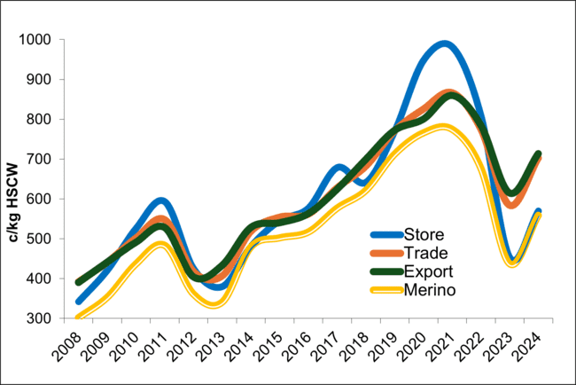

Figure 7 Eastern States Lamb Price Trends (2008 to October 2024)

* Historically trade lambs generally return more per kilo than heavier categories. There has been a pattern where every 4 to 5 years Exports out-perform Trade lamb categories for an extended period – we have been in one such period since spring 2022. Export categories have averaged 25c/kg more than trades during this time
* Merino lamb has, until 2022, traded around 50c/kg lower than trade lamb. This meant Merino carcases were returning between 90 to 93% of trade lamb values. When we factor in the strength of our lamb meat markets, a shift towards a dual-purpose style Merino and additional income from skins and/or wool returns the Merino has been extremely competitive in recent years. Greater differences between trade and Merino prices since 2022 is principally supply driven
* Store lamb demand is driven by seasonal conditions, availability and finished lamb returns. Between 2019 and 2022 store lamb values traded at or above finished lamb categories on a cents per kilogram basis. This made on-farm grain finishing risky at times in terms of achieving reasonable profit margins. I strongly advised clients to consider selling stores during this period particularly if the margin above their cost of production was greater than when finishing lambs. Since 2023 we have seen a decline in store lamb values relative to finished lamb categories as flock size and availability improved. At what stage does it become viable and profitable to finish these lambs within grain-based systems?

## Store versus trade price trends

A store lambs value continues to be the largest cost when feeding lambs – around 55-65% of total costs when finishing to trade weights. Feed normally constitutes 25-30% of total costs

Regardless of whether an ‘own-bred’ or ‘purchase-in’ system it is important that you consider not only the actual c/kg HSCW price but that you also look at the relative price of ‘store’ lambs to finished lamb categories. Years of analysis suggests that store lamb values in eastern states need to be trading at or below 85% (relative to trade lamb values on a c/kg HSCW basis at time of sale) when feedlotting to minimise risk and provide opportunities for reasonable profit margins.

Figure 8 illustrates the value (c/kg) of store lambs relative to Ttade weight lamb values 6 weeks later (to simulate prices received for trade weight lambs 6 weeks after buying/finishing 17-18kg store lambs). I call this the ‘store lamb relativity’ value.

An example of how to calculate this store lamb ‘relativity’ value is shown below:

17kg store lamb, $120 landed on-farm = $120/17 = 700c/kg (skin value included)

23kg trade lamb, $180 (gross) sold = $180/23 = 782c/kg

700c/kg / 782c/kg = 0.89 (89%)

Note: This relativity value does not equal gross sale value for trade divided by gross store lamb value. $120/$180 = 0.767 or 67% not the 89% shown in the example above

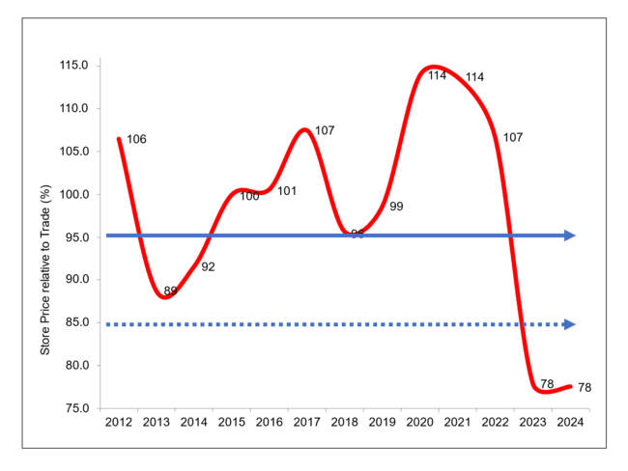

Figure 8 Store vs trade relativities 2012 to October 2024 (Trade off-set 6 weeks)

We have seen a significant drop off in store lamb values and relativity over the past 2 years due principally to supply. The consistently high store lamb values have made grain finishing reasonably risky in recent years – store lamb values relative to trade values, in my opinion, need to be trading at or below 0.85 (85%) to minimise risk and provide opportunities for reasonable profit margins to be achieved.

The red line in Figure 8 depicts the store lamb relativity values since 2012. Reading from the ‘Y’ axis:

* 100% is when store lamb values (on a c/kg basis) are the same as trade lamb sale values 6 weeks later
* 95% represents the point at which pasture finishing should be reasonably profitable with limited risk. Pasture finishing is generally cheaper than grain-finishing due to lowered costs for feed, labour and depreciation on infrastructure costs etc. A higher relativity value can therefore be factored in without a significant impact on likely profit margin(s)
* 85% or higher represents the point at which I believe grain-based finishing is risky in terms of profitability. The store lamb relativity has sat at or below 85% for the past 12 months – the first time we have seen an extended low relativity value for many years. This should bode well in terms of achieving reasonable profit margins when feedlotting lamb in the near future.

## So does feedlotting make ‘cents’?

The following analysis was undertaken using current price data and the Sheep CRC Feedlot Calculator. I co-developed the calculator with Dave Stanley and Steve Semple while with NSW DPI. It can be downloaded from dpi.nsw.gov.au/animals-and-livestock/nutrition/feeding-practices/feedlot-calculator.

### Background data:

* 3 store lamb prices ($95, $115 and $135)
* 3 finished lamb prices – 750c, 800 and 850c for 23kg ($179.20, $191 and $202.75) and 28kg carcases ($214.50, $228.60 and $242.70)
* ration cost of $405 as fed ($450 on dry matter basis) for a barley/lupins and cereal hay with mineral supplements (salt/acid buf) mix
* ME 11.4 MJ and CP 16%
* 280g/h/d growth rate (includes 2-week introduction period)
* lambs consume 4.2% of their liveweight daily)
* lambs on feed 33 days (23kg analysis) and 71 days (28kg analysis)
* 1% deaths, 2% shy feeders
* drench, vaccines etc included
* $13/tonne machinery running costs
* 5c/lamb/day labour cost (self-feeders)
* no shearing costs (assume shorn prior to purchase OR costs/income allocated to normal running costs if home-bred) or capital costs included
* $5/head transport cost
* 5.5% sale commission/yard fees etc.

## Findings:

|  |  |  |  |  |  |  |  |  |  |
| --- | --- | --- | --- | --- | --- | --- | --- | --- | --- |
| **Buy In Price** | **$95 (560c)** | | | **$115 (676c)** | | | **$135 (794c)** | | |
| Sale Price 23kg | $179.25 | $191.00 | $202.25 | $179.25 | $191.00 | $202.25 | $179.25 | $191.00 | $202.25 |
| StoreLamb Relativity (%) | 75 | 70 | 66 | 90 | 85 | 80 | 105 | 99 | 93 |
| Profit | 27.50 | 38.41 | 49.32 | 7.35 | 18.25 | 29.16 | -12.81 | -1.90 | 9 |
| Sale Price 28kg | $214.50 | $228.60 | $242.70 | $214.50 | $228.60 | $242.70 | $214.50 | $228.60 | $242.70 |
| StoreLamb Relativity (%) | 73 | 69 | 65 | 88 | 83 | 78 | 104 | 98 | 92 |
| Profit | 18.01 | 31.08 | 44.14 | -2.30 | 10.76 | 23.82 | -22.61 | -9.50 | 3.51 |

## 

## Discussion

Looking at analysis outcomes it’s reasonably safe to say that there is potential going forward for producers to achieve reasonable profit margins when grain finishing lamb. Points of interest are:

* profits margins rely heavily on the buy-in store lamb price with profit margins lower when targeting export weight lamb due to the increased cost (and share of total production costs) of the ration, increased labour costs and commissions etc
* store lamb cost as a percentage of total costs reduces when targeting heavier weights (between 49 to 61%) compared to 64 to 71% if finishing to trade weight
* ration cost as a percentage of total costs increases when targeting heavier weights (between 31 to 37%) compared to 17 to 22% if finishing to trade weights
* because of the lowered store lamb prices of late, strong finished lamb prices and the reasonably low ration cost the store lamb relativity target of 85% is easily reached. The 85% point beyond which profits drop holds true if looking to take lambs through to heavier carcase weights while a relativity of 90% will still provide reasonable profits if targeting trade lamb weights.

## Take home messages are many

Before making the decision to feedlot producers should consider:

* the availability of contracts
* any seasonal price variations
* store price relativities
* feed storage/availability and price etc.

Crunch the numbers using the Sheep CRC Feedlot Calculator and make an informed decision!

# Extreme weather changes

Veronica Campbell and Morgan Cassell, Animal Health and Welfare, Agriculture Victoria

Although winter is over, extreme weather conditions can happen at any time of the year, including spring and summer. Sudden and dramatic changes in temperature with rain can have more impacts on animal welfare in summer, than in winter.

To aid sheep in their ability to endure adverse weather events, producers should maintain animals in good body condition, provide proper and sufficient feed to meet the animal’s nutritional requirements, ensure effective control of worm burdens, and provide appropriate attention and/or veterinary treatment promptly to sick animals.

Producers should have a plan for extreme weather that includes the actions they will take to provide shelter to their animals.

Guidelines on shelter for sheep can be found on the Agriculture Victoria website as well as additional care information for recently shorn sheep, shelter for lambing ewes, lambing in bad weather and information on stress and metabolic disease in extreme weather.

Being aware and actively checking weather forecasts is essential. The Bureau of Meteorology (BOM) issues weather warnings, including Severe Weather Warnings and Sheep Grazier Warnings. Warnings issued for Victoria can be read on the BOM website. A notification can be set up via the BOM application on a mobile phone to receive Severe Weather Warnings for a location.

Under the Prevention of Cruelty to Animals Act 1986 livestock owners and persons in charge of livestock must ensure proper and sufficient feed, water and shelter is provided to livestock. Victoria’s Codes of Practice provide guidance on what is proper and sufficient and are available on the Agriculture Victoria website.

Anyone wishing to make a specific animal welfare complaint regarding livestock welfare can contact Agriculture Victoria on 136 186 or email aw.complaint@agriculture.vic.gov.au

### Resources:

* Agriculture Victoria webpages:
* Sheep shelter guidelines: [agriculture.vic.gov.au/livestock-and-animals/sheep/health-and-welfare/sheep-shelter-guidelines](http://agriculture.vic.gov.au/livestock-and-animals/sheep/health-and-welfare/sheep-shelter-guidelines)
* Feeding Livestock website: [feedinglivestock.vic.gov.au/](http://feedinglivestock.vic.gov.au/)
* Victorian codes of practice for animal welfare: [agriculture.vic.gov.au/livestock-and-animals/animal-welfare-victoria/pocta-act-1986/victorian-codes-of-practice-for-animal-welfare](http://agriculture.vic.gov.au/livestock-and-animals/animal-welfare-victoria/pocta-act-1986/victorian-codes-of-practice-for-animal-welfare)
* WormBoss website: [wormboss.com.au/](http://wormboss.com.au/)
* Bureau of Meteorology: [bom.gov.au/vic/warnings/](http://bom.gov.au/vic/warnings/)

# Agriculture Victoria animal health and sheep industry contacts

Although our offices are currently closed, the office numbers provided below are diverted to staff who can assist you. Alternatively, you can contact Agriculture Victoria on 136 186.

|  |  |  |  |  |
| --- | --- | --- | --- | --- |
|  |  | **Meat and Wool Services** | |  |
| **Location** | **Office Contact** | **Livestock Industry Development Officers** | **Land Management Officers\*** | **Animal health** |
| **South-West region** | | | | |
| **Ararat** | 136 186 | Yes | Yes |  |
| **Ballarat** | 5336 6856 | Yes | Yes | Yes |
| **Colac** | 5233 5504 | Yes |  | Yes |
| **Geelong** | 5226 4878 |  | Yes |  |
| **Hamilton** | 5573 0900 | Yes |  | Yes |
| **Horsham** | 0343 443 111 |  |  | Yes |
| **Queenscliff** | 5258 0229 |  |  |  |
| **Warrnambool** | 5561 9946 | Yes |  | Yes |
| **South-East region** | | | | |
| **Attwood** | 9217 4200 |  |  | Yes |
| **Bairnsdale** | 136186 | Yes | Yes | Yes |
| **Cranbourne** | 136 186 |  | Yes | Yes |
| **Ellinbank** | 5624 2222 | Yes | Yes | Yes |
| **Leongatha** | 5662 9900 |  | Yes | Yes |
| **Maffra** | 5147 0800 | Yes |  | Yes |
| **Swifts Creek** | 5159 5134 | Yes | Yes |  |
| **Northern region** | | | | |
| **Alexandra** | 5772 0200 |  | Yes |  |
| **Benalla** | 5761 1611 | Yes | Yes | Yes |
| Bendigo | 5430 4444 | Yes | Yes | Yes |
| Echuca | 5482 1922 |  |  | Yes |
| Rutherglen | 02 6030 4500 | Yes |  |  |
| Seymour | 5735 4300 |  |  | Yes |
| Swan Hill | 5036 4800 |  | Yes | Yes |
| Tatura | 5833 5222 |  | Yes | Yes |
| Wangaratta | 5723 8600 |  |  | Yes |
| Wodonga | 02 6043 7900 |  | Yes | Yes |

Contact[jane.court@agriculture.vic.gov.au](mailto:jane.court@agriculture.vic.gov.au)   
phone: 0436 606 742  
[Jeff.cave@agriculture.vic.gov.au](mailto:Jeff.cave@agriculture.vic.gov.au)

© The State of Victoria Department of Energy, Environment and Climate Action, 2024

This work is licensed under a Creative Commons Attribution 3.0 Australia licence. You are free to re-use the work under that licence, on the condition that you credit the State of Victoria as author. The licence does not apply to any images, photographs or branding, including the Victorian Coat of Arms, the Victorian Government logo and the Department of Economic Development, Jobs, Transport & Resources logo. To view a copy of this licence, visit [creativecommons.org/licenses/by/3.0/au/deed.en](http://creativecommons.org/licenses/by/3.0/au/deed.en)

ISSN 1326-4559  
ISSN 1836-4756 (Online)

**Accessibility**

If you would like to receive this publication in an alternative format, please telephone the DEECA Customer Service Centre on 136186, email [customer.service@deeca.vic.gov.au](mailto:customer.service@deeca.vic.gov.au) (or relevant address), or via the National Relay Service on 133 677 [relayservice.com.au](mailto:relayservice.com.au). This document is also available on the internet at [agriculture.vic.gov.au](http://agriculture.vic.gov.au/)

**Disclaimer**

This publication may be of assistance to you but the State of Victoria and its employees do not guarantee that the publication is without flaw of any kind or is wholly appropriate for your particular purposes and therefore disclaims all liability for any error, loss or other consequence which may arise from you relying on any information in this publication.