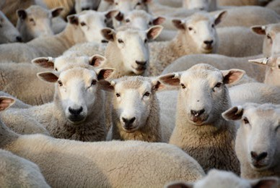

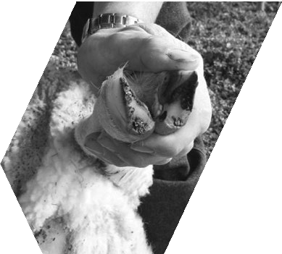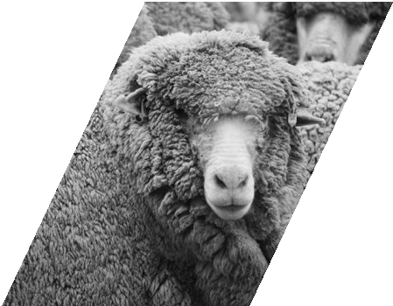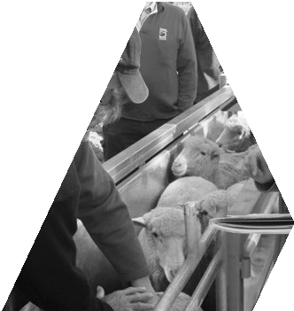

**Sheep**

Notes

**Autumn 2024**

#### Inside

Once it’s gone- it’s gone – your carbon? 1

FeedingLivestock website 5

Condition scoring in sheep 6

Lambing – 24 hours to shine 7

Comparing enterprise performance

based on lambing season 8

Grasslands Society of Southern Australia

– 64th Annual Conference 9

Copper deficiency 10

BestWool/BestLamb and BetterBeef

# Welcome to SheepNotes

Jane Court and Jeff Cave

We hope you find articles of interest and use in what is looking like a challenging year. At the time of compiling this edition, most of the state is experiencing a very dry autumn, despite some summer and early autumn rains in some areas. The green pick over joining has led to good pregnancy scanning rates in many areas – which means many lambs on potentially not much pasture. Pregnancy scanning will provide such valuable information on the different nutritional needs across ewe mobs and inform feed budgets. Feeding to requirements can have long term beneficial implications – for the lambs born and their future growth, maturity and fertility, as well as the ewes. Single bearing ewes require less feed over pregnancy and lambing and can be run about half a condition score lighter than twin bearing ewes. Prioritising feed and resources to ewes’ specific needs is even more critical when seasons are tough. We have listed some resources that may be of use (page 12). Plus the FeedingLivestock website has so much feeding information (recorded webinars; articles; drought feeding books and calculators).

If you are in a producer group, the group will be an invaluable resource. Agriculture Victoria staff are always happy to assist or direct you, if farmers in your area are keen to form new a group.

# Once it’s gone- it’s gone – your carbon?

Conferences and Dinner 2024 11

Property Identification Codes (PICs)

and their role in emergency responses 12

Seasonal reminders and resources 12

Digital Tip Improving battery life 13

Making decisions early in 2023 – Case Study - Rob Cooper; Manager

Barton Station 14

Agriculture Victoria animal health

and sheep industry contacts 16

**Contact:** [jane.court@agriculture.vic.gov.au](mailto:jane.court@agriculture.vic.gov.au) phone: 0436 606 742 [Jeff.cave@agriculture.vic.gov.au](mailto:Jeff.cave@agriculture.vic.gov.au)

Compiled by Jane Court with input and comments from Richard Eckard (University of Melbourne) and Cam Nicholson and Fiona Conroy (Knewleave Partnership). Cam and Fiona have been investigating and monitoring

the Carbon (C) on their farm for some time and have developed a clear understanding about C and emissions that are relevant to farmers. Their additional comments are included in green.

Livestock farmers are generally in a good position maintaining and building healthy carbon stocks in trees and soils. This is due to minimal soil disturbance compared to cropping, and the added value of trees in the landscape for livestock as shade and shelter. This carbon may appeal as a potential commodity, however you should be aware that if you do sell it – it’s gone for someone else to use and you can’t double dip and use it yourself.

If you sell carbon you are then responsible for managing your land to look after that carbon for someone else. It needs to be maintained so it stays there for the permanency period. There can be implications if you change enterprises e.g. go back to cropping after a pasture phase. This also raises potential intergenerational and sales risk.

While you retain the real benefits of healthy soils and tree plantations, (which should be the main drivers), you would not to be able to use the carbon sequestered for your own carbon accounting. This is becoming more highly desired from supply chains and some banks. Even so, there are other important considerations in the complexity; the measurement and the ability to control or manage this carbon , before considering entering any market.

#### Measurement - accurate measurement of soil and tree carbon is difficult and expensive.

There are simple models for estimating tree sequestration. Carbon calculators such as the SB-GAF tools and others that have been adapted from these (e.g. MLA calculator) use a simplification from the FullCam Model, using

tree area, age and region. The estimates can be very conservative but may also overestimate in some cases. You can pay consultants to measure your trees for you if you think this is the case, but it is expensive and there is the risk of being disappointed. A link to a video with Hugh

Stewart (Forestry scientist) and Graeme Anderson (Climate specialist, Agriculture Victoria) that walks through the various resources for estimating tree C sequestration, is provided in the reference list.

Similarly, getting accurate measure of soil C requires strict protocols and measurement over time given the variation across paddocks/soil types and time.

It is currently expensive and even these methods return a high degree of variability even in long term, undisturbed and well fertilised perennial pastures - see our soil C results in Figure 1.

A guide to these protocols can be found at: Soil carbon measurement practices required for carbon accounting in carbon farming projects – ‘Estimating soil organic carbon sequestration using measurement and model method’ Australian Government Clean Energy Regulator’s methodology for soil sampling guidelines.

#### Potential stocks – where you are and how high can you go?

For trees there will be a limit to how much you can plant on your farm with or without impacting on farm productivity. Generally, trees will peak in sequestration rates after about 10 years. They will keep sequestering after this but at much lower rates until they plateau. You may have heard recent interviews with Mark Wootten from Jigsaw Farms (links in reference list) who has been at the forefront of C neutral farming with significant tree plantations (17% of the farm). This gave them 11 years of carbon neutrality. Trees don’t give C neutrality forever but provide short term wins and long-term farm and livestock benefits.

Although soil is a huge store of carbon globally, the potential to make significant long-term changes in pasture-based agriculture systems is not as easy as we might think. Large scale Australian research conducted

between 2012 and 2016 collected information on soil carbon stocks, including the potential of agricultural soils to store

additional carbon, the rate that soils can accumulate C, the permanence and how to measure. (Soil Carbon Research Program SCaRP).

In Victoria, stocks of C were measured at 615 sites in pasture and cropping systems, encompassing 8 regions. The results showed an extremely wide range in SOC (Soil Organic Carbon), from 2 to 239 t C/ha (at 0–30 cm). Almost 80% of the variation in SOC stock was related to annual rainfall or vapour pressure deficit (i.e. humidity). Texture- related soil properties accounted for a small, additional amount of variation (e.g. clay soils can hold more C than sandy soils).

Management practices had a minor influence (Fiona Robertson et al, 2016). Pastures that have been relatively stable in management are most likely at or close to optimum and have limited potential to grow. It will jump around from year to year. This has been found to be closely related to seasonal conditions and it would be unwise to commit to any significant and long-term change without good research and measurements.

Figure 1 shows the changing soil organic carbon on Cam and Fiona’s farm from soil tests (0-10 cm), from 9 paddocks (118 ha) of similar soil type over 28 years.

There is a slight trend up over time, and the variation looks to be explained by improved pasture production in the early years from more perennial grasses, fertiliser, lime and grazing, to growing season rainfall (GSR) in later years.

The numbers beside GSR refer to the decile GSR of each year in the period. According to the Socrates soil carbon model, our max carbon (Leco) is about 3.9%. The values in the graph are Walkley-Black, but when we have compared Walkley-Black to Leco on the same soil samples our Leco is consistently about 0.3% in SOC higher. We believe our attainable soil carbon is about 3.6% on the Walkley-Black scale. Therefore, we are close to the upper limit.

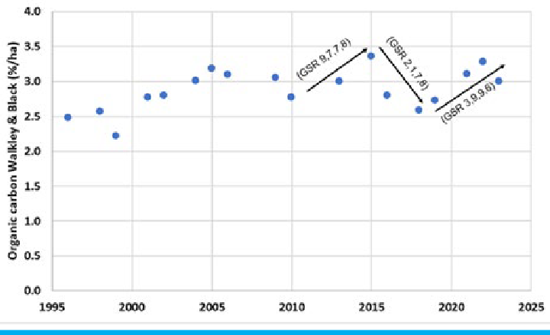

**Pasture Improvement**

Figure 1. Soil organic carbon tests (0-10cm) at Knewleave taken over 28 years from 9 paddocks.

Another similar example from Jigsaw farm that has also done multiple soil C testing over time (14 years), shows similar trend (Figure 2.).

**Further Reading and references**

A farmer’s perspective – making sense of carbon and emissions - webinar with Cam Nicholson and Fiona Conroy

agriculture.vic.gov.au/climate-and- weather/climate-updates-newsletters- and-webinars/climate-webinars (scroll down to 2022, many other webinars and resources listed here).

Country Hour interview with Mark Wootten:

abc.net.au/listen/programs/ vic-country-hour/victorian- country-hour/103590630?utm_ campaign=abc_listen&utm_

content=link&utm_medium=content_ shared&utm_source=abc_listen

Introduction to soil C – (elearn) agriculture.vic.gov.au/climate-and- weather/understanding-carbon-and- emissions/introduction-to-soil-carbon- what-you-need-to-know

Robertson F. et al (2016) Soil organic carbon in cropping and pasture systems of Victoria, Australia publish.csiro.au/sr/ sr15008

Selling carbon from trees and soils agriculture.vic.gov.au/climate-and- weather/understanding-carbon-and- emissions/selling-carbon-from-trees- and-soils

Soil Carbon Snapshot: Graeme Anderson, Melissa Cann and Heather Field Agriculture (updated 2022) This booklet includes the latest science around soil carbon and links to 70 research references and soil carbon reports relevant for Australian agriculture. agriculture.vic.gov.au/ data/assets/pdf_file/0006/857607/Soil- Carbon-Snapshot-updated-May-2022. pdf

Soil carbon measurement practices required for carbon accounting in carbon farming projects – ‘Estimating soil organic carbon sequestration using measurement and model method’ Australian Government Clean Energy Regulator’s methodology for soil sampling guidelines.

The Australian Ag Podcast Mark Wootton: Debunking the carbon myths. Over The Fence with Joe Briggs. - The Australian Ag Podcast - Omny.fm

The Soil Carbon Research Program (SCaRP) csiropedia.csiro.au/soil-carbon- research-program/

Trees and farming – perfect partners (YouTube video with Hugh Stewart and Graeme Anderson) and includes list of resources used (scroll to the bottom of the page) piccc.org.au/research/project/ TreesOnFarm.html

The influence of carbon on property prices - Agrifutures video agrifutures. com.au/resource/the-influence-of- carbon-on-property-prices/

R. A. Viscarra Rossel et al 2024 in the Nature Portfolio Journal ‘Nature A warming climate will make Australian soil a net emitter of atmospheric CO2’: nature.com/articles/s41612-024-00619-z

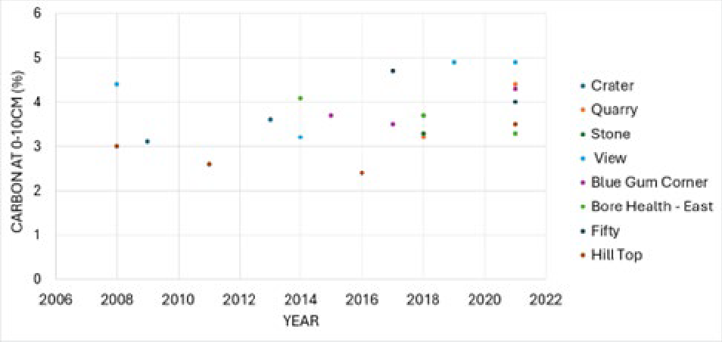

Figure 2.Soil carbon tests (0-10cm) at Jigsaw taken over 14 years from 8 paddocks

For both tree and soil C stocks, floods, drought and fire can have large impacts – which are generally out of your control. Also, scientists have estimated that

a future climate that is warmer and has more droughts will see loss of soil C (Viscerra et al 2024).

#### Offset vs insetting

The term offsetting has been widely used as companies/organisations buy carbon credits (or purchase land to plant trees for example) to offset their emissions, largely from energy use. If farmers sell their carbon storage for others to offset their emissions, these farmers will not be able to use this carbon to offset their own farm emissions – termed insetting.

Credible insetting still has obligations, permanency, auditing etc. We could look to inset some of our stuff now, but it comes at a cost. However, the market isn’t mature enough to recognise this cost with improved prices offered. Why create them when it just increases your cost? This will change but it’s not there yet. It’s also worth calculating your emissions before considering entering a carbon scheme (schemes with integrity only credit net sequestration i.e. sequestration less any increase in emissions anyway) that way you can understand just how much carbon you would need to offset. Do you really have a surplus to sell?

For livestock farmers, most greenhouse gas emissions are methane from sheep and cows. Carbon sequestrated in trees (and possibly soil) can be used to inset your emissions to reduce your farm net GHG balance. If you still own them, you can choose how or to what product to allocate them to, i.e. if you produce meat and wool, the carbon sequestered in any year can be allocated to the meat or wool

or split between depending on what markets are paying a premium or providing market access.

Similarly there is some evidence that the property market may be starting to look at the C status of farmland and the growing pressure from speculators that will potentially distort markets. agrifutures.com.au/resource/the-influence-of-carbon- on-property-prices/

There are a number of carbon markets and not all have the same integrity. It is also worth mentioning the landholder usually wears the risk when it comes to selling carbon. If you commit to a project but then cannot meet your obligation, then credible schemes will require you to buy carbon on the open market to offset that obligation at some point in the future. At whatever the current carbon price is at the time.

The key message is therefore to do your homework, know what you’ve got and get good advice before entering into C markets. We have listed below some of the available resources.

# What to sow for quick winter feed

## – reviewing Reg Hills article from 2011

Neil James

Agriculture Victoria, Ballarat

##### In 2011 renowned agronomist Reg Hill (then with PGG Wrightson Seeds), presented a paper at the 52nd Annual Conference of the Grassland Society of Southern Australia (GSSA), titled ‘What to sow for quick winter feed’.

(Neil — Very much still right)

‘Fodder ryecorn performed well at any sowing time but was consistently the best treatment when sown mid-to-late season. If the break hasn’t arrived by mid-April and feed is desperately short, it was by far the quickest option. It will perform well in poor soils and during

Although 13 years have passed, many of the recommendations from this paper still ring true. Extracts from the paper have been shared (kindly, thanks to GSSA), with several comments regarding currency. The paper related to a series of experiments initiated by PGG Wrightson Seeds in 2007 to help farmers evaluate what they could sow to get the quickest possible winter feed.

#### Annual ryegrass sowing rate

Annual ryegrass (Winter Star II) was sown at 5 different sowing rates (10, 20, 30, 40 and 50 kg/ha) in 4 experiments and

over 3 years. Increasing the sowing rates from; 10 to 20 kg/ha increased winter feed supply by about 1000 kg DM/ha (Dry Matter), from 20 to 30 kg/ha by about

700 kg DM/ha, from 30 to 40 kg/ha by

about 500 kg DM/ha and from 40 to 50 kg/ ha by about 200 kg DM/ha. Note ‘if 1 tonne of supplementary feed is worth about $150 and 10 kg of seed about $35, the economics stacked up well’

(Neil — Even with current prices, the economics still stack up. For example if a tonne of supplementary feed is $350/ tonne and 10 kg of seed is $40-$45).

#### Sowing times

In 2007, 26 treatments and 2 sowing times (11 April and 2 June) were established at the Ballarat research site. This included appin leafy turnip (which has no winter cold requirement); 4 rape varieties; Southern Green ryecorn; oats; triticale; annual ryegrass; Italian ryegrass and oats and annual ryegrass.

‘The brassicas performed very well, but only when sown early. Appin leafy turnip was consistently the quickest brassica but bolted to seed after 2 or 3 grazing’s (Neil - We now have some more winter active brassicas). Nevertheless, if feed is critically short and an early break occurs it is a good option. Rapes do last an extra grazing or 2 but may have to be re-sown in spring unless sown with an Italian ryegrass which can extend growth into the spring/summer.’

‘Annual and Italian ryegrasses were good options if an early break occurred (i.e. early sown). They have quality advantages over the cereals and can extend the supply of quality feed into summer; however, if quick winter feed is the priority and the break is at all slow, they were not as good as cereal’s.

droughts.

However, its growth rate is, in part due to its lack of a winter cold requirement and after 2 or 3 grazing’s, it will send up a seedhead and quality will decline rapidly.’

(Neil — Recent demonstrations have confirmed this and needs to be grazed hard to avoid bolting to a seed head, and stock avoiding it).

‘Early grazing will delay bolting and enable 3 grazing’s but if left until it’s 30 or 40 cm high and grazed hard by cattle, recovery will be very poor.

Fodder ryecorn can be sown with ryegrass to extend the feed supply and quality into spring but in drought years this will reduce yields.

Oats remain an excellent option for later sowings. While they don’t have the speed of ryecorn, they do last longer and can provide useful hay or silage.

If sowing 3 or 4 paddocks, an option may be to sow 1 paddock of ryecorn for the first grazing and 3 paddocks of oats. Deciding what to sow? All species tested have a role and the best choice

will depend on when the autumn break occurs and when you need the feed.’

The following ‘decision tree’ summarises Reg’s findings and are still relevant today although the varieties have changed.

**Further information**

For more information contact Neil James, Agriculture Victoria.

See advertisement for this year’s GSSA conference, Bendigo.

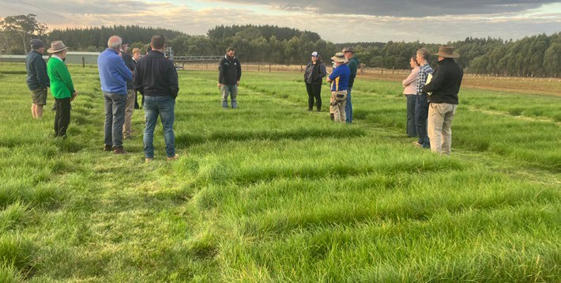Smeaton BWBL and Ballarat BetterBeef group inspect winter active pasture trial site

**Quickest feed + hay/silage**

**Little slower but extended quality into summer**

**Quickest feed + quality hay**

**Mid break, to mid May**

**Quickest feed - sow brassicas in spring**

**Oats**

**Italian ryegrass**

**Annual ryegrass**

**Sthn green ryecorn**

**Rape**

**Appin**

|  |  |  |  |
| --- | --- | --- | --- |
|  | | | **Quickest feed & re-sow in early spring** |
|  | |  |
| **Early break, to 10 April** |  |
|  | |
|  |
|  | **Quickest feed & extended quality to later winter - re-sow spring** |
|  | |
|  | | |

Source: Reg Hill in the Proceedings of the 52nd Annual Conference of the Grassland Society of Southern Australia Inc. 2011

**Little slower but extended growth**

**Late break, after mid May**

**Quickest feed**

**Oats**

**Sthn green ryecorn**

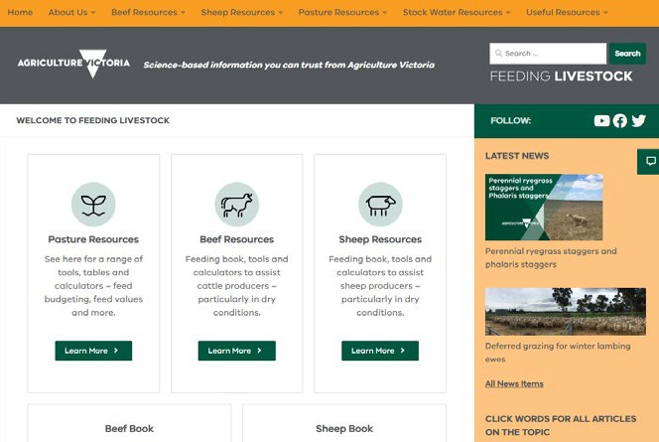

**FeedingLivestock website**

The FeedingLivestock website (feedinglivestock.vic.gov.au) houses many resources on the feeding

and nutrition of sheep and beef cattle. This includes our well known and utilised Drought Feeding and Management books. The useful tables sections include all the critical tables such as feed requirements for different classes of stock so you don’t have to scroll through the books.

There are tools and calculators (including links to apps) that can make the process of estimating feed and water requirements easier.

Pasture resources also provides guides to estimating pasture quality, quantity and growth rates.

# Condition scoring in sheep

Lisa Brown, Veterinary Officer,

Agriculture Victoria

Winter can be a stressful time for livestock. During cold weather the maintenance requirements of sheep increases as they use more energy to help them maintain their body

temperature. Sheep in poor condition are especially vulnerable to extremes of weather. Therefore, it is essential

to ensure they are in good condition coming into winter and can maintain until the spring feed takes off. It is far cheaper to maintain weight than it is to try and put weight back on.

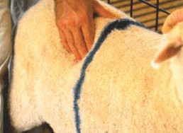 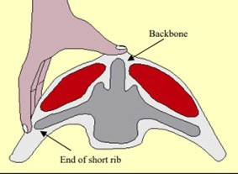

Figure 3. Location and position for Body Condition Score assessment (Source – Lifetime Wool).

Assessing the condition of sheep is useful for monitoring stock and

estimating their nutritional well-being. Condition scoring is generally more useful than liveweight for assessing ewes and adult sheep not affected by different frames sizes within a flock; and corrections don’t need to be made for wool length, the weight of the foetus in pregnant ewes or fluid weight during lactation. It also doesn’t require equipment such as scales. Weighing stock is more useful for assessing young growing stock that need to put

Place your thumb on the backbone just behind the last long rib and your fingers against the stubby ends of the short ribs as shown in Figure 3.

Using the scoring system described below in Figure 4 assign a score to each sheep and record the score so that an average can be calculated.

Most people use a system of half scores, such as 2.5 or 3.5, for animals that fall between the scores outlined below.

**Backbone**

The ideal score falls between a range of

2.5 to 4 with variations dependant on life stage and energy demands. Breeding ewes maintained with a body condition score between 2.5 - 3.5 will have increased conception rates and decreased lamb and ewe mortalities during lambing.

**Further information**

Visit: lifetimewool.com.au/ conditionscore.html

**Short Ribs**

on weight that is not just condition. Assessing condition on a mob twice a month can provide a reliable indication of any weight loss or gain, and this can then be used to guide decisions such as feed budgeting.

#### How to assess sheep condition score

Condition score is assessed by measuring the fat and muscle coverage over the loin area. Animals are best examined in a race when standing in a relaxed position. Animals should not be tense, tightly packed against other animals or held in a crush as this makes it difficult to feel the short ribs and get an accurate condition score. Randomly draft 25-50 sheep into a race or choose a random group from the middle of the mob.

Many people will undertake condition scoring by choosing a couple of sheep from each full race when doing other husbandry activities, such as drenching.

The bones form a sharp narrow ridge. Each vertebra can be easily felt as a bone under the skin. There is only a very small eye muscle. The sheep is quite thin (virtually unsaleable).

**Backbone**

The bones form a narrow ridge but the points are rounded with muscle. It is easy to press between each bone. There is a reasonable eye muscle. Store condition - ideal for wethers and lean meat.

**Backbone**

The vertebrae are only slightly elevated above a full eye muscle.

It is possible to feel each rounded bone but not to press between them. (Forward store condition ideal for most lamb markets now. No excess fat).

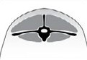**Backbone**

It is possible to feel most vertebrae with pressure. The back bone is a smooth slightly raised ridge above full eve muscles and the skin floats over it.

**Backbone**

The spine may only be felt (if at all) by pressing down firmly between the fat covered eve muscles. A bustle of fat may appear over the tail (wasteful and uneconomic).

The ends of the short ribs are very obvious. It is easy to feel the squarish shape of the ends.

Using fingers spread 1 cm apart, it feels like the fingernail under the skin with practically no covering.

**Short Ribs**

The ends of the short ribs are rounded. Using fingers spread 0.5 cm apart, the ends feel rounded like finger-ends. They are covered with flesh but it is easy to press under and between them.

**Short Ribs**

The ends of the short ribs are rounded and filled in with muscle. Using 4 fingers pressed tightly together, it is possible to feel the rounded ends but not between them. They are well covered and filled in with muscle.

**Short Ribs**

It is only possible to feel or sense one or two short ribs and only possible to press under them with difficulty. It feels like the side of the palm, where maybe one end can just be sensed.

**Short Ribs**

It is virtually impossible to feel under the ends as the triangle formed by the long

ribs and hip bone is filled with meat and fat. The short rib ends cannot be felt.

Figure 4. Description of individual condition scores (Source Lifetime Wool)

# Lambing – 24 hours to shine

**Dr Mark Ferguson** and **Sophie Barnes,** neXtgen Agri International [mark@nextgenagri.com](mailto:mark@nextgenagri.com)

##### The survival of a lamb is almost completely determined by its birthweight combined with what happens in its first 24 hours of life. There are long-term strategies that will pay dividends for lamb survival like planting shelter belts, improving pastures and permanent paddock subdivision.

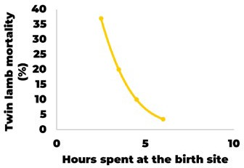For short-term strategies, the important thing is having a plan and acting early. Even at mating, you have a rough idea of how many lambs are coming and how many are likely to be multiples and you

can start your planning. You will be ready to fine-tune the plan when the pregnancy scanner gives you the final results.

#### The factors that matter

The 3 key factors we are working with

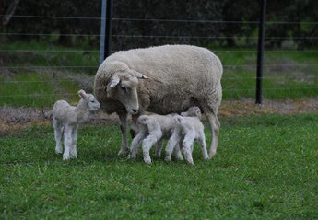

#### Their own worst enemy

One of the key disturbances a ewe will endure is from another ewe. The way to minimise this damage is to minimise the number of ewes in a paddock that are likely to be lambing on any given

are nutrition, shelter and privacy. Each paddock on the farm will have a different balance of these and this will determine which ewes end up getting allocated to those paddocks. Nutrition and privacy are important because they are key factors that keep the ewe on the birth site and the importance of shelter is obvious.

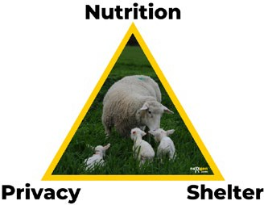

#### Keeping them on the birth site

If a ewe stays on the birth site it means there has been no reason to leave it and that means she has formed a strong bond with the lamb and it is highly likely the lamb has had a good feed of colostrum – the elixir of life.

The 2 reasons a ewe will leave are she is either hungry or has been disturbed.

Figure 5. The effect of time that the ewe spends at the birth site on twin lamb mortality. Source: Environment and reproductive behaviour D.R. Lindsay

- Animal Reproduction Science, 1996 - Elsevier

Aiming for 1400-1500 kg DM/ha of available feed in twin lambing

paddocks means ewes can relatively easily consume sufficient pasture without moving too far. Strategies

to ensure twin-lambing paddocks have enough pasture in them include deferred grazing, applying urea

or gibberellic acid or planting fast- growing fodder crops to either lamb onto or absorb grazing pressure in the time leading up to lambing.

Disturbance is the other key determinant of a ewe moving off the birth site, this disturbance can be from another lambing ewe, a human coming too close or a predator or scavenger approaching. Proximity to human contact is important to consider. Even paddocks with great shelter etc may be the worst lambing paddocks if the school bus goes through the middle twice a day for example.

day. This is especially important in multiples and can be achieved through short-term subdivisions. There is no optimum mob size as the smaller it

is the better the survival. However, practically there is a limit to how small you can go. A good aim is to have your twins should be stocked at 40-50% of your single mob size, and ideally no more than 100 ewes per paddock for twins.

#### What goes where

Data from previous years is some of the most beneficial information to have when it comes to lambing paddock allocation. To work out the plan this year, use the historical information to guide some of your decision making.

It will differ between farms, but the general rule is that you put the most vulnerable lambs to the best paddock. Ewes pregnant with twins that are a bit light are a higher priority than those the same that are in better condition and both groups are a higher priority than ewes only pregnant with a single lamb.

There is a great T90 (Towards 90) module on lambing preparation which goes through these principles in detail and will help you master the mindset and skills around lambing planning.

**Further information**

Check out [www.towards90.com.au](http://www.towards90.com.au/)

# Comparing enterprise performance based on lambing season

Sam Henty, Farm Business Economist,

Agriculture Victoria

A commonly asked question is ‘how does the timing of lambing effect enterprise performance?’. This article uses data from Agriculture Victoria’s Livestock Farm Monitor Project (LFMP) to investigate the characteristics of beef, wool sheep and prime lamb enterprises lambing and calving across the winter, spring and autumn seasons.

#### Supplementary feeding

Autumn beef and prime lamb enterprises had the highest reliance on

supplementary feed. Their supplementary feeding rates were the highest. Winter enterprises had the least reliance on supplementary feed recording the lowest average supplementary feeding rates across all enterprises.

#### Comparing risk and gross margins of enterprises

Table 1. Various measures in 2022-23 for

Risk was measured by the standard deviation in gross margin across the time period 2019-20 to 2022-23. Gross margins that fall toward the right-hand side of Figure 6 are considered riskier than those indicated by points toward the left-hand side.

Autumn and winter calving beef enterprises had the highest average gross margins but were also among the riskiest enterprises. All sheep enterprises were less risky than the beef enterprises except for autumn prime lamb which had the most risk of all enterprises. Prime lamb winter and spring lambing enterprises were the highest gross margins of the sheep enterprises. Both had similar gross margins and risks. Wool sheep spring enterprises had almost half the risk and 40% higher gross margin than wool sheep winter enterprises.

This analysis shows the relationship between risk and return for the

enterprises across winter, spring and autumn lambing and calving.

#### Stocking rate

All autumn calving or lambing enterprises had the lowest average stocking rates. Whereas spring enterprises had the highest stocking rates. Autumn enterprises tended

to be in locations where average annual rainfall and carrying capacity were lower than spring and winter enterprises.

4-year average gross margin ($/ha)

Average gross margins were calculated for each enterprise for each season over the last 4 years. The criteria used to compare the enterprises were the size of 4-year average gross margins (return) and the variability in gross margin over the 4 years (risk).

different enterprises and different seasons. Enterprises with higher gross margins tended to have higher risk.

Managing the volatility of an enterprise over time is a characteristic of good farm managers. They will choose a seasonal enterprise so the risk-return mix suits their business location, goals and objectives.

$8 00

Beef Autumn calving

Beef Spring calving

$750

Prime lamb Winter lambing

Beef Winter calving

$700

$650

Prime lamb Spring lambing

Wool sheep Spring lambing

$600

$550

Prime lamb Autumn lambing

$500

Wool sheep Winter lambing

$450

$400

Wool sheep Autumn lambing

$350

$300

Risk

#### Sales and price

There were minimal differences in prices received for beef or lamb across the seasons but for wool there was a large range. This could be the influence of time of lambing on the time of shearing and therefore time of sale, with sales later in the year more exposed to downward price trends experienced across 2022-23. All autumn enterprises had the heaviest average stock sale weights and winter enterprises had the

lightest sale weights.

Figure 6. Return versus risk: Average and standard deviation of gross margins (2019-20 to 2022-24).

#### Free benchmarking and profit assessment of your farm business



Agriculture Victoria is offering individual sheep, beef and cropping farmers the opportunity to participate in this respected, rigorous and long running benchmarking program. Individual positions are available across Victoria in 2024.

Participation is free and all information is treated as highly confidential.

Each participating farm receives an annual individualised farm report with farm benchmark information from the reporting year as well as all previous years of participation. A participating farm business can use the results from this report to compare itself over time and help identify the critical variables to inform and provide confidence for on- farm decision making. The report is a trusted and un-biased source of information that can assist farm businesses with conversations with the bank, consultants and industry.

##### ‘Had the first serious meeting with the bank today since starting the farm monitor and it was very helpful. I just kept saying “yep the data is there and you can see the comparison to the previous year’’. It made something that can be a bloody nightmare so much easier.’

Livestock Farm Monitor participant.

### Grasslands Society of Southern Australia

### – 64th Annual Conference

#### GSSA Conference - program highlights

##### The GSSA Conference being held at Bendigo on July 17-18 will offer something for everyone. The central theme will focus on ‘Evidence Based Decision Making’ and the topics have been built around what farmers need to know.

Delegates will be able to choose from 2 bus tours. One to a property north of Bendigo integrating lucerne into a profitable livestock system and one to a higher rainfall perennial pasture property south of Bendigo.

#### Topics will include:

* Carbon - An informed farmers perspective
* Carbon neutral livestock production - is it possible?
* Soil carbon and fertility
* Measuring and knowing your soil carbon levels
* Old clover identification and sub optimal clover nodulation
* Paddock livestock weighing
* What bugs You?

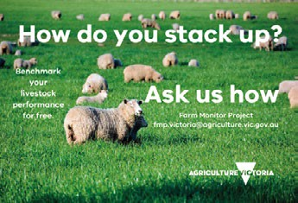

**Further information**

For further information about getting involved please contact: Sam Henty; Farm Business Economist

Agriculture Victoria. [sam.henty@agriculture.vic.gov.au](mailto:sam.henty@agriculture.vic.gov.au)

* Use of drones in agriculture
* Facial livestock recognition
* Remote pasture measurement
* Running lambs on improved varieties of perennial ryegrass vs more persistent Victorian ryegrass - animal responses above yield responses
* N efficiency and endophytes in ryegrass pastures
* Introduction to fertiliser calculator tool.

The Mac Troup oration will be delivered by well- known farm management guru Professor Bill Malcolm, Melbourne University

**Further information**

**grasslands.org.au/2024- annual-conference**

# Copper deficiency

John Jardine, Veterinary Officer,

Agriculture Victoria

##### Copper deficiency was a significant problem encountered by sheep producers in west and south west Victoria during spring and early summer last year. It presented as fractured legs and enzootic ataxia (swayback) in weaned and unweaned lambs.

3-4 times normal width, and it has greatly reduced tensile strength and elasticity. Greying of black- woolled sheep is a sensitive sign of copper deficiency

* **Enzootic ataxia (swayback)**, The nervous tissue of the lamb has a special requirement for copper in

Copper deficiency has been described in sheep in Victoria since 1945 and several parts of the state have been diagnosed with copper deficiency in pasture or livestock, see Figure 7. Areas of peat swamp, granite soil, or sandy soil near the coast can be naturally lacking in copper.

Copper is an essential trace element, being involved in at least 10 enzymes which catalyze oxidase type reactions in animals. Copper is required

for body, bone and wool growth, for pigmentation, myelination of

nerve fibres and leucocyte function (Underwood 1977, Arthur et al. 1981).

Copper concentration in a pasture is affected by the pasture species,

maturity of the grass and the season.

Grasses generally have lower copper concentrations than clovers. The copper concentration declines in pasture from winter to late spring.

During summer as the grasses dry off, the concentration increases and the copper forms in the pasture change to make it more readily absorbed by animals. During this time the rumen

flora change to a more fibrous diet and these further aids copper absorption.

#### Clinical signs associated with copper deficiency:

* **Wool abnormalities**, loss of wool crimp is one of the first clinical signs of copper deficiency in sheep. The wool develops a sheen or lustre (‘steely wool’) with crimps

the last two months of gestation, when it is rapidly developing, and in the immediate post-natal period. The ataxia is seen as paralysis or a staggering gait in

newborn lambs or develops up to 6 weeks after birth

* **Bone fragility** in lambs is often associated with copper deficiency, with increased incidence of fractures in long bones and rib bones
* **Anaemia** in sheep can occur with extreme copper deficiency. In grazing sheep, parasitism, cobalt deficiency or malnutrition are more likely to be causes of anaemia than copper deficiency alone.

#### Interactions with other minerals

High dietary intakes of molybdenum, sulphur, zinc, iron, cadmium and calcium have all been shown to decrease the availability of dietary copper to animals (ARC 1980, Underwood 1977). In the Victorian situation, the interaction between copper and molybdenum is particularly important in determining copper availability to animals. Many of the areas which are marginal or deficient in copper are also deficient in molybdenum (Savage 1974) and molybdenum applications to these areas can exacerbate the copper deficiency. Liming of pastures can result in an overall decrease in copper available to animals and can increase the availability of molybdenum.

Figure 7. Areas where copper deficiency in pasture and livestock has been identified in

Victoria, based on data published by Savage (1974)

#### Diagnosing copper deficiency:

Diagnosis of copper deficiency is made by testing a blood or liver sample. This is best performed during at risk periods (winter and spring). Further testing of pastures may be useful if the sulphur and molybdenum concentrations are measured as well to see if there are interactions with other minerals.

#### Treatment options

In the short term an injection, a rumen bullet or a feed supplement that contains copper can be given to affected animals. In the longer term,

long-acting injections or rumen bullets can be included as part of the flock’s management plan. Other options include topdressing paddocks with copper or using a fertiliser with added

copper. Please discuss this with your

## BestWool/BestLamb and BetterBeef Conferences and Dinner 2024

The Agriculture Victoria 2024 BestWool/ BestLamb & BetterBeef Conferences and Dinner will be held at the Goods Shed, Ballarat on Wednesday 19 and Thursday 20 June. This event is a partnership between Agriculture Victoria and AWI Extension VIC, supported

BestWool/BestLam BetterBeef Confere

and Dinner 2024

b and

nces

by Meat and Livestock Australia (MLA) and the Australian Government Farm Business Resilience Program.

#### BestWool/BestLamb program

fertiliser consultant/retailer for advice.

#### Copper toxicity

Care needs to be taken when supplementing with copper. Sheep

are prone to acute and chronic copper toxicity. It is not advisable to give large amounts of copper to animals when their copper status is unknown and if giving copper in several ways, e.g. in feed and an injection.

**Cam Nicholson**, Nicon Rural Services, Grazing management

**John Francis**, Agrista, Thriving under pressure - are you ready for the challenge

**Bonnie Skinner**, Sheep Producers Australia, Market access - what are our customers asking for?

Concurrent sessions

**Bruce Jackson**, Vet consultant, Feet health - know your enemy

**Angus, Nick and Phillip Locke**, ‘FairyView’ Hollbrook, Early lambing makes life easy

**Jess Revell**, Rumenate Livestock Services, Unravelling the growth challenges of weaners

**Jason Trompf,** JT Agrisource, More live lambs from ewe lambs

**Charlie de Fegley**, Quamby,

Targets and trigger points - driving optimisation of a prime lamb system

**Emily King, AWI and Dr Sarah Weaver**, University of Adelaide - Bioharvesting - what’s the latest?

**Mark Ferguson**, neXtgen Agri, Flocks of the future - the role of artificial intelligence



To register and see the full program for both days go to trybooking.com/events/landing/1211584 or scan the QR code

# Property Identification Codes (PICs) and their role in emergency responses

##### Property Identification Codes (PIC) play an essential role

in responses to emergency disease incidents and natural disasters because they identify where at-risk animals are located.

PICs are also used for emergency relief and recovery activities within an impacted zone.

Victorian law requires people to have a PIC for the properties on which they are, or are intending to, graze or keep:

* one or more cattle, sheep, goats, pigs, alpaca, llamas, deer, horses, camels
* more than 50 poultry (i.e. domesticated fowl, chickens, ducks, geese, turkey, guinea fowl, pigeons, quail or pheasants) or
* 10 or more emus or ostriches.

#### Are your PIC details up to date?

Victoria’s PIC register can only be relied on if people keep their PIC details up to date. The property owner and manager are responsible for ensuring that Agriculture Victoria is notified within 28 days of changes to any of the following details relating to a PIC:

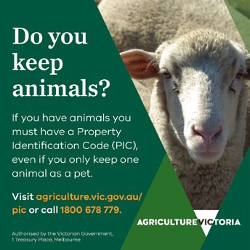

**Further information**

You can apply, update, or cancel a PIC by contacting the Agriculture Victoria helpdesk on **1800 678 779** during business hours, online at **pic.a**griculture.vic.gov.au or

using the **QR code**.

1. owner contact details including name, address and contact phone number
2. manager contact details including name, address and contact phone number
3. changes to property boundaries involving their expansion through acquisition or agreement to graze sheep or goats, or their reduction through sale or the relinquishing of a lease or agistment right
4. the livestock species that are or will be kept on the property.

**12 Sheep Notes** Autumn 2024

**Seasonal reminders and resources**

Below is a reference to some past articles that may be useful over the coming months.

These are available either as previous SheepNotes articles on the Agriculture Victoria website (agriculture.vic.gov.au and search for ‘Sheep Notes’) or on the FeedingLivestock (FL) website

|  |  |  |
| --- | --- | --- |
| Topic | Content | Where is it |
| Options for improving winter pasture growth | Lisa Warn presents the options for boosting winter growth to achieve late winter and spring pasture and the tools and triggers to achieve best results | Bestwoolbestlamb conference presentations 2019 (youtube) |
| Nutrition and health of ewes after the break | Guides on ewe requirements - pasture, health and Condition | SheepNotes Autumn 2015 |
| Imprint feeding | Training lambs to eat grain before weaning | FL website in news |
| Safely getting stock onto grain | Outlines a program for introducing sheep to grain to prevent health issues | Drought Feeding and Management of Sheep Chapter 4 available on FL website |
| Early weaning | Outlines some guidelines for early weaning of lambs, including production targets and nutrient requirements. | SheepNotes Winter 2019 |
| Targets for maternals | Outlines results from research to develop guidelines for condition scores for crossbred ewes | SheepNotes Autumn 2020 |
| Calcium disorders of ewes and lambs | Colin Trengove outlines hypocalcaemia, risks and potential treatment | SheepNotes Spring 2016 |
| Prolapsing ewe | Possible causes and prevention of prolapses in ewes | SheepNotes Autumn 2022 |
| Tail length – getting it right | Guidelines (and why) of getting tail length in | SheepNotes Autumn 2016 |
| Feed testing | The importance of testing feeds to be cost effective and meet animal needs. Interpret the results of a feed test. | SheepNotes Autumn 2023  Webinar: feedinglivestock.vic.gov.au  /2023/05/24/feed-testing-webinar-recording |
| Do you need help assessing how good your pastures/crop are for stock? | Links to visual resources for assessing pasture and crops for amount and quantity. Links to tables on animals requirements | FL website in news |
| Ram health | Pre-joining ram checks | SheepNotes Spring 2015 |

# Digital Tip

## Improving battery life

#### iPhone

###### Always make sure your device is using the latest version of iOS.

* + **Optimise your settings.**
    - Adjust your screen brightness and use Wi Fi
    - Dim the screen or turn on auto- brightness to extend battery life
    - To dim, open control centre and drag the brightness slider to the bottom
    - Auto-brightness automatically adjusts your screen to the lighting conditions
    - When you use your device to access data, a Wi Fi connection uses less power than a mobile network — so keep Wi Fi on at all times
    - Turn off Bluetooth when not using to connect to another device.

###### Enable Low Power Mode.

* + - Settings > Battery. Low power mode reduces display brightness, optimises device performance and minimises system animations. Apps

including Mail will not download content in the background, and features like AirDrop, iCloud sync and continuity will be disabled. You can still use key functions such as making and receiving phone calls, email and messages, accessing the internet and more. And when your phone charges up again,

Low Power Mode automatically switches off.

* **View battery usage information.** With iOS, you can easily manage your device’s battery life, because you can see the proportion of your battery used by each app (unless the device is charging). To view your usage, go

to Settings > Battery. Messages you may see listed include:

* + **Background activity.** This indicates the battery was used by an app while it was in the background — that is, while you were using another app. To

improve battery life, you can turn off the feature that allows apps to refresh in the background.

Go to Settings > General > Background App Refresh and select ‘WiF’, ’WiFi & Mobile Data’ or ‘Off’ to turn off Background App Refresh entirely

* + **Location and Background Location**. This indicates an app is using Location Services. You can optimise your battery life by turning off Location Services for an app. Turn off in Settings

> Privacy > Location Services. In Location Services, you can see each app listed with its permission setting. Apps that

recently used Location Services have an indicator next to the on/off switch

* + **Home and Lock Screen**. This indicates the Home Screen

or Lock Screen was displayed on your device. For example, the display was awakened

by pressing the Home button or by a notification. If an app frequently wakes your display with notifications, you can turn off push notifications for the app in Settings > Notifications. Tap the app and set Allow Notifications to Off

###### No Mobile Data Coverage

**and Low Signal**. This indicates either you are in a poor mobile coverage area and your iOS device is searching for a better signal or you’ve used your device in low-signal conditions, which has affected your battery life

* + You can optimise your battery life by turning on aeroplane mode.

Consider carrying

at least 1 spare battery pack, perhaps a solar powered one.

**Android phones**

* **Choose settings that use less battery**

–

–

–

–

Turn on adaptive battery

Delete unused accounts Turn on dark theme

Access Setting>battery and see what is using the most power and see options to change power mode (e.g. medium to low).

* **Stretch a low battery**

–

* Let your screen turn off sooner
* Reduce screen brightness
* Set the brightness to change automatically

–

–

–

–

Turn off keyboard sounds or vibrations

Restrict apps with high battery use

1. **Take care of your battery**

–

Use the power adapter that came with your phone

Keep it cool.

–

–

Turn on battery saver or low power mode

Avoid actions that keep the screen on

Avoid constant internet connection

Avoid actions that process too much information

Limit connectivity and location.

–

**Making decisions early in 2023** – Case Study - Rob Cooper; Manager Barton Station

#### Barton Station

Rob Cooper is the manager at Barton Station Moyston, 20 km east of Ararat, near the Grampians. Barton Station is part of the Paraway Pastoral Group

and consists of 8,244ha with a 26,000

Rob Shea

Perennial Pasture Systems

#### Background

Perennial Pasture System (PPS) has an ongoing soil probe network providing daily readings of soil conditions - soil temperature and moisture at 10 cm increments to 80 cm. The information from these and other spoil probes is available on the Agriculture Victoria soil probe network site extensionaus. com.au/soilmoisturemonitoring/.

To investigate if they could add value to the information provided and get some early warning of spring seasonal

#### What we did

Early in spring, Agriculture Victoria generated predicted spring pasture growth rates for 3 PPS sites, using initial pasture and soil moisture conditions with historic climate data. The seasonal forecasts were used as an indication of likely scenarios for the spring season. This was done using ‘GrassGro’, a CSIRO software program that uses extensive soil, pasture, animal and climate data to generate pasture growth rates on the farms involved.

At the previous 2 years, the spring

composite breeding ewe flock. In recent years a 3,000 mob of Angus breeders has been added to the operation. In the past decade, Rob and his team have increased the carrying capacity of Barton through old pasture rejuvenation, establishing new pastures especially lucerne, extensive use of silage and paddock subdivision to refine the pasture rotations. Rob said the addition of cattle was the final piece of the program adding grazing pressure where needed and providing a separate source of income with yearling steer turn off.

It had been a good season until September, and Rob had taken the opportunity to trade in ewes, cows and weaner steers to use autumn/winter feed. Things dried up in September and Rob estimated pasture growth was only 60% of average. In the September report the profile was much drier than other sites with very low soil moisture in the top soil and also less at depth than at other sites (Figure 8). The report indicated that significant rains were required soon (higher than long term average) to get good growth rates for the rest of spring, or at least close to average to get more growth (Figure 9). So in September, there was still time for a large rain to revive the spring growth but this wasn’t a high probability.

**CURRENT SOIL MOISTURE OVERALL SOIL MOISTURE**

conditions, PPS obtained funding through the Australian Government ‘Smart Farms Small Grants Round 3’ program (2021). This provided funds to get pasture growth estimates on 3 of their sites through spring. In 2023,

seasonal conditions across the PPS region had been very good with full soil moisture profiles at the start of spring in 2021 and 2022 and forecasts

for above average rainfall. Therefore, in

these years predictions for spring were

10cm: 20cm: 30cm: 40cm:

50cm:

**29%**

**24%**

**44%**

**54%**

**63%**

25%

Dry

50%

75%

Sat

they gained further funding from a

Wimmera CMA Landcare Victoria grant to continue the project.

for both above average growth rates and for a prolonged growing season – which occurred.

60cm: 70cm:

**41%**

**64%**

current 1 month

ago

1 year ago

This article outlines the experience at 1 of the sites that used the information to make some early decisions, noting

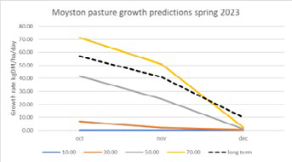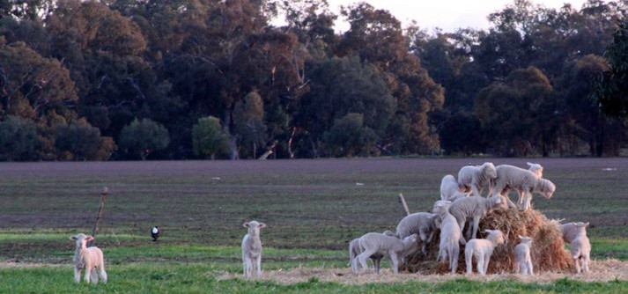

that the ‘drier than average’ or ‘El Nino ’conditions did not eventuate for much of the state.

**14 Sheep Notes** Autumn 2024

In 2023, an early easter autumn break set up the year as 1 of the best years on record. However, by late August the conditions across some of the sites were quite different. While 2 of the sites were depleting in moisture (Tottington and Stawell), they still had potential

to have an average (or above) spring if they got good rainfall. The outlook at the Moyston site (Barton station) indicated that pasture would cease growing without good rains soon.

Figure 8. September 23rd 2023 soil moisture summary at Moyston

Figure 9. Pasture Predictions for spring 2023 (with rainfall for 10,30, 50 and 70 weather deciles plus the long-term average)

By October, rainfall had not occurred, the profile had dried further (figure x), and pasture predictions were for well below spring averages (they needed 30 mm of rain within seven days to achieve this). They had plans in place for this situation and implemented them after the first report confirmed expectations for the rest of spring.

**CURRENT SOIL MOISTURE OVERALL SOIL MOISTURE**

After the livestock sales, the focus turned to weaner sheep and cattle and feeding plans were made to get them to thrive through the summer and autumn and grazing plans for breeding stock were implemented.

PPS asked Rob ‘what happens if it starts raining again?’ Rob’s answer was he needs to deal with the present situation and the stock sales would go ahead. The dry spring prediction was

|  |  |  |  |  |
| --- | --- | --- | --- | --- |
| 10cm: | **16%** | 50% |  | accurate, and rainfall was about 50% |
| 20cm: | **11%** | 25% | 75% | of the average. |
| 30cm: | **29%** |  |  |  |
| 40cm: | **36%** |  |  | **Christmas present** |

50cm: 60cm: 70cm:

**47%**

**18%**

**44%**

Dry

current 1 month

ago

Sat

1 year ago

It started raining again at Christmas with 35 mm and a further 90 mm of rain in January. Barton’s lucerne fired up, clover germinated and grew to a grazable height, and perennial grasses

Barton Station manager, Rob Cooper, in planning mode.

Figure 10. October 20th, 2023, soil moisture

summary at Moyston

Figure 11. Pasture Predictions from October 2023 (with rainfall for 10,30, 50 and 70 weather deciles plus the long-term average)

#### Sounds like a plan

This galvanised Rob’s thinking and he correctly judged the weather patterns wouldn’t deliver a large rain in time. Rob commented he was fairly confident in his decision making but the report gave him the extra confidence to make the large

alteration to the timing of stock selling. Old ewes were moved on a week after their lambs were weaned. There were also 1,300 young cattle to be sold and the Wagyu cross mixed sex and Angus yearlings were immediately listed on the market. The focus was then on getting weight on breeding stock and setting up for a dry summer.

All this was done while there was still a small chance of a big spring rain and some further spring growth.,

However, Rob’s management is not based around small chances. ‘Hope is not a strategy’ he said, recalling that advice from a mentor in his early farm management days.

were safe to graze without risking animal or plant health.

Did Rob regret his decision to sell off stock? Not in the least! Large feed bills were avoided before the new growth and we were able to spread out the breeding ewes and put a half a condition score

on them. They all had green feed to flush them prior to joining. ‘We are set up for 2024’. The result of the summer preparation of the ewes resulted in the best ever scanning results. pretty handy when you joined 26,000 ewes.

Rob commented, this project combined with the feed quality assessments (being made as part of the PPS MLA PDS (Meat and Livestock Australia

Feed quality is a key focus at Barton, even the end users check the feed test samples

Producer Demonstration Site) ‘Productive grazing with feed quality management’, is a great benefit and it is helping them to continuously refine their system to improve production and sustainability. Barton Station is a very productive enterprise with spectacular scenery under the mountains, massive red gums inhabit the paddocks and

the resident emus and kangaroos are always in great condition.

The project conducts an analysis of predicted pasture growth for the region using the above tools and getting it formatted into an easily understood visual format to assist farmer decision making in grazing systems in the variable climate conditions that are now part of the region’s farming systems.

##### The project estimates are conducted by Jane Court, Agriculture Victoria and Dr Nathan Robinson; CeRDI, Federation University.

PPS thanks them for their assistance with this project. Thanks to Paraway Pastoral for their support of the PPS and their cooperation with this and other PPS projects.

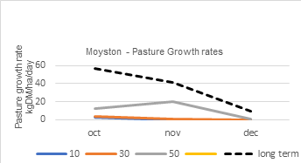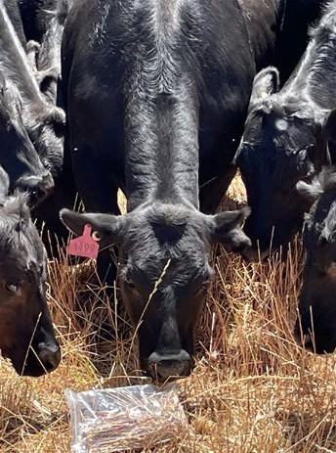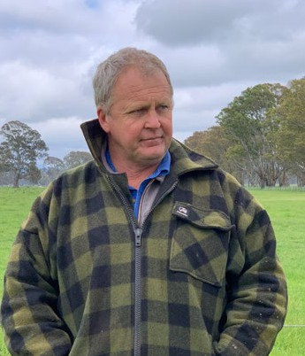

**Sheep Notes** Autumn 2024 **15**

**Agriculture Victoria animal health and sheep industry contacts**

Although our offices are currently closed, the office numbers provided below are diverted to staff who can assist you. Alternatively, you can contact Agriculture Victoria on 136 186.

|  |  |  |  |  |
| --- | --- | --- | --- | --- |
| **Location** | **Office Contact** | **Meat and Wool Services** | | **Animal health** |
| **Livestock Industry Development Officers** | **Land Management Officers\*** |
| **South-West region** | | | | |
| **Ararat** | 136 186 | ✓ | ✓ |  |
| **Ballarat** | 5336 6856 | ✓ | ✓ | ✓ |
| **Colac** | 5233 5504 |  |  | ✓ |
| **Geelong** | 5226 4878 |  | ✓ | ✓ |
| **Hamilton** | 5573 0900 | ✓ |  | ✓ |
| **Horsham** | 0343 443 111 |  |  | ✓ |
| **Queenscliff** | 5258 0229 |  |  |  |
| **Warrnambool** | 5561 9946 | ✓ |  | ✓ |
| **South-East region** | | | | |
| **Attwood** | 9217 4200 |  |  | ✓ |
| **Bairnsdale** | 136186 | ✓ | ✓ | ✓ |
| **Cranbourne** | 136 186 |  | ✓ | ✓ |
| **Ellinbank** | 5624 2222 | ✓ | ✓ | ✓ |
| **Leongatha** | 5662 9900 |  | ✓ | ✓ |
| **Maffra** | 5147 0800 | ✓ |  | ✓ |
| **Swifts Creek** | 5159 5134 | ✓ | ✓ |  |
| **Northern region** | | | | |
| **Alexandra** | 5772 0200 |  | ✓ |  |
| **Benalla** | 5761 1611 | ✓ | ✓ | ✓ |
| **Bendigo** | 5430 4444 | ✓ | ✓ | ✓ |
| **Echuca** | 5482 1922 |  |  | ✓ |
| **Rutherglen** | 02 6030 4500 | ✓ |  |  |
| **Seymour** | 5735 4300 |  |  | ✓ |
| **Swan Hill** | 5036 4800 |  | ✓ | ✓ |
| **Tatura** | 5833 5222 |  | ✓ | ✓ |
| **Wangaratta** | 5723 8600 |  |  | ✓ |
| **Wodonga** | 02 6043 7900 |  | ✓ | ✓ |

*Farm planning, soil health advice, soil conservation advice, dryland farm water planning

© The State of Victoria Department of Energy, Environment and Climate Action, 2024



This work is licensed under a Creative Commons Attribution 3.0 Australia licence. You are free to re-use the work under that licence, on the condition that you credit the State of Victoria as author. The licence does not apply to any images, photographs or branding, including the Victorian Coat of Arms, the Victorian Government logo and the Department of Economic

Development, Jobs, Transport & Resources logo. To view a copy of this licence, visit [creativecommons.org/licenses/by/3.0/au/deed.en](http://creativecommons.org/licenses/by/3.0/au/deed.en)

ISSN 1326-4559

ISSN 1836-4756 (Online)

**Accessibility**

If you would like to receive this publication in an alternative format, please telephone the DJPR Customer Service Centre on 136186, email customer. [service@ecodev.vic.gov.au](mailto:service@ecodev.vic.gov.au) (or relevant address), or via the National Relay Service on 133 677 [relayservice.com.au](http://relayservice.com.au/). This document is also available on the internet at [agriculture.vic.gov.au](http://agriculture.vic.gov.au/)

**Disclaimer**

This publication may be of assistance to you but the State of Victoria and its employees do not guarantee that the publication is without flaw of any kind or is wholly appropriate for your particular purposes and therefore disclaims all liability for any error, loss or other consequence which may arise from you relying on any information in this publication.

**16 Sheep Notes** Autumn 2024